AZURE ENTERPRISE INFRASTRUCTURE LAB
06 — Identity & Security
Managed Identity + Azure RBAC + Key Vault
Evidence-based implementation documentation with attached Azure Portal screenshots

1. Objective
Demonstrate Azure identity and security fundamentals by reviewing RBAC scope, enabling a system-assigned managed identity on the Windows VM, creating an Azure Key Vault with Azure RBAC, assigning the VM the Key Vault Secrets User role, and troubleshooting a data-plane permission error while creating a test secret.

2. Environment
Resource / Setting | Observed value
Subscription | My Test Azure subscription 1
Resource Group | rg-azure-enterprise_MM
VM | vm-web-MM
VM OS | Windows Server 2025 Datacenter
VNet | vnet-azure-enterprise-MM
Subnet | WebSubnet_MM
VM Private IP | 10.0.1.4
VM Public IP | 20.244.97.131
Key Vault | kv-azure-enterprise-mm
Key Vault region | Central India
Key Vault pricing tier | Standard
Key Vault permission model | Azure role-based access control

3. Security Architecture
- User / administrator → Azure RBAC at subscription/resource scopes
- vm-web-MM → System-assigned Managed Identity → Microsoft Entra ID
- Managed Identity → Key Vault Secrets User → kv-azure-enterprise-mm
- Key Vault → Secrets → DemoSecret (planned test secret; creation currently blocked by the user's own data-plane permissions)

4. RBAC Scope Review
The subscription IAM screenshot shows the signed-in account has an active Owner role at subscription scope. The VM IAM screenshot shows that Owner is inherited from the subscription.
No additional Owner or Contributor assignment is required for the administrator. This is useful evidence for explaining RBAC scope inheritance and least-privilege design.

5. Managed Identity Configuration
A system-assigned managed identity was enabled on vm-web-MM. The identity is tied to the lifecycle of the VM and can be granted Azure RBAC permissions without embedding credentials in code or configuration.
Verified state: System assigned = On.

6. Key Vault Creation
- Key Vault name: kv-azure-enterprise-mm
- Resource group: rg-azure-enterprise_MM
- Region: Central India
- Pricing tier: Standard
- Soft delete: Enabled
- Retention: 90 days
- Purge protection: Disabled
- Permission model: Azure RBAC
- Networking: Public endpoint / all networks for the initial lab

7. Key Vault RBAC Assignment
The VM managed identity was assigned the built-in role:
Key Vault Secrets User
Scope: kv-azure-enterprise-mm. Member: vm-web-MM (Virtual machine managed identity).
This role is intended for reading secret values; it is not sufficient for the signed-in administrator to create or manage secrets.

8. Troubleshooting: Secret Creation Forbidden
A test secret named DemoSecret was prepared with a dummy value, but creation failed with a Forbidden/RBAC error.
Observed issue: The portal reported that the operation was not allowed by RBAC and advised allowing several minutes for recently changed role assignments to become effective. The caller was not authorized to perform the secret set operation.
This behavior is consistent with a separation between Azure resource-plane administration and Key Vault data-plane permissions. Having Owner at subscription/resource scope does not by itself grant the required Key Vault secret data action under the Azure RBAC permission model.

9. Correct Remediation
To allow the administrator to create/manage test secrets while preserving the VM's least-privilege read access:
- Key Vault → Access control (IAM) → Add role assignment
- Role: Key Vault Secrets Officer
- Assign access to: User, group, or service principal
- Member: the administrator's Azure account
- Review + assign
- Allow several minutes for RBAC propagation, then refresh/retry
Do not remove the VM's Key Vault Secrets User role. Keep it so the VM can later retrieve secrets without write permissions.

10. Planned Test Secret
- Name: DemoSecret
- Value: AzureLab-Test-2026
- Enabled: Yes
Use this dummy value only. Never use a production password, API token, connection string, or other real credential in a learning secret or public GitHub repository.

11. Validation Plan
- Create DemoSecret successfully from the administrator account after the Secrets Officer role propagates.
- Keep vm-web-MM as Key Vault Secrets User.
- From vm-web-MM, authenticate with its managed identity and perform a read-only secret retrieval test.
- Capture successful role-assignment, secret listing, and read-validation screenshots.
- For a production-style design, replace the public Key Vault endpoint with private connectivity and restrict network access.

12. Interview Skills Demonstrated
- Azure RBAC and scope inheritance
- Least privilege
- System-assigned managed identity
- Microsoft Entra ID integration
- Azure Key Vault
- Key Vault RBAC
- Secrets management
- Data-plane vs control-plane permissions
- RBAC propagation troubleshooting
- Credential-free VM-to-service authentication

13. Interview Questions
Q1. Why use a managed identity?
It allows an Azure resource such as a VM to authenticate to supported Azure services without storing application credentials.
Q2. What is the difference between control-plane and data-plane permissions?
Control-plane permissions manage the Azure resource itself; data-plane permissions govern operations against the data or objects inside the resource, such as Key Vault secret operations.
Q3. Why did the VM receive Key Vault Secrets User?
The VM only needs to read secrets for the planned test; it does not need permission to create or delete secrets.
Q4. Why did secret creation fail even though the administrator is Owner?
The Key Vault uses Azure RBAC for its data plane, so the administrator needs an appropriate Key Vault data role for secret creation.
Q5. Why choose Key Vault Secrets Officer instead of Administrator?
Secrets Officer is narrower and supports secret management without granting all Key Vault data operations.
Q6. Why is public network access acceptable here?
It is being used for the initial learning exercise; a production design should consider network restriction/private connectivity.

14. Evidence Index
- 1. Subscription IAM — Owner assignment — 01-subscription-iam-owner.png
- 2. VM IAM — inherited Owner role — 02-vm-iam-inherited-owner.png
- 3. VM Network Settings — existing NSG/network evidence — 03-vm-network-settings.png
- 4. VM Identity — system-assigned managed identity enabled — 04-vm-managed-identity-enabled.png
- 5. Key Vault Access Configuration — Azure RBAC — 05-key-vault-access-configuration.png
- 6. Key Vault Networking — public endpoint, all networks — 06-key-vault-networking.png
- 7. Key Vault Review + Create — 07-key-vault-review-create.png
- 8. Key Vault deployment operation details — 08-key-vault-deployment-operation.png
- 9. Add Role Assignment — Key Vault Secrets User selected — 09-role-assignment-role.png
- 10. Add Role Assignment — vm-web-MM managed identity selected — 10-role-assignment-vm-member.png
- 11. Key Vault RBAC role assignment success — 11-key-vault-rbac-success.png
- 12. Create Secret — DemoSecret form — 12-create-demo-secret-form.png
- 13. Key Vault secret creation — Forbidden/RBAC error — 13-key-vault-secret-rbac-error.png

15. Screenshot Evidence
Figure 1 — Subscription IAM — Owner assignment
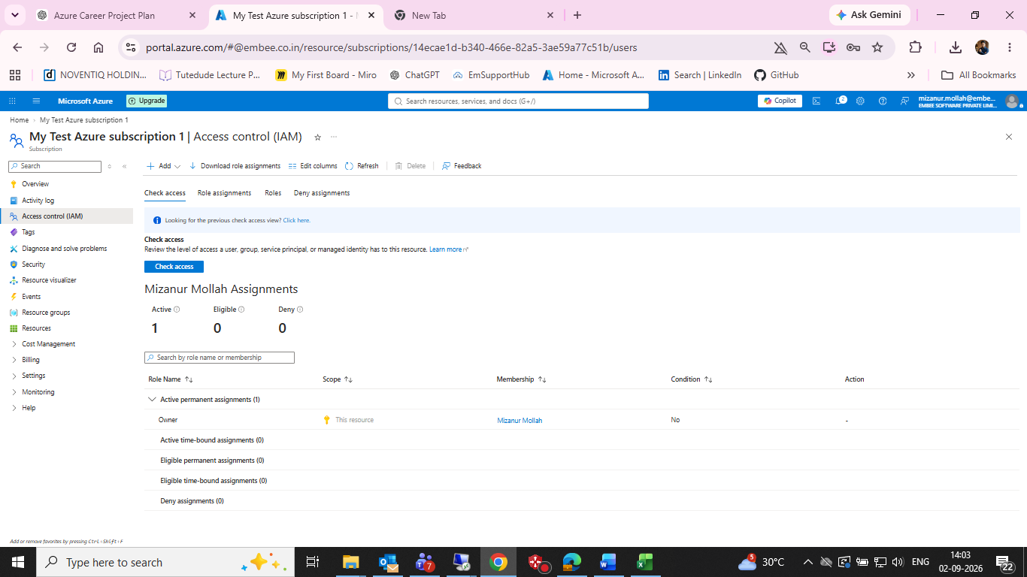
Subscription IAM — Owner assignment

Figure 2 — VM IAM — inherited Owner role
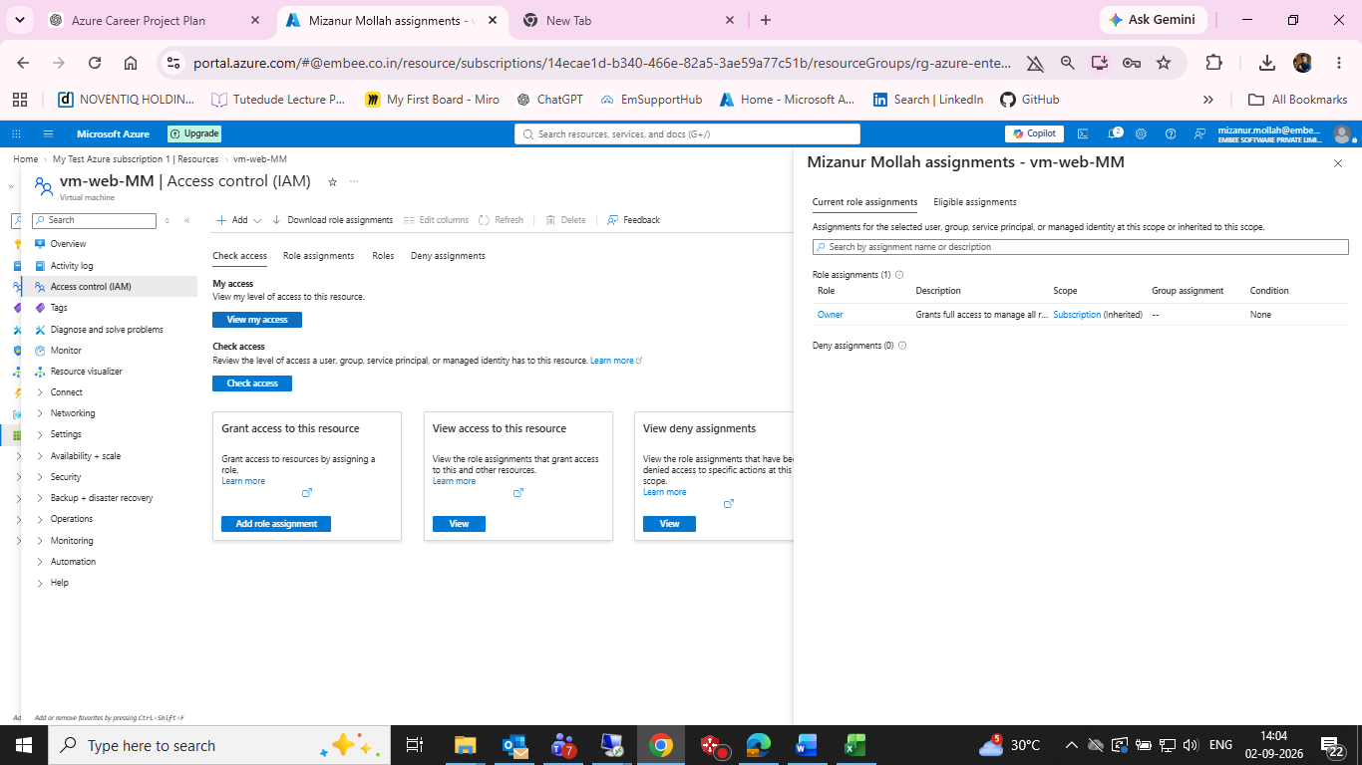
VM IAM — inherited Owner role

Figure 3 — VM Network Settings — existing NSG/network evidence
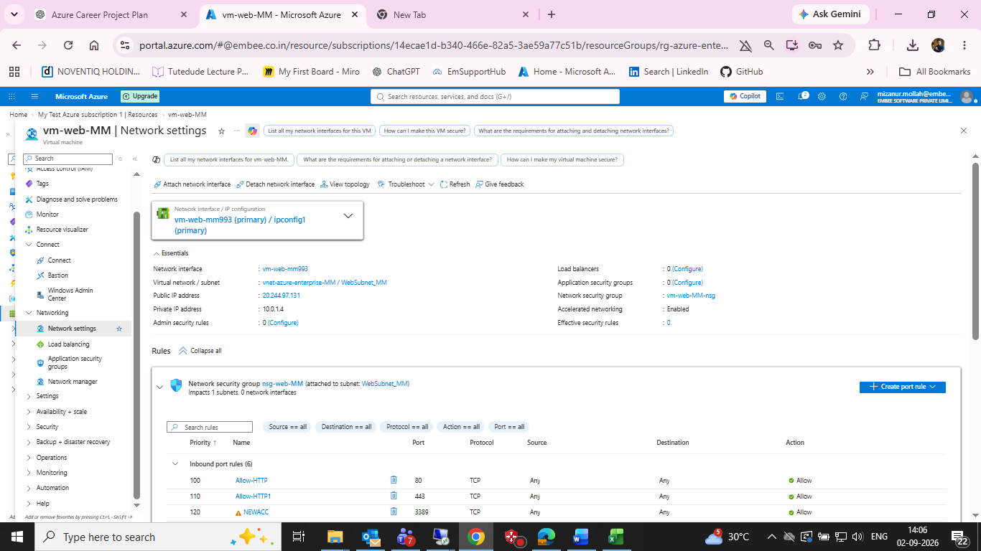
VM Network Settings — existing NSG/network evidence

Figure 4 — VM Identity — system-assigned managed identity enabled
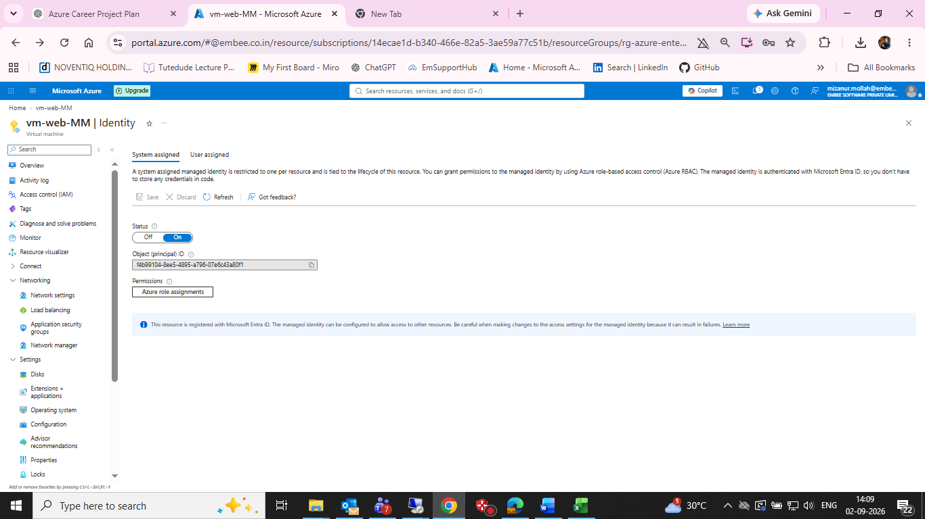
VM Identity — system-assigned managed identity enabled

Figure 5 — Key Vault Access Configuration — Azure RBAC
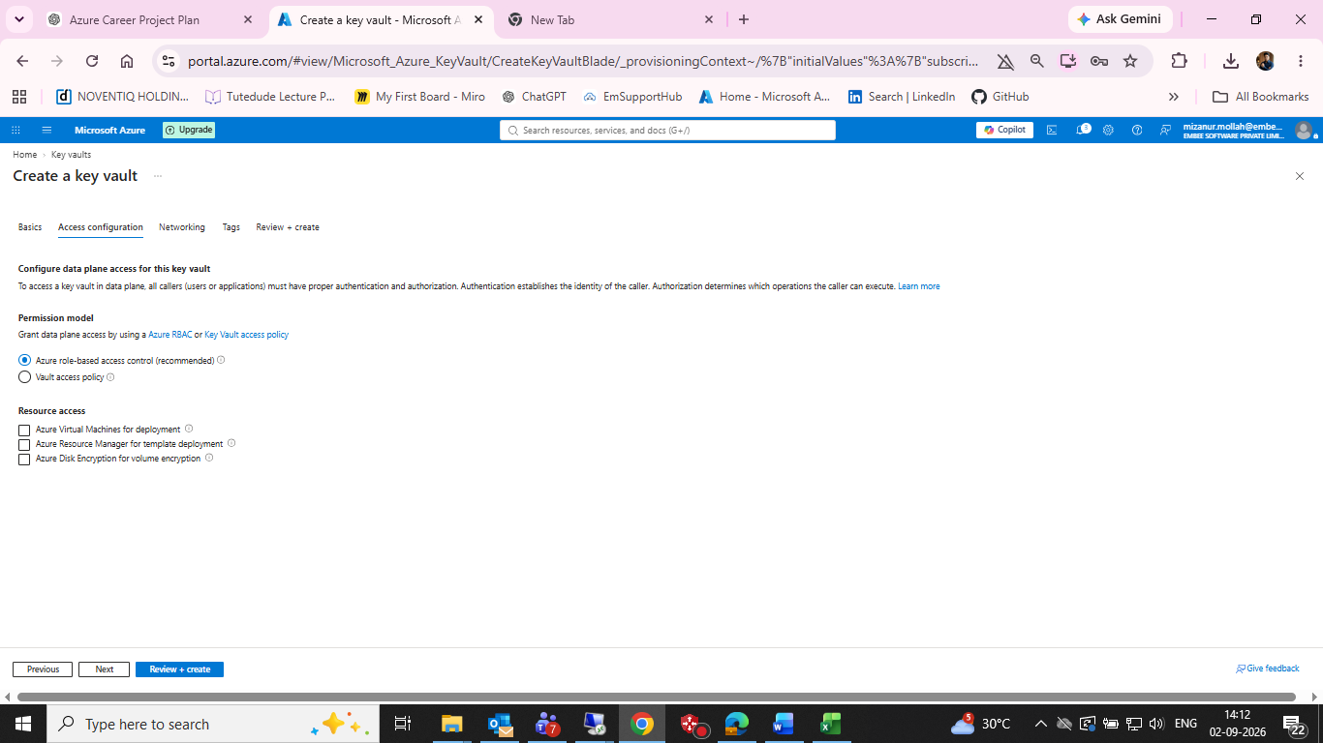
Key Vault Access Configuration — Azure RBAC

Figure 6 — Key Vault Networking — public endpoint, all networks
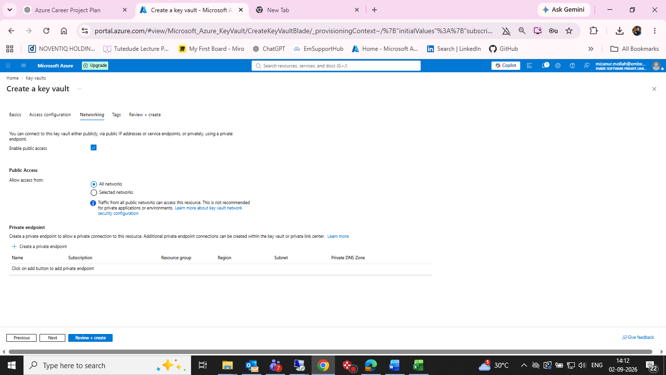
Key Vault Networking — public endpoint, all networks

Figure 7 — Key Vault Review + Create
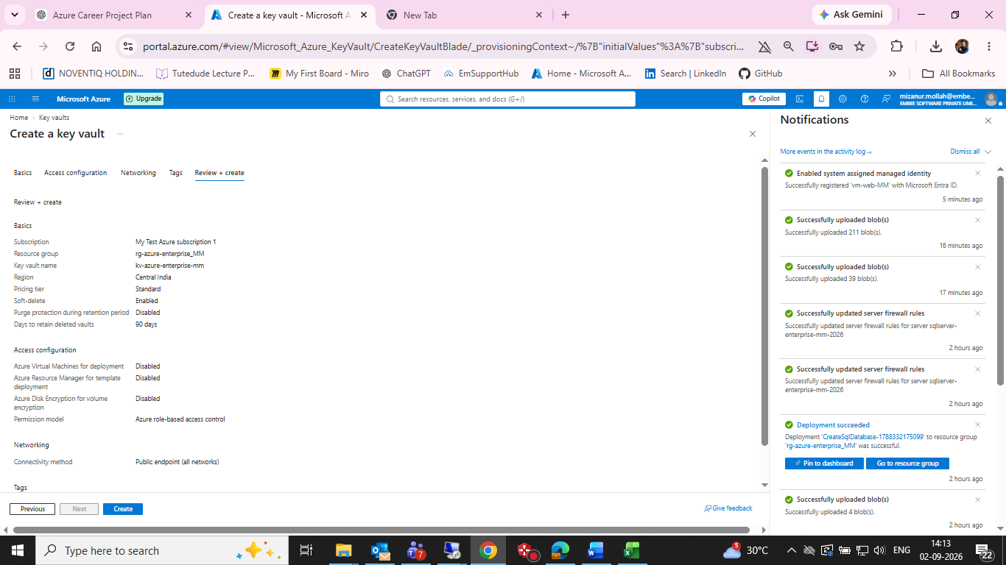
Key Vault Review + Create

Figure 8 — Key Vault deployment operation details
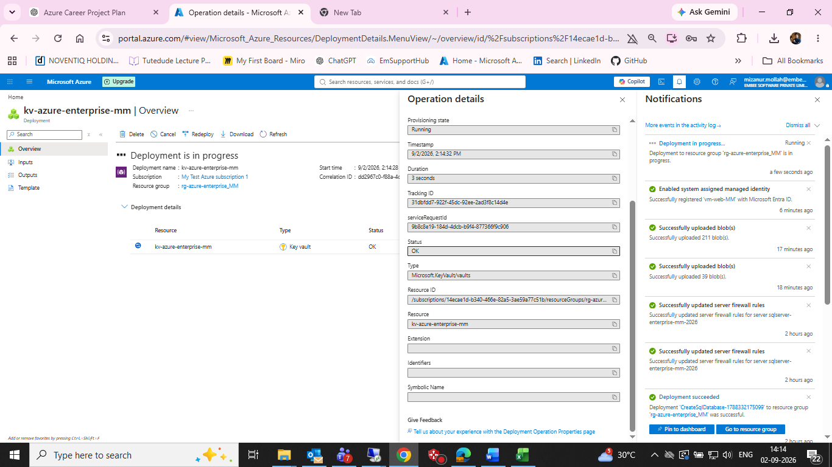
Key Vault deployment operation details

Figure 9 — Add Role Assignment — Key Vault Secrets User selected
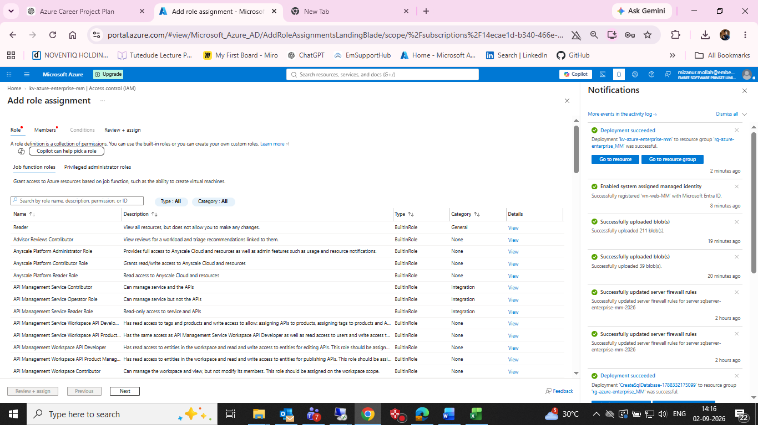
Add Role Assignment — Key Vault Secrets User selected

Figure 10 — Add Role Assignment — vm-web-MM managed identity selected
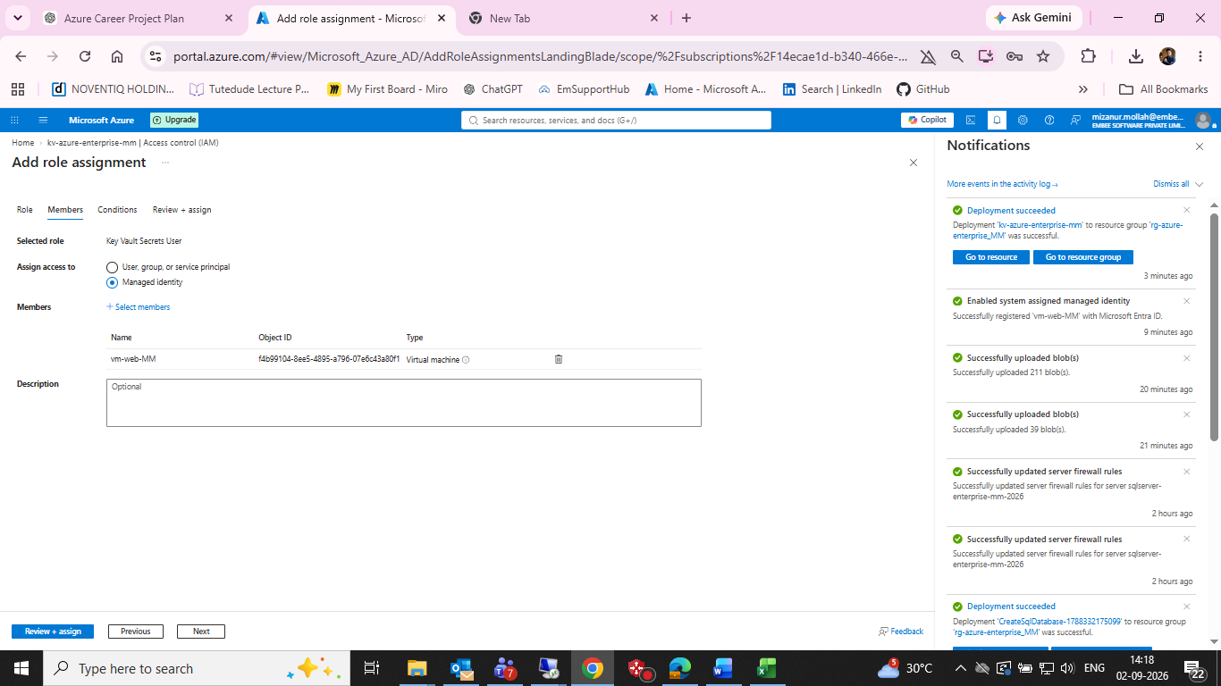
Add Role Assignment — vm-web-MM managed identity selected

Figure 11 — Key Vault RBAC role assignment success
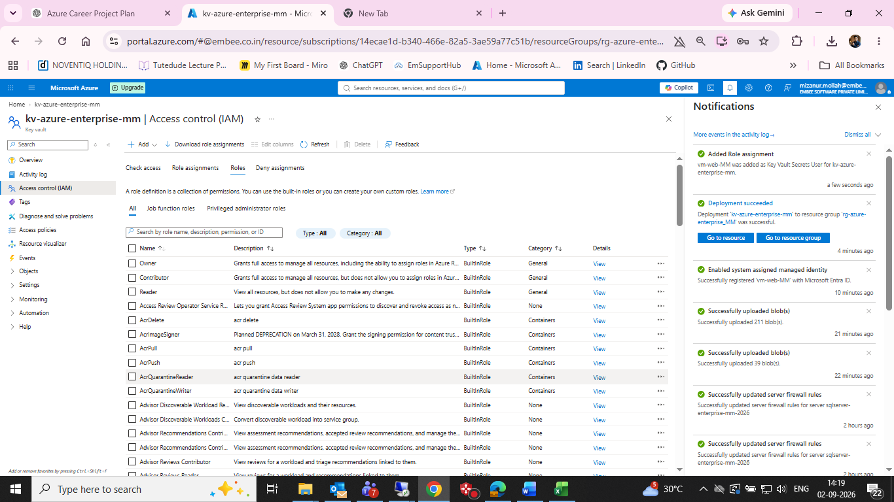
Key Vault RBAC role assignment success

Figure 12 — Create Secret — DemoSecret form
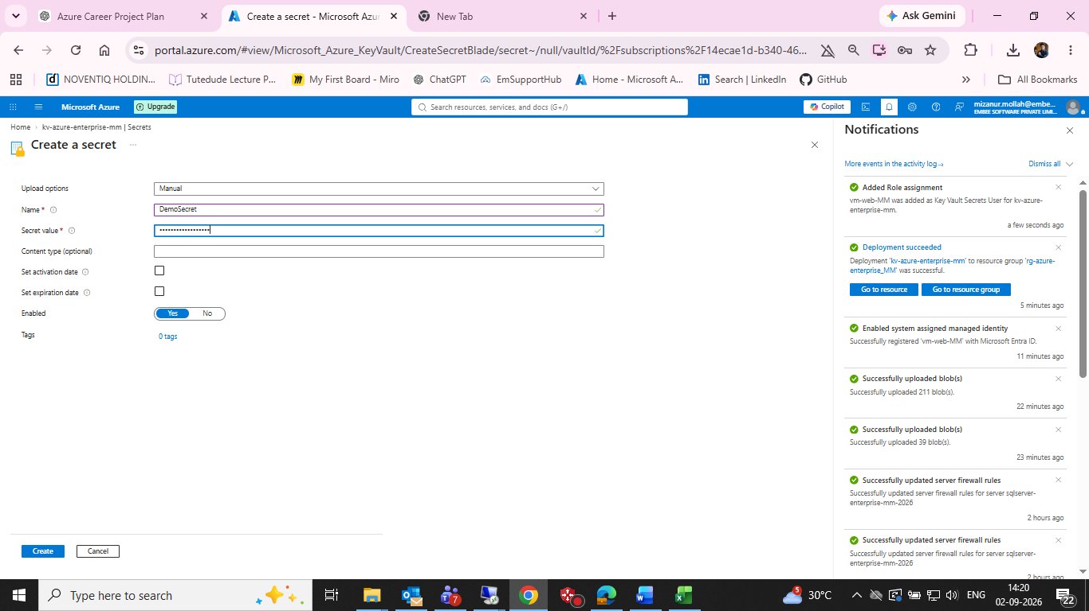
Create Secret — DemoSecret form

Figure 13 — Key Vault secret creation — Forbidden/RBAC error
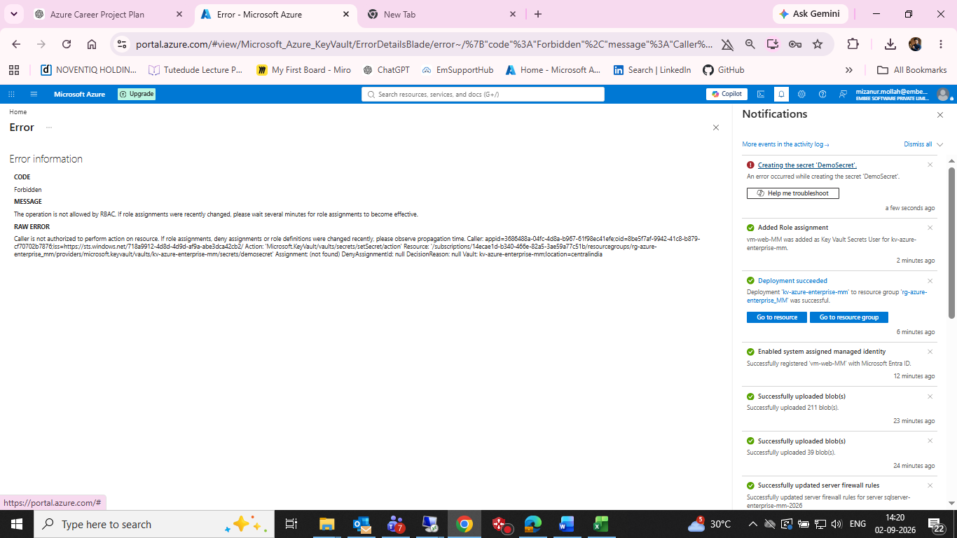
Key Vault secret creation — Forbidden/RBAC error

16. GitHub Structure
- 06-identity-security/README.md
- 06-identity-security/screenshots/
- 06-identity-security/managed-identity/
- 06-identity-security/key-vault-rbac/

17. Git Commit
cd /d C:\azure-enterprise-infrastructure-lab
git add 06-identity-security
git commit -m "Document Azure identity, RBAC and Key Vault lab"
git push

18. Completion Checklist
☑ Subscription RBAC reviewed
☑ VM RBAC inheritance reviewed
☑ System-assigned managed identity enabled
☑ Key Vault created
☑ Azure RBAC permission model selected
☑ Key Vault Secrets User assigned to vm-web-MM
☑ RBAC assignment success captured
☑ DemoSecret creation attempted
☑ RBAC Forbidden error captured
☐ Assign Key Vault Secrets Officer to administrator
☐ Wait for RBAC propagation and retry DemoSecret creation
☐ Verify DemoSecret appears in Secrets
☐ Read DemoSecret from vm-web-MM using managed identity
☐ Capture post-success screenshots
☐ Update README with final validation
☐ Sanitize personal identifiers before public GitHub upload

19. Final Status
The core identity and authorization path is configured: vm-web-MM has a system-assigned managed identity, and that identity has Key Vault Secrets User access to kv-azure-enterprise-mm. The remaining blocker is the administrator's own permission to create secrets. The documented remediation is to assign Key Vault Secrets Officer to the administrator, allow RBAC propagation, create the dummy secret, and then validate read access from the VM.

