AZURE ENTERPRISE INFRASTRUCTURE LAB
08 — Azure Backup
Backup Vault + Recovery Services Vault for Azure VM
Complete evidence-based documentation with all screenshots captured in this workflow

1. Objective
Understand backup and recovery for Azure workloads by creating/reviewing backup vault resources, preparing a Recovery Services vault for the Windows VM workload, and documenting the configuration journey, including identification of an initially incorrect Backup vault/workload path.

2. Task Requirements
- Create/review a Recovery Services vault.
- Configure backup for the supported lab workload.
- Run an on-demand backup if appropriate.
- Review backup status and retention.
- Document recovery considerations.
Required evidence: Recovery Services vault, backup policy, and backup job/status.

3. Environment
Item | Value / status
Subscription | My Test Azure subscription 1
Resource Group | rg-azure-enterprise_MM
Target VM | vm-web-MM
Region | Central India
VM backup target | Azure Virtual Machine
Recovery Services vault | rsv-vm-backup-mm
Initial Backup vault | rsv-azure-enterprise-mm
Backup vault storage redundancy | Locally-redundant

4. Important Vault Distinction
Two different vault types were encountered during the exercise. The first vault, rsv-azure-enterprise-mm, was a Backup vault and its overview/configuration screens showed workloads such as Azure Database for PostgreSQL and Azure Blobs. That path was not used for the Windows VM backup.
The correct workload-specific path for the existing Windows VM is the Recovery Services vault rsv-vm-backup-mm. The resource group screenshot confirms both vault types are present.

5. Backup Vault — Initial Configuration
- Backup vault name: rsv-azure-enterprise-mm
- Resource group: rg-azure-enterprise_MM
- Region: Central India
- Backup storage redundancy: Locally-redundant
- Security configuration used Azure RBAC where shown
This vault remains available for workloads supported by Backup vault. It was not used for the VM backup task.

6. Recovery Services Vault — VM Backup Configuration
- Vault name: rsv-vm-backup-mm
- Resource group: rg-azure-enterprise_MM
- Region: Central India
- Backup storage redundancy: Locally-redundant
- Encryption: Microsoft-managed key
- Immutability: Disabled
- Networking: Allow public access from all networks

7. Deployment Status
The Recovery Services vault deployment created the resource rsv-vm-backup-mm. The deployment operation screenshot shows the vault resource in Created state while the overall ARM deployment page was briefly still completing.
The resource-group evidence then shows rsv-vm-backup-mm with type Recovery Services vault alongside the existing VM and the earlier Backup vault.

8. Current Status / Remaining Work
Completed: Recovery Services vault creation and configuration evidence; correct vault type identified.
Pending: Configure Azure VM backup for vm-web-MM, establish the backup policy, run an on-demand backup when appropriate, and capture the backup job/status and recovery point evidence.

9. Next Exact Steps
- Open Recovery Services vaults → rsv-vm-backup-mm.
- Select Backup.
- Set workload location to Azure.
- Select workload type Virtual machine.
- Select vm-web-MM.
- Create/select a suitable daily backup policy.
- Enable backup/protection.
- Run Backup now after protection is active, if appropriate.
- Open Backup jobs and verify the job completes.
- Open the backup item and verify a recovery point.
- Capture the policy, protected VM, job status and recovery point screenshots.

10. Suggested Learning-Lab Policy
For a small learning environment, a daily schedule with modest retention is generally easier to manage and keeps the lab simple. Use the portal's available backup policy options and record the actual selected retention rather than assuming a value before configuration.

11. Recovery Considerations
- Recovery point availability is the key evidence that backup protection is operational.
- Retention determines how far back a recovery can be performed.
- Backup jobs should be reviewed for completion/failure status.
- VM restore planning should consider region, networking, storage, identity and application dependencies.
- For production, evaluate redundancy, security, immutability and recovery objectives separately from this learning lab.

12. Portfolio / Interview Skills
- Azure Backup
- Recovery Services vault administration
- Backup vault vs Recovery Services vault
- Backup policy and retention
- Backup job monitoring
- Recovery point validation
- Azure VM protection
- Recovery planning
- Cost-aware lab configuration

13. Evidence Checklist
☐ Recovery Services vault
☐ Backup policy
☐ Backup job/status
☐ Recovery point
☐ Backup retention
☐ Resource-group inventory
The first three items above are required by the project specification; the recovery point and retention views strengthen the portfolio evidence.

14. GitHub Structure
- 08-backup/README.md
- 08-backup/screenshots/01-backup-center-search.png
- 08-backup/screenshots/10-recovery-services-vault-create-basics.png
- 08-backup/screenshots/15-recovery-services-vault-review-create.png
- 08-backup/screenshots/16-recovery-services-vault-deployment.png
- 08-backup/screenshots/17-resource-group-backup-resources.png
Additional captured screenshots are stored under 08-backup/screenshots/.

15. Screenshot Evidence
Figure 1 — Azure Portal search showing Recovery Services vaults, Backup vaults and related services
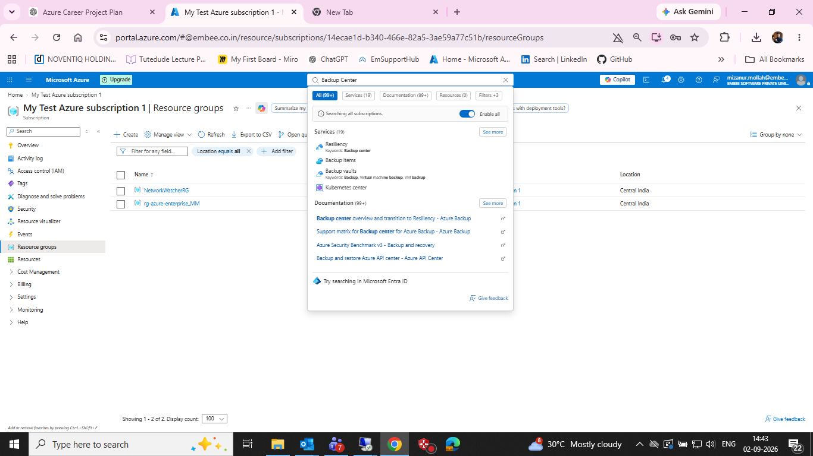
Azure Portal search showing Recovery Services vaults, Backup vaults and related services

Figure 2 — Create Backup Vault — Basics
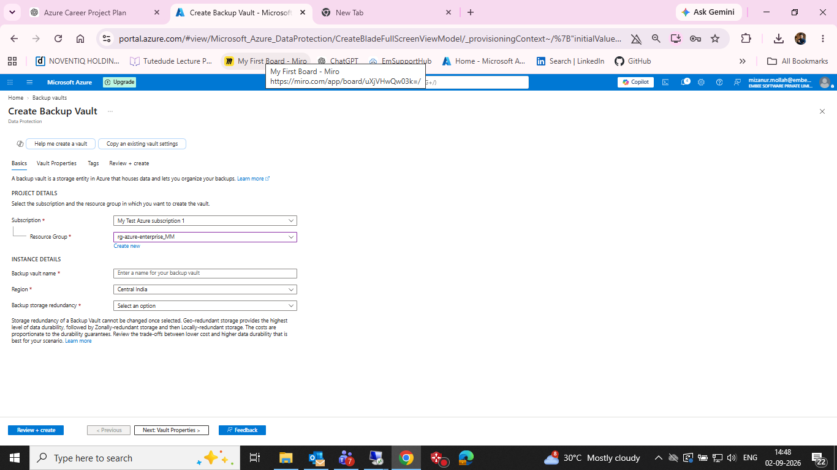
Create Backup Vault — Basics

Figure 3 — Backup Vault — Vault Properties
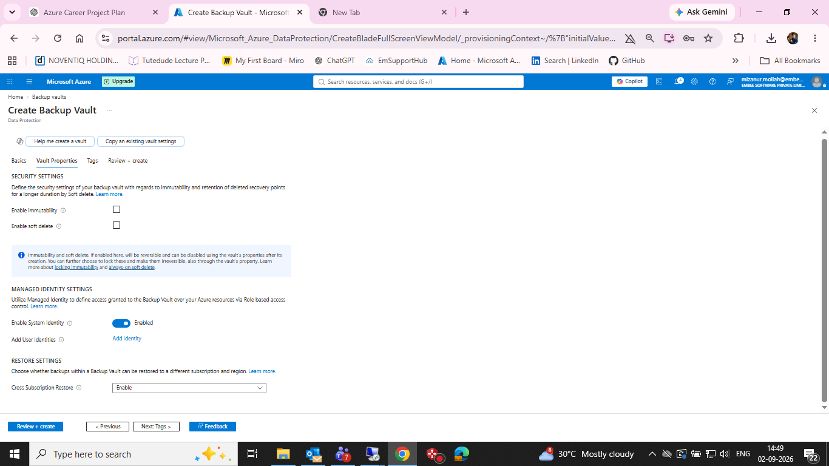
Backup Vault — Vault Properties

Figure 4 — Backup Vault — Review + create
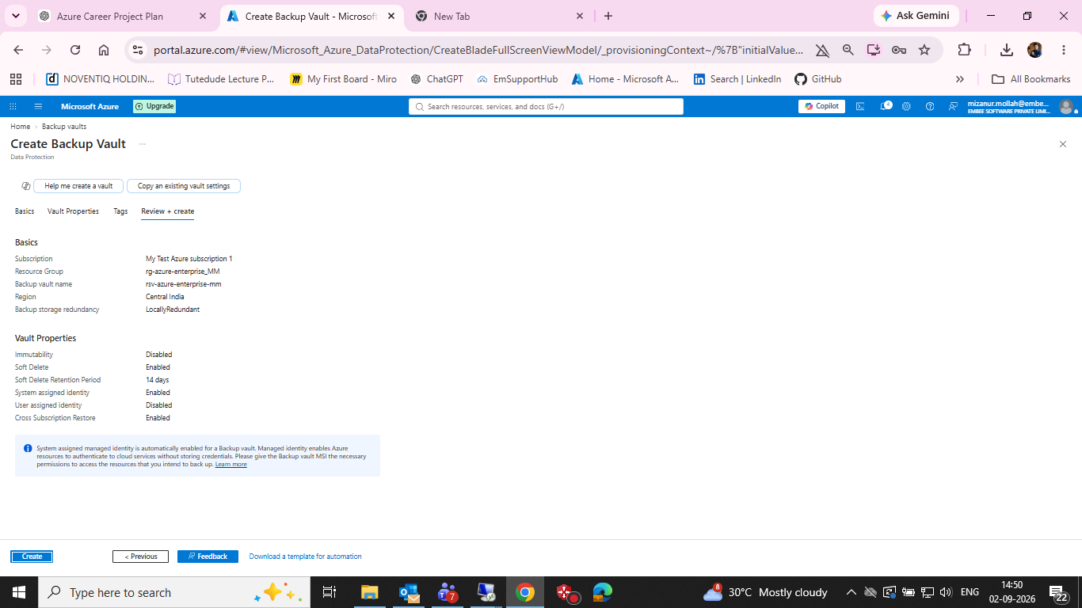
Backup Vault — Review + create

Figure 5 — Backup Vault deployment operation
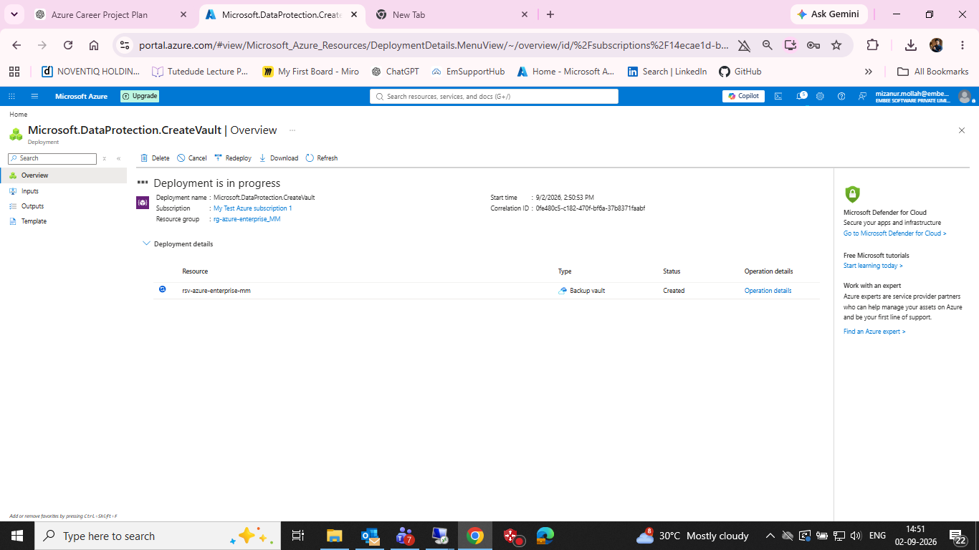
Backup Vault deployment operation

Figure 6 — Backup vaults list showing rsv-azure-enterprise-mm
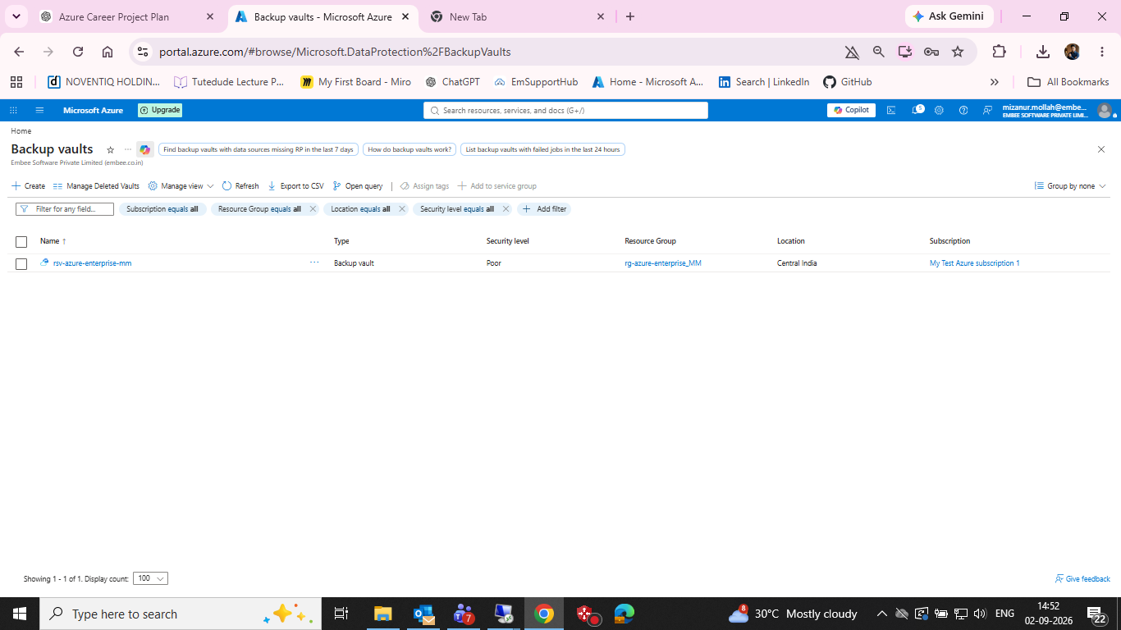
Backup vaults list showing rsv-azure-enterprise-mm

Figure 7 — Backup vault overview showing Azure Database for PostgreSQL workload type
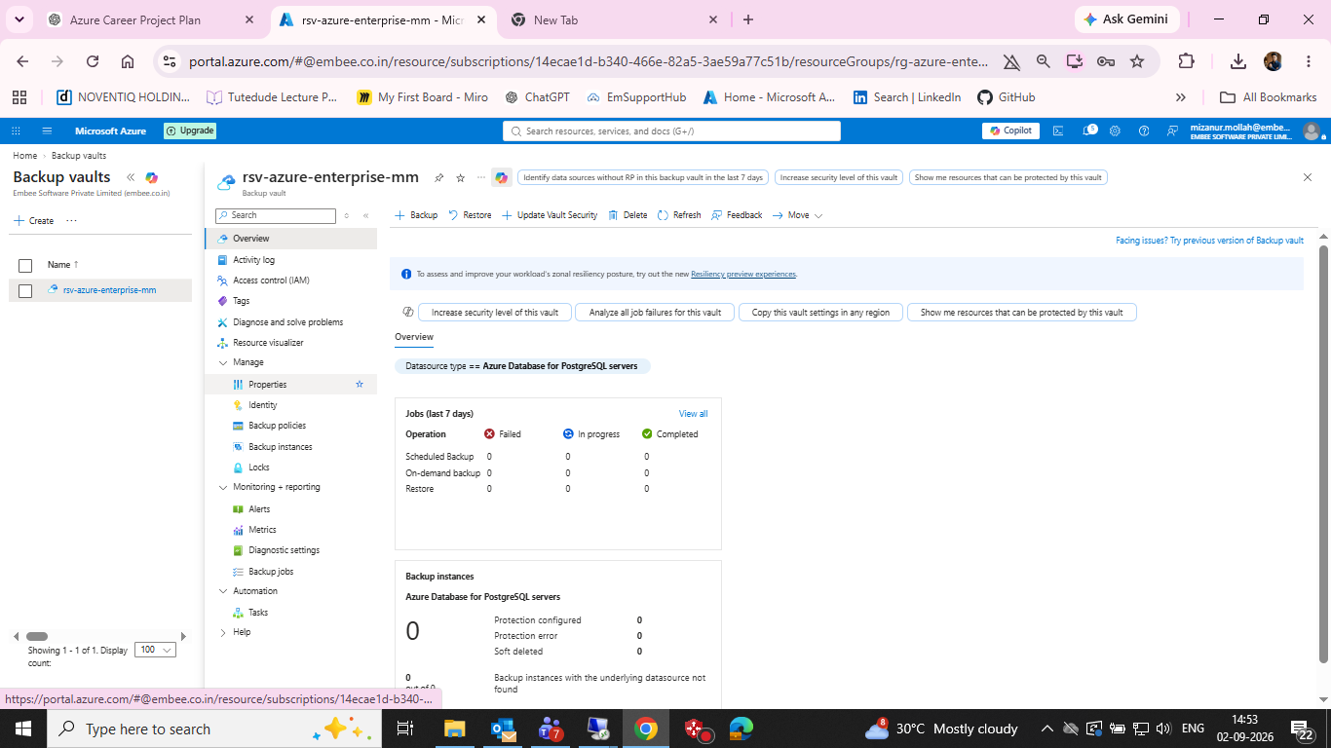
Backup vault overview showing Azure Database for PostgreSQL workload type

Figure 8 — Configure Backup — Azure Blobs selected in Backup vault
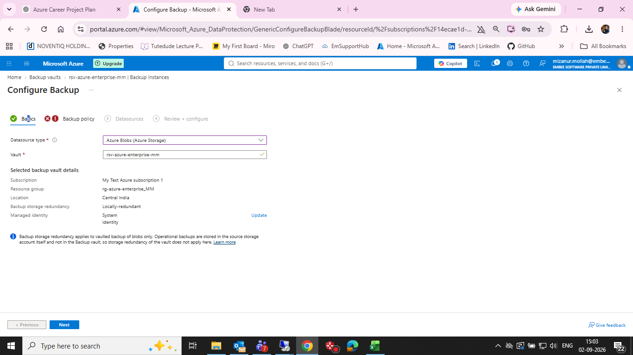
Configure Backup — Azure Blobs selected in Backup vault

Figure 9 — Backup policy/retention screen for Backup vault/Blob workflow
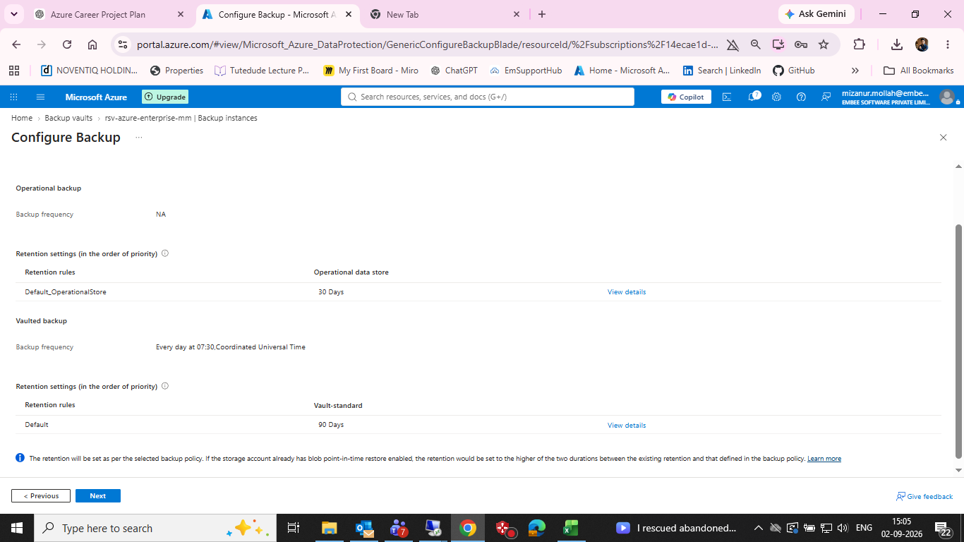
Backup policy/retention screen for Backup vault/Blob workflow

Figure 10 — Create Recovery Services vault — Basics
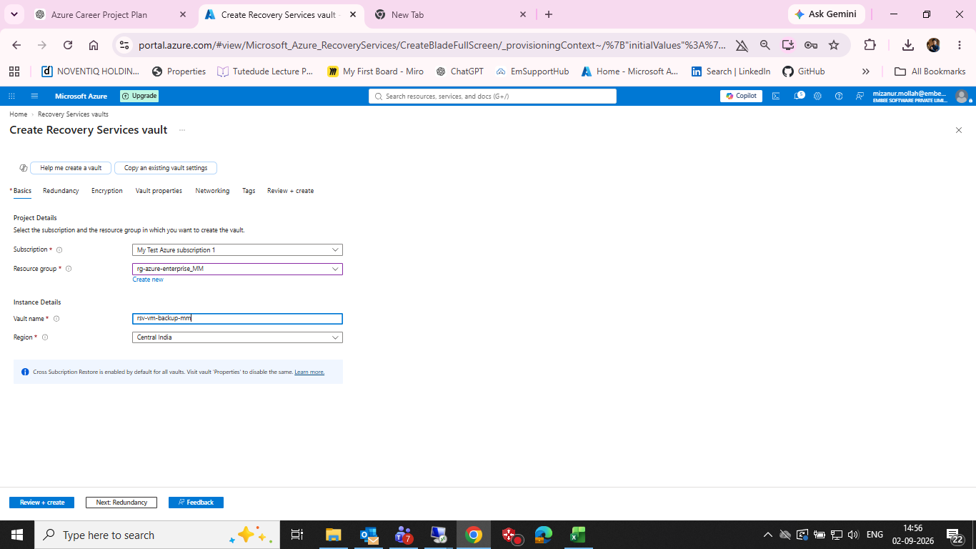
Create Recovery Services vault — Basics

Figure 11 — Recovery Services vault — Redundancy
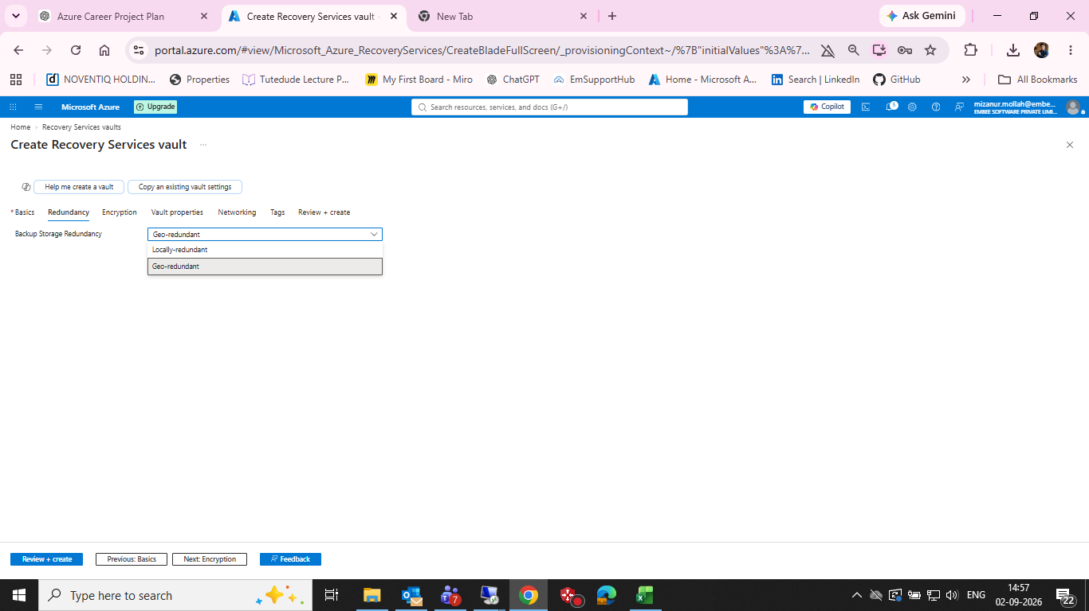
Recovery Services vault — Redundancy

Figure 12 — Recovery Services vault — Encryption
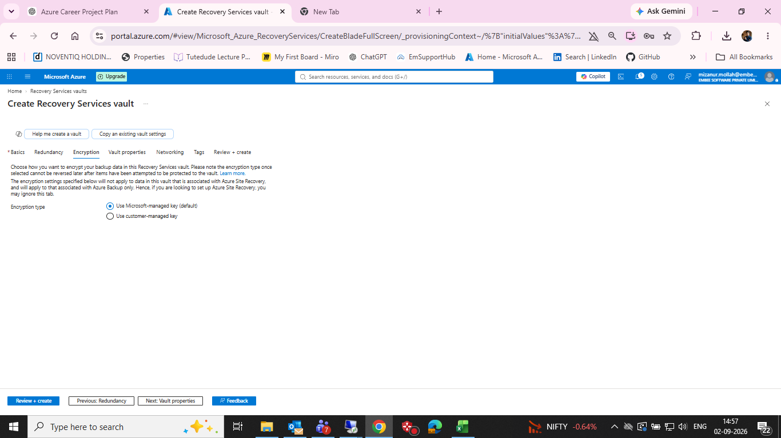
Recovery Services vault — Encryption

Figure 13 — Recovery Services vault — Vault properties
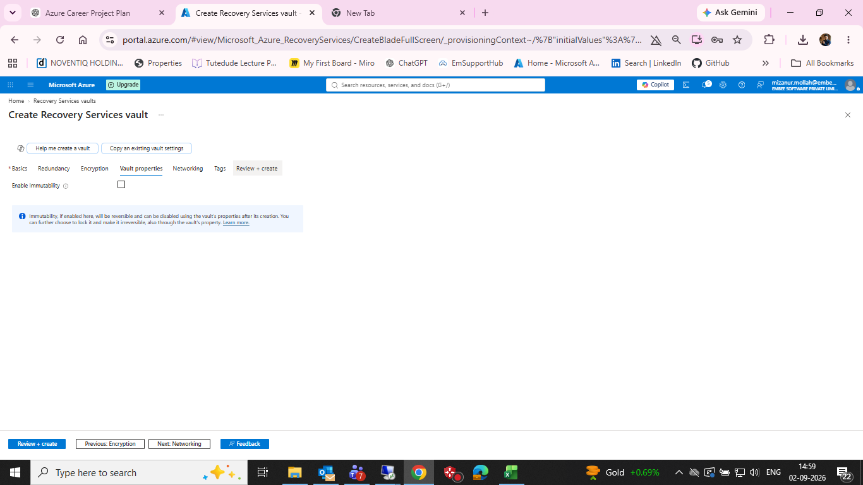
Recovery Services vault — Vault properties

Figure 14 — Recovery Services vault — Networking
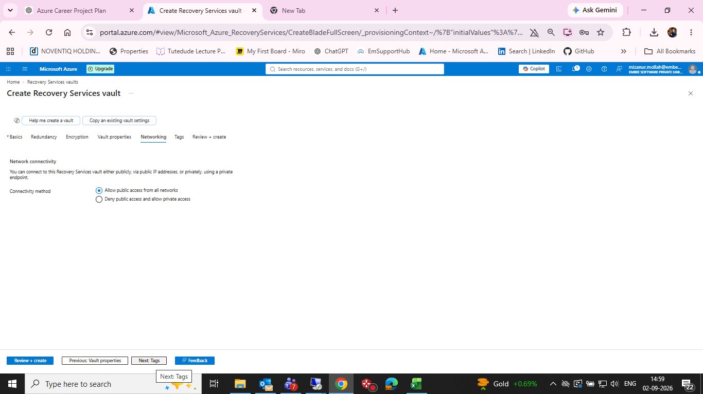
Recovery Services vault — Networking

Figure 15 — Recovery Services vault — Review + create
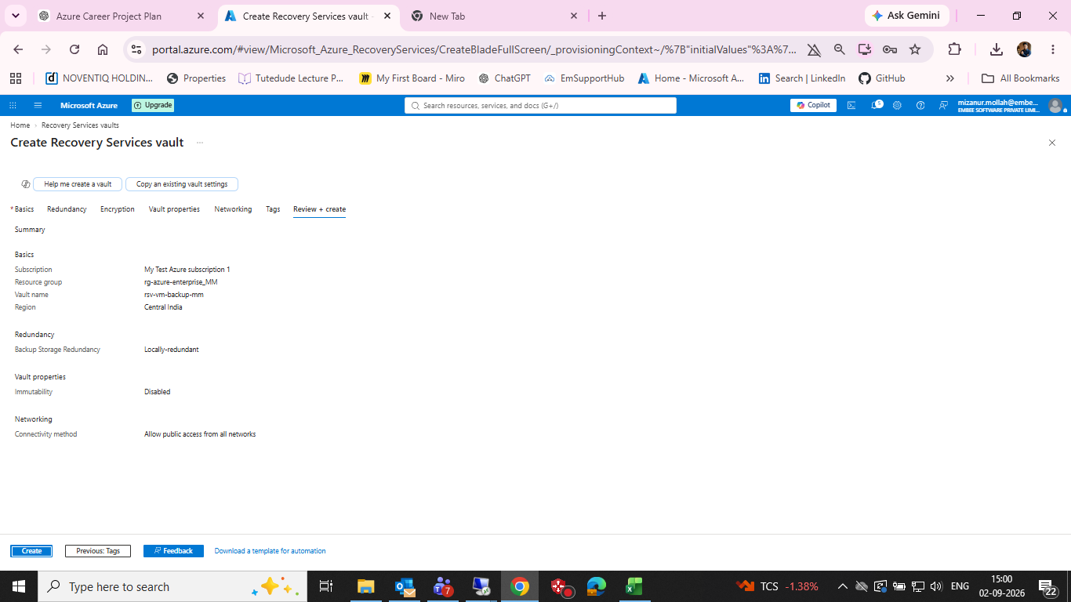
Recovery Services vault — Review + create

Figure 16 — Recovery Services vault deployment — resource created
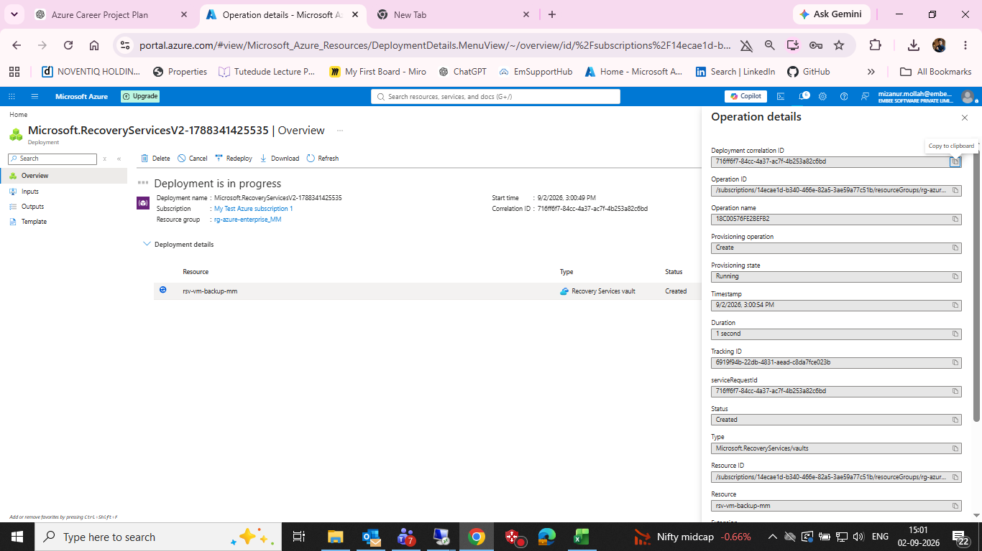
Recovery Services vault deployment — resource created

Figure 17 — Resource group showing Backup vault, Recovery Services vault and VM
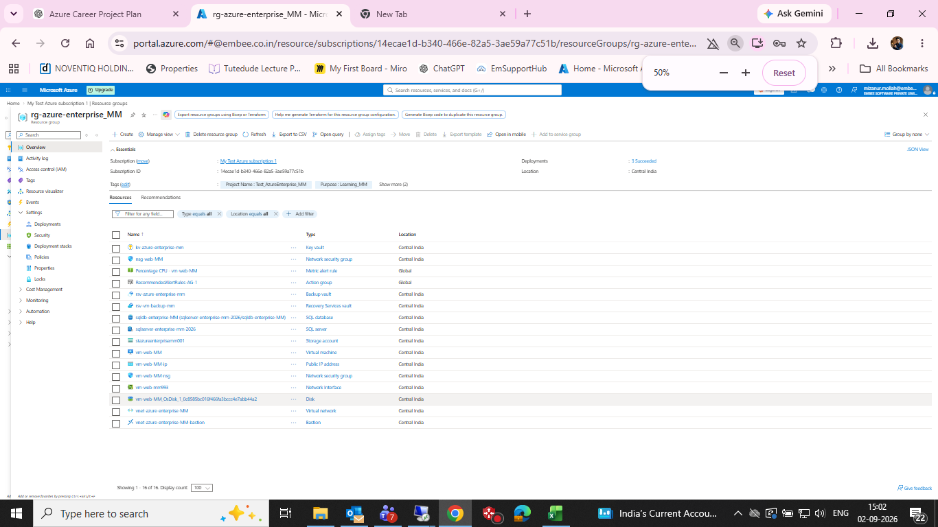
Resource group showing Backup vault, Recovery Services vault and VM

16. Git Commit
cd /d C:\azure-enterprise-infrastructure-lab
git add 08-backup
git commit -m "Document Azure Backup and Recovery Services vault lab"
git push

17. Final Note
This document intentionally preserves the incorrect Backup vault path as troubleshooting evidence instead of presenting it as successful VM backup. The correct Recovery Services vault rsv-vm-backup-mm has been created; the next evidence to capture is the actual vm-web-MM protection, policy, backup job completion and recovery point.

