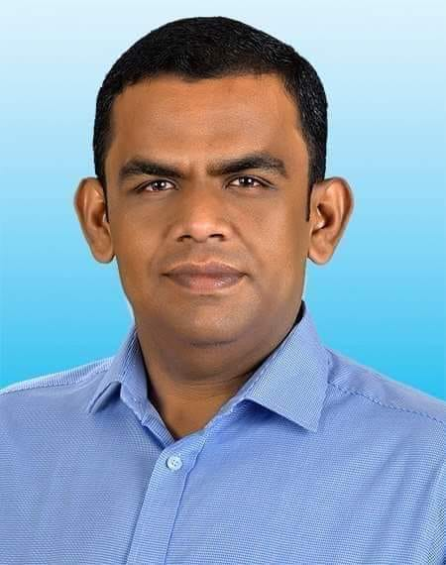

**Chairman:**

**Zadeed Al Rahman,**

**Masters in English,Jahangirnagar University.**

**Chairman,**

**Deshi System Ltd.**

**Managing Director**

Engr. Md. Babul Mia, Lt.( Dtn),BN. 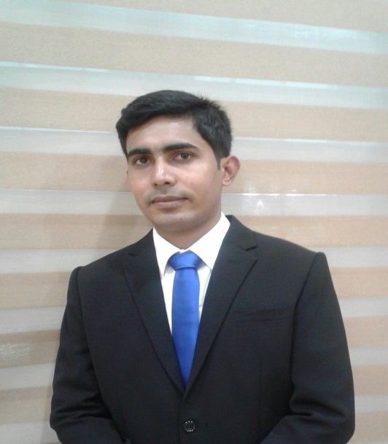

MIEB-37815

B.sc in (Civil),CUET.

M.sc in (Geotechnical),BUET.

**Project In charge:**

Engr. Al Mamun

B.sc in Mechanical.

West coast Institute of Management & Tec.



**Structural Team:**

Engr. Mostafijur Rahman Khan.

Rajuk Reg.No-DMINB/CE-0468.

MIEB-30981

Str. Structural Engineer.

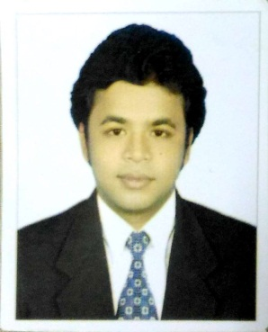

Engr. **SHIMANTA SHAHA**

MIEB-39414.

B.sc in civil Engineering(CUET)

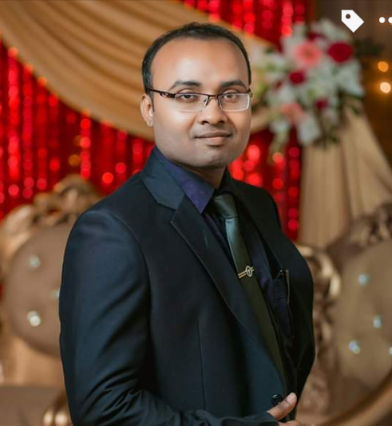

Engr. Taif Mahmud

B.sc in Civil Engineering.

Architecture Team:

Arch. Avi Das 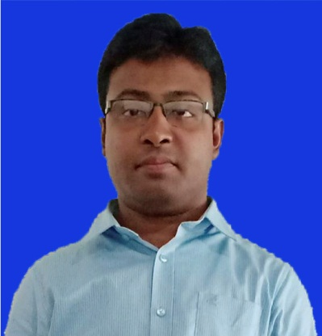

B.sc in Architecture(CUET).

Md. Failul Islam,

Diploma in Architecture.

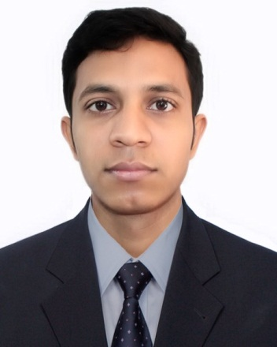

Construction Team:

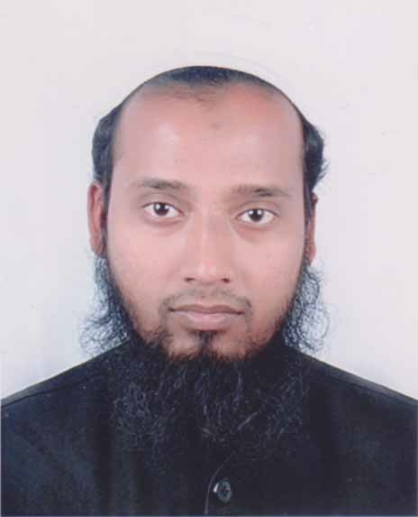

Project Director:

Engr. Sadi Md Zulker Nine.

B.sc in civil Engineering(CUET)

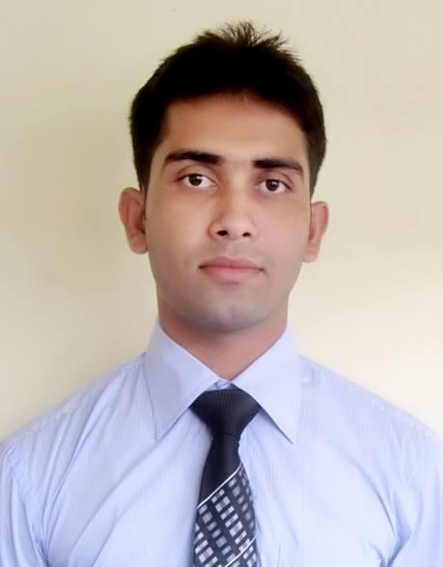

Project Manager:

Engr.M A Hasan.

B.sc Engg.(Civil)



Project Engineer:

Engr. Al Mamun

B.sc in Mechanical.

West coast Institute of Management & Tec.

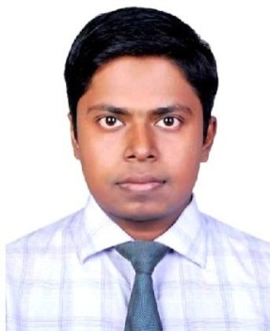

MEP Team:

Engr. Maksur Rahman.

B.sc in Mechical (CUET).

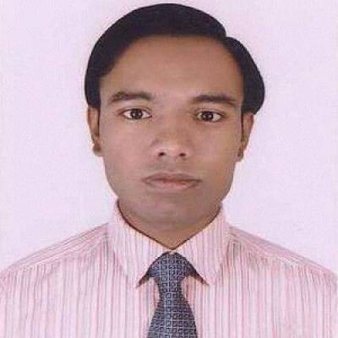

Engr. **MD. SAYAM**

B.sc in Mechical (CUET).