**Riddles**

1. What has to be broken before you can use it? (An egg)
2. I’m tall when I’m young, and I’m short when I’m old. What am I? (A candle)
3. What is full of holes but still holds water? (A sponge)
4. What question can you never answer yes to? (Are you asleep yet?)
5. What is always in front of you but can’t be seen? (The future)
6. 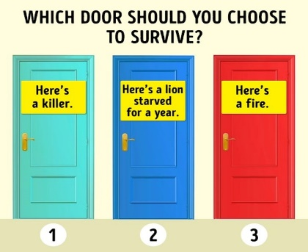
7. 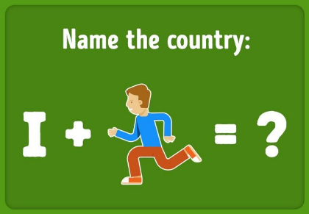
8. 