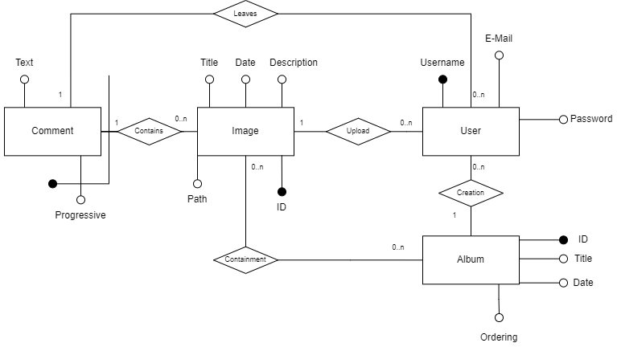

**Tables:**

USER(Username, E-Mail, Password)

IMAGE(ID, Path, Title, Date, Description, UploaderUsername)

ALBUM(ID, Title, Date, Ordering, CreatorUsername)

COMMENT(Progressive, ImageId, User, Text)

CONTAINMENT(ImageId, AlbumID)

**References:**

IMAGE.UploaderUsername -> USER.Username

ALBUM.CreatorUsername -> USER.Username

COMMENT.ImageId -> IMAGE.ID

COMMENT.User -> USER.Username

CONTAINMENT.ImageId -> IMAGE.ID

CONTAINMENT.AlbumID -> ALBUM.ID

**Legend**:

Primary key

Foreign key