Homework – Project - Asset List
Joseph Lodico
Name of student:

- List each asset you wish to create by name, give the resolution of the texture, poly count (tris) budget, level of detail
Name | Texture resolution (?x?) | Poly count budget (tris) | Level of details
Ice Telescope Planet | 1024x1024 | 10000 | 2
Red Rocket | 512x512 | 30000 | 2
Pink Gem | 128x128 | 1000 | 2
Telescope | 512x512 | 3000 | 2

- For each listed asset, provide a description of the role of the asset.
Name | Description
Ice Telescope Planet | A planet where you visit to telescope your surroundings.
Red Rocket | An item the player uses to explode the environment in the world.
Pink Gem | An item you can collect or see displayed in the world.
Telescope | A Object used for scoping a far distance to see the planets in space.

- For each listed asset, provide a list of reference images. You can attach the images with or in this document any way you want.

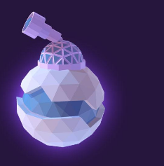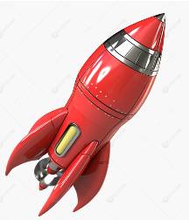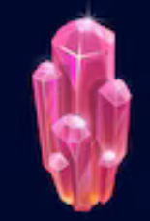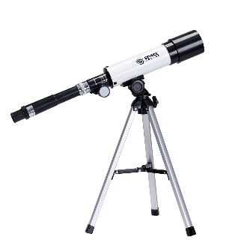

- If any assets are co-created, list the co-creators and role(s):

Name | Co-creator 1 | Co-creator 2

