Zadanie 3

Plik - SIN/sin_60Hz.wav

Fsize [256, 4096, 65536]
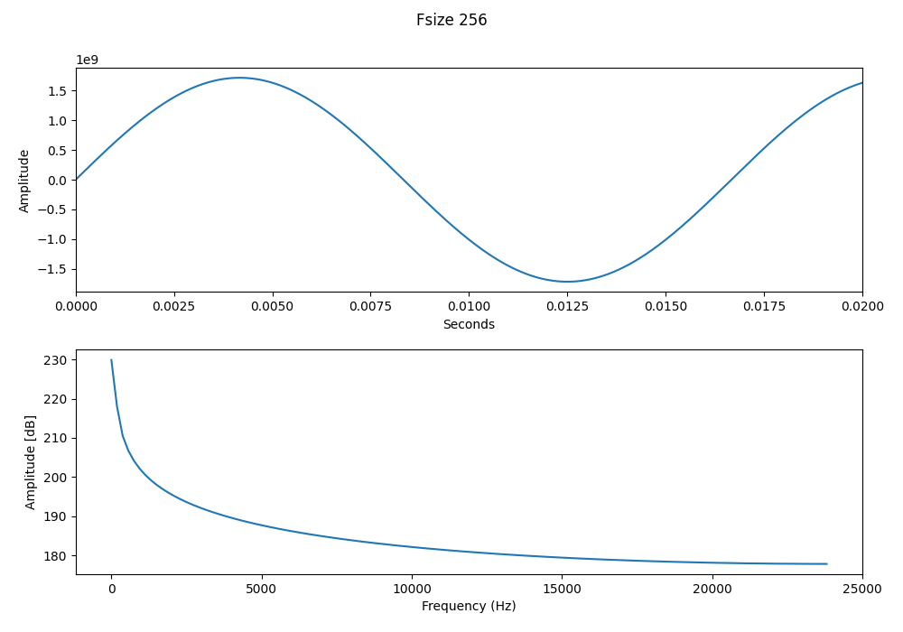
Max amplitude:229.86 dB, Max frequency: 0.00Hz

Fsize [256, 4096, 65536]
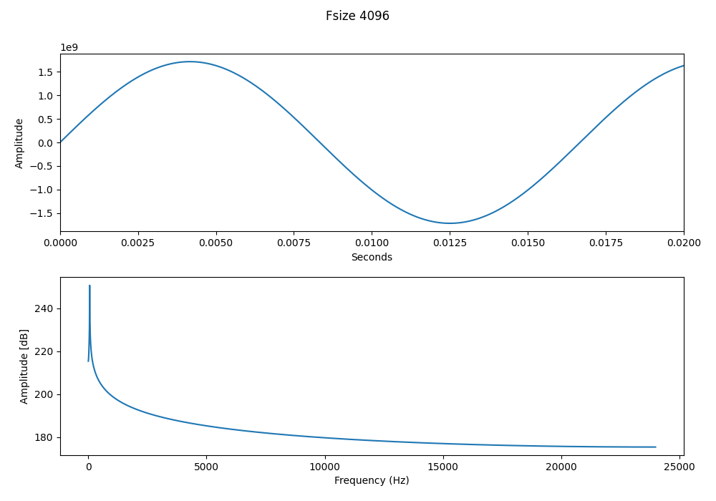
Max amplitude:250.64 dB, Max frequency: 58.59Hz

Fsize [256, 4096, 65536]
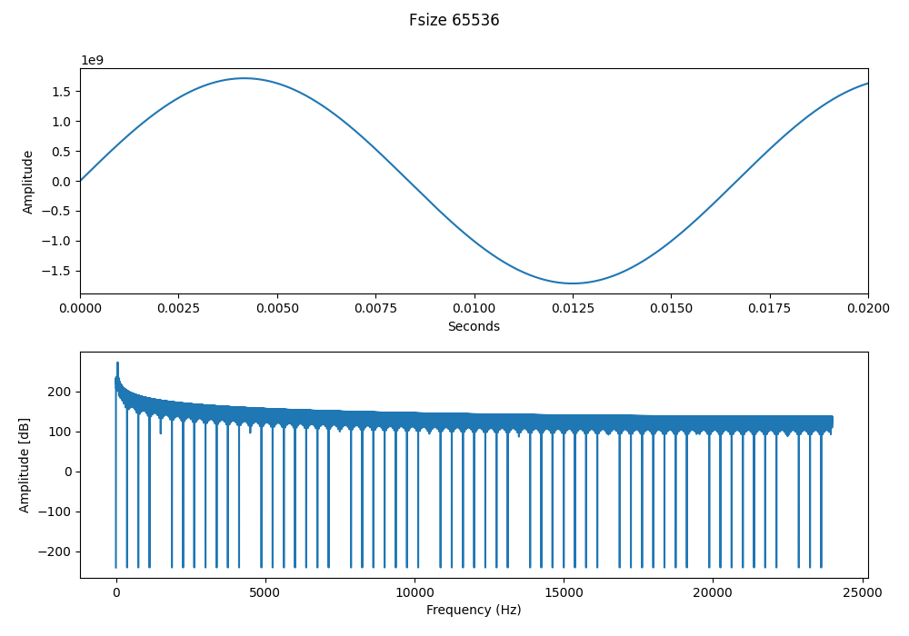
Max amplitude:272.25 dB, Max frequency: 60.06Hz

Plik - SIN/sin_440Hz.wav

Fsize [256, 4096, 65536]
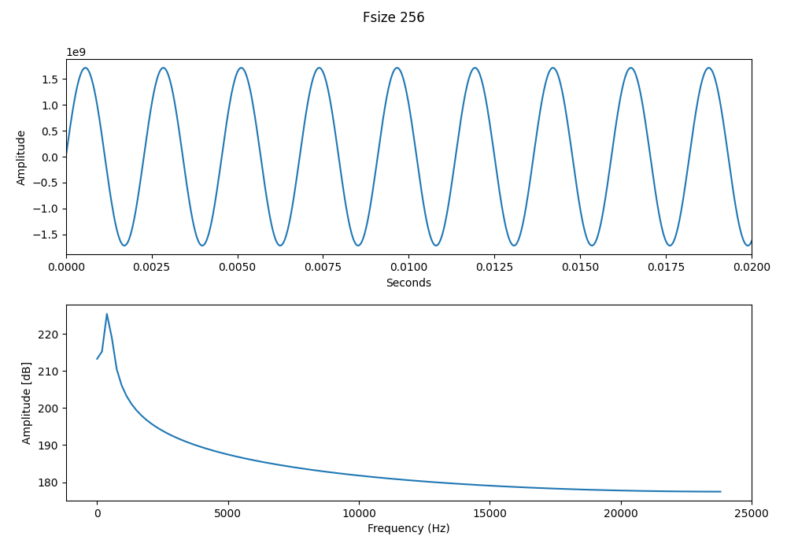
Max amplitude:225.43 dB, Max frequency: 375.00Hz

Fsize [256, 4096, 65536]
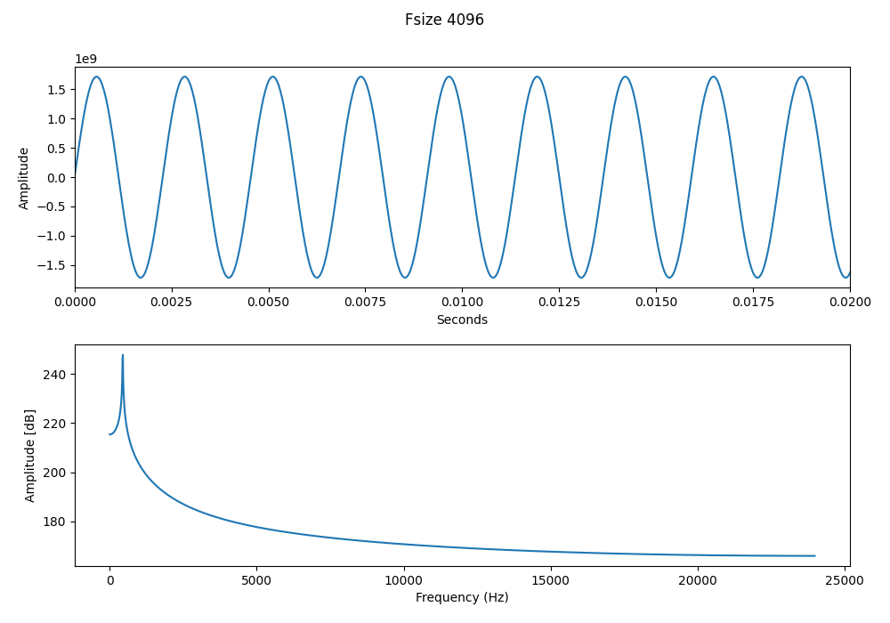
Max amplitude:247.71 dB, Max frequency: 445.31Hz

Fsize [256, 4096, 65536]
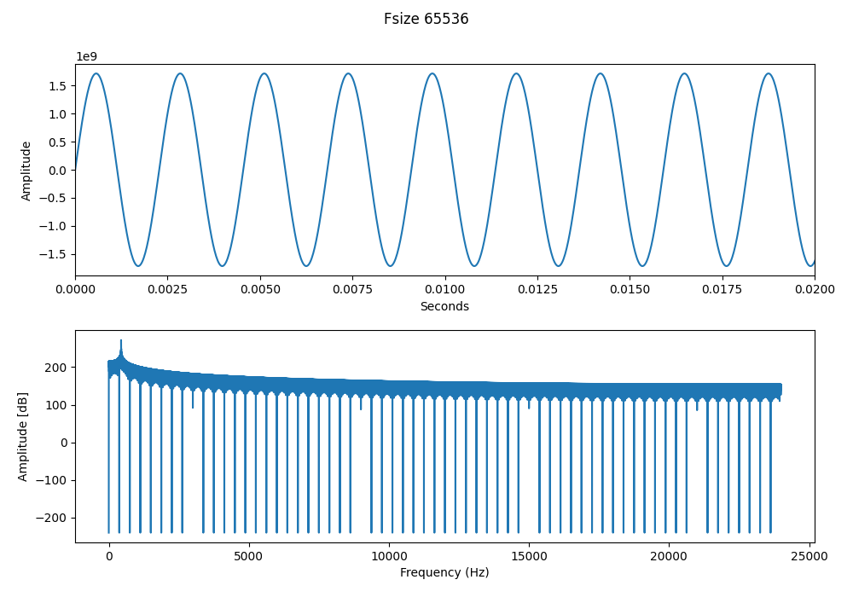
Max amplitude:271.81 dB, Max frequency: 440.19Hz

Plik - SIN/sin_8000Hz.wav

Fsize [256, 4096, 65536]
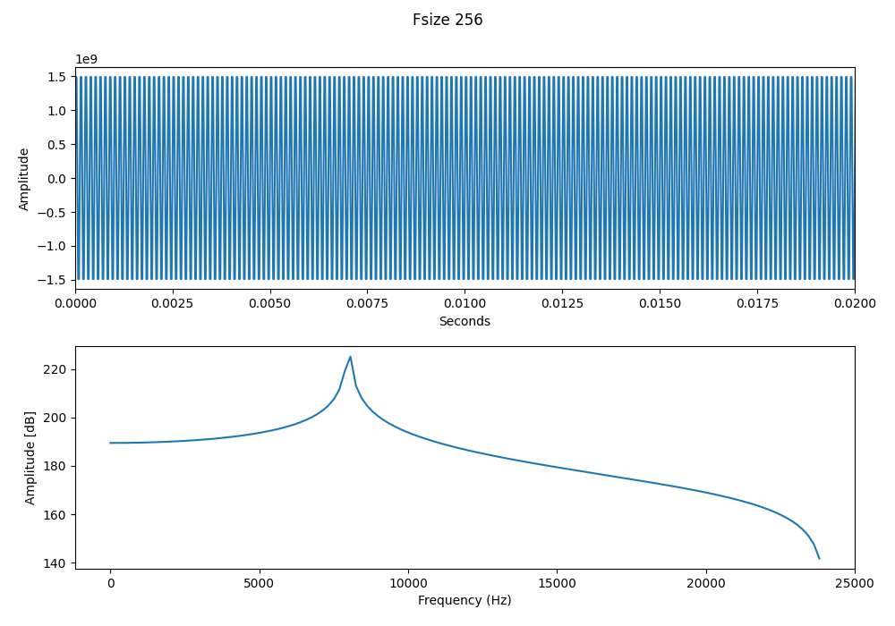
Max amplitude:225.15 dB, Max frequency: 8062.50Hz

Fsize [256, 4096, 65536]
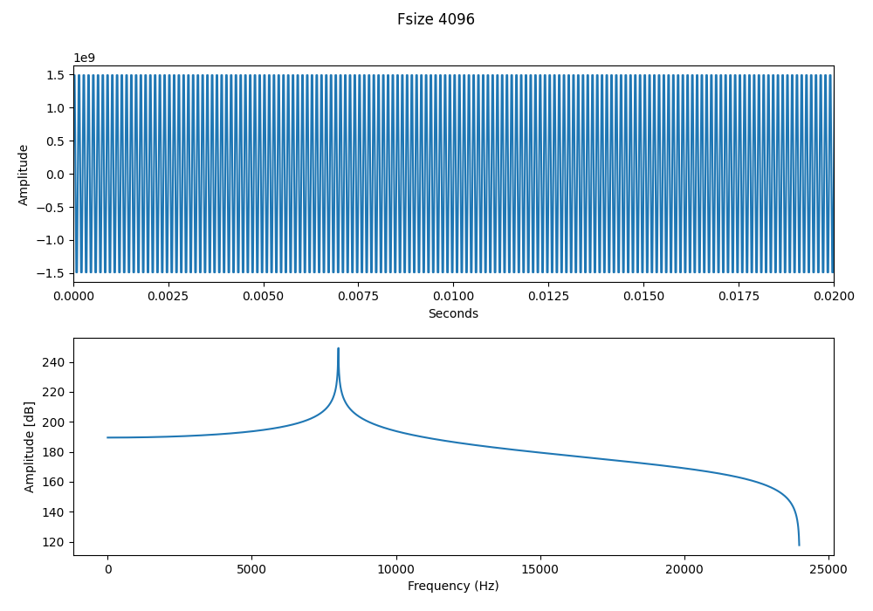
Max amplitude:249.27 dB, Max frequency: 8003.91Hz

Fsize [256, 4096, 65536]
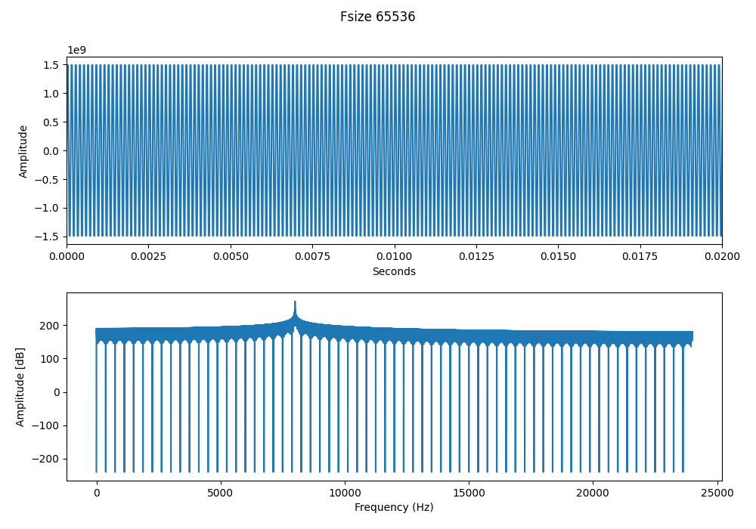
Max amplitude:271.44 dB, Max frequency: 8000.24Hz

