Zadanie Obraz 3

Fragment 0:200 - 0:200
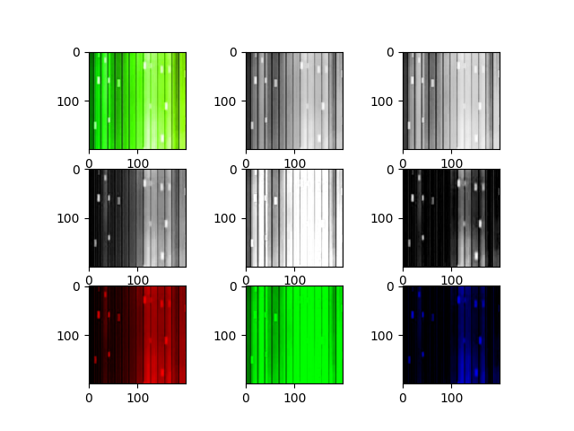

Fragment 0:200 - 200:400
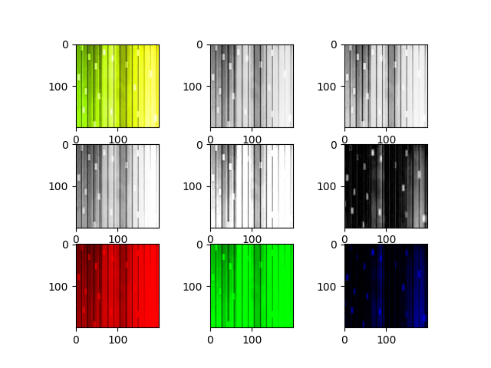

Fragment 0:200 - 400:600
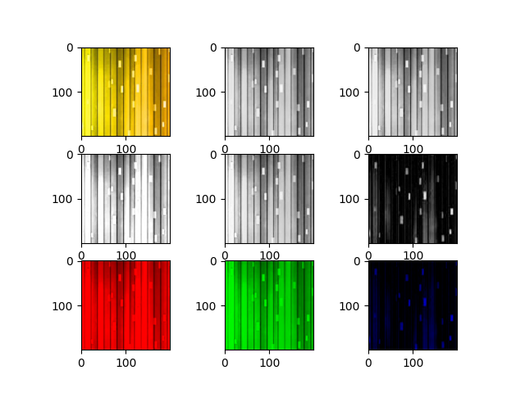

Fragment 200:400 - 0:200
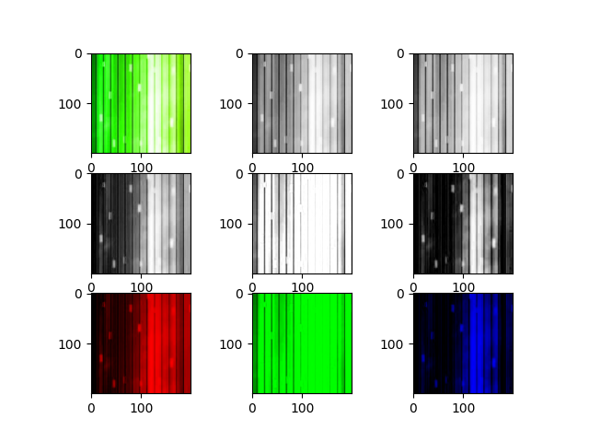

Fragment 200:400 - 200:400
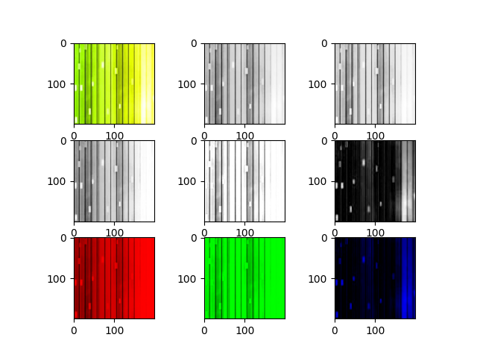

Fragment 200:400 - 400:600
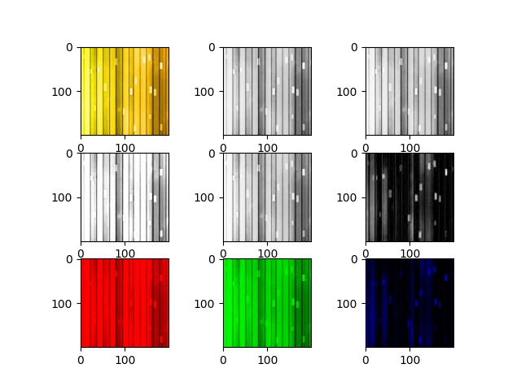

Fragment 400:600 - 0:200
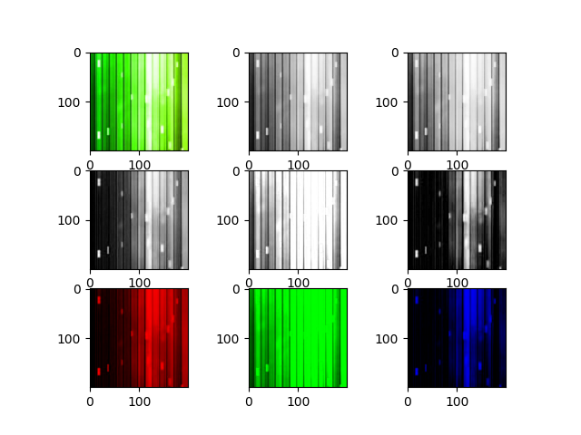

Fragment 400:600 - 200:400
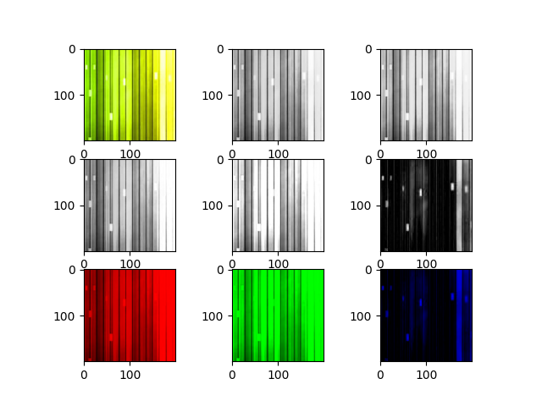

Fragment 400:600 - 400:600
