Chimera
UCSF Chimera is a highly extensible program for interactive visualization and analysis of molecular structures and related data, including density maps, supramolecular assemblies, sequence alignments, docking results, trajectories, and conformational ensembles. High-quality images and animations can be generated.
The ViewDock tool facilitates interactive analysis of receptor-ligand docking results in Chimera. One example of docking result visualization:
the co-crystallized ligand GCP, for comparison with docked molecules
Docked ligand

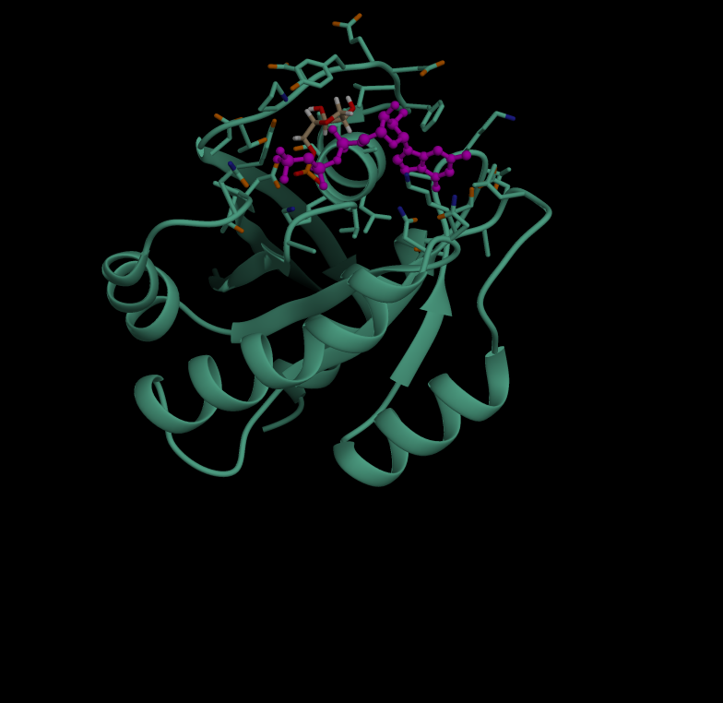

the structure of the receptor

The co-crystallized ligand GCP (shown in magenta) indicates the location of the active site. As shown in the following figure, this compound is not docked in the active site like the others. Its docking scores are zero.
