**The RosettaDock server for local protein–protein docking**

**RosettaDock** is a multi-start, multi-scale Monte Carlo-based algorithm. **RosettaDock** is a structure-prediction-based program, which works by simultaneous optimization of side-chain conformation and rigid body of two interacting proteins to find a minimum free-energy complex structure. The former is performed by a packing algorithm, and the latter is performed by a rigid-body Monte Carlo Minimization (MCM) strategy.

The RosettaDock server ([http://rosettadock.graylab.jhu.edu](http://rosettadock.graylab.jhu.edu/)) requires two protein structures as inputs and a starting location for the search. RosettaDock generates 1000 independent structures, and the server returns pictures, coordinate files and detailed scoring information for the 10 top-scoring models. A plot of the total energy of each of the 1000 models created shows the presence or absence of an energetic binding funnel. RosettaDock has been validated on the docking benchmark set and has been highly successful in the blind prediction challenge of the **C**ritical Assessment of PRedicted Interactions (CAPRI) producing several structures that were the most atomically accurate models submitted by any group in the CAPRI challenge. Two limitations of RosettaDock have been that (i) the command-line interface can be difficult to use and (ii) it requires significant computational time to generate all-atom models, typically requiring a cluster of computers.

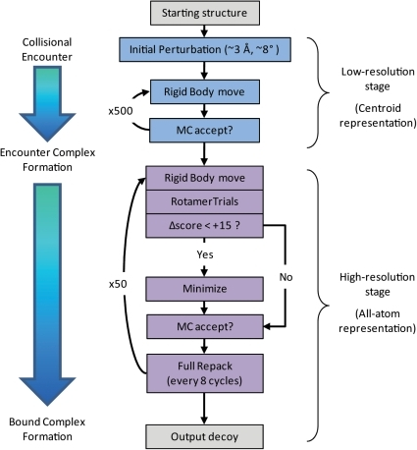

Monte Carlo+Minimization (MCM) steps are made in which:

1. The rigid-body position is perturbed by a random direction and magnitude specified by a Gaussian distribution around 0.1 Å and 3.0˚
2. The rigid-body orientation is energy-minimized
3. The side-chain conformations are optimized with RotamerTrials, followed by a test of the Metropolis criteria.

Every eight steps, an additional combinatorial side-chain optimization is carried out using the full side-chain packing algorithm, followed by an additional Metropolis criteria check. To reduce the time devoted to the computationally expensive energy-minimization for unproductive rigid-body moves, minimization is skipped if a rigid-body move results in a change in score of greater than +15. The all-atom score function used in this stage primarily consists of Van der Waals attractive and repulsive terms, a solvation term, an explicit hydrogen bonding term, a statistical residue-residue pair-wise interaction term, an internal side-chain conformational energy term, and an electrostatic term.

For particular targets, a variety of RosettaDock sampling strategies are often used to improve the chance of achieving an accurate structure prediction. If no prior structural or biochemical information is known about the protein interaction of interest, global docking is used to randomize the initial docking poses. From there, score filters and clustering are used to identify clusters of acceptable low-energy structures for further docking and refinement. In most cases, there is some known information about the complex, either in the form of related protein complexes or in biochemical or bioinformatics data which identify probable regions of interaction on the protein partners. In these cases users manually arrange the starting docking pose to a configuration that is compatible with the information and carry out a local docking perturbation. Additionally, users can set distance-based filters that bias sampling towards those docking poses that are compatible with specified constraints.