Root-mean-square deviation

The root-mean-square deviation (RMSD) or root-mean-square error (RMSE) is a frequently used measure of the differences between values predicted by a model or an estimator and the values actually observed. Basically, the RMSD represents the sample standard deviation of the differences between predicted values and observed values. These individual differences are called residuals when the calculations are performed over the data sample that was used for estimation, and are called prediction errors when computed out-of-sample. The RMSD serves to aggregate the magnitudes of the errors in predictions for various times into a single measure of predictive power. RMSD is a good measure of accuracy, but only to compare forecasting errors of different models for a particular variable and not between variables, as it is scale-dependent [1].

The RMSD of an [estimator](http://en.wikipedia.org/wiki/Estimator) \hat{\theta} with respect to an estimated parameter \theta is defined as the square root of the mean square error:



For an unbiased estimator, the RMSD is the square root of the variance, known as the standard error.

TM-SCORE

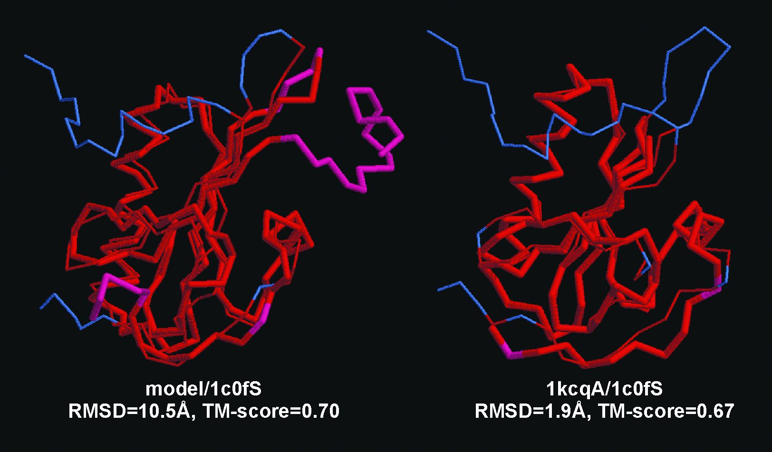

In this example, two structure pairs have similar topology in core regions, with TM-score=0.7 and 0.67 respectively. However, the tail/loop variations can result in significant differences in RMSD (from 1.9 Angstrom to 10.5 Anstrom). The figure is taken from Figure 5 of Nucleic Acids Research (2005) 33, 2303-2309 [2].

TM-score is an algorithm to calculate the structural similarity of two protein models. It is often used to quantitatively assess the accuracy of protein structure predictions relative to the experimental structure. Because TM-score weights the close atom pairs stronger than the distant matches, it is more sensitive to the topology fold than the often-used root-mean-square deviation (RMSD) since a local variation can result in a high RMSD value TM-score has the value in (0, 1]. Based on statistics, a TM-score <0.17 corresponds to a random similarity and a TM-score >0.5 generally corresponds to the same fold in SCOP/CATH. The definition of TM-score is independent on the length of the proteins [2].

Chimera – Visualization

UCSF Chimera is a highly extensible program for interactive visualization and analysis of molecular structures and related data, including density maps, supramolecular assemblies, sequence alignments, docking results, trajectories, and conformational ensembles. High-quality images and animations can be generated [3].

Chimera is segmented into a core that provides basic services and visualization, and extensions that provide higher level functionality. This architecture ensures that the extension mechanism satisﬁes the demands of outside developers who wish to incorporate new features. Two unusual extensions are presented: Multiscale, which adds the ability to visualize large-scale molecular assemblies such as viral coats, and Collaboratory, which allows researchers to share a Chimera session interactively despite being at separate locales. Other extensions include Multalign Viewer, for showing multiple sequence alignments and associated structures; ViewDock, for screening docked ligand orientations; Movie, for replaying molecular dynamics trajectories; and Volume Viewer, for display and analysis of volumetric data. A discussion of the usage of Chimera in real-world situations is given, along with anticipated future directions. Chimera includes full user documentation, is free to academic and nonproﬁt users, and is available for Microsoft Windows, Linux, Apple Mac OS X, SGI IRIX, and HP Tru64 Unix from <http://www.cgl.ucsf.edu/chimera/> [4].

References

[1] Hyndman, Rob J. Koehler, Anne B. (2006). "Another look at measures of forecast accuracy". International Journal of Forecasting: 679–688. doi:10.1016/j.ijforecast.2006.03.001

[2] TM-score: Quantitative assessment of similarity between protein structures. (n.d.). Retrieved from <http://zhanglab.ccmb.med.umich.edu/TM-score/>

[3] UCSF Chimera Home Page. (n.d.). Retrieved from http://www.cgl.ucsf.edu/chimera/

[4] Pettersen, E. F., Goddard, T. D., Huang, C. C., Couch, G. S., Greenblatt, D. M., Meng, E. C., & Ferrin, T. E. (2004). UCSF Chimera - A visualization system for exploratory research and analysis. Journal of Computational Chemistry. doi:10.1002/jcc.20084