**Project 4 Instructions**

1. Download Project4 from: https://github.com/MizzouNeuro/Project4-GeneralNetworkModel
2. Extract both zipped directories
3. From the Project4 folder open **sim_builder.exe** you should see a window like this:

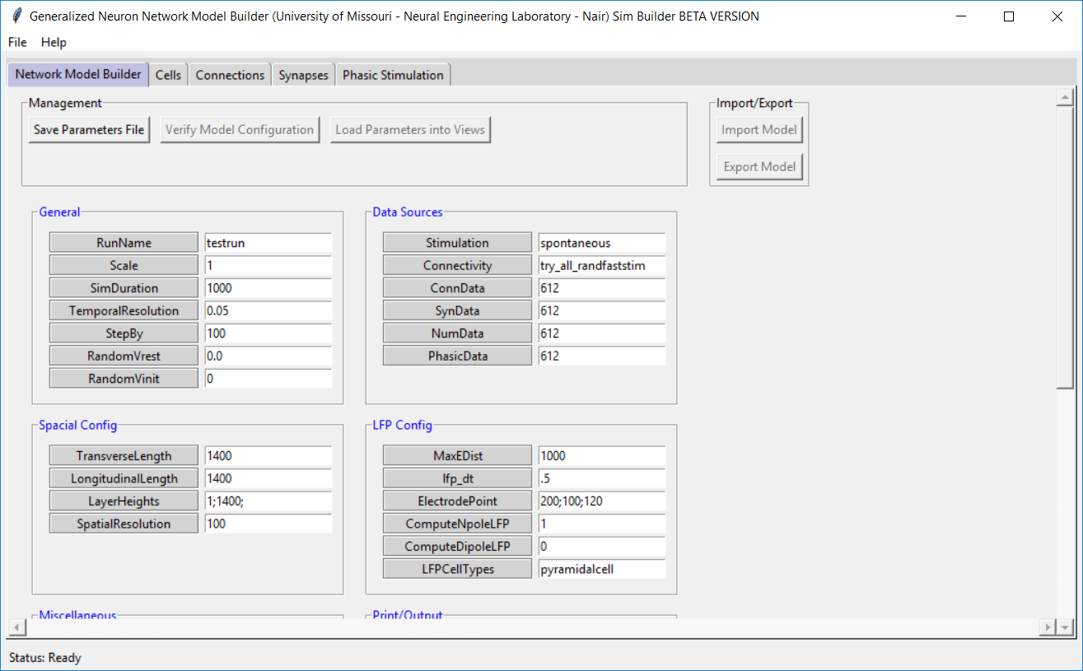

1. From the SimAgentMPI folder open **SimAgentMPI.exe**

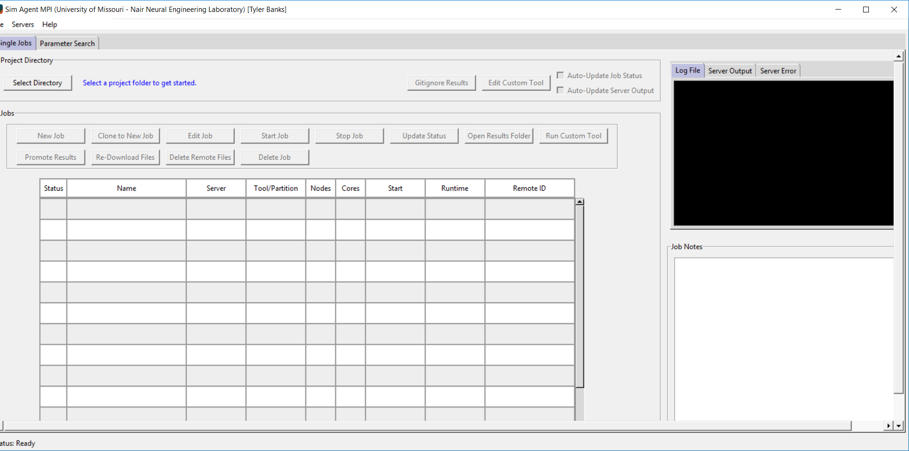

1. Go to Help->Update and update to the latest ‘master’ branch. Re-open SimAgent after the update completes.

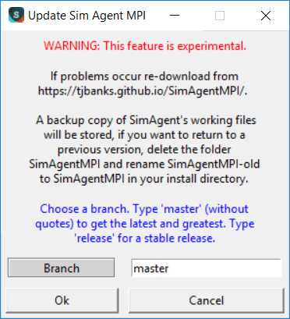

1. Click ‘Select Directory and navigate to/select the project4-Gamma directory

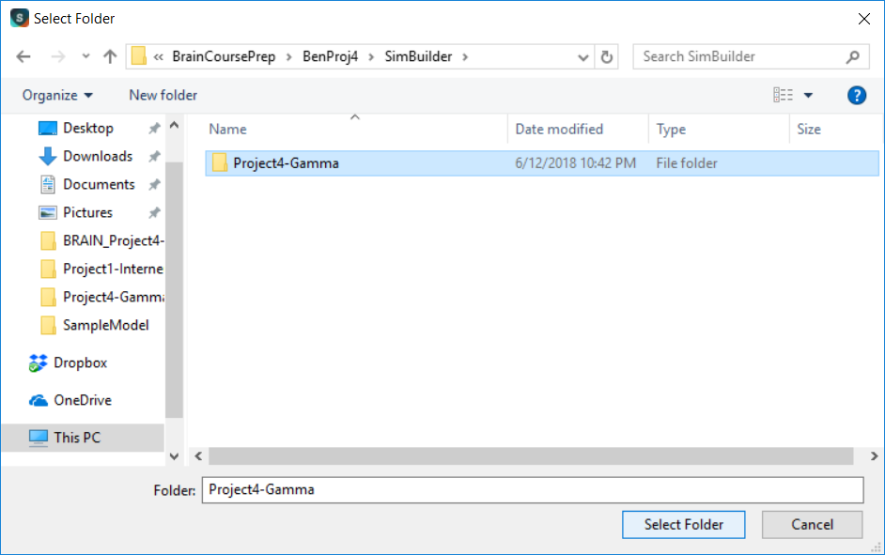

1. From the Sim Builder window, access the different tabs and click ‘Load NumData’, ‘Load ConnData’, etc. Adjust the parameters from this window and click ‘Save’ for any change made.

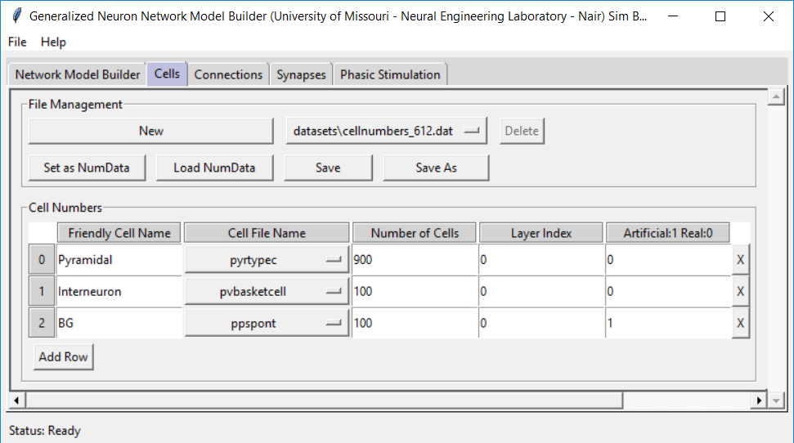

1. Return to the SimAgent window. Create a new job with appropriate parameters.

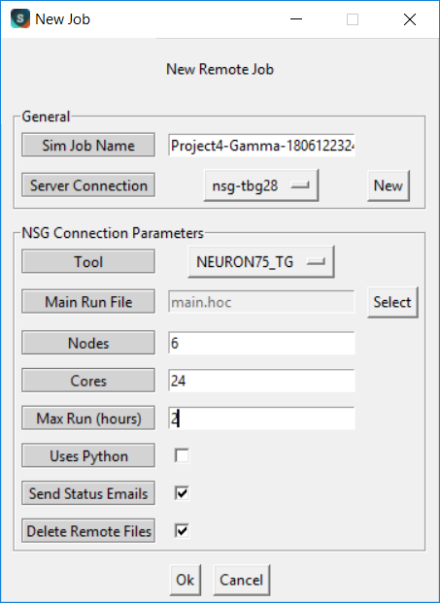

1. Start the job and wait for completion. When the job completes click ‘Run Custom Tool’ to view a raster plot like this:

