//SINGLE INHERITANCE:

#include<iostream>

using namespace std;

class moni{

public:

int a;

void nagesh(){

cout<<"enter a number :";

cin>>a;

}

};

class n1:public moni{

public:

int b;

void raj(){

cout<<"enter a number: ";

cin>>b;

cout<<"addition of two num:"<<a+b;

}

};

int main()

{

n1 n2 ;

n2.nagesh();

n2.raj();

}

OUTPUT:

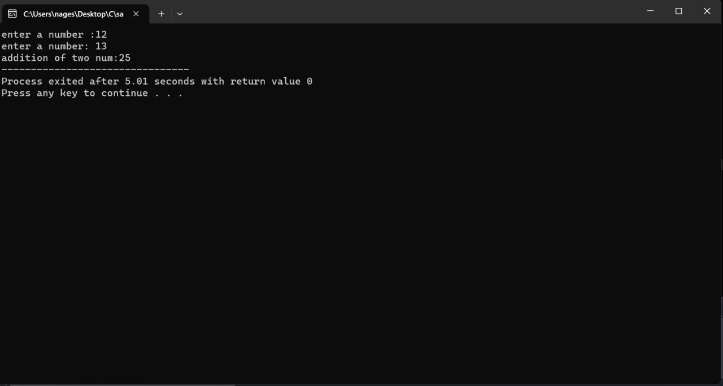

//MULTI LEVEL INHERITANCE:

#include<iostream>

using namespace std;

class worker{

public:

string name;

int age;

void m1(){

cout<<"ENGINEER DETAILS:\n";

cout<<"enter your name:";

cin>>name;

cout<<"enter your age:";

cin>>age;

}

};

class engineer:public worker{

public:

string speciality;

void m2(){

cout<<"enter speciality:";

cin>>speciality;

}

};

class manager:public engineer{

public:

int exp,income;

void m3(){

cout<<"enter experience:";

cin>>exp;

cout<<"enter your income:";

cin>>income;

}

void display(){

cout<<name<<endl;

cout<<age<<endl;

cout<<exp<<endl;

cout<<speciality<<endl;

cout<<income<<endl;

}

};

int main(){

manager manager;

manager.m1();

manager.m2();

manager.m3();

manager.display();

}

OUTPUT:

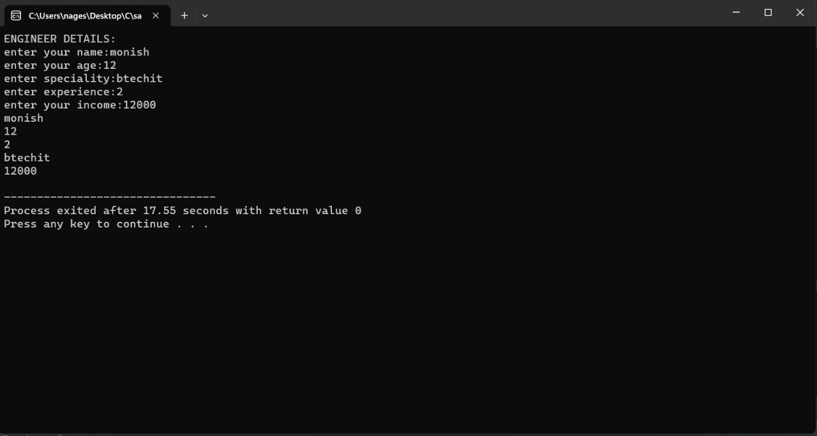

//MULTIPLE INHERITANCE:

#include<iostream>

using namespace std;

class worker{

public:

string name;

int age;

void m1(){

cout<<"ENGINEER DETAILS:\n";

cout<<"enter your name:";

cin>>name;

cout<<"enter your age:";

cin>>age;

}

};

class engineer{

public:

string speciality;

void m2(){

cout<<"enter speciality:";

cin>>speciality;

}

};

class manager:public worker,public engineer{

public:

int exp,income;

void m3(){

cout<<"enter experience:";

cin>>exp;

cout<<"enter your income:";

cin>>income;

}

void display(){

cout<<name<<endl;

cout<<age<<endl;

cout<<exp<<endl;

cout<<speciality<<endl;

cout<<income<<endl;

}

};

int main(){

manager manager;

manager.m1();

manager.m2();

manager.m3();

manager.display();

}

OUTPUT:

