//VIRTUAL FUNCTION:

#include<iostream>

using namespace std;

class person{

public:

virtual void work(){

cout<<"person is working"<<endl;

}

};

class employee : public person{

public:

void work() override{

cout<<"employee is working"<<endl;

}

};

class manager : public person{

public:

void work() override{

cout<<"mananger is working"<<endl;

}

};

int main()

{

person person;

employee employee;

manager manager;

person.work();

employee.work();

manager.work();

return 0;

}

OUTPUT:

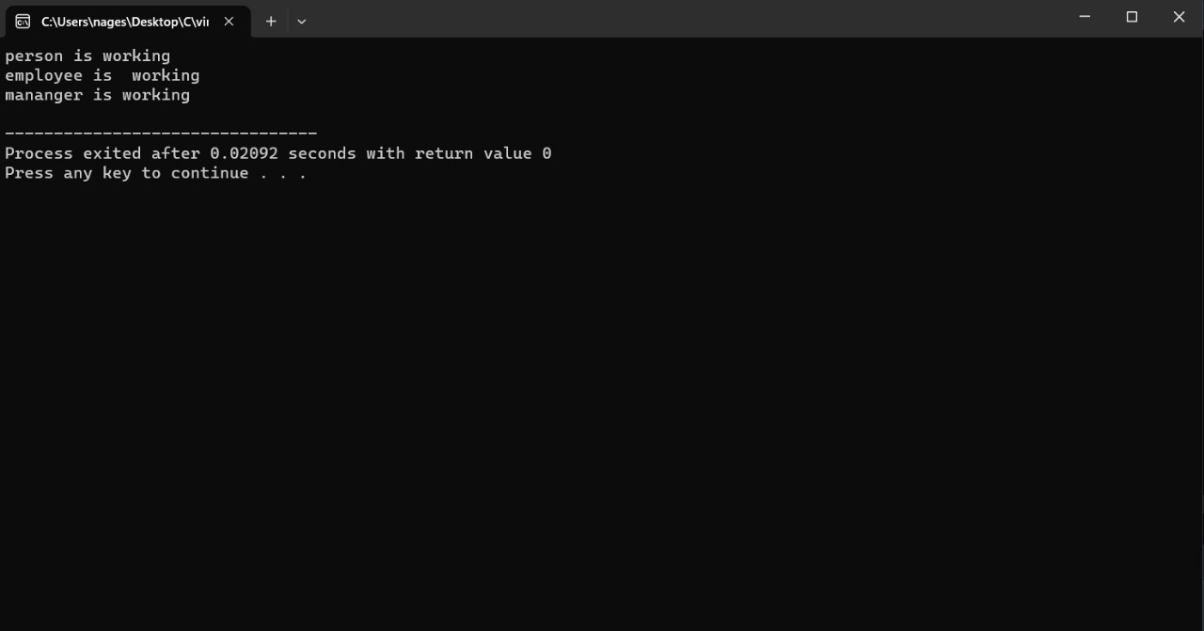

//FRIEND FUNCTION:

#include <iostream>

using namespace std;

class Box

{

private:

int length;

public:

friend int Length(Box);

};

int Length(Box b)

{

b.length += 10;

return b.length;

}

int main()

{

Box obj;

cout<<"Length of box: "<<Length(obj)<<endl;

return 0;

}

OUTPUT:

