DYNAMIC MEMORY ALLOCATION:

#include<iostream>

using namespace std;

int main(){

int a,\*n=new int;

float \*f=new float;

char \*c=new char;

double \*d=new double;

cout<<"DYNAMIC MEMORY ALLOCATION:\n";

cout<<"FOR PRIMITIVE DATATYPE\n";

cout<<"1.INTEGER\n";

cout<<"2.FLOAT\n";

cout<<"3.DOUBLE\n";

cout<<"4.CHARACTER\n";

for(int i=1;i<=5;i++){

cout<<"\nENTER YOUR CHOICE:";

cin>>a;

switch(a){

case 1:

cout<<"enter a num:";

cin>>\*n;

cout<<\*n;

delete n;

break;

case 2:

cout<<"enter a num:";

cin>>\*f;

cout<<\*f;

delete f;

break;

case 3:

cout<<"enter a num:";

cin>>\*d;

cout<<\*d;

delete d;

break;

case 4:

cout<<"enter a character:";

cin>>\*c;

cout<<\*c;

delete c;

break;

default:

cout<<"program finished!!!";

break;

}

}

return 0;

}

OUTPUT:

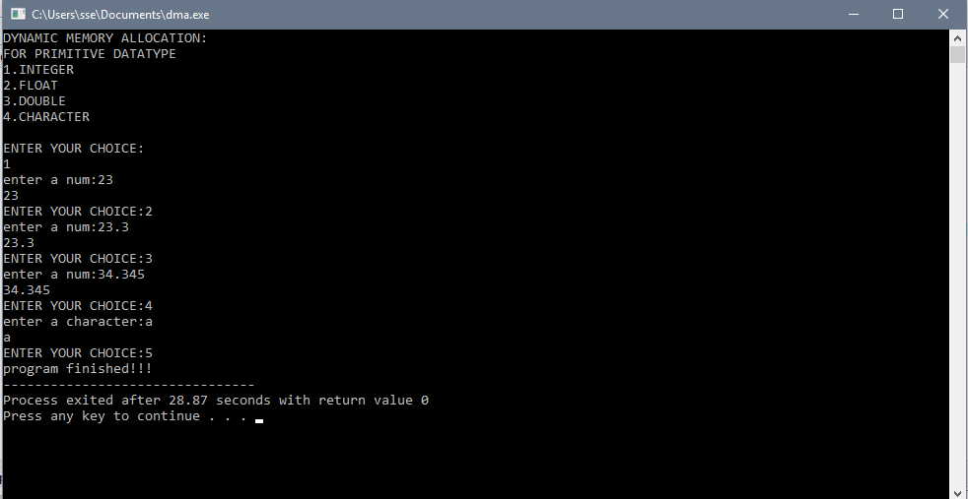

DYNAMIC MEMORY ALLOCATION USER DEFINED DATATYPES:

#include<iostream>

using namespace std;

int main(){

int s;

cout<<"enter size of array:";

cin>>s;

int a,\*n=new int[s];

float \*f=new float[s];

char \*c=new char[s];

double \*d=new double[s];

cout<<"DYNAMIC MEMORY ALLOCATION:\n";

cout<<"FOR USER DEFINED DATATYPE\n";

cout<<"1.ARRAY INTEGER\n";

cout<<"2.ARRAY FLOAT\n";

cout<<"3.ARRAY DOUBLE\n";

cout<<"4.ARRAY CHARACTER\n";

for(int i=1;i<=4;i++){

cout<<"\nENTER YOUR CHOICE:";

cin>>a;

switch(a){

case 1:

cout<<"INTEGER VALUES:";

for(int i=0;i<s;i++){

cout<<"n["<<i<<"]=";

cin>>\*(n+i);

}

for(int i=0;i<s;i++){

cout<<"n["<<i<<"]="<<\*(n+i)<<endl;

}

break;

case 2:

cout<<"FLOAT VALUES:";

for(int i=0;i<s;i++){

cout<<"f["<<i<<"]=";

cin>>\*(f+i);

}

for(int i=0;i<s;i++){

cout<<"f["<<i<<"]="<<\*(f+i)<<endl;

}

break;

case 3:

cout<<"DOUBLE VALUS:";

for(int i=0;i<s;i++){

cout<<"d["<<i<<"]=";

cin>>\*(d+i);

}

for(int i=0;i<s;i++){

cout<<"d["<<i<<"]="<<\*(d+i)<<endl;

}

break;

case 4:

cout<<"CHARACTER ONLY:";

for(int i=0;i<s;i++){

cout<<"c["<<i<<"]=";

cin>>\*(c+i);

}

for(int i=0;i<s;i++){

cout<<"c["<<i<<"]="<<\*(c+i)<<endl;

}

break;

default:

cout<<"program finished!!!";

break;

}

}

}

OUTPUT:

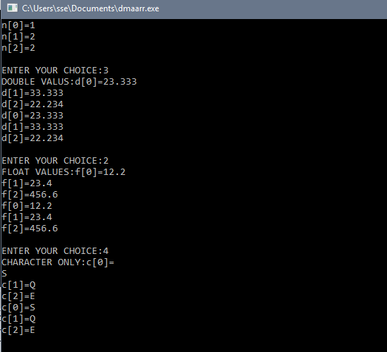

FOR OBJECT:

#include<iostream>

using namespace std;

class dmaobj{

public:

string s;

dmaobj(){

cout<<"enter your name:";

cin>>s;

cout<<s<<endl;

}

~dmaobj(){

cout<<"bye bye!\n";

}

};

class staticarr{

public:

string s;

staticarr(){

cout<<"enter your name:";

cin>>s;

cout<<s<<endl;

}

~staticarr(){

cout<<"tataa! tataa!\n";

}

};

class dynarr{

public:

int age;

dynarr(){

cout<<"enter your age:";

cin>>age;

cout<<age<<endl;

}

~dynarr(){

cout<<"varata maame drrr!!!\n";

}

};

int main(){

dmaobj \*obj1=new dmaobj;

delete obj1;

int n;

cout<<"enter no of objjects:";

cin>>n;

staticarr obj[n];

delete obj;

dynarr \*obj3=new dynarr[n];

delete []obj3;

}

OUTPUT:

