//SINGLE CATCH:

#include<iostream>

using namespace std;

int main(){

int a;

try{

cout<<"enter your age to verify to vote:";

cin>>a;

if(a<18)

throw "not eligible to vote";

else

cout<<"congratulations! ..you are eligible to vote";

}

catch( const char \*c){

cout<<c;

}

}

OUTPUT:

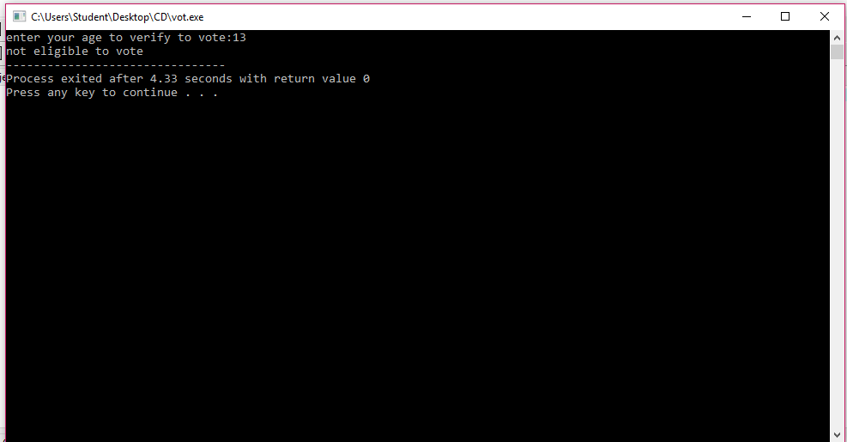

//MULTIPLE CATCH:

#include<iostream>

using namespace std;

int main(){

int a;

try{

cout<<"enter your age to verify to vote:";

cin>>a;

if(a<18){

throw a;

}

else

cout<<"congratulations! ..you are eligible to vote";

}

catch( const char \*c){

cout<<c;

}

catch(float x){

cout<<x;

}

catch(...){

cout<<"wait for "<<18-a<<" years to vote";

}

}

OUTPUT:

