//INTEGER POINTER:

#include<iostream>

using namespace std;

int main(){

int c;

c=12;

int \*p;

p=&c;

cout<<\*p;

}

OUTPUT:

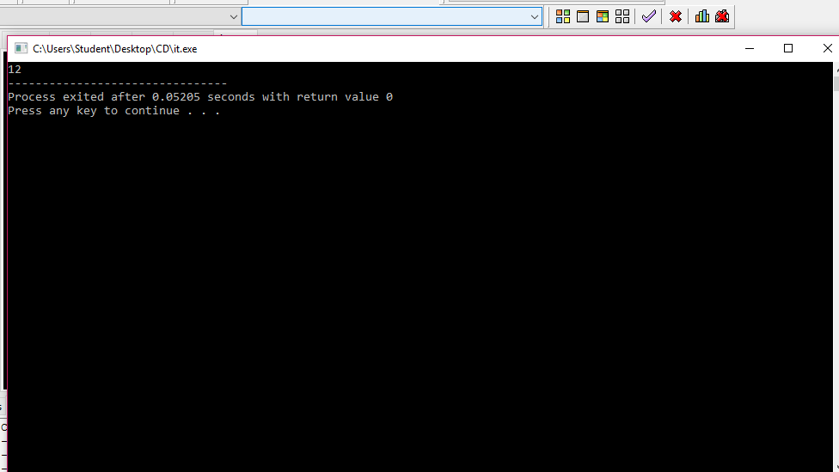

//FLOAT POINTER:

#include<iostream>

using namespace std;

int main(){

float c;

c=12.9;

float \*p;

p=&c;

cout<<\*p;

}

OUTPUT:

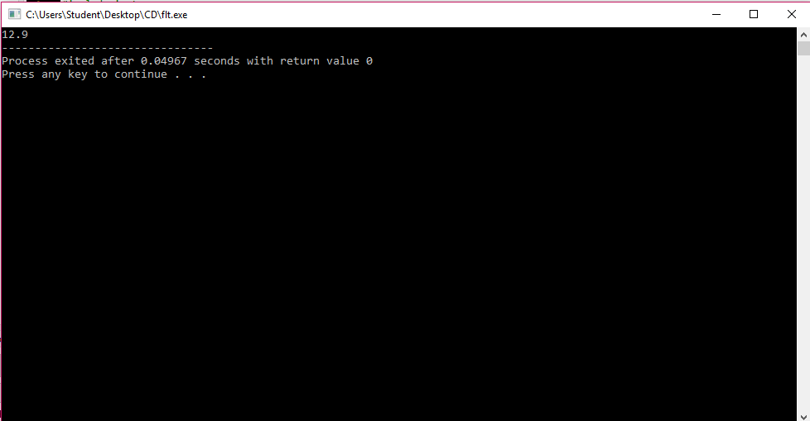

//CHARACTER POINTER:

#include<iostream>

using namespace std;

int main(){

char c;

c='a';

char \*p;

p=&c;

cout<<\*p;

}

OUTPUT:

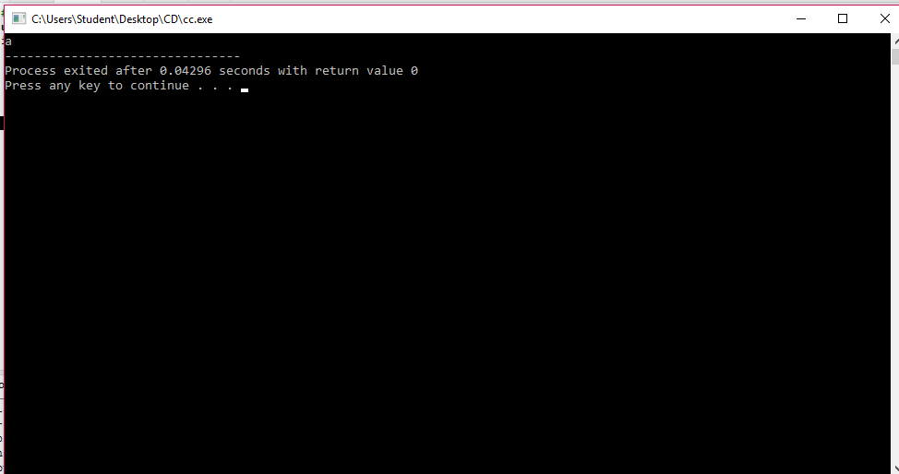

//STRING POINTER:

#include<iostream>

using namespace std;

int main(){

string c;

c="jii";

string \*p;

p=&c;

cout<<\*p;

}

OUTPUT:

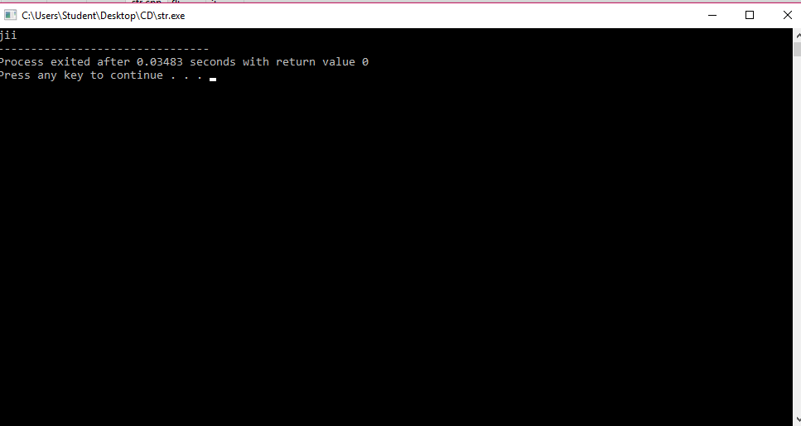

// ARRAY POINTER:

#include<iostream>

using namespace std;

int main(){

int a[3];

for(int i=0;i<3;i++){

cin>>a[i];

}

int \*p;

for(int i=0;i<3;i++){

p=&a[i];

cout<<\*p<<endl;

}

}

OUTPUT:

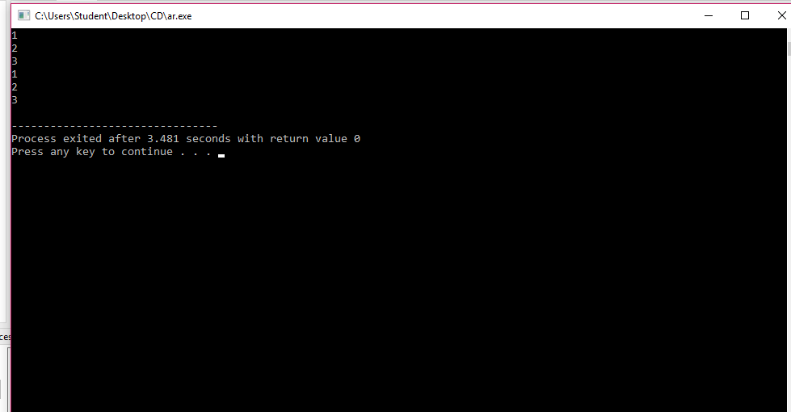

//POINTER TO OBJECT:

#include<iostream>

using namespace std;

class pri{

private:

int a;

public:

void set(){

a=5;

cout<<a<<endl;

}

private:

float b;

public:

void get(){

b=1.3;

cout<<b<<endl;

}

private:

string s;

public:

void go(){

s="hi";

cout<<s;

}

};

int main(){

pri obj;

pri \*p;

p=&obj;

p->set();

p->get();

p->go();

}

OUTPUT:

