Russell Alleen-Willems
Digital Archaeologist and VR Enthusiast
4 hrs ago · 4 min read · Unlisted

Puzzler VR: An Introduction to VR Design Principles
This project was made for Udacity’s VR Developer NanoDegree. It demonstrates experience designing and implement a puzzle-based experience while using personas, sketches, and user test feedback to iterate and complete the design.

Puzzler VR is a mobile VR application for Android/Cardboard which immerses the user in a medieval dungeon environment and challenges users to solve pattern-matching puzzles in order to progress.

Outcome
PuzzlerVR uses game logic similar to the electronic game “Simon.” The user starts the experience outside an imposing stone fort.

Puzzler Project VR [[https://youtu.be/vqMGlB2d-qY]]

Watch this video in a VR viewer

Development Process
I began with an environment that closely mirrored the one built through the Udacity videos. I sketched a few alternate designs for the puzzle and the environment. I conducted several user tests of the user interface, environment, and puzzle feedback. The user feedback told me that the interior of the environment had a well-established mood, but that the exterior felt small and not much like a large, mysterious fort. users were also often unclear about the nature of the puzzle. Several users failed to recognize that they needed to match the pattern shown by the shapes, so I added more explanatory text about the puzzle objective to the beginning of the experience.

Persona
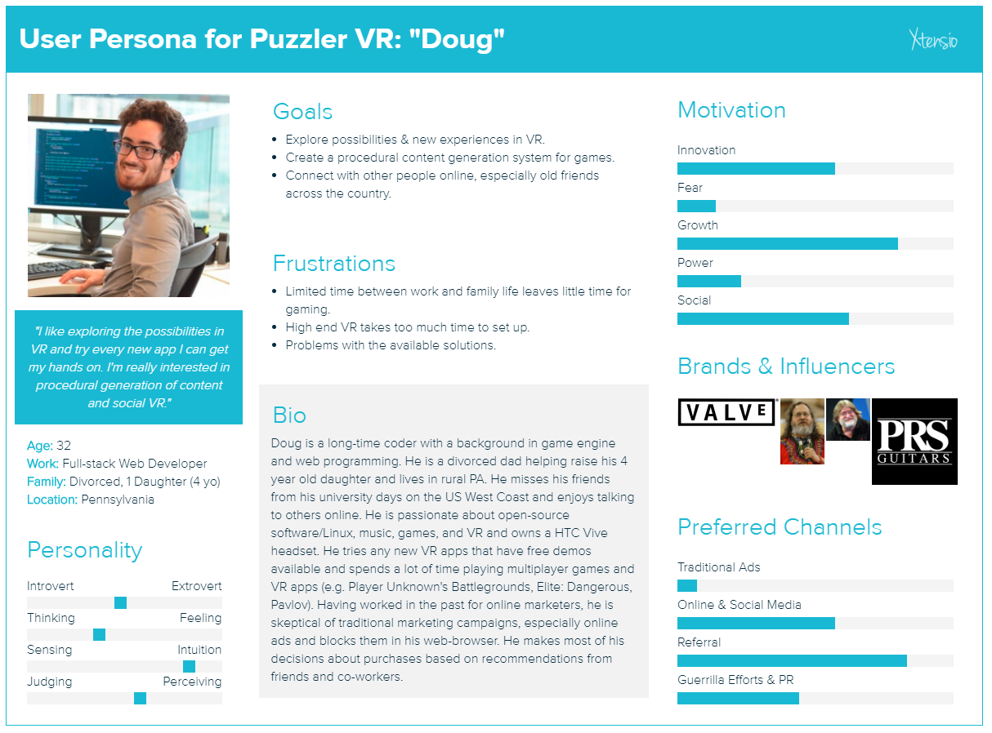
Doug is a long-time coder with a background in game engine and web programming. He is a divorced dad helping raise his 4 year old daughter and lives in rural PA. He misses his friends from his university days on the US West Coast and enjoys talking to others online.
VR Experience: Advanced
He is passionate about open-source software/Linux, music, games, and VR and owns a HTC Vive headset. He tries any new VR apps that have free demos available and spends a lot of time playing multiuser games and VR apps (e.g. user Unknown's Battlegrounds, Elite: Dangerous, Pavlov).

Sketches
Udacity provided some pre-made models of dungeon elements to use for the environment. I sketched a rough design of the app, showing three different stages: outside the fort gate, inside the dungeon, and outside the fort posterior. I added distinct shapes for the puzzle objects to give an extra detail for players to remember the pattern with (e.g. Square, Triangle, Gem, Gem, Square). I also added entry and exit drawbridges so that, when the bridges are up, the player would feel contained within the fort interior.
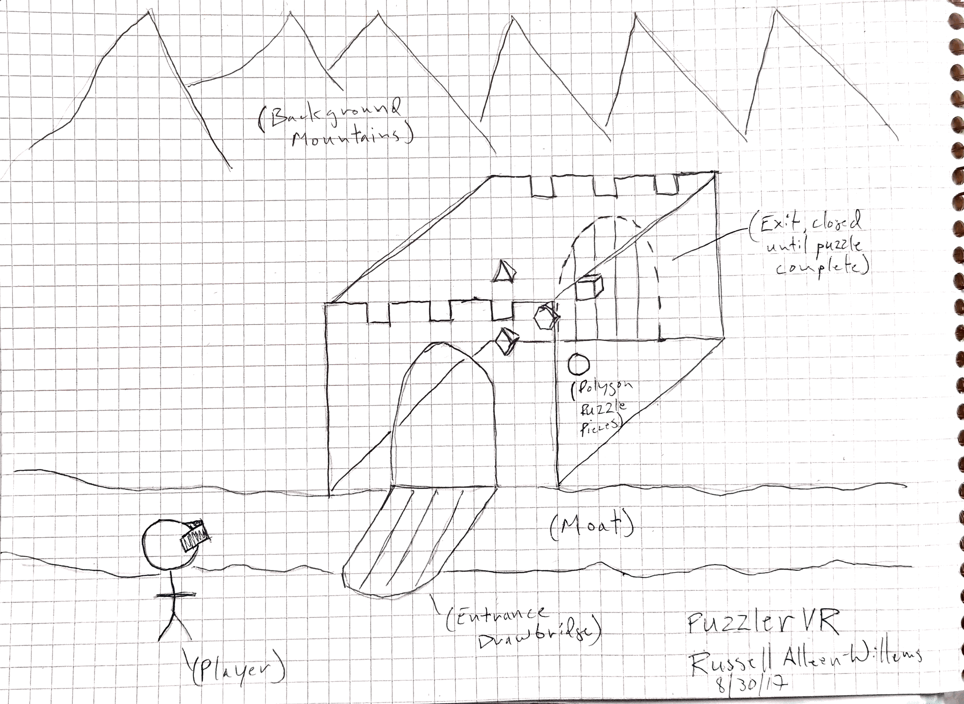

User Testing

User Test 1 - Scale
User 1 viewed the first build of the application, demonstrating the exterior and interior of the fort. She said that the overall scale of the interior felt true-to-life, but that the exterior made the fort seem quite small. To make the exterior of the fort more impressive, I used the dungeon tiles, torch objects, and particle effects to build out the fort exterior and make it appear bigger.

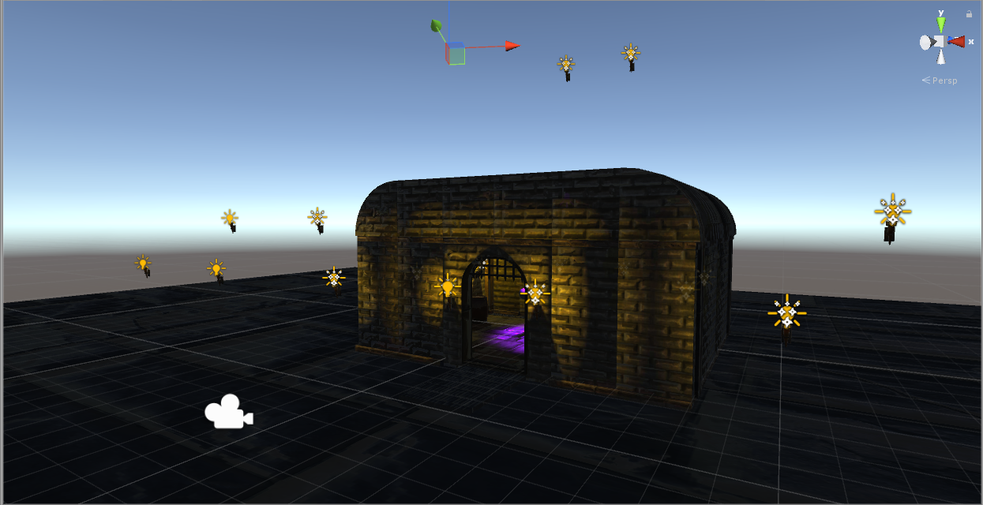
Before

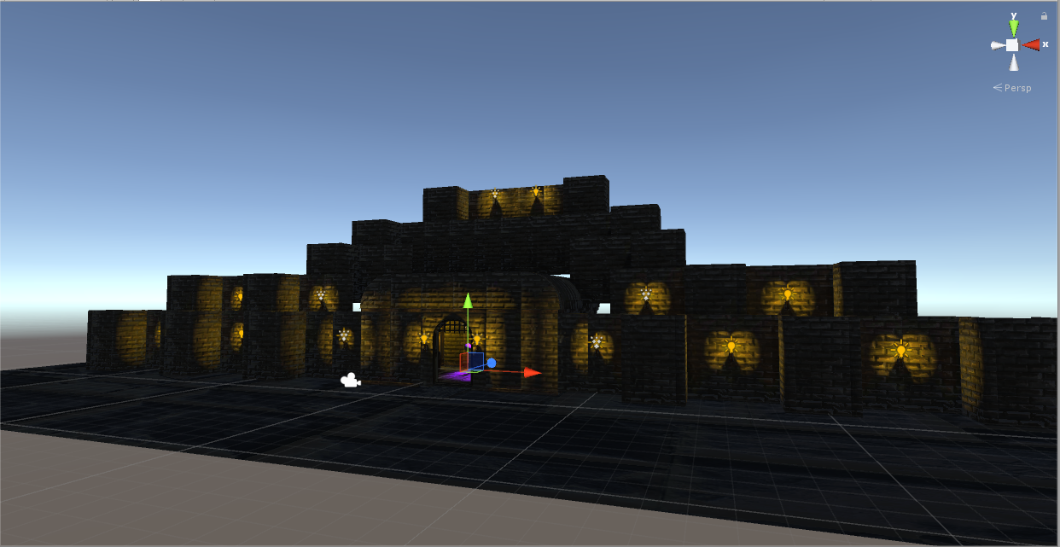

After

User Test 2 – User Interface
User 2 viewed a VR mockup of two start user interface panels. Mockup 1 was almost exclusively flavor-text to provide a reason why the user was in the environment. Mockup 2 provided just a bit of explanation (e.g. you have “mystic powers”) but more information on the controls used in the application. User 2 reported that they liked having a bit of explanation for the context of the puzzle and environment, but that Mockup 2 provided essential information about how to use the application that wasn’t obvious otherwise.

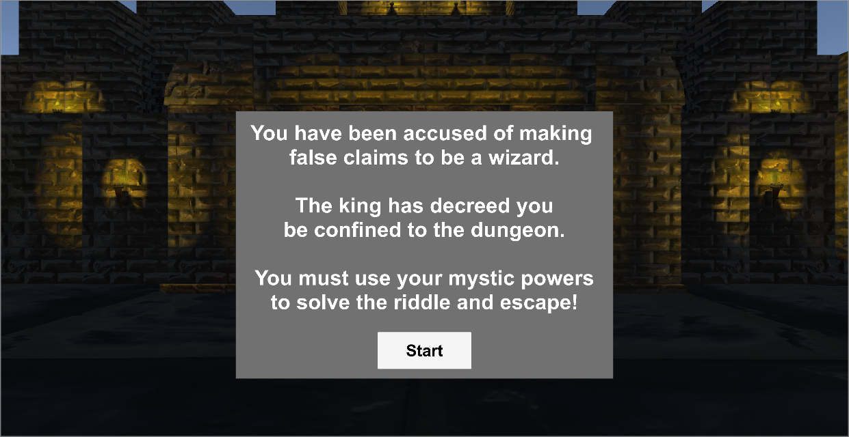
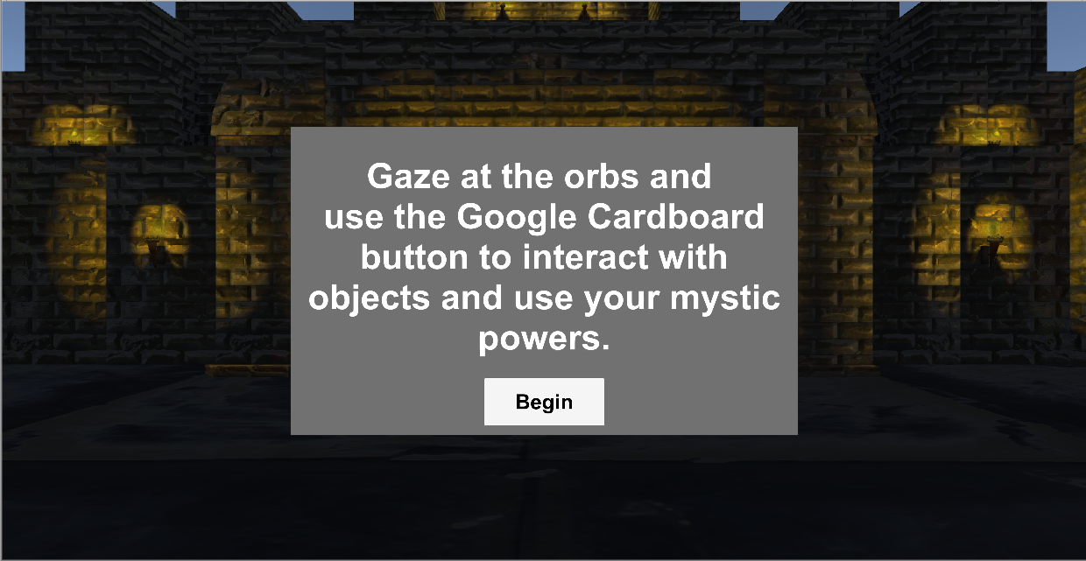
UI Mockup 1

UI Mockup 2

Based on the user feedback, I made the decision to show two introductory UI panels at the beginning: one to provide a reason why the user is completing the puzzle and a second to give instructions on the puzzle objective and controls.

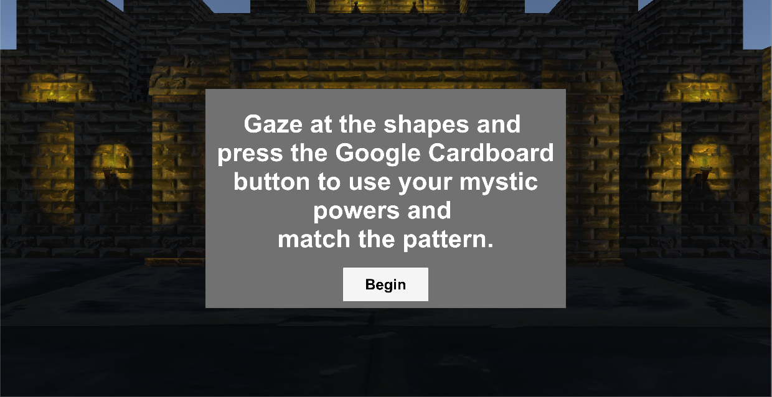

Revised second UI panel explaining how to control the application.

User Test 3 - Movement
Feedback: User 3 tested a short mockup of the application which included the start and end interfaces and the dungeon environment, but which did not include the puzzle itself. When asked about any discomfort, the user reported experiencing no issues and, when asked specifically to rate the movement, reported that they barely noticed the movement and could not recall any issues.

Action Taken: I did not make any changes since users reported no discomfort from the motion.

User Test 4 – Final
Feedback: User 4 tested a complete build of the application. They said the environment inside the fort had a “mysterious mood” but that the exterior skybox was so bright blue that it didn’t seem to match the dark, nighttime atmosphere of the rest of the application environment.

Action Taken: I changed the default skybox to a different skybox depicting a sunset against a mountainous landscape. The sunset provided a logical source for the dim lighting in the environment and better matched the mysterious mood of the environment. The exterior of the front of the fort is dimly lit by the torches outside the front gate, but when the user solves the puzzle and escapes through the exit gate, they are presented with a more brightly lit landscape.

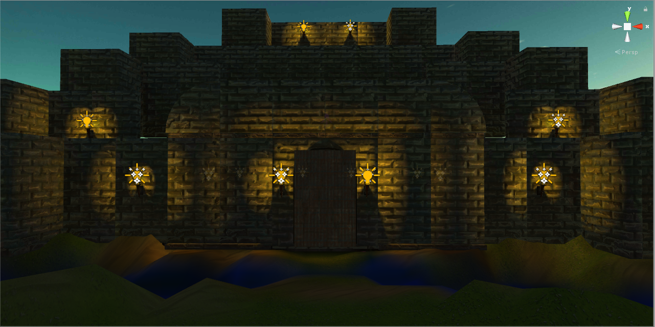
Dim Exterior of the Front of the Fort.

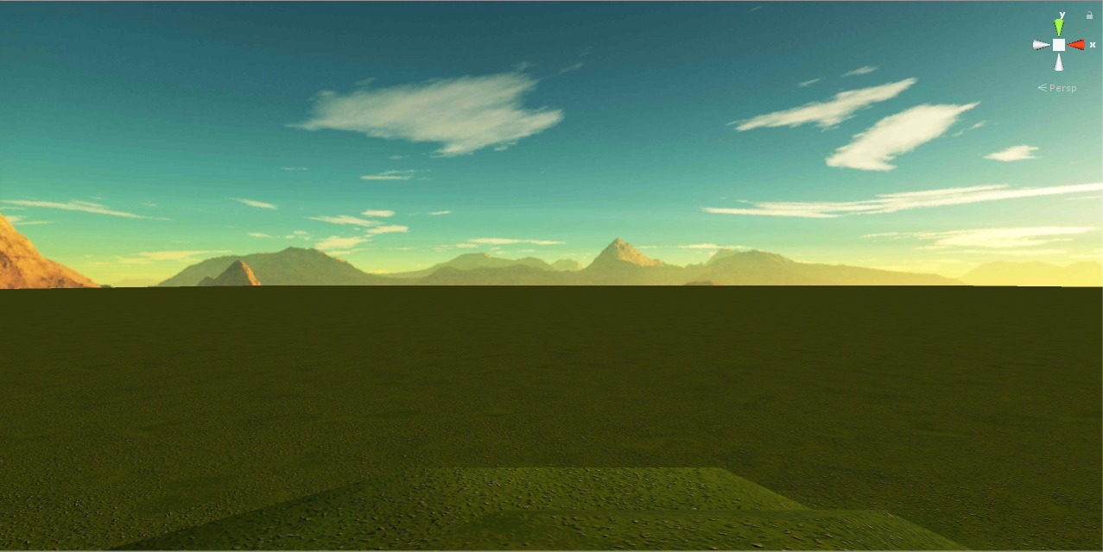

Brightly Lit Exterior of the Rear of the Fort.

Breakdown of the Final Piece

Building the Scene
To better emphasize the scale of the fort, I expanded the exterior quite a bit using the dungeon walls and torches. I built out the environment just enough to present a believable illusion of a large fort from the user’s limited point of view without building out a full fort exterior. I added drawbridges to the entry and exit gates of the fort to communicate that the dungeon was an enclosed space rather than an open gate between locations. Finally, I selected a skybox that displayed a sunset and better reflected the atmosphere inside the fort.

Lighting
During user testing, a few users commented that the lighting contributed a lot to how believable the scene was. However, with using just lighting sources to provide lighting, several users commented that they didn’t understand what was casting each light. To provide a better illusion, I added particle emitters to the visible torches to represent flames and provide a realistic source for the lighting. To provide better performance when deployed to a mobile device, I omitted particle emitters from hidden light sources and baked the lighting into the environment textures. Because of the mystic nature of the floating shapes, users had few issues accepting the purple spotlight as a “magic light.”

Movement
I utilized invisible waypoints and the iTween animation plugin to move the user’s camera to different points in the environment. Because of the slow motion and smooth linear curve for the movement, users reported no discomfort issues with the movement. In several cases, users failed to recall the motion occurring at all.

Conclusion
Lorem ipsum dolor sit amet, consectetur adipiscing elit, sed do
eiusmod tempor incididunt ut labore et dolore magna aliqua. Ut enim

ad minim veniam, quis nostrud exercitation ullamco laboris nisi ut
aliquip ex ea commodo consequat. Duis aute irure dolor in
reprehenderit in voluptate velit esse cillum dolore eu fugiat nulla
pariatur. Excepteur sint occaecat cupidatat non proident, sunt in culpa
qui oﬃcia deserunt mollit anim id est laborum.

Next Steps
There are several places where I’d like to improve on the application. I added instructional text to the beginning of the experience to better acquaint the user with the application controls. However, I think it would be better to use less text to communicate controls and instead provide a series of additional simple puzzles which gradually lead the user through selecting a shape, selecting multiple shapes in a simple pattern, and then finally moving on to the main puzzle.

Links to Additional Work
Lorem ipsum dolor sit amet, consectetur adipiscing elit, sed do
eiusmod tempor incididunt ut labore et dolore magna aliqua.

