This is for Mac users:

Followed the MySQLHerokuDeploymentProcess.pdf from steps 1-12.

At Step 13, I launched Workbench, and did the following:

1. Clicked the Wrench icon to manage my connections:  
   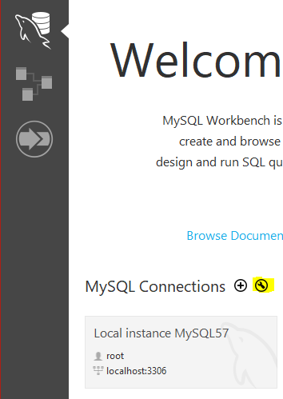
2. Filled in the Hostname, Port, Username, and Password  
   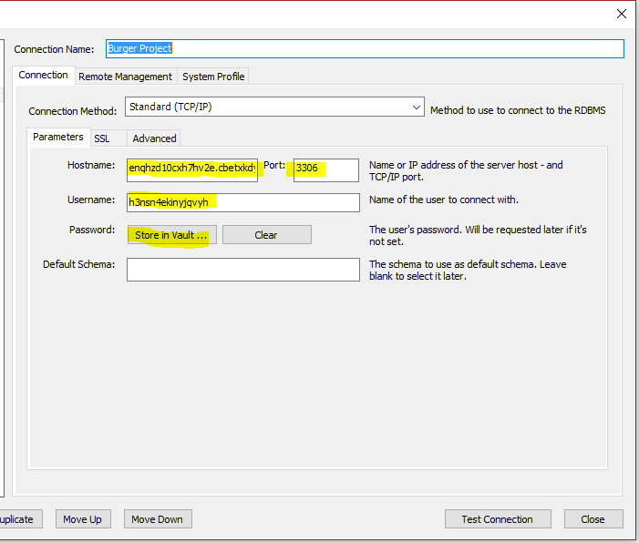
3. Clicked “Test Connection” - if it worked, it gives a very nice success message:

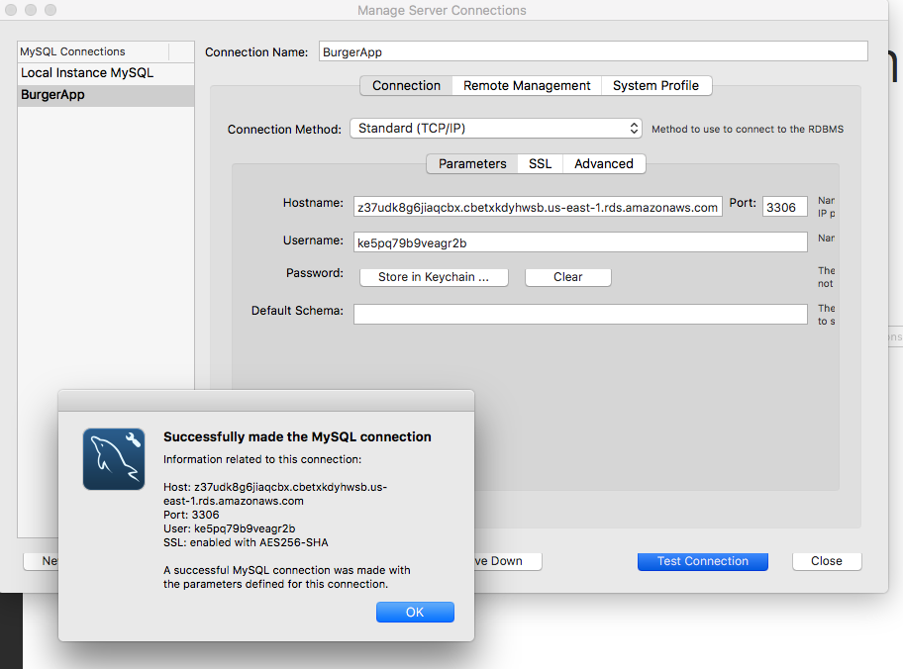

1. Closed the Manage Connections dialog box and returned to the home screen. Click on the new Project that was just created:  
   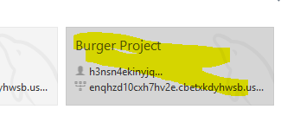
2. Right click on “Tables” and click “Create Table”:  
   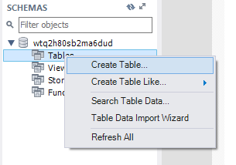  
   (Note: I had to provision a new JawsDB, so the DB name “wtq2h80…” is the new Username. It will be whatever is in the details for the JawsDB in Heroku
3. Manually configured the columns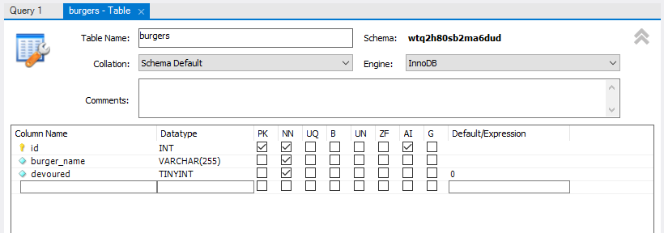
4. Click apply. A screen will pop up with the script to be applied to the database (note the username in front of the table):  
     
   CREATE TABLE `wtq2h80sb2ma6dud`.`burgers` (  
   `id` INT NOT NULL AUTO_INCREMENT,  
   `burger_name` VARCHAR(255) NOT NULL,  
   `devoured` TINYINT NOT NULL DEFAULT 0,  
   PRIMARY KEY (`id`));

1. Verify that the table and columns are in the DB:

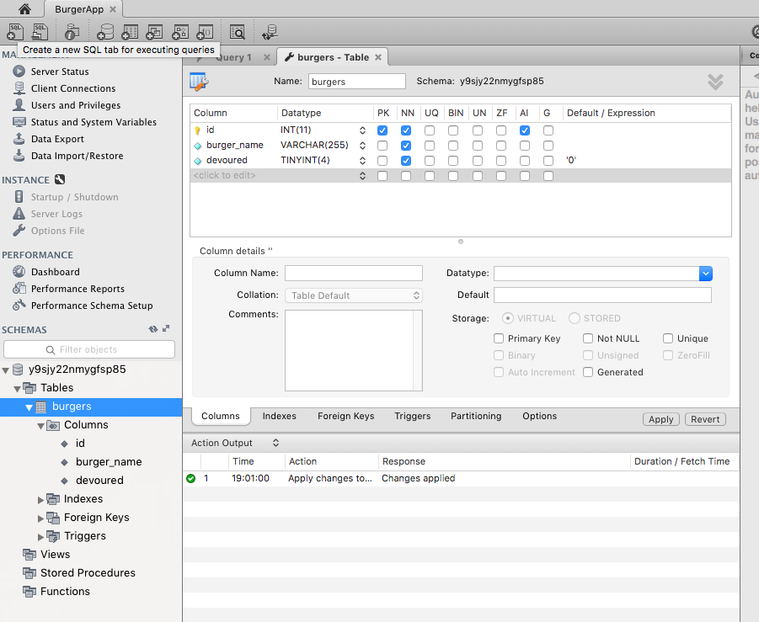

10. Once your DB is set, go to Heroku and click on your application. It should show your app browser.