Homework 6: Host Configuration

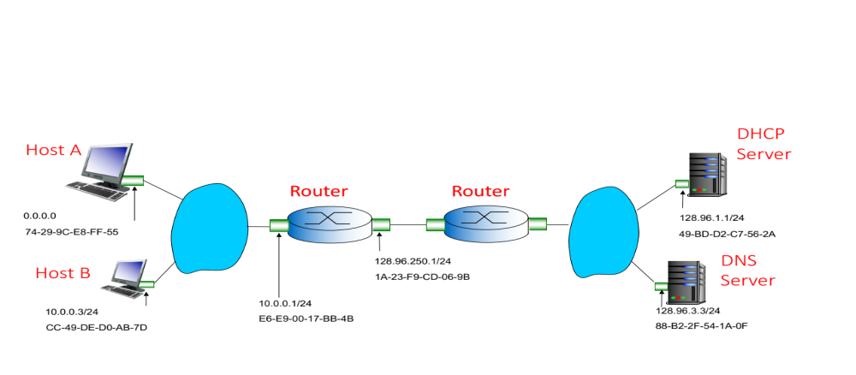

Host A attaches to the above institutional network for the first time. The Ethernet link comes up. Suppose ARP, DNS and web caches are empty.

What minimum network configuration does Host A need to communicate with other hosts within a subnet and off-subnet?

As hints to answer this question, ask yourself the following:
- What address does a source host need to send and receive IP Packets? What range of addresses are valid for this host given the topology above?
- What address does a source host need to know to send packets to a destination host that is not on the same subnet?
- How does a source host know whether a destination is on or off-subnet?
- How does a source host resolve a destination hostname to an IP address?

List the network configuration needed, and the valid values of this configuration based on the information in the network topology above.

Answers:
a)

b)

c)

Homework 7: Communicating on and off-subnet

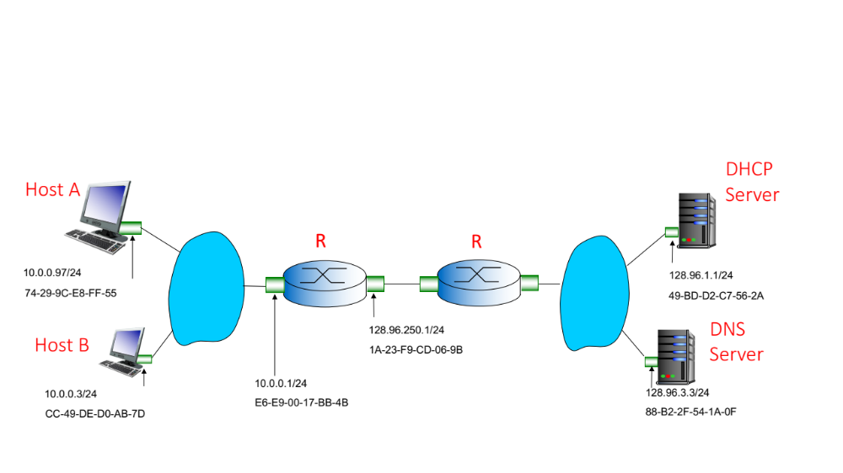User on Host A uses the well-known ping program to ping the IP address of Host B. (In this case, suppose the user knows the IP address of the destination they want to ping.) The ping utility will request the ICMP layer to send an ICMP Echo Request to the destination IP address. Given the network topology above what are the values of the fields in the various network headers of the ICMP packet when it is sent. How does the host know this information? (Note some information is hard-coded, some information is determined by the protocol, or has standard “well-known” or default values, and other fields are dynamically learned via some protocol. Indicate which fields fall into which category, and if dynamically learned, specify the protocol.)

ICMP Header:
Message Code:
Message Type:

IP Header:
Source IP:
Destination IP:
Time-to-live:
Encapsulated Protocol:

Ethernet Header:
Destination MAC:
Source MAC:
Encapsulated Protocol:

Homework 7 (continued):

Suppose the user on Host A now pings the DNS Server using its IP address. Which fields in the above headers change and what are their values set to? How is this information determined?

ICMP Header (list changes if any):

IP Header (list changes if any):

Ethernet Header (list changes if any):

Homework 8: Email, DNS and NAT

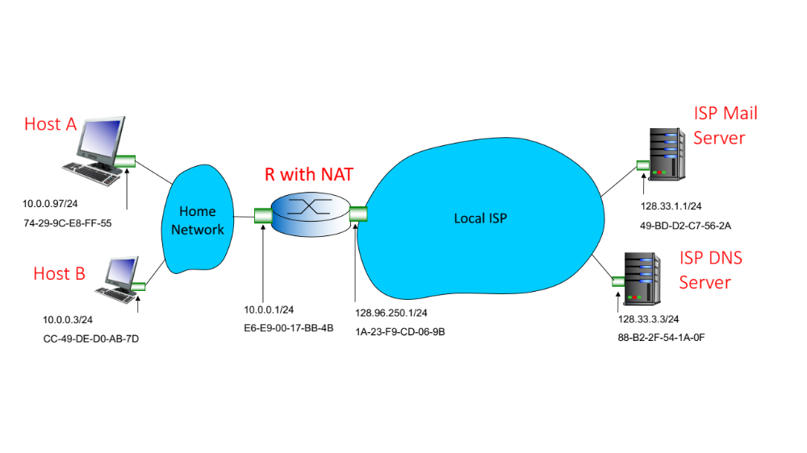

User on Host A sends email to the local ISP mail server using a mail user agent with SMTP enabled. First, the email program needs to know the hostname and IP address of the user’s mail server.

- Describe how the email program can use DNS resource records to determine the hostname and IP address of the mail server to send the email to.

Homework 8 (cont):

When the mail server IP address is known, the mail user agent will open a TCP connection to the mail server and use SMTP to send email. To access the mail server the packets will need to be processed via the NAT on the router as the host has IP addresses from the private IP address space.

- Show what the TCP and IP header fields of the TCP and SMTP packets from Host A look like before NAT:

TCP Source Port:
TCP Destination Port:
IP Source Address:
IP Destination Address:

- Show what the TCP and IP header fields of the TCP and SMTP packets from Host A look like after NAT:

TCP Source Port:
TCP Destination Port:
IP Source Address :
IP Destination Address:
.

