CS 356

Project 2

Matthew Kehoe

4/6/2017

Readme.txt
sUDP.h
cUDP.h
funct.h
sT0.cpp
screenshots
README

Project contains seven files

sT0.cpp
sT1.cpp
sT2.cpp
sT3.cpp
sUDP.h
cUDP.h
funct.h

All are compiled on linux with:

"g++", "-std=c++11", "-pthread", "${file}", "-o", "${file_path}/${file_base_name}

Which results in the following commands

g++ -std=c++11 -pthread sT0.cpp -o sT0
g++ -std=c++11 -pthread sT1.cpp -o sT1
g++ -std=c++11 -pthread sT2.cpp -o sT2
g++ -std=c++11 -pthread sT3.cpp -o sT3

g++ -std=c++11 -pthread sUDP.h -o sUDP
g++ -std=c++11 -pthread cUDP.h -o cUDP
g++ -std=c++11 -pthread funct.h -o funct

Operating the program:
After compiling, the four server files sT0 sT1 sT2 sT3 must be executed

./sT0

The program will start and will wait for input commands.

=========PORT NUMBERS==========

Each server is the same except for its individual port and routing values

Name Port Table
sT0 28330 0 1 3 7
sT1 28331 1 0 1 99
sT2 28332 3 1 0 2
sT3 28333 7 99 2 0

If needed the port can be changed, it is referenced once in line 120 in each .cpp file

|port number|
std::thread first (runServer, 28330, std::ref(table));

If the port number is changed for any reason, the four ports all must be changed to be sequential
If this is not done, the program will not be able to update

If all ports are changed, the lowest port number must be changed in line 83
This is the starting port for the update command

argument[1]=28330;

=====COMMANDS=======

The program accepts four commands

push pull print update

Push pull and print must be followed by the port number of the server you are conecting to

push 28330

This will push the current table to server on port 28330

pull 28331

THis will pull the table from the server on port 28331 and update the local table

print 28333

This will print the table from the server on port 2833

print 1

A port number of 1 will print the local table

The Update function does not need a port number

update

This will start the update process for the server

**Important**

This command will only update the local server using the BELLMNAN FORD ALGORTHIM
To update all four servers, the update command must be executed on each server

==========NOTES=========

This program was only tested locally on a single machine
The NJIT servers were not connectable
This is most likely due to port forwarding settings that I have no control over

This program was tested on

Linux PC-Ubuntu 4.4.0-71-generic #92-Ubuntu SMP Fri Mar 24 12:59:01 UTC 2017 x86_64 x86_64 x86_64 GNU/

CUDP.h
#include <iostream>
#include <string.h>
#include <sys/types.h>
#include <arpa/inet.h>
#include <stdlib.h>
#include <unistd.h>
#include "funct.h"

using namespace std;

dataTable runClient(short* argument, dataTable &table)
{
std::cout<<" CLIENT RUNNING "<<std::endl;
int client=0;
short portNum = argument[1];
bool ak = 0;

message M;
int messageSize = sizeof(M);
char *buffer = (char *) &M;
char *ack = (char *) &ak;

struct sockaddr_in server_addr;
socklen_t size = sizeof(server_addr);

size = sizeof(server_addr);

M.header[0]= 9;
M.header[1]= 1;
M.header[2]= 9;

M.body[0]=table.table[0];
M.body[1]=table.table[1];
M.body[2]=table.table[2];
M.body[3]=table.table[3];

///////////////////////////////////////////
////////// Create Socket //////////
///////////////////////////////////////////

client = socket(AF_INET, SOCK_DGRAM, 0);

if (client < 0){
std::cout<<endl<<"Socket creation error"<<endl;
}

std::cout<<endl<<"Socket created"<<endl;

server_addr.sin_family = AF_INET;
server_addr.sin_addr.s_addr = inet_addr("127.0.0.1");
server_addr.sin_port = htons(portNum);

///////////////////////////////////////////
//////// Connect to Server /////////
///////////////////////////////////////////
if (connect(client,(struct sockaddr *)&server_addr, sizeof(server_addr))<0){
std::cout<<"No connection to server"<<endl;
// exit(0);
}
///////////////////////////////////////////
////////// PRINT TABLE ///////////
///////////////////////////////////////////
std::cout<<"Initial Routing Table"<<endl;

if (argument[0] == 2){

M.header[1]=1;
M.header[2]=2;

//Port 1 = selft print
if (argument[1] == 1){
printTable(M);
}

//Connect to server, get table, print table
if (argument[1] >= 2){
std::cout<<"Pulling data from : "<<inet_ntoa(server_addr.sin_addr)<<endl;
std::cout<<"On port : "<<ntohs(server_addr.sin_port)<<endl;

M.header[1]=2;
M.header[2]=2;

sendto(client,buffer,14,0,(struct sockaddr *)&server_addr,size);
if (recvfrom(client,buffer,14,0,(struct sockaddr *)&server_addr, &size)>0){
std::cout<<"Data received successfully"<<endl;
printTable(M);
}
else
std::cout<<"Data not received successfully"<<endl;
}
}
///////////////////////////////////////////
////////// PUSH TABLE //////////
///////////////////////////////////////////
if (argument[0] == 0){

std::cout<<"Pushing data to : "<<inet_ntoa(server_addr.sin_addr)<<endl;
std::cout<<"On port : "<<ntohs(server_addr.sin_port)<<endl;

M.header[1]=0;
M.header[2]=0;

std::cout<<"IN CLIENT "<<M.body[0]<<endl;
sendto(client,buffer,14,0,(struct sockaddr *)&server_addr,size);
if(recvfrom(client,ack,2,0,(struct sockaddr *)&server_addr, &size)>0)
std::cout<<"Data sent successfully "<<endl;
else
std::cout<<"Data not sent successfully"<<endl;

}
///////////////////////////////////////////
////////// PULL TABLE //////////
///////////////////////////////////////////
if (argument[0] == 1){

std::cout<<"Pulling data from : "<<inet_ntoa(server_addr.sin_addr)<<endl;
std::cout<<"On port : "<<ntohs(server_addr.sin_port)<<endl;

M.header[1]=2;
M.header[2]=2;

sendto(client,buffer,14,0,(struct sockaddr *)&server_addr,size);
if (recvfrom(client,buffer,14,0,(struct sockaddr *)&server_addr, &size)>0){
std::cout<<"Data received successfully"<<endl;
printTable(M);
table.table[0] = M.body[0];
table.table[1] = M.body[1];
table.table[2] = M.body[2];
table.table[3] = M.body[3];
return table;

}
else
std::cout<<"Data not received successfully"<<endl;
}
///////////////////////////////////////////
////////// UPDATE COMMAND //////////
///////////////////////////////////////////
if (argument[0] == 3){
M.header[1]=2;
M.header[2]=3;

std::cout<<"UPDATE COMMAND "<<inet_ntoa(server_addr.sin_addr)<<endl;
std::cout<<"Sending to : "<<ntohs(server_addr.sin_port)<<endl;

std::cout<<"IN CLIENT "<<M.body[0]<<endl;
sendto(client,buffer,14,0,(struct sockaddr *)&server_addr,size);
if(recvfrom(client,ack,2,0,(struct sockaddr *)&server_addr, &size)>0)
std::cout<<"Data sent successfully "<<endl;
else
std::cout<<"Data not sent successfully"<<endl;

}
///////////////////////////////////////////
///////// Terminate Connection //////////
///////////////////////////////////////////

std::cout<<"Connection terminated "<<endl;
close(client);

}
sUDP.h

// #include <iostream>
#include <sys/types.h>
#include <sys/socket.h>
#include <netinet/in.h>
#include <arpa/inet.h>
#include <stdlib.h>
#include <unistd.h>
#include <string.h>
#include <arpa/inet.h>
#include <netdb.h>
#include "funct.h"
using namespace std;

dataTable updateServerTable(dataTable &table){
return table;
}

dataTable updateAll(dataTable &table);
//////////////////////////////////////////
/////////// UDP SERVER ////////////
///////////////////////////////////////////

void runServer(int portNum, dataTable &table){
int client, server, n;
message M,T;
int messageSize = sizeof(M);
struct sockaddr_in server_addr;
struct sockaddr_in client_addr;
socklen_t size = sizeof(server_addr);
bool isExit = false;
bool function;
bool ak = 0;
M.header[0]= 2;
M.header[1]= 3;
M.header[2]= 3;
M.body[0]=table.table[0];
M.body[1]=table.table[1];
M.body[2]=table.table[2];
M.body[3]=table.table[3];
char *buffer = (char *) &M;
char *temp = (char *) &T;
char *ack = (char *) &ak;

///////////////////////////////////////////
////////// DISPLAY DATA ///////////
///////////////////////////////////////////

std::cout<<"Initial Routing Table"<<endl;
printTable(M);

///////////////////////////////////////////
////////// Create Socket //////////
///////////////////////////////////////////

client = socket(AF_INET, SOCK_DGRAM, 0);

if (client < 0) {
std::cout<<endl<<"Socket creation error"<<endl;
exit(0);
}

std::cout<<endl<<"Socket created"<<endl;

server_addr.sin_family = AF_INET;
server_addr.sin_addr.s_addr = htons(INADDR_ANY);
server_addr.sin_port = htons(portNum);

///////////////////////////////////////////
/////////// Bind Socket ///////////
///////////////////////////////////////////

if ((bind(client,(struct sockaddr*)&server_addr,sizeof(server_addr)))< 0){
std::cout << " Socket Bind Error " << endl;
exit(0);
}

size = sizeof(server_addr);
std::cout << "Waiting for connection " << endl;

///////////////////////////////////////////
////////// DATA TRANSFER ///////////
///////////////////////////////////////////
while (1) {

M.body[0]=table.table[0];
M.body[1]=table.table[1];
M.body[2]=table.table[2];
M.body[3]=table.table[3];

recvfrom(client,temp,14,0,(struct sockaddr *)&client_addr,&size);

//CLient pushing data
if (T.header[2]==0){

M = T;

table.table[0] = T.body[0];
table.table[1] = T.body[1];
table.table[2] = T.body[2];
table.table[3] = T.body[3];

std::cout<<"Router Table Updated"<<endl;

printTable(T);
sendto(client,ack,2,0,(struct sockaddr *)&client_addr,size);

}

//client pulling data
if (T.header[2]==1){
std::cout<<"Client pull update "<<endl;
std::cout<<"Client IP address : "<<inet_ntoa(client_addr.sin_addr)<<endl;
std::cout<<"Connected on Port : "<<ntohs(client_addr.sin_port)<<endl<<endl;
sendto(client,buffer,14,0,(struct sockaddr *)&client_addr,size)
}

// client printing data
if (T.header[2]==2){
std::cout<<"Client print command "<<endl;
std::cout<<"Client IP address : "<<inet_ntoa(client_addr.sin_addr)<<endl;
std::cout<<"Connected on Port : "<<ntohs(client_addr.sin_port)<<endl<<endl;
sendto(client,buffer,14,0,(struct sockaddr *)&client_addr,size);
}

//Client Update Command
if (T.header[2]==3){
std::cout<<"Client update command "<<endl;
std::cout<<"Client IP address : "<<inet_ntoa(client_addr.sin_addr)<<endl;
std::cout<<"Connected on Port : "<<ntohs(client_addr.sin_port)<<endl<<endl;
sendto(client,temp,14,0,(struct sockaddr *)&client_addr,size);
}
}

///////////////////////////////////////////
///////// Terminate Connection //////////
///////////////////////////////////////////

int shutdown(int socket, int SHUT_RDWR);
std::cout<<"Connection terminated "<<endl;
close(server);
exit(0);

}
funct.h

#include <iostream>
#include <string>
#include <typeinfo>
#include <sstream>
// #include "cUDP.h"

#ifndef FUNCT_H
#define FUNCT_H

struct dataTable{

short table[4];
};

struct message{
short header[3];
short body[4];
};
void printTable(message M){
std::string type;
std::string ident;

if (M.header[2]==0)
ident = "PUSH";

if (M.header[2]==1)
ident = "PULL";
if (M.header[2]==2)
ident = "PRINT";
if (M.header[2]==3)
ident = "INIT ";

if (M.header[1]!=0){
if (M.header[1] == 1)
type = "Request ";
if (M.header[1] == 2)
type = "Response";
if (M.header[1] == 3)
type = "INITIAL ";
}
std::cout<<std::endl;
std::cout<<"*---------------HEADER----------------*"<<std::endl;
std::cout<<"* Version | Type | Identifier *"<<std::endl;
std::cout<<"* " <<M.header[0]<<" | " <<type<<" | "
<<ident<<" *"<<std::endl;
std::cout<<"* | | *"<<std::endl;

std::cout<<"*----------------BODY-----------------*"<<std::endl;
std::cout<<"* Destination Routers *"<<std::endl;
std::cout<<"* Source | R0 | R1 | R2 | R3 *"<<std::endl;
std::cout<<"*-------------------------------------*"<<std::endl;
std::cout<<"* R0 | "<<M.body[0]<<" | "<<M.body[1]<<" | "
<<M.body[2]<<" | "<<M.body[3]<<" *"<<std::endl;
std::cout<<"*-------------------------------------*"<<std::endl<<std::endl;
}

short* argCheck(){
short *argument = new short[3];
bool check;
short portn;
std::string input;
std::string command;

while (1){
std::cout<<"ENTER COMMAND : "<<std::endl<<"> ";
argument[2]=0;
std::getline(std::cin, input);
std::istringstream iss (input);
iss >> std::noskipws;
iss >> command >> std::ws >> portn;
std::cout<<std::endl;

if (portn == 0 ){
if (command == "update") {
std::cout<<"UPDATE COMMAND"<<std::endl;
argument[2] = 1;
argument[0] = 3;
return argument;
}
std::cout<<"Enter command (push / pull / print) followed blank space then by port number"<<std::endl;
std::cout<<"e.g. push 80 to push table to server on port 80. "<<std::endl;
std::cout<<" print 1 to print local table. "<<std::endl<<std::endl;
break;
}
argument[1]=portn;
portn = 0;

if (command == "push"){
std::cout<<"PUSH COMMAND"<<std::endl;
argument[2] = 1;
argument[0] = 0;
return argument;
}

if (command == "pull"){
std::cout<<"PULL COMMAND"<<std::endl;
argument[2] = 1;
argument[0] = 1;
return argument;

}

if (command == "print"){
std::cout<<"PRINT COMMAND"<<std::endl;
argument[2] = 1;
argument[0] = 2;
return argument;

}

// if (command == "update")
// {
// std::cout<<"UPDATE COMMAND"<<std::endl;
// argument[2] = 1;
// argument[0] = 3;
// return argument;
// }

if (check == false){
std::cout<<"Enter command (push / pull / print) followed blank space then by port number"<<std::endl<<std::endl;
std::cout<<" e.g. push 80 "<<std::endl;
break;
}

}
}
#endif
sT0.cpp / sT1.cpp / sT2.cpp / sT3.cpp
#include <iostream>
#include <thread>
#include <unistd.h>
#include "cUDP.h"
#include "sUDP.h"
#include "funct.h"

dataTable updateAll(dataTable &table);
int command(dataTable &table);

dataTable runClient(short* argument, dataTable &table);

int command(dataTable &table){

string input;
string command;
short portn;
short* returnTable;
short* argument;
dataTable temp;

std::cout<<"Enter command (push / pull / print) followed blank space";
std::cout<<" then by port number"<<endl;
std::cout<<"e.g. push 80 to push table to server on port 80. "<<std::endl;
std::cout<<" print 1 to print local table. "<<std::endl<<std::endl;

while (1){
//Clear variables
input.clear();
command.clear();
portn =0;

//Run input stream through check
//Get array [2] back
//[0] = command, push pull print
//[1] = port number
//[2] = acceptance check, 1 is good 0 is not good
argument = argCheck();

if (argument[2]==1){
//Run client code with command and destination port
//Client returns message with updated table or print table
if (argument[0] != 3){

std::cout<<"ARG push pull print "<<endl;
runClient(argument, table);
}

if (argument[0] == 3){
std::cout<<"ARG 3 UPDATE"<<endl;
for (int i = 0; i < 2; ++i){
usleep(100000);
updateAll(table);

}
}
//Updates table on server
updateServerTable(table);
}
}
}

dataTable updateAll(dataTable &table){

dataTable temp =table;
short* argument = new short[3];
argument[0]=1;
argument[1]=28330;
argument[2]=1;

//BELLMNAN FORD ALGORTHIM
for (int i = 0; i < 4; ++i){
//pull from server then increment port
temp = runClient(argument,temp);
argument[1] +=1;

//add cost from local server to pulled data
for (int k = 0; k < 4; ++k){
temp.table[k] += table.table[i];
}

//compare and update
for (int j = 0; j < 4; ++j){
if (temp.table[j] < table.table[j]){
table.table[j] = temp.table[j];
}
}
}
}

int main(){

dataTable table;

//Initial table
table.table[0] = 0;
table.table[1] = 1;
table.table[2] = 3;
table.table[3] = 7;

std::thread first (runServer, 28330, std::ref(table));
usleep(100000);
std::thread second(command, std::ref(table));

second.join();
first.join();

}

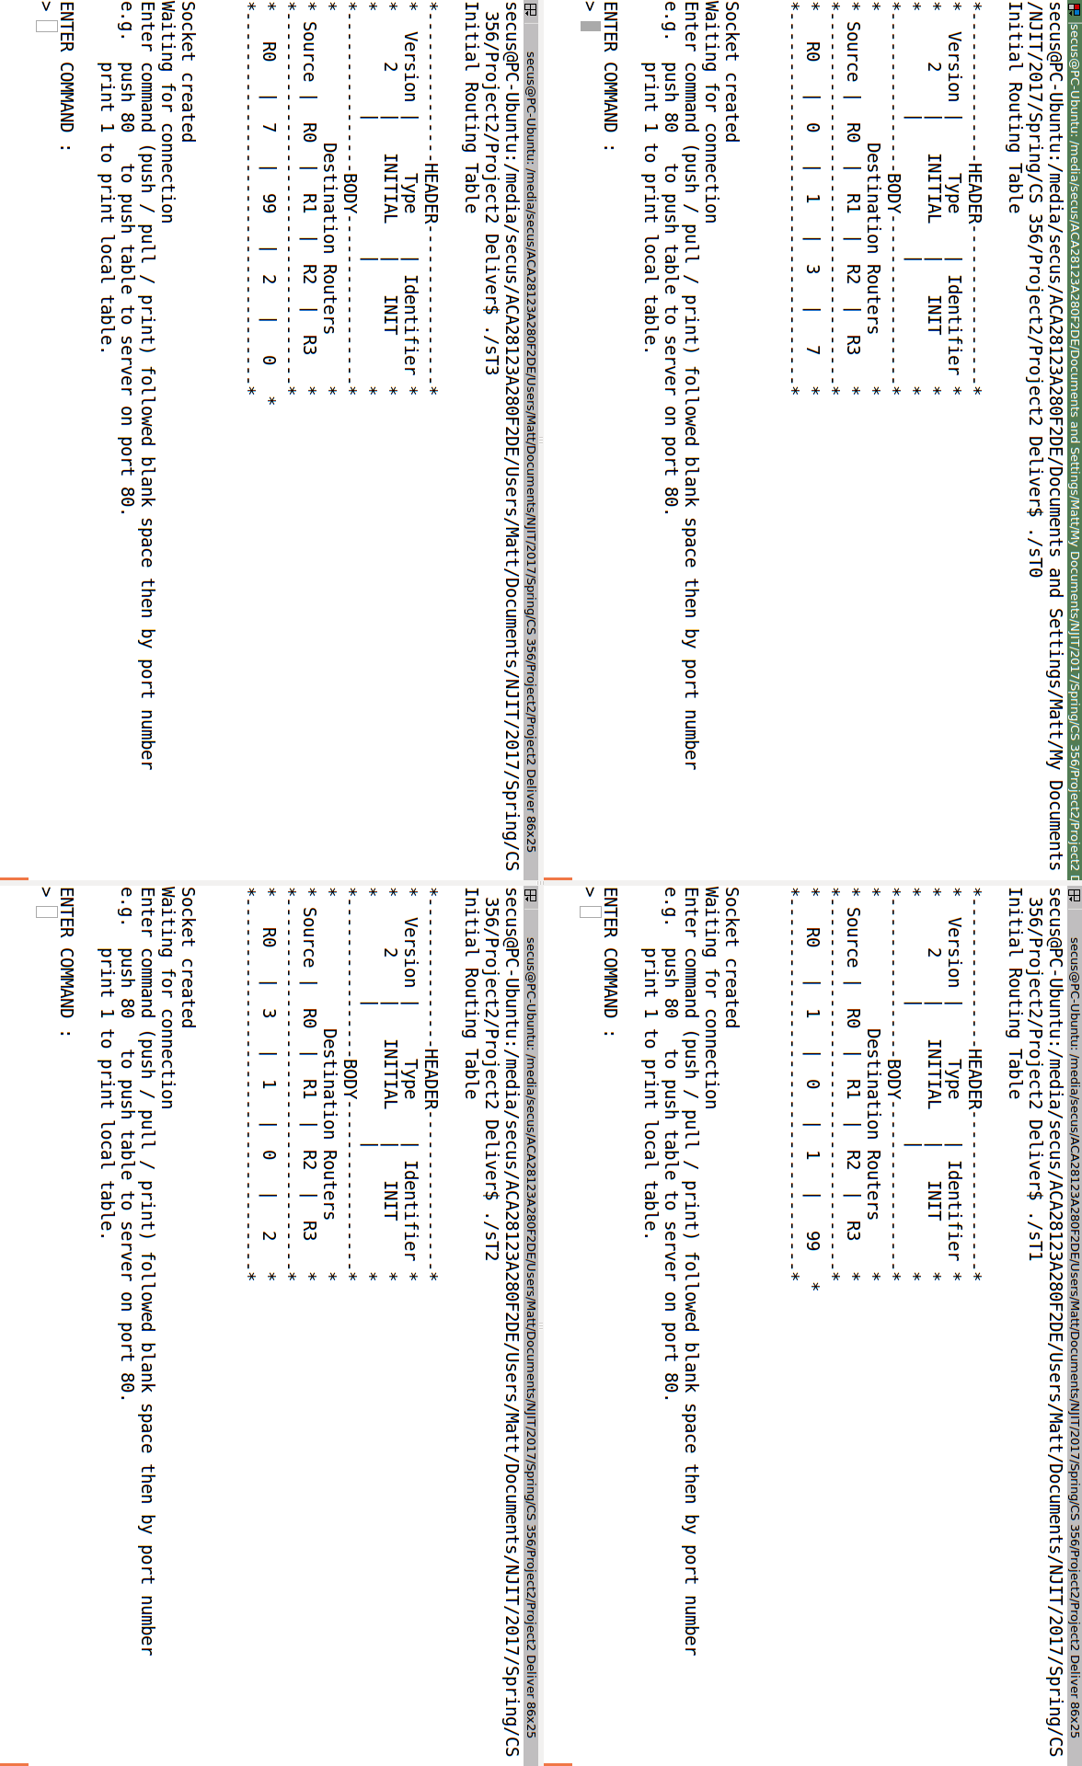
Initial
After Update
