Johnson_hw_6
04/21/2021

R Markdown
This is an R Markdown document. Markdown is a simple formatting syntax for authoring HTML, PDF, and MS Word documents. For more details on using R Markdown see http://rmarkdown.rstudio.com.
When you click the Knit button a document will be generated that includes both content as well as the output of any embedded R code chunks within the document. You can embed an R code chunk like this:
Note that the echo = FALSE parameter was added to the code chunk to prevent printing of the R code that generated the plot.

Markdown Basics

Favorite Foods
- Mexican
- Pies
- M&M’s

Images
All Cases [Log Plot]
All Cases [Log Plot]

Add a Quote
The definition of insanity…

Add an Equation
2 ‘add’ 2

Add a Footnote

This is a footnote

Add Citations
- R for Everyone @Manual{R-base, title = {R For Everyone}, author = {{Jared P Lander}}, organization = {Addison Wesley}, address = {Boston, Mass}, year = {2017}, }
- Discovering Statistics Using R @Manual{R-base, title = {Discovering Statistics Using R}, author = {{Andy Field, Jeremy Miles, Zoe Field}}, organization = {Sage Publishing}, address = {California}, year = {2012},
}

Inline Code
library(ggplot2)
california_df <- read.csv("us-states.csv")
ny_df <- read.csv("us-states.csv")
florida_df <- read.csv("us-states.csv")

NY Times COVID-19 Data
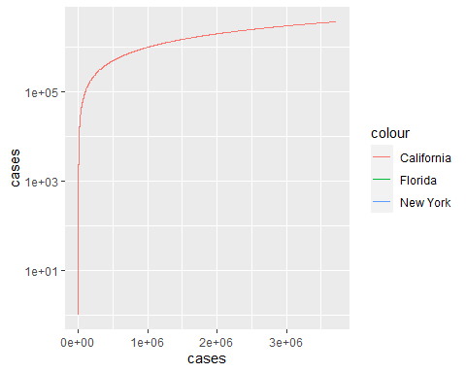

R4DS Height vs Earnings
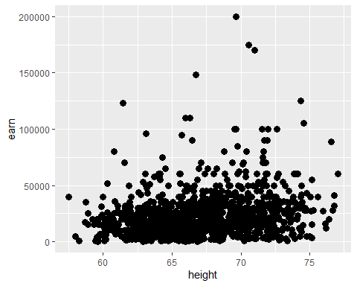 # Tables

Knitr Table with Kable

Pandoc Table
## Warning: package 'knitr' was built under R version 4.0.5
## Executing: pandoc -t html -o "heights.html" "heights.csv"
## [1] "heights.html"

References

