Abstract
Here lies the abstract.

Introduction
Here lies the introduction. We will discuss the PETtab software¹.
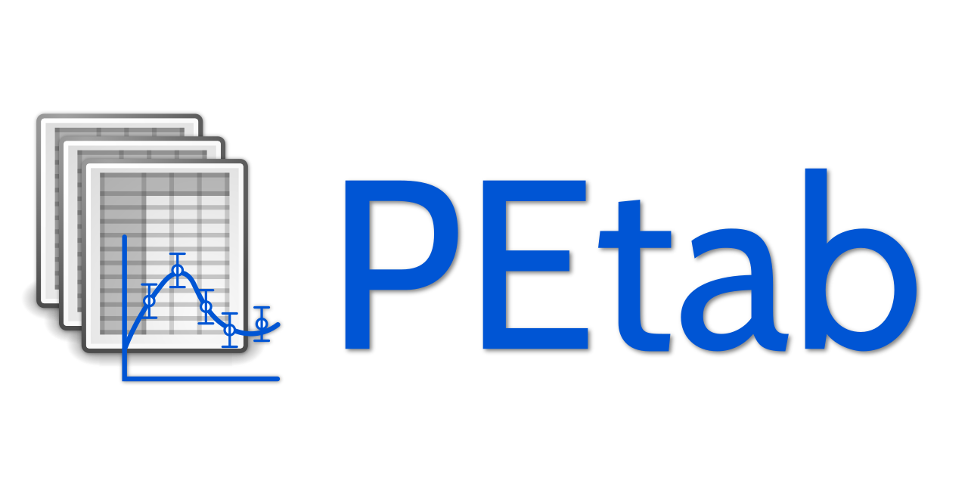

Results
Here lies the discussion. #Check
p2
p3
p4
p5
Here is an equation: i​​

Conclusion
Here lies the conclusion.

Methods
Here lies the methods.

References
1. Schmiester, L. et al. PEtab specification of parameter estimation problems in systems biology. PLOS Computational Biology 17, e1008646 (2021).

