Title Here

Author Name,\* Another Author’s Name

Affiliation and address [authors’ names in the manuscript and in ACS Paragon Plus must accord]

Abstract

Abstract text

Graphical Abstract

fig1.pdf

Keywords

Include *JCE*-specific keywords: these must exactly match the keyword terms selected in ACS Paragon Plus during electronic submission. Choose at least one term from each category: [Audience, Domain, Pedagogy, and Topic](http://pubs.acs.org/page/jceda8/topics.html). The keyword term “[Chemical Education Research](http://pubs.acs.org/paragonplus/submission/jceda8/jceda8_cerguide.pdf)” is reserved for manuscripts that have been written and reviewed using the [specific criteria described online](http://pubs.acs.org/paragonplus/submission/jceda8/jceda8_cerguide.pdf). Keywords aid in finding appropriate reviewers and in readers discovering the work online.

The main text of the manuscript starts here.1 This sentence and those that follow in this paragraph develop the topic sentence.2 Note that reference call-outs in the text appear as superscripted arabic numbers.

Extended quotes (those that would be three lines or longer if left in the same paragraph) appear as extracts.3 Page numbers from source material are given to introduce the text extract (ref *4*, p XXX):

The reference call-out and page number for an extract should appear before the quote rather than in the extract. No quotation marks are needed.

The continuation of a paragraph that is interrupted by extract text is set flush left; this is easily done by applying the style “JCE Flush body”. (This style also commonly follows display equations.)

First-Level Heading [also called an H1 heading]

Second-Level Heading [also called an H2 heading]

First- and second-level headings signal the progression of ideas in the text and help guide readers through the discussion. This paragraph would include ideas3 relating to and further developing H1 and this H2.

Another Second-Level Heading

Further text, with ideas pertaining to H1 and this H2.

Equations appear as display objects; an equation editor should be used.

 (1)

where the definitions of *S*, *F*, and the subscript *i* are given in the text (but not as equation objects).4

Tables, figures, and boxes should be placed in the manuscript file near the point of first mention in the text. A table tool should be used for tables. Note the placement of the table title, numbering, and notes in the following example (Table 1). Tables must have more than one column and each column must have a column heading. Use the table function to create the table rather than tabs and spaces in text. [See the *ACS Style Guide,* 3rd ed., Chapter 16](http://pubs.acs.org/doi/pdf/10.1021/bk-2006-STYG.ch016), for more information about tables.

|  |  |  |
| --- | --- | --- |
| Table 1. The Measured Henry’s Law Constant and the First-Order Loss Rate of Toluene in Water | | |
| *T*/K | *H*cp/(mol L–1 atm–1)*a* | *k*/s–1*a* |
| 283 | 0.38 ± 0.002 | 0.0002 ± 0.00005 |
| 293 | 0.23 ± 0.005 | 0.0001 ± 0.00002 |
| *a*Both *H*cp (Henry’s law constant) and *k* (first-order loss rate) are derived from four sets of experiments. Data reported as average ± standard deviation. | | |

Table 2 shows an example with figures (in this case, chemical structures) incorporated into a column of a table.

|  |  |  |
| --- | --- | --- |
| Table 2. Candidate Compounds | | |
| Structure | Name | Aliphatic Degree*a* |
|  | Benzene | No substituent |
|  | Toluene | Primary substituent |
|  | Ethyl benzene | Secondary substituent |
|  | Cumene | Tertiary substituent |
| *a*Open-chain aliphatic. | | |

Figures (see Figure 1) and schemes should be embedded in the manuscript file. Figures, especially photographs and adapted material, should be evaluated concerning the need for permissions and model releases.

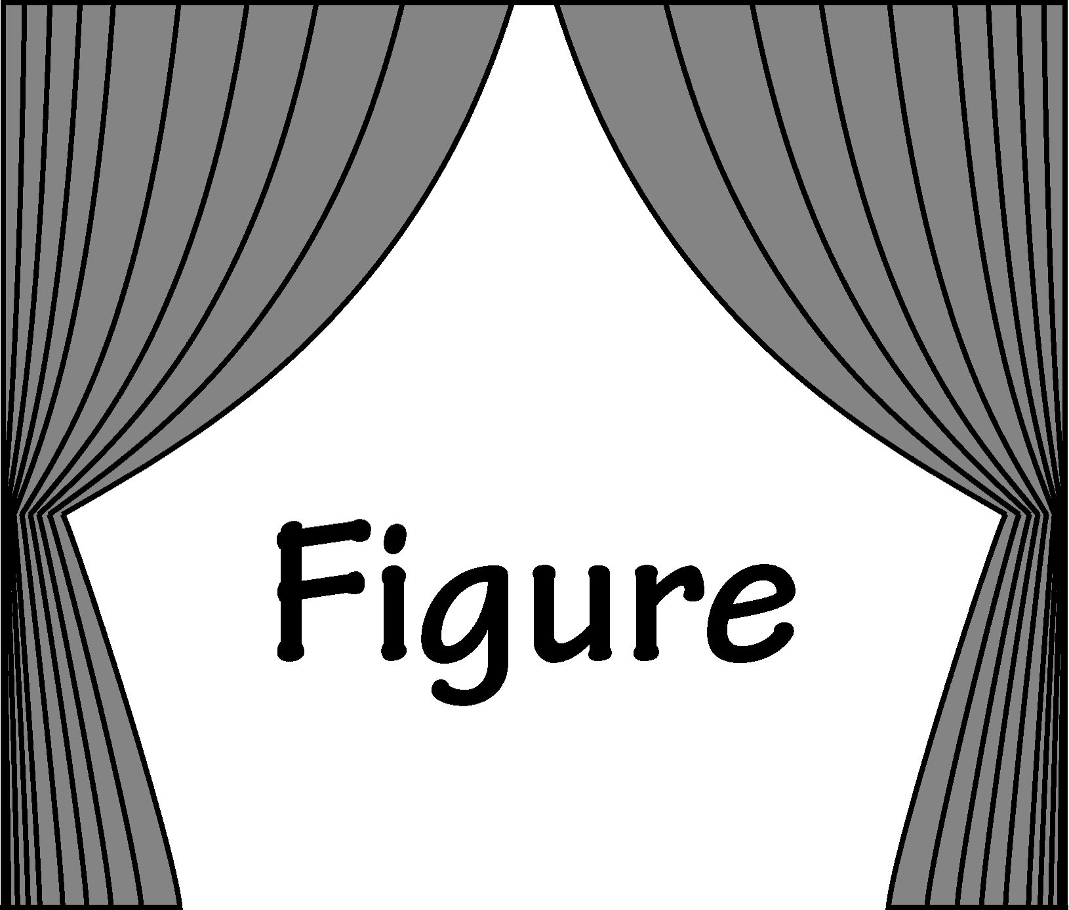

Figure 1. Include a descriptive figure caption (separate from the figure), which should be understandable independent of the text. Any credit lines would be included here. (Note that the source of this figure should either be a paste from PowerPoint or ChemDraw, or an embedded graphics file. [Instructions](http://pubs.acs.org/page/jceda8/submission/jceda8_templates.html), along with a [PowerPoint template](http://pubs.acs.org/page/jceda8/submission/jceda8_templates/JCE_2018_PowerPoint.pptx) and a [ChemDraw template](http://pubs.acs.org/page/jceda8/submission/jceda8_templates/JCE_2018_ChemDraw.cdx), are freely available.

A box (see Box 1) is a good way to present sample problems, for example, or material that might be presented as a list separate from the main body of the text. Use the textbox tool for creating and editing boxes.

**Box 1. Conservation of Energy Problem Used To Demonstrate a Box**

An object of mass *m*1 rests at a height, *h*i = 0. A second object of mass *m*2 travels horizontally at a speed *v*2 toward a non-compressible wire and a frictionless channel that would convert all of the second object’s kinetic energy into potential energy by elevating the first object to a height *h*f.

RJW iMac HD:Users:rwildman:work:attatch:text_box_fig.pdf

What is the height *h*f of the first object after the second object collides with the non-compressible wire and converts all of its kinetic energy into potential energy?

Lists with more than three elements should be presented as a separate bulleted (unordered) or numbered (ordered) list with each list element on its own line, rather than run-in with the paragraph discussing the list items. Make sure to include transitional text to introduce lists. Here is an example. “The goals of this experiment are to train students to:”

* Search the relevant literature
* Prepare their experiments based on published results
* Communicate effectively with their group
* Document their work carefully

Associated content

Supporting Information

The Supporting Information is available on the ACS Publications website at DOI: 10.1021/acs.jchemed.XXXXXXX. [ACS will fill this in.] Example brief descriptions with file formats indicated are shown below; customize for your material.

Notes for Instructors (DOCX)

Survey Instrument (DOCX)

AUTHOR INFORMATION

Corresponding Author

\*E-mail:

Acknowledgments

This is the section for acknowledging colleagues, funding sources, students, departments, programs, and creators other than the authors of the graphical abstract.

REFERENCES

1. Lastname, W. W.; Lastname, X. X. Title of Article. *Title of Journal.* **year,** *volume number* (issue number), starting page number–ending page number.

2. Lastname, Y. Y. *Book Title,* X ed.; Publisher: City, State or Country, Year; pp XXX–XXX.

3. Lastname, Z. [if a name is available] Web Site Title. *http://www.XXX.org/XXX.html* (accessed Month [3-letter month abbreviation] 20XX).

4. Textual material that might otherwise constitute a footnote or endnote must be incorporated into the References section as complete sentences. In-text citations and references should be numbered sequentially. For information about ACS style conventions for citing references and listing reference citations, [consult the *ACS Style Guide,* 3rd ed., Chapter 14](http://pubs.acs.org/doi/pdf/10.1021/bk-2006-STYG.ch014).