## Abstract

Here lies the abstract.

## Introduction

Here lies the introduction. We will discuss the PETtab software1.

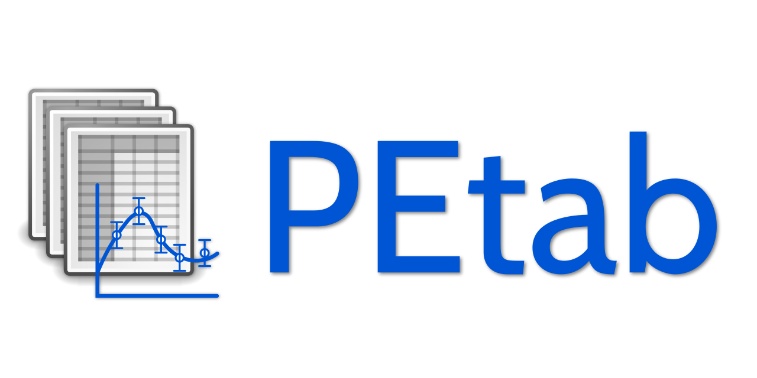

## Results

Here lies the discussion. #Check

p2

p3

p4

p5

Here is an equation:

## Conclusion

Here lies the conclusion.

## Methods

Here lies the methods.

## References

1. Schmiester, L. *et al.* PEtab specification of parameter estimation problems in systems biology. *PLOS Computational Biology* **17**, e1008646 (2021).