**Question-01:**

A researcher is interested in how variables, such as GRE (Graduate Record Exam scores), GPA (grade point average) and prestige of the undergraduate institution, effect admission into graduate school. The response variable, admit/don’t admit, is a binary variable. The data set taken from [https://stats.idre.ucla.edu/stat/data/binary.csv](https://stats.idre.ucla.edu/stat/data/binary.csv%20) and fit logistic generalized linear models (GLMs) to identify the effect admission into graduate school. Interpret the result.

For our data analysis below:

**install.packages("aod")**

**install.packages("ggplot2")**

**library**(aod)

**library**(ggplot2)

mydata <- **read.csv**("https://stats.idre.ucla.edu/stat/data/binary.csv")

*## view the first few rows of the data*

**head**(mydata)

## admit gre gpa rank

## 1 0 380 3.61 3

## 2 1 660 3.67 3

## 3 1 800 4.00 1

## 4 1 640 3.19 4

## 5 0 520 2.93 4

## 6 1 760 3.00 2

This dataset has a binary response (outcome, dependent) variable called admit. There are three predictor variables: gre, gpa and rank. We will treat the variables gre and gpa as continuous. The variable rank takes on the values 1 through 4. Institutions with a rank of 1 have the highest prestige, while those with a rank of 4 have the lowest. We can get basic descriptives for the entire data set by using summary. To get the standard deviations, we use sapply to apply the sd function to each variable in the dataset.

**summary**(mydata)

## admit gre gpa rank

## Min. :0.000 Min. :220 Min. :2.26 Min. :1.00

## 1st Qu.:0.000 1st Qu.:520 1st Qu.:3.13 1st Qu.:2.00

## Median :0.000 Median :580 Median :3.40 Median :2.00

## Mean :0.318 Mean :588 Mean :3.39 Mean :2.48

## 3rd Qu.:1.000 3rd Qu.:660 3rd Qu.:3.67 3rd Qu.:3.00

## Max. :1.000 Max. :800 Max. :4.00 Max. :4.00

**sapply**(mydata, sd)

## admit gre gpa rank

## 0.466 115.517 0.381 0.944

*## two-way contingency table of categorical outcome and predictors we want*

*## to make sure there are not 0 cells*

**xtabs**(~admit + rank, data = mydata)

## rank

## admit 1 2 3 4

## 0 28 97 93 55

## 1 33 54 28 12

The code below estimates a logistic regression model using the glm (generalized linear model) function. First, we convert rank to a factor to indicate that rank should be treated as a categorical variable.

mydata$rank <- **factor**(mydata$rank)

mylogit <- **glm**(admit ~ gre + gpa + rank, data = mydata, family = "binomial")

**summary**(mylogit)

##

## Call:

## glm(formula = admit ~ gre + gpa + rank, family = "binomial",

## data = mydata)

##

## Deviance Residuals:

## Min 1Q Median 3Q Max

## -1.627 -0.866 -0.639 1.149 2.079

##

## Coefficients:

## Estimate Std. Error z value Pr(>|z|)

## (Intercept) -3.98998 1.13995 -3.50 0.00047 ***

## gre 0.00226 0.00109 2.07 0.03847 *

## gpa 0.80404 0.33182 2.42 0.01539 *

## rank2 -0.67544 0.31649 -2.13 0.03283 *

## rank3 -1.34020 0.34531 -3.88 0.00010 ***

## rank4 -1.55146 0.41783 -3.71 0.00020 ***

## ---

## Signif. codes: 0 '***' 0.001 '**' 0.01 '*' 0.05 '.' 0.1 ' ' 1

##

## (Dispersion parameter for binomial family taken to be 1)

##

## Null deviance: 499.98 on 399 degrees of freedom

## Residual deviance: 458.52 on 394 degrees of freedom

## AIC: 470.5

##

## Number of Fisher Scoring iterations: 4

In the output above, the first thing we see is the call, this is R reminding us what the model we ran was,

For every one unit change in gre, the log odds of admission (versus non-admission) increases by 0.002.

For a one unit increase in gpa, the log odds of being admitted to graduate school increases by 0.804.

The indicator variables for rank have a slightly different interpretation. For example, having attended an undergraduate institution with rank of 2, versus an institution with a rank of 1, changes the log odds of admission by -0.675.

We can use the confint function to obtain confidence intervals for the coefficient estimates. Note that for logistic models, confidence intervals are based on the profiled log-likelihood function. We can also get CIs based on just the standard errors by using the default method.

*## CIs using profiled log-likelihood*

**confint**(mylogit)

## 2.5 % 97.5 %

## (Intercept) -6.271620 -1.79255

## gre 0.000138 0.00444

## gpa 0.160296 1.46414

## rank2 -1.300889 -0.05675

## rank3 -2.027671 -0.67037

## rank4 -2.400027 -0.75354

*## CIs using standard errors*

**confint.default**(mylogit)

## 2.5 % 97.5 %

## (Intercept) -6.22424 -1.75572

## gre 0.00012 0.00441

## gpa 0.15368 1.45439

## rank2 -1.29575 -0.05513

## rank3 -2.01699 -0.66342

## rank4 -2.37040 -0.73253

We can test for an overall effect of rank using the wald.test function of the aod library. The order in which the coefficients are given in the table of coefficients is the same as the order of the terms in the model. This is important because the wald.test function refers to the coefficients by their order in the model. We use the wald.test function. b supplies the coefficients, while Sigma supplies the variance covariance matrix of the error terms, finally Terms tells R which terms in the model are to be tested, in this case, terms 4, 5, and 6, are the three terms for the levels of rank.

**wald.test**(b = **coef**(mylogit), Sigma = **vcov**(mylogit), Terms = 4:6)

## Wald test:

## ----------

##

## Chi-squared test:

## X2 = 20.9, df = 3, P(> X2) = 0.00011

The chi-squared test statistic of 20.9, with three degrees of freedom is associated with a p-value of 0.00011 indicating that the overall effect of rank is statistically significant.

l <- **cbind**(0, 0, 0, 1, -1, 0)

**wald.test**(b = **coef**(mylogit), Sigma = **vcov**(mylogit), L = l)

## Wald test:

## ----------

##

## Chi-squared test:

## X2 = 5.5, df = 1, P(> X2) = 0.019

The chi-squared test statistic of 5.5 with 1 degree of freedom is associated with a p-value of 0.019, indicating that the difference between the coefficient for rank=2 and the coefficient for rank=3 is statistically significant.

*## odds ratios only*

**exp**(**coef**(mylogit))

## (Intercept) gre gpa rank2 rank3 rank4

## 0.0185 1.0023 2.2345 0.5089 0.2618 0.2119

*## odds ratios and 95% CI*

**exp**(**cbind**(OR = **coef**(mylogit), **confint**(mylogit)))

## OR 2.5 % 97.5 %

## (Intercept) 0.0185 0.00189 0.167

## gre 1.0023 1.00014 1.004

## gpa 2.2345 1.17386 4.324

## rank2 0.5089 0.27229 0.945

## rank3 0.2618 0.13164 0.512

## rank4 0.2119 0.09072 0.471

Now we can say that for a one unit increase in gpa, the odds of being admitted to graduate school (versus not being admitted) increase by a factor of 2.23.

newdata1 <- **with**(mydata, **data.frame**(gre = **mean**(gre), gpa = **mean**(gpa), rank = **factor**(1:4)))

*## view data frame*

newdata1

## gre gpa rank

## 1 588 3.39 1

## 2 588 3.39 2

## 3 588 3.39 3

## 4 588 3.39 4

newdata1$rankP <- **predict**(mylogit, newdata = newdata1, type = "response")

newdata1

## gre gpa rank rankP

## 1 588 3.39 1 0.517

## 2 588 3.39 2 0.352

## 3 588 3.39 3 0.219

## 4 588 3.39 4 0.185

In the above output we see that the predicted probability of being accepted into a graduate program is 0.52 for students from the highest prestige undergraduate institutions (rank=1), and 0.18 for students from the lowest ranked institutions (rank=4), holding gre and gpa at their means. We can do something very similar to create a table of predicted probabilities varying the value of gre and rank. We are going to plot these, so we will create 100 values of gre between 200 and 800, at each value of rank (i.e., 1, 2, 3, and 4).

newdata2 <- **with**(mydata, **data.frame**(gre = **rep**(**seq**(from = 200, to = 800, length.out = 100),

4), gpa = **mean**(gpa), rank = **factor**(**rep**(1:4, each = 100))))

newdata3 <- **cbind**(newdata2, **predict**(mylogit, newdata = newdata2, type = "link",

se = TRUE))

newdata3 <- **within**(newdata3, {

PredictedProb <- **plogis**(fit)

LL <- **plogis**(fit - (1.96 * se.fit))

UL <- **plogis**(fit + (1.96 * se.fit))

})

*## view first few rows of final dataset*

**head**(newdata3)

## gre gpa rank fit se.fit residual.scale UL LL PredictedProb

## 1 200 3.39 1 -0.811 0.515 1 0.549 0.139 0.308

## 2 206 3.39 1 -0.798 0.509 1 0.550 0.142 0.311

## 3 212 3.39 1 -0.784 0.503 1 0.551 0.145 0.313

## 4 218 3.39 1 -0.770 0.498 1 0.551 0.149 0.316

## 5 224 3.39 1 -0.757 0.492 1 0.552 0.152 0.319

## 6 230 3.39 1 -0.743 0.487 1 0.553 0.155 0.322

It can also be helpful to use graphs of predicted probabilities to understand and/or present the model. We will use the ggplot2 package for graphing. Below we make a plot with the predicted probabilities, and 95% confidence intervals.

**ggplot**(newdata3, **aes**(x = gre, y = PredictedProb)) + **geom_ribbon**(**aes**(ymin = LL,

ymax = UL, fill = rank), alpha = 0.2) + **geom_line**(**aes**(colour = rank),

size = 1)

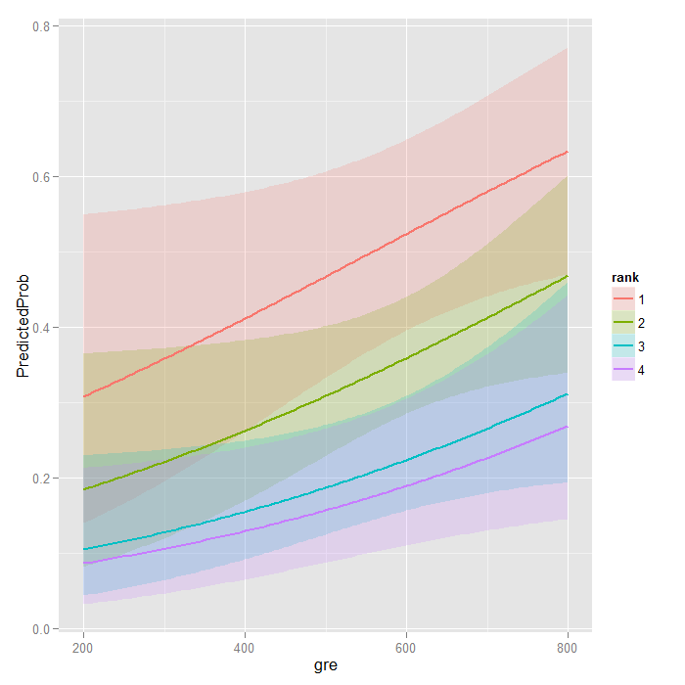

**with**(mylogit, null.deviance - deviance)

## [1] 41.5

The degrees of freedom for the difference between the two models is equal to the number of predictor variables in the mode, and can be obtained using:

**with**(mylogit, df.null - df.residual)

## [1] 5

Finally, the p-value can be obtained using:

**with**(mylogit, **pchisq**(null.deviance - deviance, df.null - df.residual, lower.tail = FALSE))

## [1] 7.58e-08

The chi-square of 41.46 with 5 degrees of freedom and an associated p-value of less than 0.001 tells us that our model as a whole fits significantly better than an empty model. This is sometimes called a likelihood ratio test (the deviance residual is -2*log likelihood). To see the model’s log likelihood, we type:

**logLik**(mylogit)

## 'log Lik.' -229 (df=6)

**Question-02:**

The number of awards earned by students at one high school. Predictors of the number of awards earned include the type of program in which the student was enrolled (e.g., vocational, general or academic) and the score on their final exam in math. The data set is taken from [**https://stats.idre.ucla.edu/stat/data/poisson_sim.csv**](https://stats.idre.ucla.edu/stat/data/poisson_sim.csv)and fit the poisson generalized linear models (GLMs) to identify the factors associated with number of awards earned by students at one high school. Interpret the result.

Let’s start with loading the data and looking at some descriptive statistics.

**install.packages("msm")**

**install.packages("sandwich")**

**require**(ggplot2)

**require**(sandwich)

**require**(msm)

p <- **read.csv**("https://stats.idre.ucla.edu/stat/data/poisson_sim.csv")

p <- **within**(p, {

prog <- **factor**(prog, levels=1:3, labels=**c**("General", "Academic",

"Vocational"))

id <- **factor**(id)

})

**summary**(p)

## id num_awards prog math

## 1 : 1 Min. :0.00 General : 45 Min. :33.0

## 2 : 1 1st Qu.:0.00 Academic :105 1st Qu.:45.0

## 3 : 1 Median :0.00 Vocational: 50 Median :52.0

## 4 : 1 Mean :0.63 Mean :52.6

## 5 : 1 3rd Qu.:1.00 3rd Qu.:59.0

## 6 : 1 Max. :6.00 Max. :75.0

## (Other):194

**with**(p, **tapply**(num_awards, prog, **function**(x) {

**sprintf**("M (SD) = %1.2f (%1.2f)", **mean**(x), **sd**(x))

}))

## General Academic Vocational

## "M (SD) = 0.20 (0.40)" "M (SD) = 1.00 (1.28)" "M (SD) = 0.24 (0.52)"

**ggplot**(p, **aes**(num_awards, fill = prog)) +

**geom_histogram**(binwidth=.5, position="dodge")

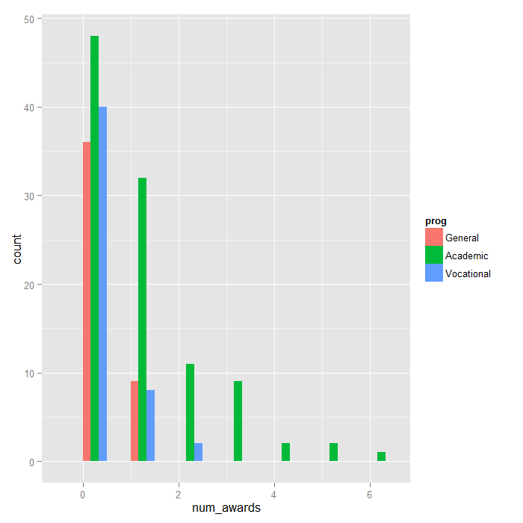

At this point, we are ready to perform our Poisson model analysis using the glm function. We fit the model and store it in the object m1 and get a summary of the model at the same time.

**summary**(m1 <- **glm**(num_awards ~ prog + math, family="poisson", data=p))

##

## Call:

## glm(formula = num_awards ~ prog + math, family = "poisson", data = p)

##

## Deviance Residuals:

## Min 1Q Median 3Q Max

## -2.204 -0.844 -0.511 0.256 2.680

##

## Coefficients:

## Estimate Std. Error z value Pr(>|z|)

## (Intercept) -5.2471 0.6585 -7.97 1.6e-15 ***

## progAcademic 1.0839 0.3583 3.03 0.0025 **

## progVocational 0.3698 0.4411 0.84 0.4018

## math 0.0702 0.0106 6.62 3.6e-11 ***

## ---

## Signif. codes: 0 '***' 0.001 '**' 0.01 '*' 0.05 '.' 0.1 ' ' 1

##

## (Dispersion parameter for poisson family taken to be 1)

##

## Null deviance: 287.67 on 199 degrees of freedom

## Residual deviance: 189.45 on 196 degrees of freedom

## AIC: 373.5

##

## Number of Fisher Scoring iterations: 6

cov.m1 <- **vcovHC**(m1, type="HC0")

std.err <- **sqrt**(**diag**(cov.m1))

r.est <- **cbind**(Estimate= **coef**(m1), "Robust SE" = std.err,

"Pr(>|z|)" = 2 * **pnorm**(**abs**(**coef**(m1)/std.err), lower.tail=FALSE),

LL = **coef**(m1) - 1.96 * std.err,

UL = **coef**(m1) + 1.96 * std.err)

r.est

## Estimate Robust SE Pr(>|z|) LL UL

## (Intercept) -5.24712 0.64600 4.567e-16 -6.5133 -3.98097

## progAcademic 1.08386 0.32105 7.355e-04 0.4546 1.71311

## progVocational 0.36981 0.40042 3.557e-01 -0.4150 1.15463

## math 0.07015 0.01044 1.784e-11 0.0497 0.09061

The Poisson regression coefficients for each of the variables along with the standard errors, z-scores, p-values and 95% confidence intervals for the coefficients. The coefficient for math is .07. This means that the expected log count for a one-unit increase in math is .07. The indicator variable progAcademic compares between prog = “Academic” and prog = “General”, the expected log count for prog = “Academic” increases by about 1.1. The indicator variable prog.Vocational is the expected difference in log count ((approx .37)) between prog = “Vocational” and the reference group (prog = “General”).

**with**(m1, **cbind**(res.deviance = deviance, df = df.residual,

p = **pchisq**(deviance, df.residual, lower.tail=FALSE)))

## res.deviance df p

## [1,] 189.4 196 0.6182

*## update m1 model dropping prog*

m2 <- **update**(m1, . ~ . - prog)

*## test model differences with chi square test*

**anova**(m2, m1, test="Chisq")

## Analysis of Deviance Table

##

## Model 1: num_awards ~ math

## Model 2: num_awards ~ prog + math

## Resid. Df Resid. Dev Df Deviance Pr(>Chi)

## 1 198 204

## 2 196 189 2 14.6 0.00069 ***

## ---

## Signif. codes: 0 '***' 0.001 '**' 0.01 '*' 0.05 '.' 0.1 ' ' 1

s <- **deltamethod**(**list**(~ **exp**(x1), ~ **exp**(x2), ~ **exp**(x3), ~ **exp**(x4)),

**coef**(m1), cov.m1)

*## exponentiate old estimates dropping the p values*

rexp.est <- **exp**(r.est[, -3])

*## replace SEs with estimates for exponentiated coefficients*

rexp.est[, "Robust SE"] <- s

rexp.est

## Estimate Robust SE LL UL

## (Intercept) 0.005263 0.00340 0.001484 0.01867

## progAcademic 2.956065 0.94904 1.575551 5.54620

## progVocational 1.447458 0.57959 0.660335 3.17284

## math 1.072672 0.01119 1.050955 1.09484

The output above indicates that the incident rate for prog = “Academic” is 2.96 times the incident rate for the reference group (prog = “General”). Likewise, the incident rate for prog = “Vocational” is 1.45 times the incident rate for the reference group holding the other variables at constant. The percent change in the incident rate of num_awards is by 7% for every unit increase in math.

(s1 <- **data.frame**(math = **mean**(p$math),

prog = **factor**(1:3, levels = 1:3, labels = **levels**(p$prog))))

## math prog

## 1 52.65 General

## 2 52.65 Academic

## 3 52.65 Vocational

**predict**(m1, s1, type="response", se.fit=TRUE)

## $fit

## 1 2 3

## 0.2114 0.6249 0.3060

##

## $se.fit

## 1 2 3

## 0.07050 0.08628 0.08834

##

## $residual.scale

## [1] 1

In the output above, we see that the predicted number of events for level 1 of prog is about .21, holding math at its mean. The predicted number of events for level 2 of prog is higher at .62, and the predicted number of events for level 3 of prog is about .31. The ratios of these predicted counts ((frac{.625}{.211} = 2.96), (frac{.306}{.211} = 1.45)) match what we saw looking at the IRR.

*## calculate and store predicted values*

p$phat <- **predict**(m1, type="response")

*## order by program and then by math*

p <- p[**with**(p, **order**(prog, math)), ]

*## create the plot*

**ggplot**(p, **aes**(x = math, y = phat, colour = prog)) +

**geom_point**(**aes**(y = num_awards), alpha=.5, position=**position_jitter**(h=.2)) +

**geom_line**(size = 1) +

**labs**(x = "Math Score", y = "Expected number of awards")

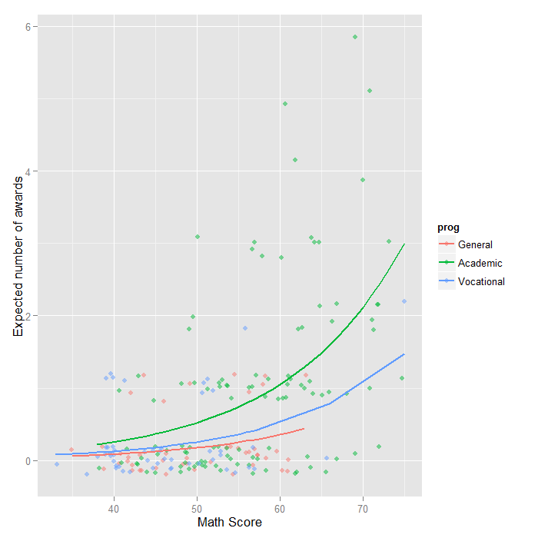

**Question-03:**

School administrators study the attendance behavior of high school juniors at two schools. Predictors of the number of days of absence include the type of program in which the student is enrolled and a standardized test in math. The data set is taken from **("**[**https://stats.idre.ucla.edu/stat/stata/dae/nb_data.dta**](https://stats.idre.ucla.edu/stat/stata/dae/nb_data.dta)**")** and fit the negative binomial generalized linear models (GLMs) to identify the factors associated with number of awards earned by students at one high school. Interpret the result.

Let’s look at the data. It is always a good idea to start with descriptive statistics and plots.

**install.packages("foreign")**

**install.packages("MASS")**

**require**(foreign)

**require**(ggplot2)

**require**(MASS)

dat <- **read.dta**("https://stats.idre.ucla.edu/stat/stata/dae/nb_data.dta")

dat <- **within**(dat, {

prog <- **factor**(prog, levels = 1:3, labels = **c**("General", "Academic", "Vocational"))

id <- **factor**(id)

})

**summary**(dat)

## id gender math daysabs

## 1001 : 1 female:160 Min. : 1.0 Min. : 0.00

## 1002 : 1 male :154 1st Qu.:28.0 1st Qu.: 1.00

## 1003 : 1 Median :48.0 Median : 4.00

## 1004 : 1 Mean :48.3 Mean : 5.96

## 1005 : 1 3rd Qu.:70.0 3rd Qu.: 8.00

## 1006 : 1 Max. :99.0 Max. :35.00

## (Other):308

## prog

## General : 40

## Academic :167

## Vocational:107

**ggplot**(dat, **aes**(daysabs, fill = prog)) + **geom_histogram**(binwidth = 1) + **facet_grid**(prog ~

., margins = **TRUE**, scales = "free")

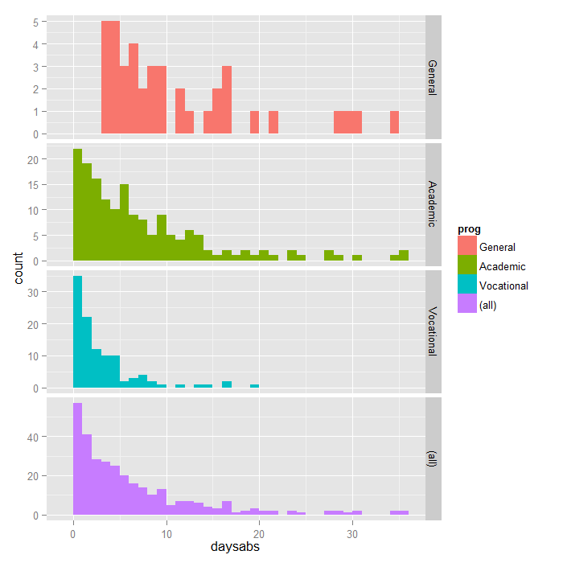

**with**(dat, **tapply**(daysabs, prog, **function**(x) {

**sprintf**("**M** (SD) = %**1.2f** (%1.2f)", **mean**(x), **sd**(x))

}))

## General Academic Vocational

## "M (SD) = 10.65 (8.20)" "M (SD) = 6.93 (7.45)" "M (SD) = 2.67 (3.73)"

**summary**(m1 <- **glm.nb**(daysabs ~ math + prog, data = dat))

## Call:

## glm.nb(formula = daysabs ~ math + prog, data = dat, init.theta = 1.032713156,

## link = log)

##

## Deviance Residuals:

## Min 1Q Median 3Q Max

## -2.155 -1.019 -0.369 0.229 2.527

##

## Coefficients:

## Estimate Std. Error z value Pr(>|z|)

## (Intercept) 2.61527 0.19746 13.24 < 2e-16 ***

## math -0.00599 0.00251 -2.39 0.017 *

## progAcademic -0.44076 0.18261 -2.41 0.016 *

## progVocational -1.27865 0.20072 -6.37 1.9e-10 ***

## ---

## Signif. codes: 0 '***' 0.001 '**' 0.01 '*' 0.05 '.' 0.1 ' ' 1

##

## (Dispersion parameter for Negative Binomial(1.033) family taken to be 1)

##

## Null deviance: 427.54 on 313 degrees of freedom

## Residual deviance: 358.52 on 310 degrees of freedom

## AIC: 1741

##

## Number of Fisher Scoring iterations: 1

##

##

## Theta: 1.033

## Std. Err.: 0.106

##

## 2 x log-likelihood: -1731.258

R first displays the call and the deviance residuals. Next, we see the regression coefficients for each of the variables, along with standard errors, z-scores, and p-values. The variable math has a coefficient of -0.006, which is statistically significant. This means that for each one-unit increase in math, the expected log count of the number of days absent decreases by 0.006. The indicator variable shown as progAcademic is the expected difference in log count between group 2 and the reference group (prog=1). The expected log count for level 2 of prog is 0.44 lower than the expected log count for level 1. The indicator variable for progVocational is the expected difference in log count between group 3 and the reference group.The expected log count for level 3 of prog is 1.28 lower than the expected log count for level 1. To determine if prog itself, overall, is statistically significant, we can compare a model with and without prog. The reason it is important to fit separate models, is that unless we do, the overdispersion parameter is held constant.

m2 <- **update**(m1, . ~ . - prog)

**anova**(m1, m2)

## Likelihood ratio tests of Negative Binomial Models

##

## Response: daysabs

## Model theta Resid. df 2 x log-lik. Test df LR stat.

## 1 math 0.8559 312 -1776

## 2 math + prog 1.0327 310 -1731 1 vs 2 2 45.05

## Pr(Chi)

## 1

## 2 1.652e-10

m3 <- **glm**(daysabs ~ math + prog, family = "poisson", data = dat)

**pchisq**(2 * (**logLik**(m1) - **logLik**(m3)), df = 1, lower.tail = **FALSE**)

## 'log Lik.' 2.157e-203 (df=5)

The associated chi-squared value estimated from 2*(logLik(m1) – logLik(m3)) is 926.03 with one degree of freedom. This strongly suggests the negative binomial model, estimating the dispersion parameter, is more appropriate than the Poisson model.

We can get the confidence intervals for the coefficients by profiling the likelihood function.

(est <- **cbind**(Estimate = **coef**(m1), **confint**(m1)))

## Estimate 2.5 % 97.5 %

## (Intercept) 2.615265 2.2421 3.012936

## math -0.005993 -0.0109 -0.001067

## progAcademic -0.440760 -0.8101 -0.092643

## progVocational -1.278651 -1.6835 -0.890078

We might be interested in looking at incident rate ratios rather than coefficients. To do this, we can exponentiate our model coefficients. The same applies to the confidence intervals.

**exp**(est)

## Estimate 2.5 % 97.5 %

## (Intercept) 13.6708 9.4127 20.3470

## math 0.9940 0.9892 0.9989

## progAcademic 0.6435 0.4448 0.9115

## progVocational 0.2784 0.1857 0.4106

The output above indicates that the incident rate for prog = 2 is 0.64 times the incident rate for the reference group (prog = 1). Likewise, the incident rate for prog = 3 is 0.28 times the incident rate for the reference group holding the other variables constant. The percent change in the incident rate of daysabs is a 1% decrease for every unit increase in math.

newdata1 <- **data.frame**(math = **mean**(dat$math), prog = **factor**(1:3, levels = 1:3,

labels = **levels**(dat$prog)))

newdata1$phat <- **predict**(m1, newdata1, type = "response")

newdata1

## math prog phat

## 1 48.27 General 10.237

## 2 48.27 Academic 6.588

## 3 48.27 Vocational 2.850

In the output above, we see that the predicted number of events (e.g., days absent) for a general program is about 10.24, holding math at its mean. The predicted number of events for an academic program is lower at 6.59, and the predicted number of events for a vocational program is about 2.85.

newdata2 <- **data.frame**(

math = **rep**(**seq**(from = **min**(dat$math), to = **max**(dat$math), length.out = 100), 3),

prog = **factor**(**rep**(1:3, each = 100), levels = 1:3, labels =

**levels**(dat$prog)))

newdata2 <- **cbind**(newdata2, **predict**(m1, newdata2, type = "link", se.fit=**TRUE**))

newdata2 <- **within**(newdata2, {

DaysAbsent <- **exp**(fit)

LL <- **exp**(fit - 1.96 * se.fit)

UL <- **exp**(fit + 1.96 * se.fit)

})

**ggplot**(newdata2, **aes**(math, DaysAbsent)) +

**geom_ribbon**(**aes**(ymin = LL, ymax = UL, fill = prog), alpha = .25) +

**geom_line**(**aes**(colour = prog), size = 2) +

**labs**(x = "Math Score", y = "Predicted Days Absent")

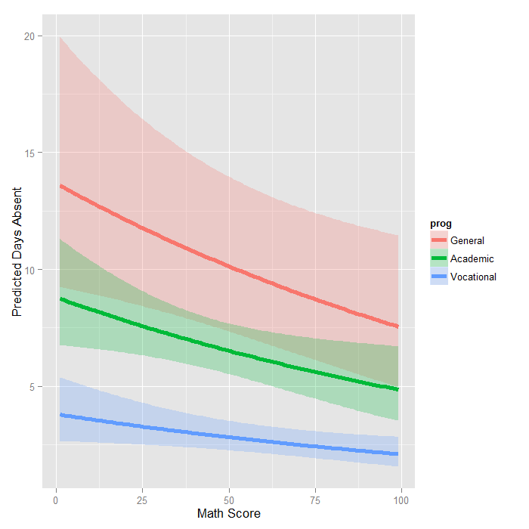

The graph shows the expected count across the range of math scores, for each type of program along with 95 percent confidence intervals. Note that the lines are not straight because this is a log linear model, and what is plotted are the expected values, not the log of the expected values.

Question:

The state wildlife biologists want to model how many fish are being caught by fishermen at a state park. Visitors are asked how long they stayed, how many people were in the group, were there children in the group and how many fish were caught. Some visitors do not fish, but there is no data on whether a person fished or not. Some visitors who did fish did not catch any fish so there are excess zeros in the data because of the people that did not fish. The data set is taken from **("**[**https://stats.idre.ucla.edu/stat/data/fish.csv**](https://stats.idre.ucla.edu/stat/data/fish.csv)**")** and fit the Zero-Inflated Poisson regression generalized linear models (GLMs) to identify the factors associated with number of awards earned by students at one high school. Interpret the result.

Let’s look at the data.

**install.packages("pscl")**

**install.packages("boot")**

**update.packages("ggplot2")**

**require**(ggplot2)

**require**(pscl)

**require**(boot)

zinb <- **read.csv**("https://stats.idre.ucla.edu/stat/data/fish.csv")

zinb <- **within**(zinb, {

nofish <- **factor**(nofish)

livebait <- **factor**(livebait)

camper <- **factor**(camper)

})

**summary**(zinb)

## nofish livebait camper persons child xb

## 0:176 0: 34 0:103 Min. :1.00 Min. :0.000 Min. :-3.275

## 1: 74 1:216 1:147 1st Qu.:2.00 1st Qu.:0.000 1st Qu.: 0.008

## Median :2.00 Median :0.000 Median : 0.955

## Mean :2.53 Mean :0.684 Mean : 0.974

## 3rd Qu.:4.00 3rd Qu.:1.000 3rd Qu.: 1.964

## Max. :4.00 Max. :3.000 Max. : 5.353

## zg count

## Min. :-5.626 Min. : 0.0

## 1st Qu.:-1.253 1st Qu.: 0.0

## Median : 0.605 Median : 0.0

## Mean : 0.252 Mean : 3.3

## 3rd Qu.: 1.993 3rd Qu.: 2.0

## Max. : 4.263 Max. :149.0

*## histogram with x axis in log10 scale*

**ggplot**(zinb, **aes**(count)) + **geom_histogram**() + **scale_x_log10**()

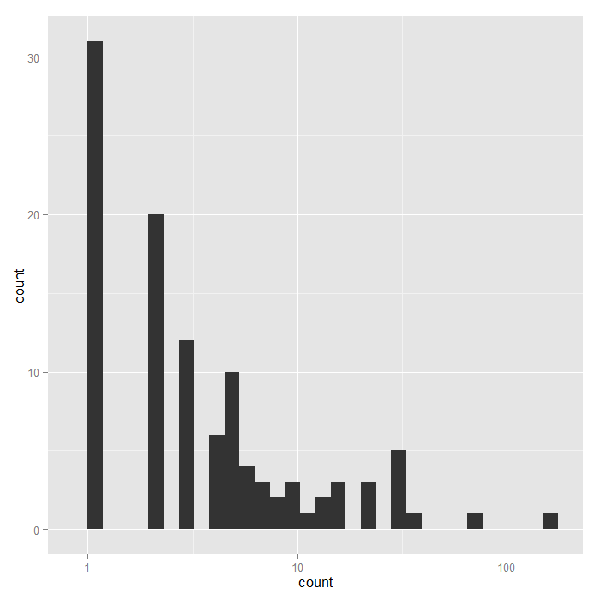

**summary**(m1 <- **zeroinfl**(count ~ child + camper | persons, data = zinb))

## Call:

## zeroinfl(formula = count ~ child + camper | persons, data = zinb)

##

## Pearson residuals:

## Min 1Q Median 3Q Max

## -1.2369 -0.7540 -0.6080 -0.1921 24.0847

##

## Count model coefficients (poisson with log link):

## Estimate Std. Error z value Pr(>|z|)

## (Intercept) 1.59789 0.08554 18.680 <2e-16 ***

## child -1.04284 0.09999 -10.430 <2e-16 ***

## camper1 0.83402 0.09363 8.908 <2e-16 ***

##

## Zero-inflation model coefficients (binomial with logit link):

## Estimate Std. Error z value Pr(>|z|)

## (Intercept) 1.2974 0.3739 3.470 0.000520 ***

## persons -0.5643 0.1630 -3.463 0.000534 ***

## ---

## Signif. codes: 0 '***' 0.001 '**' 0.01 '*' 0.05 '.' 0.1 ' ' 1

##

## Number of iterations in BFGS optimization: 12

## Log-likelihood: -1032 on 5 Df

The output looks very much like the output from two OLS regressions in R. Below the model call, you will find a block of output containing Poisson regression coefficients for each of the variables along with standard errors, z-scores, and p-values for the coefficients. A second block follows that corresponds to the inflation model. This includes logit coefficients for predicting excess zeros along with their standard errors, z-scores, and p-values.

mnull <- **update**(m1, . ~ 1)

**pchisq**(2 * (**logLik**(m1) - **logLik**(mnull)), df = 3, lower.tail = FALSE)

## 'log Lik.' 4.041e-41 (df=5)

Since we have three predictor variables in the full model, the degrees of freedom for the chi-squared test is 3. This yields a high significant p-value; thus, our overall model is statistically significant.

**dput**(**coef**(m1, "count"))

## structure(c(1.59788828690411, -1.04283909332231, 0.834023618148891

## ), .Names = c("(Intercept)", "child", "camper1"))

**dput**(**coef**(m1, "zero"))

## structure(c(1.29744027908309, -0.564347365357873), .Names = c("(Intercept)",

## "persons"))

f <- **function**(data, i) {

**require**(pscl)

m <- **zeroinfl**(count ~ child + camper | persons, data = data[i, ],

start = **list**(count = **c**(1.598, -1.0428, 0.834), zero = **c**(1.297, -0.564)))

**as.vector**(**t**(**do.call**(rbind, **coef**(**summary**(m)))[, 1:2]))

}

**set.seed**(10)

res <- **boot**(zinb, f, R = 1200, parallel = "snow", ncpus = 4)

*## print results*

res

##

## ORDINARY NONPARAMETRIC BOOTSTRAP

##

##

## Call:

## boot(data = zinb, statistic = f, R = 1200, parallel = "snow",

## ncpus = 4)

##

##

## Bootstrap Statistics :

## original bias std. error

## t1* 1.59789 -0.056661 0.30307

## t2* 0.08554 0.004257 0.01670

## t3* -1.04284 -0.002510 0.40557

## t4* 0.09999 0.004395 0.01539

## t5* 0.83402 0.017178 0.40465

## t6* 0.09363 0.004581 0.01536

## t7* 1.29744 0.020810 0.48058

## t8* 0.37385 0.008224 0.03662

## t9* -0.56435 -0.030103 0.26673

## t10* 0.16296 0.005272 0.02981

The results are alternating parameter estimates and standard errors. That is, the first row has the first parameter estimate from our model. The second has the standard error for the first parameter. The third column contains the bootstrapped standard errors, which are considerably larger than those estimated by zeroinfl.

Now we can get the confidence intervals for all the parameters. We start on the original scale with percentile and bias adjusted CIs. We also compare these results with the regular confidence intervals based on the standard errors.

*## basic parameter estimates with percentile and bias adjusted CIs*

parms <- **t**(**sapply**(**c**(1, 3, 5, 7, 9), **function**(i) {

out <- **boot.ci**(res, index = **c**(i, i + 1), type = **c**("perc", "bca"))

**with**(out, **c**(Est = t0, pLL = percent[4], pUL = percent[5],

bcaLL = bca[4], bcaLL = bca[5]))

}))

*## add row names*

**row.names**(parms) <- **names**(**coef**(m1))

*## print results*

parms

## Est pLL pUL bcaLL bcaLL

## count_(Intercept) 1.5979 0.8793 2.07810 1.087354 2.22614

## count_child -1.0428 -1.7509 -0.17531 -1.618509 -0.02203

## count_camper1 0.8340 0.0596 1.62653 0.001571 1.59995

## zero_(Intercept) 1.2974 0.3503 2.21984 0.293577 2.12070

## zero_persons -0.5643 -1.1087 -0.07847 -1.008526 0.00633

*## compare with normal based approximation*

**confint**(m1)

## 2.5 % 97.5 %

## count_(Intercept) 1.4302 1.7655

## count_child -1.2388 -0.8469

## count_camper1 0.6505 1.0175

## zero_(Intercept) 0.5647 2.0302

## zero_persons -0.8838 -0.2449

The bootstrapped confidence intervals are considerably wider than the normal based approximation. The bootstrapped CIs are more consistent with the CIs from Stata when using robust standard errors.

Now we can estimate the incident risk ratio (IRR) for the Poisson model and odds ratio (OR) for the logistic (zero inflation) model. This is done using almost identical code as before, but passing a transformation function to the h argument of boot.ci, in this case, exp to exponentiate.

*## exponentiated parameter estimates with percentile and bias adjusted CIs*

expparms <- **t**(**sapply**(**c**(1, 3, 5, 7, 9), **function**(i) {

out <- **boot.ci**(res, index = **c**(i, i + 1), type = **c**("perc", "bca"), h = exp)

**with**(out, **c**(Est = t0, pLL = percent[4], pUL = percent[5],

bcaLL = bca[4], bcaLL = bca[5]))

}))

*## add row names*

**row.names**(expparms) <- **names**(**coef**(m1))

*## print results*

expparms

## Est pLL pUL bcaLL bcaLL

## count_(Intercept) 4.9426 2.4091 7.9892 2.9664 9.2641

## count_child 0.3525 0.1736 0.8392 0.1982 0.9782

## count_camper1 2.3026 1.0614 5.0862 1.0016 4.9528

## zero_(Intercept) 3.6599 1.4195 9.2058 1.3412 8.3370

## zero_persons 0.5687 0.3300 0.9245 0.3648 1.0063

To better understand our model, we can compute the expected number of fish caught for different combinations of our predictors. In fact, since we are working with essentially categorical predictors, we can compute the expected values for all combinations using the expand.grid function to create all combinations and then the predict function to do it. We also remove any rows where the number of children exceeds the number of persons, which does not make sense logically, using the subset function.

Finally we create a graph.

newdata1 <- **expand.grid**(0:3, **factor**(0:1), 1:4)

**colnames**(newdata1) <- **c**("child", "camper", "persons")

newdata1 <- **subset**(newdata1, subset=(child<=persons))

newdata1$phat <- **predict**(m1, newdata1)

**ggplot**(newdata1, **aes**(x = child, y = phat, colour = **factor**(persons))) +

**geom_point**() +

**geom_line**() +

**facet_wrap**(~camper) +

**labs**(x = "Number of Children", y = "Predicted Fish Caught")

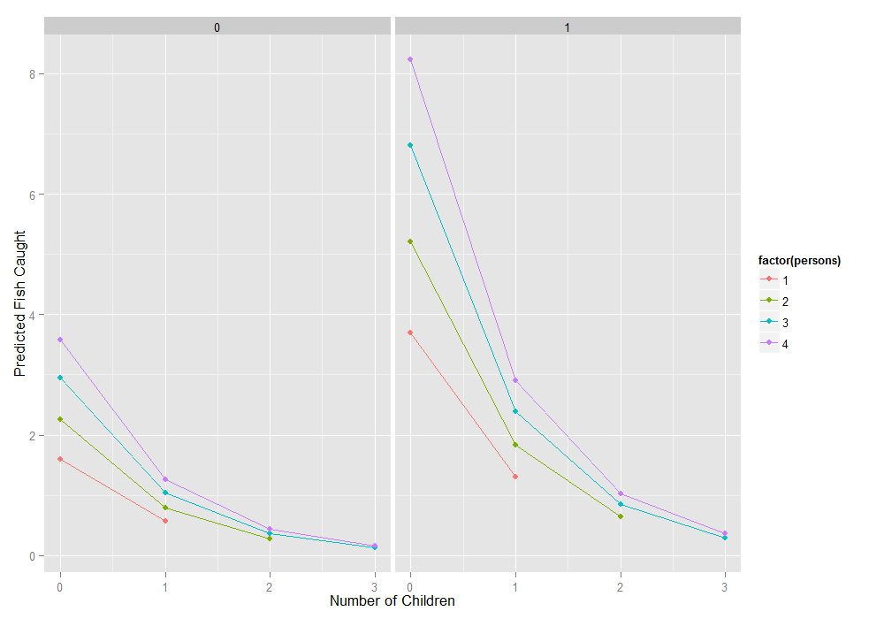

**Question-04:**

The state wildlife biologists want to model how many fish are being caught by fishermen at a state park. Visitors are asked how long they stayed, how many people were in the group, were there children in the group and how many fish were caught. Some visitors do not fish, but there is no data on whether a person fished or not. Some visitors who did fish did not catch any fish so there are excess zeros in the data because of the people that did not fish. The data set is taken from **("**[**https://stats.idre.ucla.edu/stat/data/fish.csv**](https://stats.idre.ucla.edu/stat/data/fish.csv)**")** and fit the Zero-Inflated Binomial regression generalized linear models (GLMs) to identify the factors associated with number of awards earned by students at one high school. Interpret the result.

Let’s look at the data.

**require**(ggplot2)

**require**(pscl)

**require**(MASS)

**require**(boot)

zinb <- **read.csv**("https://stats.idre.ucla.edu/stat/data/fish.csv")

zinb <- **within**(zinb, {

nofish <- **factor**(nofish)

livebait <- **factor**(livebait)

camper <- **factor**(camper)

})

**summary**(zinb)

## nofish livebait camper persons child xb

## 0:176 0: 34 0:103 Min. :1.00 Min. :0.000 Min. :-3.275

## 1: 74 1:216 1:147 1st Qu.:2.00 1st Qu.:0.000 1st Qu.: 0.008

## Median :2.00 Median :0.000 Median : 0.955

## Mean :2.53 Mean :0.684 Mean : 0.974

## 3rd Qu.:4.00 3rd Qu.:1.000 3rd Qu.: 1.964

## Max. :4.00 Max. :3.000 Max. : 5.353

## zg count

## Min. :-5.626 Min. : 0.0

## 1st Qu.:-1.253 1st Qu.: 0.0

## Median : 0.605 Median : 0.0

## Mean : 0.252 Mean : 3.3

## 3rd Qu.: 1.993 3rd Qu.: 2.0

## Max. : 4.263 Max. :149.0

*## histogram with x axis in log10 scale*

**ggplot**(zinb, **aes**(count, fill = camper)) +

**geom_histogram**() +

**scale_x_log10**() +

**facet_grid**(camper ~ ., margins=TRUE, scales="free_y")

*## stat_bin: binwidth defaulted to range/30. Use 'binwidth = x' to adjust this.*

*## stat_bin: binwidth defaulted to range/30. Use 'binwidth = x' to adjust this.*

*## stat_bin: binwidth defaulted to range/30. Use 'binwidth = x' to adjust this.*

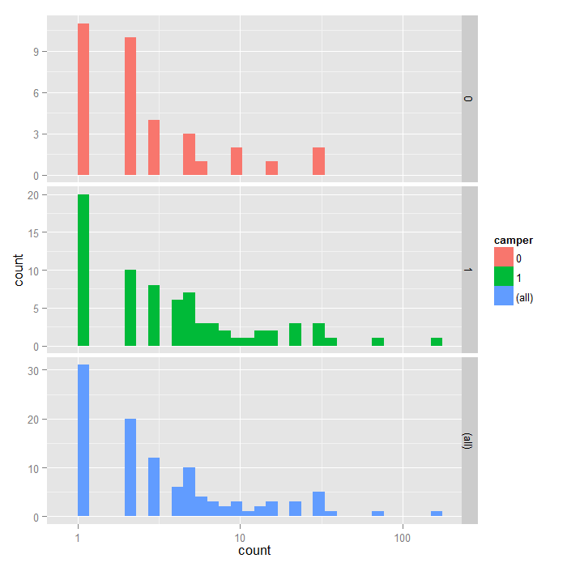

m1 <- **zeroinfl**(count ~ child + camper | persons,

data = zinb, dist = "negbin")

**summary**(m1)

##

## Call:

## zeroinfl(formula = count ~ child + camper | persons, data = zinb,

## dist = "negbin", EM = TRUE)

##

## Pearson residuals:

## Min 1Q Median 3Q Max

## -0.586 -0.462 -0.389 -0.197 18.013

##

## Count model coefficients (negbin with log link):

## Estimate Std. Error z value Pr(>|z|)

## (Intercept) 1.371 0.256 5.35 8.6e-08 ***

## child -1.515 0.196 -7.75 9.4e-15 ***

## camper1 0.879 0.269 3.26 0.0011 **

## Log(theta) -0.985 0.176 -5.60 2.1e-08 ***

##

## Zero-inflation model coefficients (binomial with logit link):

## Estimate Std. Error z value Pr(>|z|)

## (Intercept) 1.603 0.836 1.92 0.055 .

## persons -1.666 0.679 -2.45 0.014 *

## ---

## Signif. codes: 0 '***' 0.001 '**' 0.01 '*' 0.05 '.' 0.1 ' ' 1

##

## Theta = 0.373

## Number of iterations in BFGS optimization: 2

## Log-likelihood: -433 on 6 Df

The output looks very much like the output from two OLS regressions in R.

Below the model call, you will find a block of output containing negative binomial regression coefficients for each of the variables along with standard errors, z-scores, and p-values for the coefficients. A second block follows that corresponds to the inflation model. This includes logit coefficients for predicting excess zeros along with their standard errors, z-scores, and p-values.

All of the predictors in both the count and inflation portions of the model are statistically significant. This model fits the data significantly better than the null model, i.e., the intercept-only model. To show that this is the case, we can compare with the current model to a null model without predictors using chi-squared test on the difference of log likelihoods.

m0 <- **update**(m1, . ~ 1)

**pchisq**(2 * (**logLik**(m1) - **logLik**(m0)), df = 3, lower.tail=FALSE)

## 'log Lik.' 1.28e-13 (df=6)

From the output above, we can see that our overall model is statistically significant.

The predictors child and camper in the part of the negative binomial regression model predicting number of fish caught (count) are both significant predictors.

The predictor person in the part of the logit model predicting excessive zeros is statistically significant.

For these data, the expected change in log(count) for a one-unit increase in child is -1.515255 holding other variables constant.

A camper (camper = 1) has an expected log(count) of 0.879051 higher than that of a non-camper (camper = 0) holding other variables constant.

The log odds of being an excessive zero would decrease by 1.67 for every additional person in the group. In other words, the more people in the group the less likely that the zero would be due to not gone fishing. Put plainly, the larger the group the person was in, the more likely that the person went fishing.

**dput**(**round**(**coef**(m1, "count"), 4))

## structure(c(1.3711, -1.5152, 0.879), .Names = c("(Intercept)",

## "child", "camper1"))

**dput**(**round**(**coef**(m1, "zero"), 4))

## structure(c(1.6028, -1.6663), .Names = c("(Intercept)", "persons"

## ))

f <- **function**(data, i) {

**require**(pscl)

m <- **zeroinfl**(count ~ child + camper | persons,

data = data[i, ], dist = "negbin",

start = **list**(count = **c**(1.3711, -1.5152, 0.879), zero = **c**(1.6028, -1.6663)))

**as.vector**(**t**(**do.call**(rbind, **coef**(**summary**(m)))[, 1:2]))

}

**set.seed**(10)

(res <- **boot**(zinb, f, R = 1200, parallel = "snow", ncpus = 4))

##

## ORDINARY NONPARAMETRIC BOOTSTRAP

##

##

## Call:

## boot(data = zinb, statistic = f, R = 1200, parallel = "snow",

## ncpus = 4)

##

##

## Bootstrap Statistics :

## original bias std. error

## t1* 1.3711 -0.083023 0.39403

## t2* 0.2561 -0.002622 0.03191

## t3* -1.5153 -0.061487 0.26892

## t4* 0.1956 0.006034 0.02027

## t5* 0.8791 0.091431 0.47124

## t6* 0.2693 0.001873 0.01998

## t7* -0.9854 0.080120 0.21896

## t8* 0.1760 0.002577 0.01689

## t9* 1.6031 0.473597 1.59331

## t10* 0.8365 3.767327 15.65780

## t11* -1.6666 -0.462364 1.56789

## t12* 0.6793 3.771994 15.69675

The results are alternating parameter estimates and standard errors. That is, the first row has the first parameter estimate from our model. The second has the standard error for the first parameter. The third column contains the bootstrapped standard errors, which are considerably larger than those estimated by zeroinfl.

Now we can get the confidence intervals for all the parameters. We start on the original scale with percentile and bias adjusted CIs. We also compare these results with the regular confidence intervals based on the standard errors.

*## basic parameter estimates with percentile and bias adjusted CIs*

parms <- **t**(**sapply**(**c**(1, 3, 5, 9, 11), **function**(i) {

out <- **boot.ci**(res, index = **c**(i, i + 1), type = **c**("perc", "bca"))

**with**(out, **c**(Est = t0, pLL = percent[4], pUL = percent[5],

bcaLL = bca[4], bcaUL = bca[5]))

}))

*## add row names*

**row.names**(parms) <- **names**(**coef**(m1))

*## print results*

parms

## Est pLL pUL bcaLL bcaUL

## count_(Intercept) 1.3711 0.5676 2.0620 0.7226 2.2923

## count_child -1.5153 -2.1382 -1.0887 -2.0175 -0.9593

## count_camper1 0.8791 0.0431 1.8331 -0.2016 1.6669

## zero_(Intercept) 1.6031 0.4344 8.2380 0.0282 3.5197

## zero_persons -1.6666 -8.5436 -1.1002 -7.8329 -1.0781

*## compare with normal based approximation*

**confint**(m1)

## 2.5 % 97.5 %

## count_(Intercept) 0.86911 1.8731

## count_child -1.89860 -1.1319

## count_camper1 0.35127 1.4068

## zero_(Intercept) -0.03636 3.2419

## zero_persons -2.99701 -0.3355

The bootstrapped confidence intervals are considerably wider than the normal based approximation. The bootstrapped CIs are more consistent with the CIs from Stata when using robust standard errors.

*## exponentiated parameter estimates with percentile and bias adjusted CIs*

expparms <- **t**(**sapply**(**c**(1, 3, 5, 7, 9), **function**(i) {

out <- **boot.ci**(res, index = **c**(i, i + 1), type = **c**("perc", "bca"), h = exp)

**with**(out, **c**(Est = t0, pLL = percent[4], pUL = percent[5],

bcaLL = bca[4], bcaUL = bca[5]))

}))

*## add row names*

**row.names**(expparms) <- **names**(**coef**(m1))

*## print results*

expparms

## Est pLL pUL bcaLL bcaUL

## count_(Intercept) 3.9395 1.7641 7.8615 2.0599 9.8981

## count_child 0.2198 0.1179 0.3367 0.1330 0.3832

## count_camper1 2.4086 1.0441 6.2534 0.8175 5.2958

## zero_(Intercept) 4.9686 1.5441 3781.9642 1.0286 33.7757

## zero_persons 0.1889 0.0002 0.3328 0.0004 0.3402

To better understand our model, we can compute the expected number of fish caught for different combinations of our predictors. In fact, since we are working with essentially categorical predictors, we can compute the expected values for all combinations using the expand.grid function to create all combinations and then the predict function to do it. Finally we create a graph.

newdata1 <- **expand.grid**(0:3, **factor**(0:1), 1:4)

**colnames**(newdata1) <- **c**("child", "camper", "persons")

newdata1$phat <- **predict**(m1, newdata1)

**ggplot**(newdata1, **aes**(x = child, y = phat, colour = **factor**(persons))) +

**geom_point**() +

**geom_line**() +

**facet_wrap**(~camper) +

**labs**(x = "Number of Children", y = "Predicted Fish Caught")

