**SafeCo Dual Cobot Assembly**

**Joseph Seklawy – 12578845**

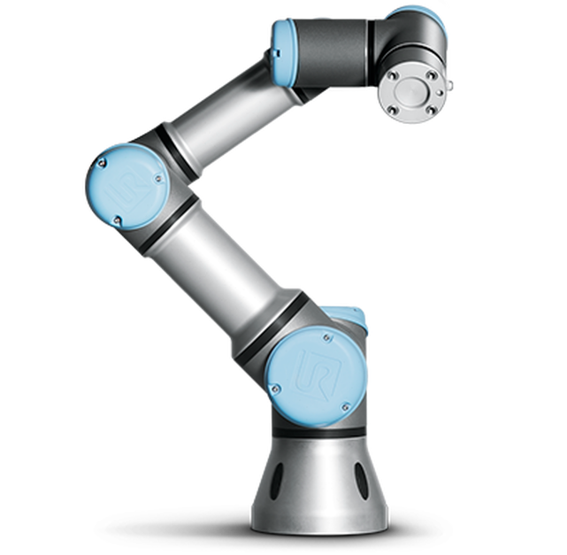

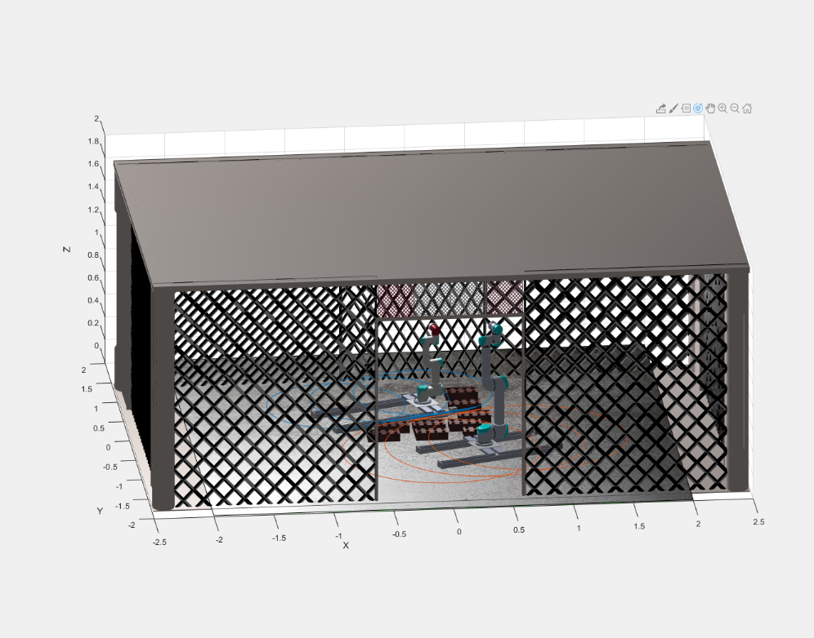

# Workspace

Put the two robots next to each other. Fuck you.

# Safety and Risks

## Risk Assessment

|  |  |  |  |  |
| --- | --- | --- | --- | --- |
| **Hazard** | **Risk** | **Likelihood** | **Rating** | **Action** |
| Robots colliding with each other | May cause damage to equipment | Possible | LOW | Real UR robots have inbuilt emergency stops when experiencing resistance |
| Robot letting go of brick whilst moving | Brick can be thrown across the space and strike a person or piece of equipment | Rare | LOW | Place robots in secure and secluded space, if possible an enclosed space to stop objects from exiting the workspace unwarranted |
| Robots knocking over built wall | Falling bricks can cause injury or damage to equipment | Possible | MEDIUM | Ensure via simulation before hand that this situation will not occur. In addition, monitor the sequence at all times and be on standby to press emergency stops |
| Robot arm driving into a person standing close by | Possible injuries | Possible | MEDIUM | Do not stand within the robots reach whilst it is in motion. Close off the workspace whilst the robots are activated to prevent personnel entry |

Refer to appendix for risk matrix.

## SWMS

Refer to appendix for SWMS.

# The UR3

# Challenges

|  |
| --- |
| UTS SAFE WORK METHOD statement (SWMS) |

|  |  |
| --- | --- |
| 1. **FACULTY/SUBJECT** | |
| Faculty/Subject title | 41013 Industrial Robotics |
| Subject supervisor/coordinator | Gavin Paul |
| SWMS prepared by | Joseph Seklawy |

|  |  |  |  |  |  |  |
| --- | --- | --- | --- | --- | --- | --- |
| 1. **WORK ACTIVITY DESCRIPTION** | | | | | | |
| Describe the work activity E.g. Operating, Handling, Using.. Include names of hazardous equipment, substances or materials used,  and any quantities and concentrations of substance(s) or reaction products. | Operation of two robotic arms, the UR3 and UR5 on separate linear rails to have them assemble a 3x3 brick wall in a controlled and closed off environment | | | | | |
| 1. HAZARDS: Choose those hazard types that will need to have control measures in Section 4 | | | | | | |
| **Work Environment**   * Working in Remote Locations * Working Outdoors/fieldwork * Clinical/Industrial setting * Poor ventilation/Air quality * Temperature extremes * Working at Height * Slip/Trip/Fall hazards | | **Plant**   * Noise * Vibration * Working with compressed air * Lifts Hoists or Cranes * Moving parts (Crushing,friction, cut, stab, shear hazards) * Pressure Vessels or Boilers | | **Chemical**   * Hazardous Chemicals use * Skin/eye irritant * Sensitiser * Mutagen * Carcinogen * Toxic to reproduction * Aquatic toxicity * Toxic * Corrosive * Dangerous when wet | | **Ergonomic/Manual Handling**   * Repetitive or awkward movements * Lifting heavy objects * Over reaching * Working above shoulder or below knee height * Poor workstation set up |
| **Electrical**   * Plug in equipment * High voltage * Exposed wiring * Exposed conductors | | **Radiation**   * Ionising Radiation * Non-ionising radiation (Lasers, Microwaves, Ultraviolet light) | | **Biological**   * Sharps/Needles * Cytotoxins * Pathogens/infectious materials * Infectious materials * Communicable diseases * Animal/insects * Work with fungi/bact/viruses | | **Psychosocial**   * Aggressive or violent clients/students * Working in isolation * Working with timeframes * Staffing issues |
| 1. **CONTROLS MEASURES: Choose those that apply for hazards identified** | | | | | | |
| **Eliminate/Isolate/Substitute / Engineering Controls**   * Remove hazard * Restrict access * Redesign equipment * Guarding / Barriers / Fume Cupboard / exhaust * Biosafety cabinet * Use safer materials/substances * Ventilation * Regular maintenance of equipment * Redesign of workspace / workflow | | | **Admin specific: Licenses/permits Work Methods**   * Training Information or Instruction * Licensing or certification of operators * Test and tag electrical equipment * Restricted access * Regular breaks * Task rotation * Work in pairs * Document Chemical risk assessment * Ladder / Sling register | | **Emergency Response Systems**   * First aid kit * Chemical spill kit * Safety shower * Eye wash station * Emergency Stop button * Remote Communication Mechanism | |
| **Other controls not listed**  **Proposed metal cage to be placed around robot working environment**  **Fire extinguishers close by**  **Emergency stops accessible outside cage** | | | | | | |
| 1. **PPE REQUIRED (Tick those that apply)** | | | | | | |
| http://www.orr.uts.edu.au/images/pictograms/protection/hand.pnghttp://www.orr.uts.edu.au/images/pictograms/protection/face.pnghttp://www.orr.uts.edu.au/images/pictograms/protection/eye.pnghttp://www.orr.uts.edu.au/images/pictograms/protection/hearing.pnghttp://www.orr.uts.edu.au/images/pictograms/protection/foot.pnghttp://www.orr.uts.edu.au/images/pictograms/protection/ppe.png | | | | | | |
|  | | | | | | |
| http://www.orr.uts.edu.au/images/pictograms/protection/respiratory.pnghttp://www.orr.uts.edu.au/images/pictograms/protection/head.pnghttp://www.orr.uts.edu.au/images/pictograms/protection/hair.png | | | | | | |
|  | | | | | | |
| 1. **EMERGENCY EQUIPMENT** | | | | | | |
| http://www.orr.uts.edu.au/images/pictograms/equipment/eyewash.pnghttp://www.orr.uts.edu.au/images/pictograms/equipment/spill.pnghttp://www.orr.uts.edu.au/images/pictograms/equipment/shower.png | | | | | | |
|  | | | | | | |

|  |
| --- |
| 1. **work activity steps** |
| **before you start:**   * Ensure cage is secure * Ensure emergency stops are operating correctly      **steps in work activity:**   1. Place bricks 2. Power robots 3. Step outside cage 4. Begin build sequence 5. Wait for sequence to complete and robots to come to full stop before entering cage   **emergency procedures:**   * Press emergency button * Notify security or dial 6 using the UTS internal phone * In case of fire use fire extinguisher   **training required:** |

|  |  |  |
| --- | --- | --- |
| 1. **sign off** | | |
| **prepared by:**  **NAME: Joseph seklawy** | **Lab Supervisor**  **Name:** | **Date:**  **Review Date:** |

|  |  |  |  |
| --- | --- | --- | --- |
| **Risk Matrix** | | | |
| **Likelihood** | **Consequence** | | |
| Insignificant | Moderate | Severe |
| Very Likely | Medium | High | High |
| Possible | Low | Medium | High |
| Rare | Low | Low | Medium |

|  |  |
| --- | --- |
| **Risk Rating** | |
| **Descriptor** | **Definition** |
| Low | Acceptable risk. No action required |
| Medium | Some amount of mitigation needed. Complete evasion unnecessary, however effect reduction desired. |
| High | Priority attention given to reduce risk. Heavy mitigation or reduction required. Must be avoided. |