Web Search and Rationale

## Title: Trustbuy Mobile application

## Authors: Muthukumar kandasamy, sukriti sharma, Mithu mathew

## Faculty Advisor(s): James wong

## Client/Industry Advisor:

## Keywords: Ex. *mobile application, rental units, sale items, Android studio, Java*

## Abstract

As students at Conestoga College we have perceived a need for new students to have better access to second hand books and other items from students who are graduating. Normally students get this information from the bulletin board at the college or from popular online advertising services like Kijiji which is a subsidiary of eBay. New students face the following problems when they move to a different location or province or country that they are unfamiliar with like transportation, different culture, language and so many more. We thought a way to counteract that problem is by setting up a mobile application. To develop the application we are using Android Studio which is the integrated development environment (IDE) for an android platform and SQLite to store our database. The application will allow students to get information more quickly by viewing posted ads from other students within the Conestoga college community. Once this application is implemented it will have a huge impact on the student community.

## Business/Technological Purpose

The application will allow students to view and purchase ads posted by other students within the community. Like Kijiji it is an advertising service that all students can access at any time. It will allow students to sell or buy an item, put it in a watchlist or report an ad. Visitors and users alike can both browse for items although visitors will have to create an account and log in to buy the item. One advantage of the TrustBuy app is that students can download and install the app on their mobile device, rather than be rendered within a browser. Another advantage is that our app can be used across all android devices.

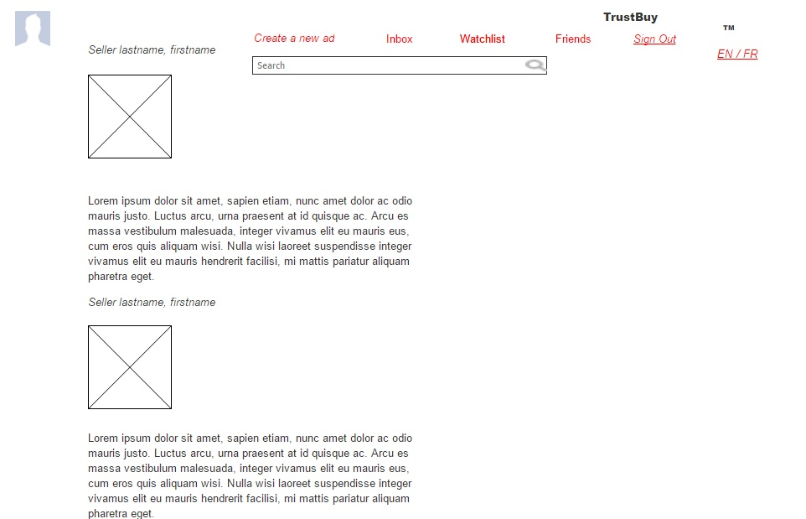

*Fig 1: Home page*

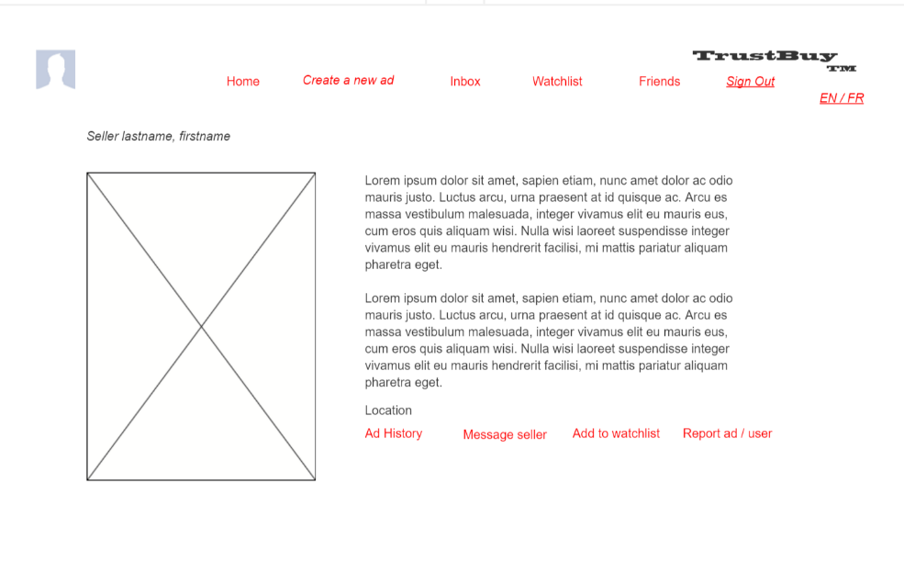

*Fig2: Individual ad home screen*

## Our Contribution:

1. Post an Ad features:
2. Select the Create a new ad icon on the home page.
3. Input keywords in the keyword field that will allow users to search easily using those keywords.
4. Browse button to upload an image from the system.
5. Description box to add a short description of the item for sale.
6. Publish icon to post the ad.
7. Home page gallery features:
8. Displays the most recent 10 ads in the homepage.
9. Ads on the homepage get a performance boost.
10. Watchlist features:
11. By selecting the watchlist icon on the homepage it gives the user the opportunity to add an item to watchlist.
12. The user has the option to view or delete the ad in the watchlist at any time.
13. Friend list features:
14. A user can search for another user in this community app by selecting search icon.
15. The user can send the other person a friend request by clicking on send friend request from the person’s ad page.
16. Reporting an ad feature:
17. This feature allows a user to report an ad that does not fit the guidelines by flagging it.
18. The administrator can remove these ads if they have been flagged many times after an investigation.

## Market Analysis

Android is leading the global market with 76% market shares as per analysis reports in the fourth quarter of 2014. And about 82% of smartphones are android operated devices (Statista, 2016). This goes to further emphasize the importance of why we decided to develop an android app instead of an iOS app.

A recent report states that second-hand economy online marketers like Kijiji, Craigslist and Facebook have contributed to 28 billion in annual sales in Canada alone (Durif, 2016). Mark Andre Hade the marketing manager at Kijiji Canada states that the above report is a confirmation that the second-hand economy is an important social and economic force in Canada, and a bright light in an otherwise worrisome economy. According to the report, an average reseller makes $883 from posting ads for items. (Durif, 2016)

What sets our app apart from Kijiji and Facebook is that it combines services that both these applications offer. While Facebook allows us to maintain a large and active network with friends, family and business contacts, Kijiji is a classified advertising service. Trustbuy combines these two services to allow Conestoga college students and staff to post ads as well as network with each other. An average reseller can potentially make $300 from posting ads for items. In addition to it, the app also encourages a sense of community and trust, by creating for all its users a feeling of belonging in the community.

## Competitors

Kijiji, eBay, Facebook

## Pricing

Cost of Amazon cloud storage service = $12/year for Free apps

Cost of deploying using Google Play store = 25$ (one-time cost) + 30% app sales revenue

## Conclusion

1. TrustBuy app will provide a communication, networking and an advertising platform for its users.
2. TrustBuy will allow sellers to sell items more quickly and buyers to have access to the items put up for sale by registering with the app.
3. Trustbuy like its name will provide users with a safe and trustworthy space in which they can conduct business.

## References:

[1] Retrieved from Statista website: https://www.statista.com/statistics/271774/share-of-android-platforms-on-mobile-devices-with-android-os/

[2] Durif, Fabien; Arcand, Manon (2016). *The Kijiji Second-Hand Economy Index: Highlight and Observations.* Retrieved from Kijiji website: http://www.kijiji.ca/kijijicentral/second-hand-economy/