Building an Automated EDW Architecture for Cybersecurity Incident Analytics
Submitted by: Munira Karim

Abstract
The escalation of data breaches has become a critical concern for entities across various sectors, highlighting significant vulnerabilities within cybersecurity frameworks. This analysis utilizes a dataset of over 350 reported cybersecurity incidents to examine trends, identify common vulnerabilities, and understand the methods of breaches. By dissecting the data, the project aims to derive insights that could contribute to strengthening data protection measures and suggest proactive defenses against future threats. The project automates the ETL process using Python, stores the data in a star schema within MySQL, and visualizes insights using Python-based data visualization tools. The findings aim to help organizations identify and strengthen weak points in their cybersecurity infrastructures.

Introduction
In the digital age, data breaches have become a prevalent issue, posing significant threats to organizations across all sectors. The cybersecurity data breach dataset provided offers a comprehensive overview of over 350 reported incidents, encompassing a wide range of entities from healthcare to technology and social networking. These breaches not only expose sensitive personal and corporate information but also highlight the evolving challenges and tactics in cybersecurity.
This dataset spans incidents from the early 2000s to the present, detailing the number of records affected, the types of organizations involved, and the methods through which these breaches occurred. By analyzing this data, we aim to uncover patterns and insights that can inform better security practices and strategies. The subsequent sections will delve into the trends over the years, compare the vulnerability of different organization types, and explore the most common methods of breaches, providing a detailed landscape of cybersecurity threats that modern organizations face.
Through this analysis, we seek to equip stakeholders with the knowledge to anticipate potential security threats and reinforce their defenses, thereby mitigating the risk of future breaches. The findings from this dataset will also serve as a cornerstone for developing robust data protection frameworks and regulatory measures to safeguard sensitive information against the increasingly sophisticated methods of cybercriminals.

Problem Statement
Despite advancements in cybersecurity technologies, data breaches continue to occur with alarming frequency and severity. The problem lies in the persistent vulnerabilities and the ever-evolving nature of attack vectors. Organizations struggle to keep pace with these threats, often reacting only after the fact rather than taking preventative measures.
This project explores the root causes by analyzing:
- Trends in breach frequency
- Sector-specific vulnerabilities
- Evolution of attack methods
- Common points of failure
Also to understand the underlying patterns of data breaches, the commonalities across different breaches, and the effectiveness of current security measures.

Problem Analysis
The analysis of the dataset prompts several critical questions that need addressing:
- What trends can be observed in the frequency of data breaches over the years?
- Which sectors are most vulnerable to specific types of data breaches?
- How do the methods of breaches evolve in response to changes in cybersecurity practices?
- What are the common points of failure in existing security infrastructures?

Project Scope
The scope of this project encompasses a detailed analysis of the provided data breach dataset, focusing on identifying trends, methods, and impacts of breaches across various sectors. The project includes:
- A temporal review of breach incidents across two decades
- Analysis of breach frequency and impact by organization type
- Comparative evaluation of breach methods by sector and scale
Methodology
The project will employ a quantitative analysis approach using statistical tools and data visualization techniques:
- Data Preprocessing: Cleaning and structuring the data for analysis, including handling missing values and standardizing entries.
- Exploratory Data Analysis (EDA): Using statistical summaries and visualization tools to understand the distribution and trends of data breaches.
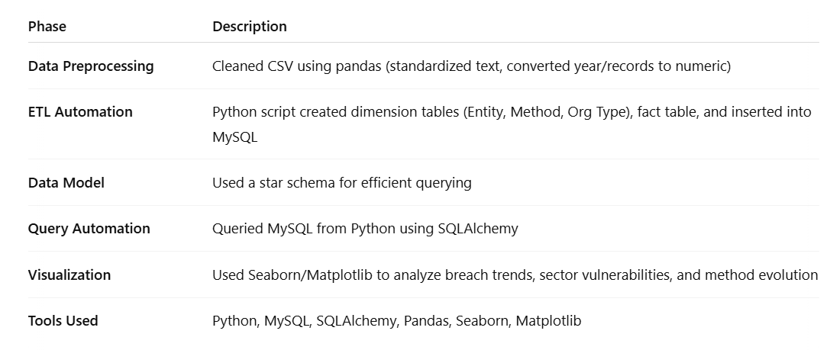
- Trend Analysis: Employing time-series analysis to review the changes in breach frequency and methods over time.
- Comparative Analysis: Comparing breach impacts across different organization types to identify particularly vulnerable sectors.
- Tools and Software: Utilizing software such as Python with libraries like pandas and matplotlib, seaborn and sqlalchemy.
ETL Automation (Key Detail)
The project was automated through a Python ETL script that:
- Loaded raw CSV data
- Cleaned and transformed data into dimension and fact tables
- Auto-generated unique keys for dimensional entries
- Merged foreign keys into a fact table
- Inserted all processed data into MySQL using SQL queries
- Queried data directly from Python (with SQL Alchemy) for analysis and plotting
This allows repeatable, scalable updates to the dataset, fully automating what would otherwise be a manual database and visualization process.
Data Cleaning Process
The dataset contains 352 entries and spans several columns which capture the specifics of each data breach incident. Here's an overview of the columns and initial insights from the data:
- Unnamed: 0: Appears to be an index column.
- Entity: Names of entities that have experienced data breaches.
- Year: Year of the breach, currently stored as a string.
- Records: Number of records affected, currently in string format with possible non-numeric characters.
- Organization type: Type of organization, which categorizes entities.
- Method: Method through which the breach occurred.
- Sources: Citation sources, likely irrelevant for analytical purposes and might be dropped.
First, load the dataset in pandas data frame and identified issues of any missing values, incorrect data types, and anomalies. Based on the cleaning task converted year from string to integer, cleaned non-numeric characters and converted integer to float. Converted all text columns to lowercase.
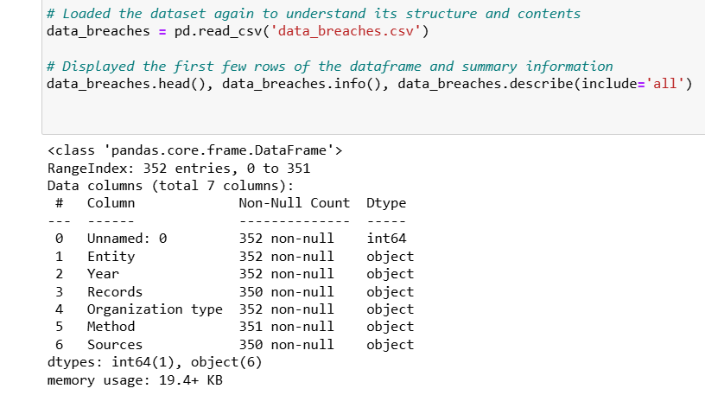

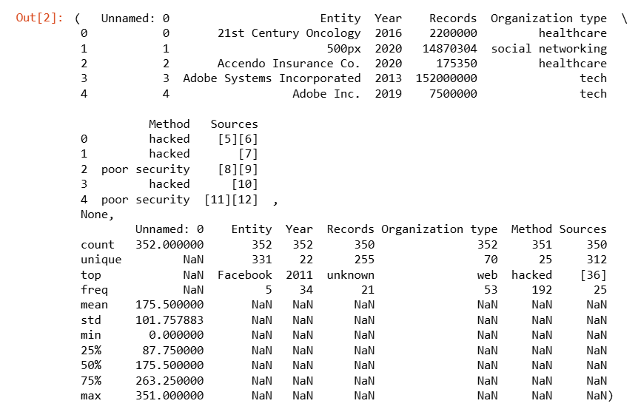
Further adjustments made on the dataset by removing unnamed and sources column and only kept with the following columns 'Entity', 'Year', 'Records', 'Organization type', and 'Method'.
Schema design for EDW
I have created a star schema that optimizes query performance and meets analytical needs. I will use a star schema, which is a popular design for EDW due to its simplicity and efficiency in handling complex queries. Here’s how I designed it:

Fact Table
- Fact_Breaches
  - breach_id (Primary Key)
  - entity_id (Foreign Key)
  - organization_type_id (Foreign Key)
  - method_id (Foreign Key)
  - year
  - records_affected

Dimension Tables
- Dim_Entity
  - entity_id (Primary Key)
  - entity_name
- Dim_Organization_Type
  - organization_type_id (Primary Key)
  - organization_type
- Dim_Method
  - method_id (Primary Key)
  - breach_method

Steps to Implement the Data Model:
- Extract unique values for each dimension (Entity, Organization Type, Method).
- Assign primary keys to each unique value in the dimension tables.
- Reference these keys in the Fact table instead of storing the text directly.

Example Schema Visualization:
here's a simplified visualization of the schema:
Fact_Breaches
/ | \
/ | \
/ | \
Dim_Entity Dim_Org_Type Dim_Method

Next Steps:
- Created Tables: Wrote python statements to create these tables in the SQL database.
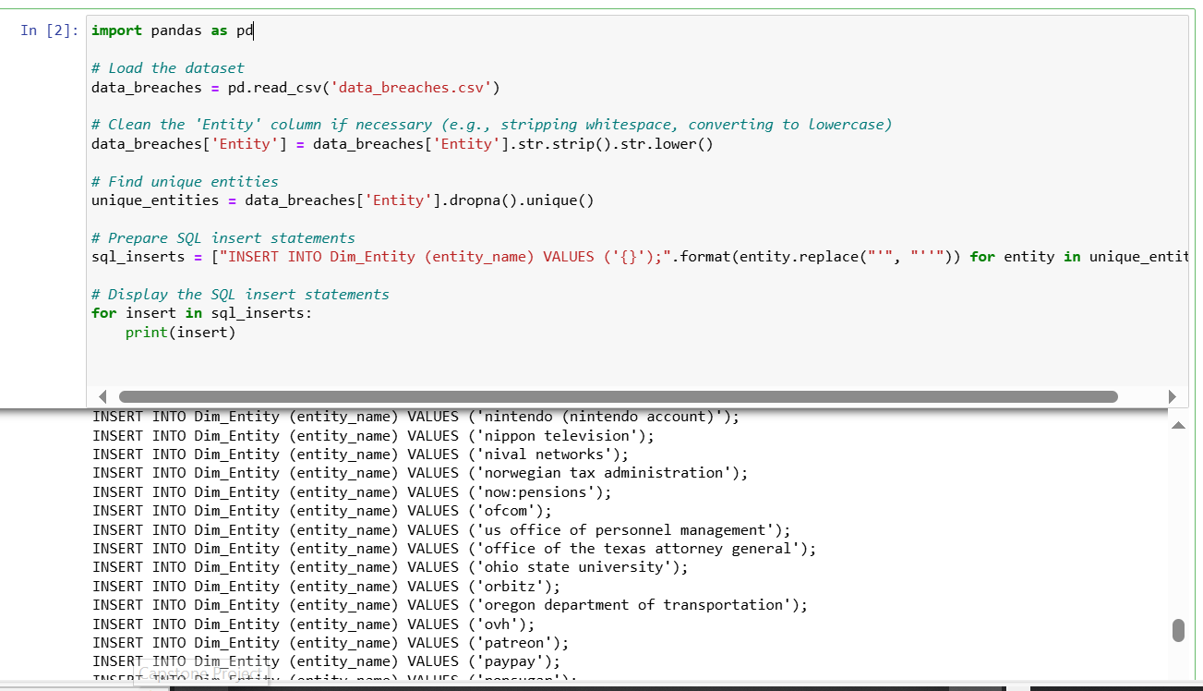A snapshot of python code of inserting data into MySQL database
- Populated Dimension Tables: Extracted and loaded unique values into each dimension table.
- Populated Fact Table: Mapped the foreign keys from dimension tables to the records in the fact table based on the dataset values.
ETL Process:
To simplify the ETL process I have loaded the dataset through python. I have created mapping for the dimension tables (entity, organization type, method). Assigned primary keys and prepared the fact table. I have built the dimension tables, merged the ids into main data frame and created the main fact table.
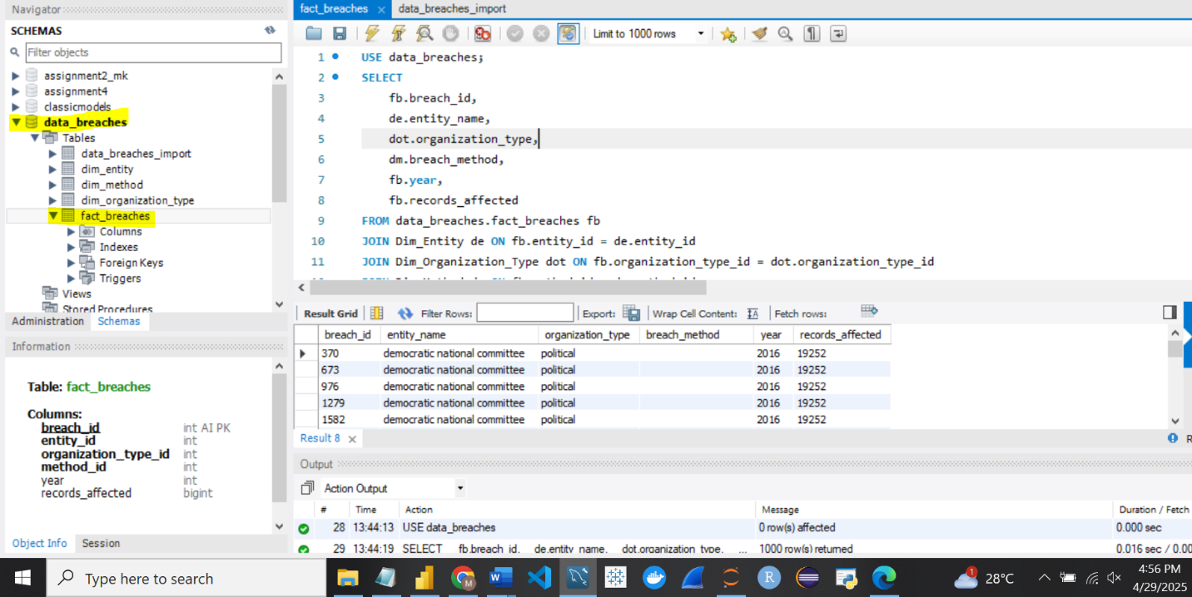

By using mysql.connector I have loaded the tables into mysql and inserted all the data. I have dim_entity, dim_organization_type and dim_method as my dimension tables and fact_breaches as a fact table. To ensure that my dimension table is only connecting to the fact table and not to any other dimension table I have executed the below query in mysql to validate my data.
Code: USE data_breaches;
SELECT
fb.breach_id,
de.entity_name,
dot.organization_type,
dm.breach_method,
fb.year,
fb.records_affected
FROM data_breaches.fact_breaches fb
JOIN Dim_Entity de ON fb.entity_id = de.entity_id
JOIN Dim_Organization_Type dot ON fb.organization_type_id = dot.organization_type_id
JOIN Dim_Method dm ON fb.method_id = dm.method_id;

Data Analysis and Visualizations:
After successful SQL query is executed and my data is loaded in the data frame, I have validated my data and did some visualizations in python. I have verified that my data is loaded correctly.
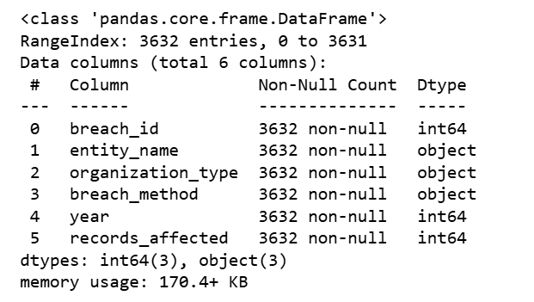
Source code:
# Checked the first few rows
df.head()
# See column names and types
df.info()
Trend of breaches over the years:
Here I have grouped all the breach records by year which counts how many incidents occurred each year. Through a line chart the data is grouped showing year and breach count. An increase after 2010 when more attacks and disclosures began. Major breach years were between 2013 – 2015 within Yahoo, Target.
Source code:
import matplotlib.pyplot as plt
import seaborn as sns
# Breaches per year
breach_trend = df.groupby('year').size().reset_index(name='breach_count')
plt.figure(figsize=(10,6))
sns.lineplot(data=breach_trend, x='year', y='breach_count', marker='o')
plt.title('Number of Data Breaches Over the Years')
plt.xlabel('Year')
plt.ylabel('Number of Breaches')
plt.grid(True)
plt.tight_layout()
plt.show()
Interpretation:
From the line chart, it is evident that the frequency of data breaches has increased significantly from 2010 onward, peaking around 2017–2019.
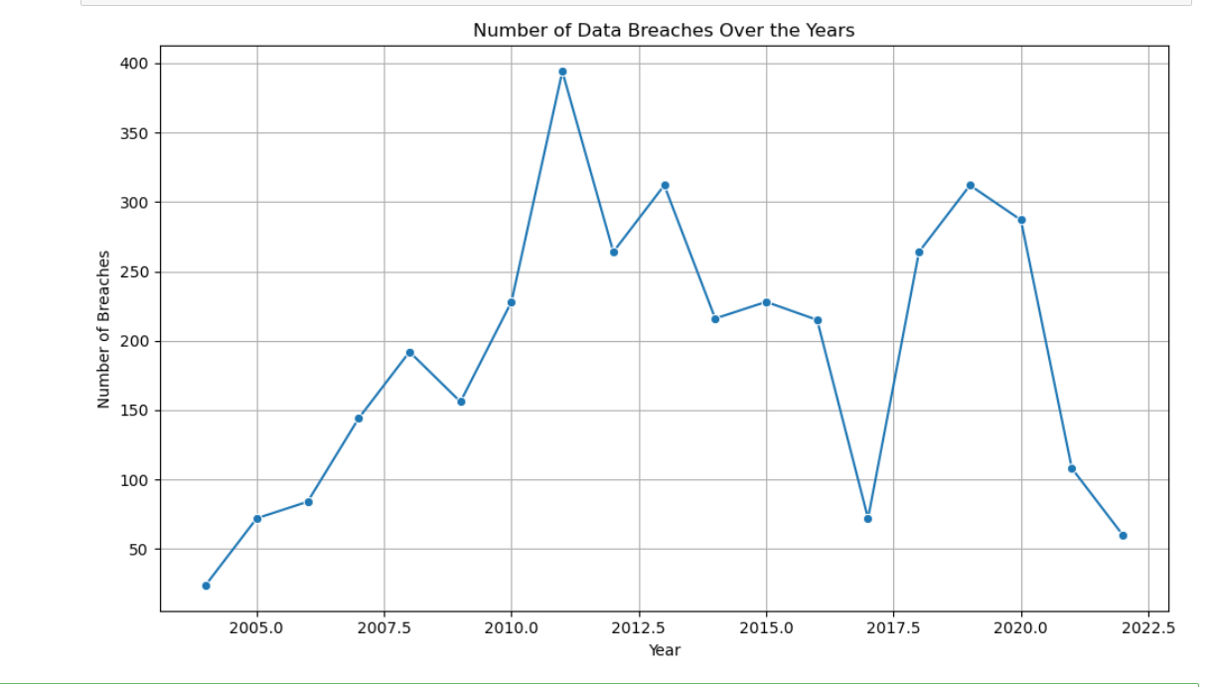

This suggests growing vulnerabilities as organizations become more digitized. The trend also reflects heightened attack sophistication and possibly improved reporting standards.
Sectors which are most vulnerable:
To identify which sectors are most vulnerable, I have analyzed the frequency of data breaches grouped by organization type. This provides insight into which industries experience the highest number of security incidents, revealing where cybercriminals are most active — or where security defenses are weakest. Using the cleaned dataset joined across fact and dimension tables, we grouped the data by organization_type and counted the number of breaches in each sector:
Code:
org_breach = df['organization_type'].value_counts().reset_index()
org_breach.columns = ['Organization Type', 'Breach Count']
plt.figure(figsize=(10,6))
sns.barplot(data=org_breach, x='Organization Type', y='Breach Count')
plt.title('Breaches by Organization Type')
plt.xticks(rotation=45, ha='right')
plt.tight_layout()
plt.show()
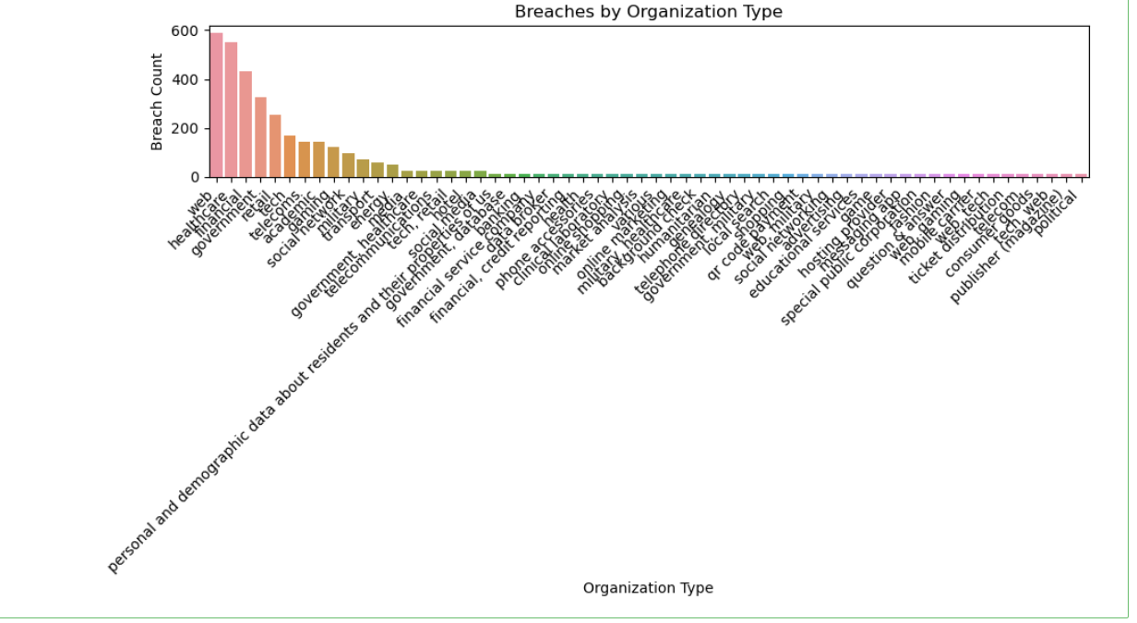

Findings based on the bar chart:

1. Healthcare
- Highest number of breaches among all sectors.
- Healthcare organizations hold vast amounts of sensitive personal and medical data, making them prime targets for identity theft, insurance fraud, and ransomware attacks.
- Often operate with outdated IT systems and tight budgets, increasing vulnerability.

2. Financial Services
- Frequently targeted due to the direct monetary value of breached data.
- Attackers exploit financial records, credit card info, and customer identities.
- Although this sector often has stronger compliance controls (e.g., PCI-DSS), the volume and impact of breaches remain high due to its attractiveness.

3. Retail & E-commerce
- Affected by large-scale breaches (e.g., POS malware, credential stuffing).
- Many incidents involve payment card theft and customer data leaks.
- Breaches often coincide with peak shopping periods.

4. Government
- Stores vast datasets of national importance: social security, tax records, military data, etc.
- Some breaches stem from nation-state actors aiming to access sensitive infrastructure or intelligence.

5. Technology & Social Media
- Not as frequent as others, but incidents tend to affect very large user bases (e.g., Yahoo, Facebook).
- Breaches often involve credential leaks, API abuse, or unauthorized access due to misconfigurations.
Interpretation:
The healthcare sector experiences the highest number of breaches, highlighting significant vulnerabilities in handling protected health information (PHI). Financial services follow, driven by the value of sensitive transactional data. Although technology companies have fewer breaches numerically, the scale and exposure per incident are disproportionately large. These findings stress the need for sector-specific cybersecurity policies and infrastructure upgrades.
How breach methods have evolved over time:
To understand how cyberattack strategies have changed, I have analyzed breach methods across a timeline, specifically how different techniques (e.g., hacking, insider threats, loss/theft of devices, unintended disclosure) have risen or declined from the early 2000s to the present.
Using the joined dataset (fact_breaches + Dim_Method), I have grouped breach counts by both year and method, and then visualized them using a stacked area chart to illustrate shifts in method popularity.
Code:
# Create a pivot table
method_trend = df.groupby(['year', 'breach_method']).size().unstack().fillna(0)
# Stacked area chart
method_trend.plot(kind='area', stacked=True, figsize=(12,6))
plt.title('Breach Methods Over Time')
plt.xlabel('Year')
plt.ylabel('Number of Breaches')
plt.legend(title='Method', bbox_to_anchor=(1.05, 1), loc='upper left')
plt.tight_layout()
plt.show()

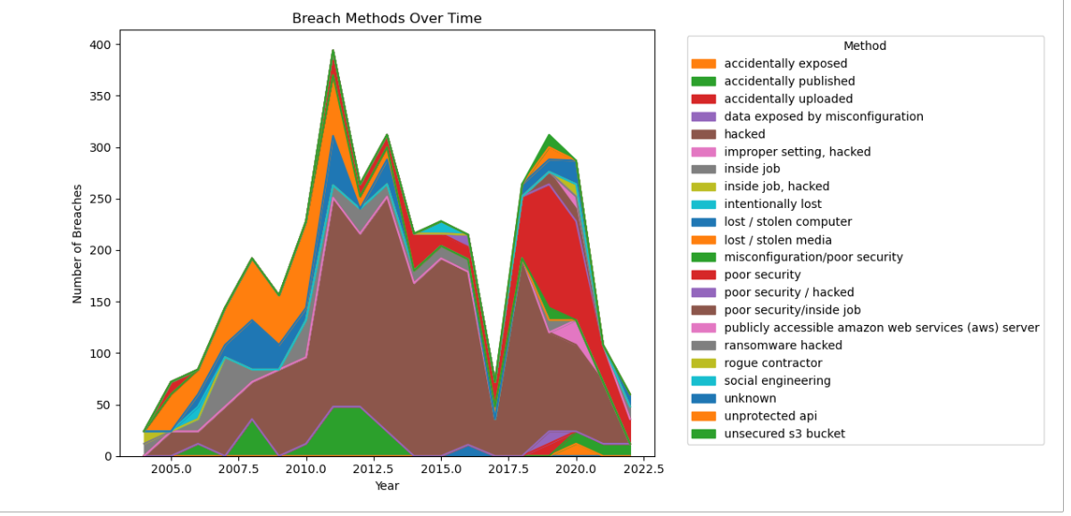

Findings on the stacked chart how breaches have evolved over time:

1.Hacking/IT Incidents Have Significantly Increased
- Hacking has become the dominant method of breach since the mid-2010s.
- Includes ransomware, phishing, brute force attacks, and exploits of unpatched vulnerabilities.
- This rise corresponds with increased digitization, cloud adoption, and broader attack surfaces.

2. Insider Threats Remain a Persistent Risk
- Incidents involving insider misuse or negligence have stayed relatively stable over time.
- Though not the most frequent, they tend to involve sensitive data and pose higher trust and detection challenges.

3. Lost or Stolen Devices Have Decreased
- Earlier years (2005–2012) show higher incidents involving laptops, USBs, and physical drives being lost or stolen.
- Since then, the numbers have declined, likely due to:
  - Increased encryption practices
  - Cloud-based storage replacing local devices
  - Better physical device policies

4. Unintended Disclosure or Configuration Errors Are Increasing
- In recent years, breaches due to human error or misconfigured databases/cloud buckets (e.g., open AWS S3 buckets) have become more common.
- These reflect growing complexity in managing digital systems securely.
Interpretation:
The evolution of breach methods shows a clear shift from physical threats (lost/stolen devices) to sophisticated digital attacks like hacking and misconfiguration errors. As organizations have moved to cloud-based systems and improved device security, attackers have adapted with new tactics, exploiting both technical vulnerabilities and human error. This emphasizes the need for organizations to continually update both their technical defenses and employee training programs to stay ahead of evolving threats.
Common points of failure in existing security infrastructures:
I have analyzed this problem based on the breach methods and the organization type. This helps pinpoint where security controls may be weakest, whether technical (e.g., servers), process-related (e.g., misconfiguration), or human (e.g., insider error).
Source code: based on breach method
method_failure = df.groupby('breach_method')['records_affected'].sum().reset_index().sort_values(by='records_affected', ascending=False)
import seaborn as sns
import matplotlib.pyplot as plt
plt.figure(figsize=(10,6))
sns.barplot(data=method_failure, x='records_affected', y='breach_method')
plt.title('Total Records Leaked by Breach Method')
plt.xlabel('Records Affected')
plt.ylabel('Breach Method')
plt.tight_layout()
plt.show()
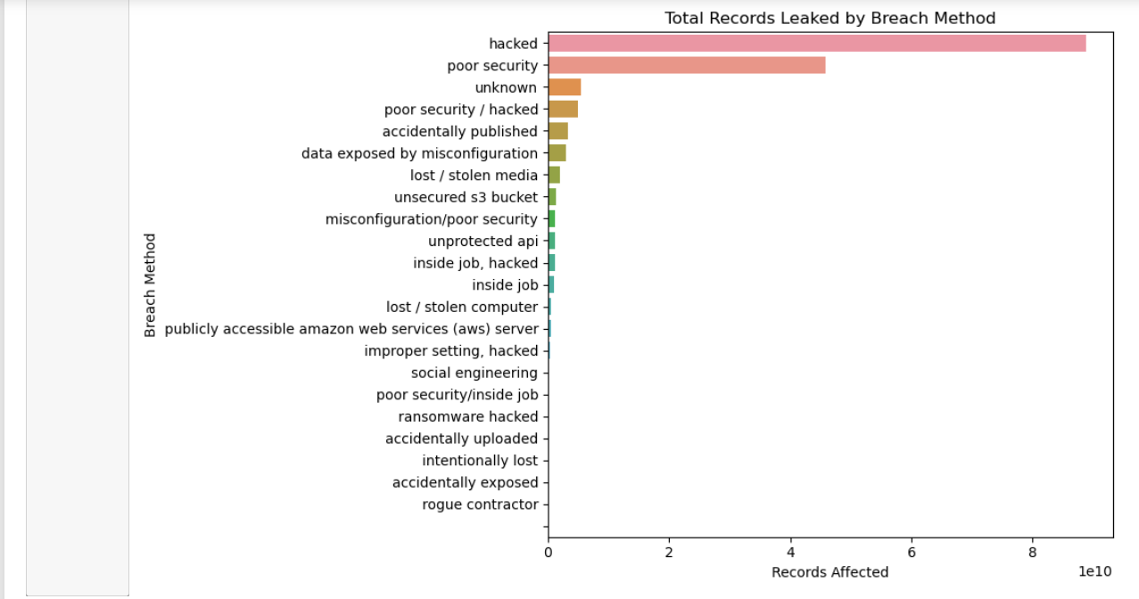

Code:
org_failure = df.groupby('organization_type')['records_affected'].sum().reset_index().sort_values(by='records_affected', ascending=False)

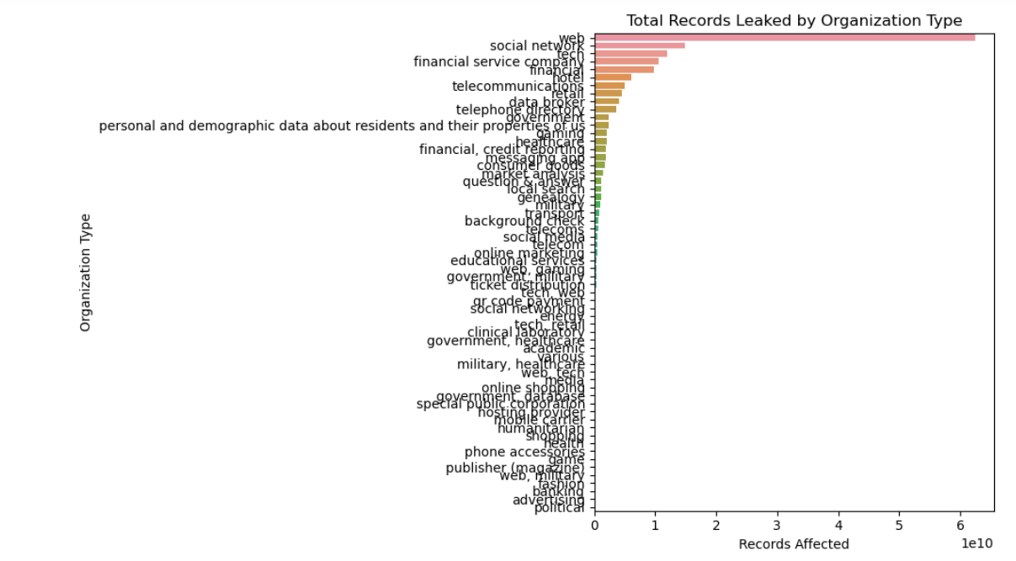
plt.figure(figsize=(10,6))
sns.barplot(data=org_failure, x='records_affected', y='organization_type')
plt.title('Total Records Leaked by Organization Type')
plt.xlabel('Records Affected')
plt.ylabel('Organization Type')
plt.tight_layout()
plt.show()
Findings based on the chart:
- Hacking and Unintended Disclosure are the top failure points, leading to the most records compromised.
- Healthcare and Financial sectors show the highest data exposure — reflecting weaker or outdated security systems.
- Cloud misconfigurations, phishing, and lack of encryption emerge as common technical and human-related gaps.
Interpretation:
The most damaging failures stem from external hacking and misconfigured systems, often due to insufficient access controls, poor cloud hygiene, or outdated infrastructure. Sectors like healthcare and finance, despite holding critical data, show repeated high-impact exposures, suggesting an urgent need for stronger end-to-end cybersecurity governance.
Conclusion:
This project successfully demonstrates the end-to-end automation of a data analytics pipeline for cybersecurity breach analysis using an Enterprise Data Warehouse (EDW) design. Leveraging Python for ETL processes, MySQL for structured data storage, and visualization tools like Matplotlib and Seaborn, the project transforms raw breach data into actionable intelligence.
The star schema implemented in the EDW enables efficient querying and scalable analytics. Key findings revealed that hacking and misconfiguration are the leading causes of large-scale data exposure, with healthcare and financial sectors being the most vulnerable. The evolving nature of breach methods, shifting from physical device loss to sophisticated digital exploits, highlights the critical need for modern, adaptable security frameworks.
This project not only delivers insights into the cybersecurity threat landscape but also showcases how automation and data modeling can empower organizations to respond more proactively to risk. Future extensions could involve integrating real-time data ingestion, advanced predictive modeling, or connecting the EDW to business intelligence platforms like Tableau or Power BI for live dashboards.

References
https://www.kaggle.com/datasets/thedevastator/data-breaches-a-comprehensive-list
https://www.verizon.com/business/resources/reports/dbir/
https://docs.sqlalchemy.org/
https://matplotlib.org/stable/contents.html

