Practice Questions for 3rd Exam

1. ) Name the following compound:

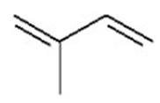

A) isoprene

B) 3-methyl-1,3-butadiene

C) 2-methyl-1,3-butadiene

D) 2-methyl-2,3-butadiene

E) isobutadiene

Answer: C

2. Write structures and give systematic names for all alkynes with molecular formula C5H8.

Answer:

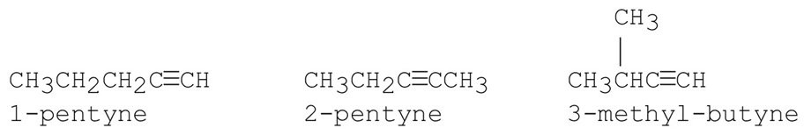

Section: 7-1

3. Name the following compound:

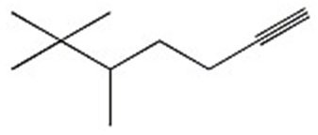

Answer: 5,6,6-trimethyl-1-heptyne

4. What is the hybridization of the carbons numbered 1 and 2 in the following compound?

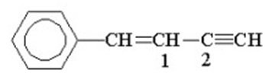

A) *sp*3, *sp*2

B) *sp*2, *sp*2

C) *sp*, *sp*

D) *sp*2, *sp*

E) *sp*, *sp*2

Answer: D

5. ) Draw the major product of the following reaction:

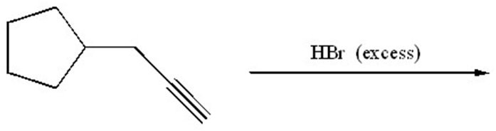

Answer:

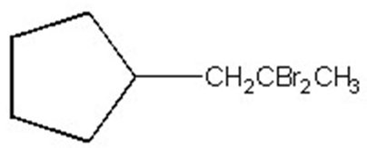

6. Draw the major product of the following reaction:

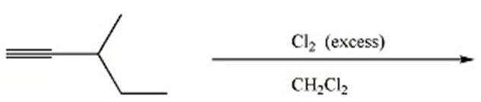

Answer:

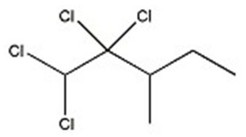

Section: 7-6

MCAT: 9.2

7. Draw the major product of the following reaction:

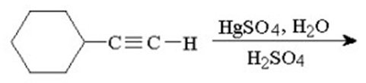

Answer:

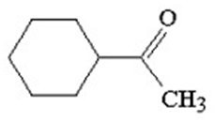

8. Draw the major product of the following reaction:

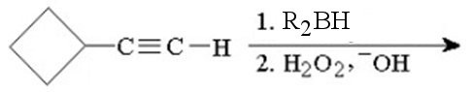

Answer:

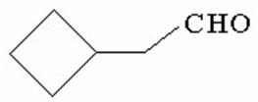

9. ) Draw the major product of the following reaction:

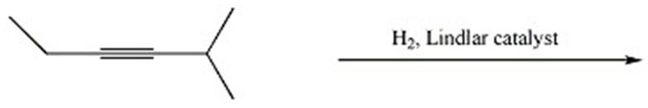

Answer:

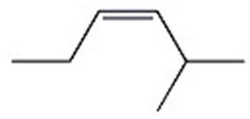

10. What is the major product of the following reaction?

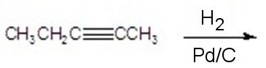

A) CH3CH2CH2CH2CH3

B)

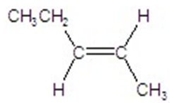

C)

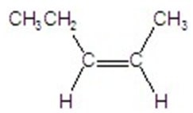

D)

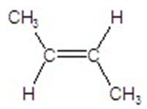

E)

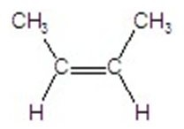

Answer: A

11. What reagents should be used for the reaction shown below?

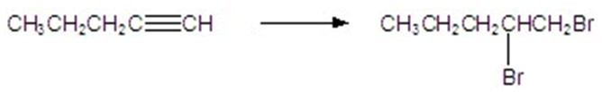

Answer: 1. H2, Lindlar catalyst or Na, NH3; 2. Br2

12. Show the sequence of reagents required to prepare 3-heptyne from acetylene.

Answer:

1) NaNH2

2) CH3CH2Br

3) NaNH2

4) CH3CH2CH2Br

13. Show the sequence of reagents required to prepare CH3CH2CH2CH2CHO from acetylene.

Answer:

1) NaNH2

2) CH3CH2CH2Br

3) disiamylborane

4) H2O2, -OH

14. Which of the following alkyl halides is the least reactive in an SN2 reaction?

A) CH3CH2Cl

B)

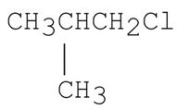

C)

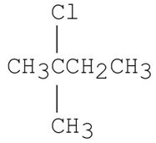

D)

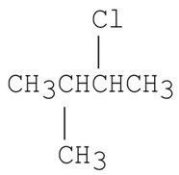

E)

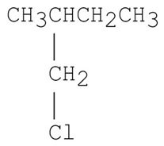

Answer: C

15. How does doubling the concentration of the alkyl halide in the following SN2 reaction affect the rate of the reaction?

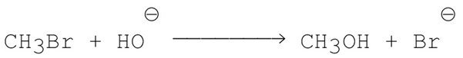

A) no change

B) doubles the rate

C) triples the rate

D) quadruples the rate

E) rate is halved

Answer: B

16. Which of the following is not a nucleophile?

A) NH3

B) NH2CH3

C) HCC**:**-

D) CH3CH2+

Answer: D

17. Which of the following is the best leaving group?

A) HO-

B) F-

C) Cl-

D) Br-

E) I-

Answer: E

18. How does doubling the concentration of the alkyl halide in the following SN1 reaction affect the rate of the reaction?

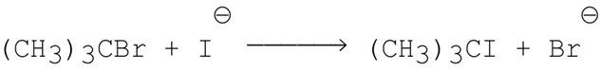

A) no change

B) doubles the rate

C) triples the rate

D) quadruples the rate

E) rate is halved

Answer: B

19. Which of the following alkyl halides is the most reactive in an SN1 reaction?

A)

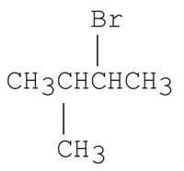

B)

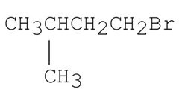

C)

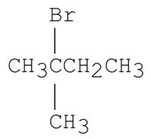

D)

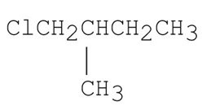

E)

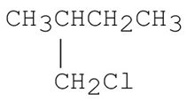

Answer: C

20. What is the major product of the following E2 reaction?

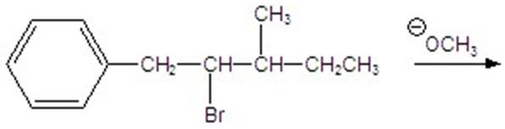

A)

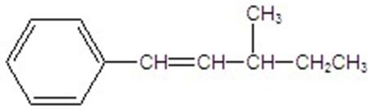

B)

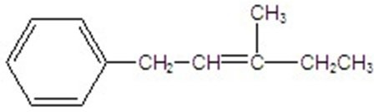

C)

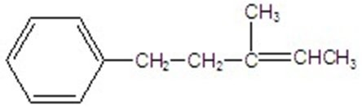

D)

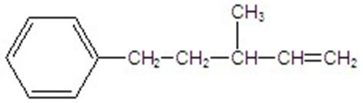

E) none of the above

Answer: A

21. What is the major product of the following E2 reaction?

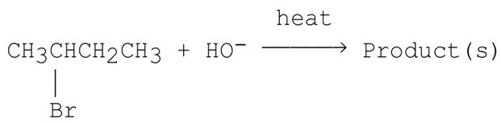

A)

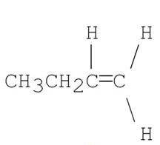

B) CH3CH2CHCH2

C)

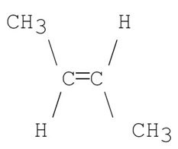

D)

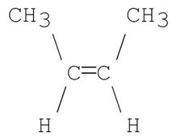

E)

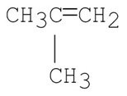

Answer: C

22. Which of the compounds shown below is the product of this reaction?

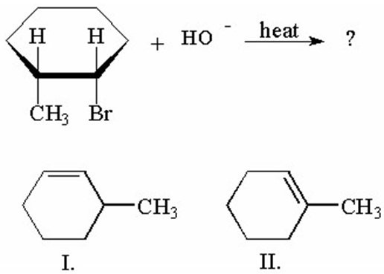

A) I only

B) II only

C) I and II are of equal yield.

D) I is major, II is minor.

E) I is minor, II is major.

Answer: E

23. What kind of reaction is the one shown below?

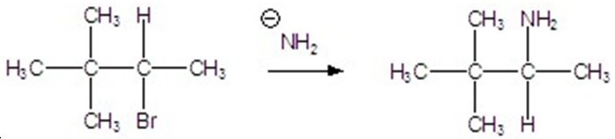

A) SN1

B) SN2

C) E1

D) E2

E) none of the above

Answer: B

24. What is the product of the following reaction?

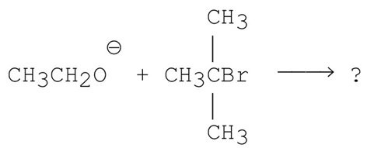

A)

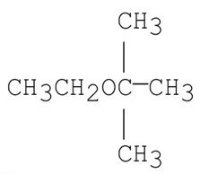

B) CH2CH2

C)

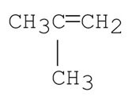

D) A and B

E) A and C

Answer: C

25. Draw the major product of the following reaction:

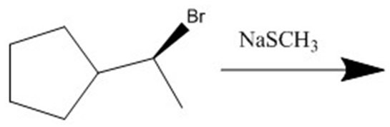

Answer:

