package shapesTest;

import static org.junit.jupiter.api.Assertions.\*;

import org.junit.jupiter.api.Test;

import shapes.AllShapes;

import shapes.Circle;

import shapes.Rectangle;

import shapes.RtAngleTriangle;

class shapesTest {

AllShapes shapes = new AllShapes();

@Test

void r1r2Test() {

Rectangle r1 = new Rectangle ("red", 2,3);

shapes.add(r1);

Rectangle r2 = new Rectangle ("red", 2,3);

shapes.add (r2);

assertEquals(r2.getColour(),r1.getColour());

assertEquals(r2.getLength(), r1.getLength());

assertEquals(r2.getWidth(), r1.getWidth());

}

@Test

void r1r3test(){

Rectangle r1 = new Rectangle ("red", 2,3);

shapes.add(r1);

Rectangle r3 = new Rectangle ("green", 2,3);

shapes.add (r3);

assertNotEquals(r3.getColour(),r1.getColour());

assertEquals(r3.getLength(), r1.getLength());

assertEquals(r3.getWidth(), r1.getWidth());

}

@Test

void t1Base() {

RtAngleTriangle t1 = new RtAngleTriangle ("red", 2,4);

shapes.add(t1);

assertEquals(4,t1.getBase());

}

@Test

void fifthLoc() {

Circle c1 = new Circle ("green", 4);

shapes.add(c1);

assertEquals(c1, shapes.getShape(0));

}

}

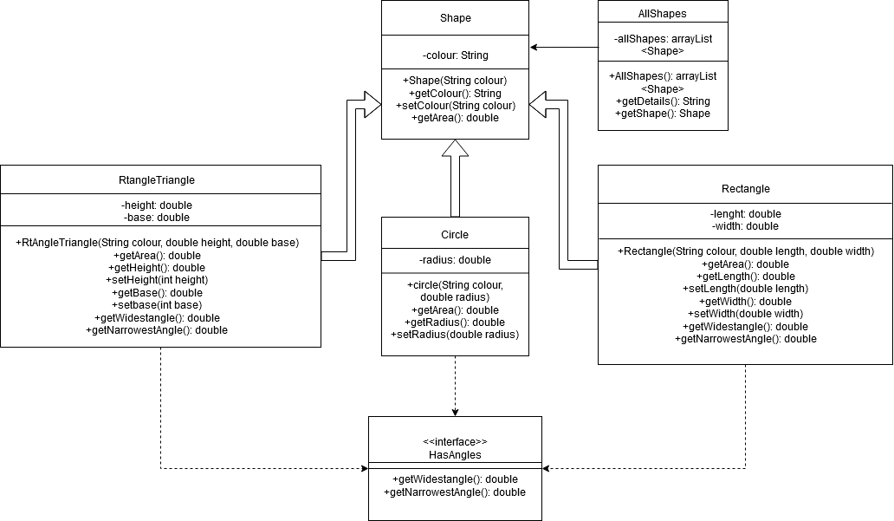

package staffListTest;

import static org.junit.jupiter.api.Assertions.\*;

import org.junit.jupiter.api.Test;

import staffList.CharityStaff;

import staffList.Name;

class staffListTest {

CharityStaff CS = new CharityStaff();

@Test

void getTotalHoursTest() {

CS.populate();

assertEquals(CS.getTotalHours(), 75);

}

@Test

void findPersonTest() {

CS.populate();

assertEquals(CS.findPerson("Helen Scott").getName().getFullName(), "Helen Scott");

}

@Test

void listAllVoulunteersTest() {

CS.populate();

assertEquals(CS.listAllVolunteers(), "ALL VOLUNTEERS\n" +

"Helen Scott\n" +

"James Jackson\n" +

"\n" +

"");

}

@Test

void populateTest() {// must test all 5 of them

CS.populate();

assertEquals(CS.findPerson("Helen Scott").getName().getFullName(), "Helen Scott");

assertEquals(CS.findPerson("James Jackson").getName().getFullName(), "James Jackson");

assertEquals(CS.findPerson("Tim Moore").getName().getFullName(), "Tim Moore");

assertEquals(CS.findPerson("Mary Munro").getName().getFullName(), "Mary Munro");

assertEquals(CS.findPerson("Keith Clark").getName().getFullName(), "Keith Clark");

}

@Test

void equalsTest() {

CS.populate();

assertTrue(CS.findPerson("Helen Scott").equals(CS.findPerson("Helen Scott")));

}

}

