Cloud Developing B (CLDV6212)



Name: Sthobile
Surname: Mkhabela
Student Number: ST10448774
Module code: INSY7213
Task Number: ICE Tasks 1 & 2

Table of Contents
Activities and Instructions 3
References 5

Table of Figures
Figure 1: Micrososft Learn. Table Storage. 3
Figure 2: GitHub. Azure Queue Storage. 3
Figure 3: K21 Academy. Azure Blob Storage: Features, Usage, And Steps to Create. 4

Activities and Instructions
- The primary benefits of using table storage over other storage options include:
- It is does not have strict schema requirements
- Cost-effective
- Ideal for storing semi-structured data
- Scenarios where Table storage would be a better option:
  - When storing user data
  - Storing product catalogs
  - Storing simple customer order details
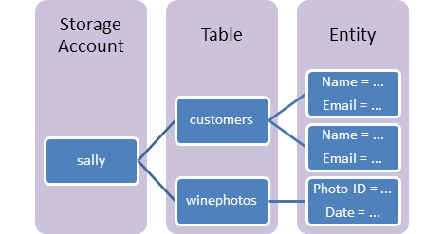
Figure 1: Micrososft Learn. Table Storage.
(Microsoft Learn, 2022)
- Queue storage scenarios:
- When sending messages to different parts of an application
- If there is a need to process tasks one at a time
- Managing traffic spikes by storing requests temporarily
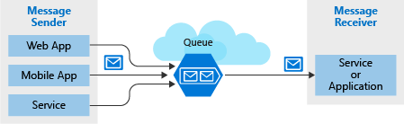
Figure 2: GitHub. Azure Queue Storage.
(GitHub, 2020)

- Common blob storage use cases:
- Storing website content (images, videos, etc.)
- Storing backups
- Storing data for analytics

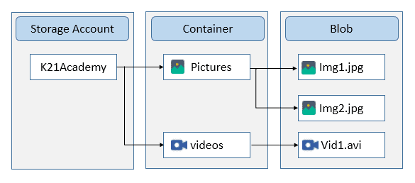
Figure 3: K21 Academy. Azure Blob Storage: Features, Usage, And Steps to Create.
(K21 Academy, 2023)

(The IIE, 2014)

References
GitHub. 2020. Azure Queue Storage. [Online]. Available at: https://basvo.github.io/azure/queue/storage/2020/03/07/communicate-with-azure-queue-storage.html [Accessed 29 July 2025]
K21 Academy. 2023. Azure Blob Storage: Features, Usage, And Steps to Create. [Online]. Available at: https://k21academy.com/microsoft-azure/admin/azure-blob-storage/ [Accessed 30 July 2025]
Microsoft Learn. 2022. Table Storage. [Online]. Available at: https://learn.microsoft.com/en-us/azure/storage/tables/table-storage-overview [Accessed 29 July 2025]
The IIE. 2014. Cloud Data Management and Communication [CLDV6212 ARC]. The Independant Institute of Education: Unpublished.

