Programming 2B (PROG6212)


Name: Sthobile
Surname: Mkhabela
Student no.: ST10448774
Assignment type: Ice task

Table of Contents
Part 1 – UI 3

Table of Figures
Figure 1: Login page 3
Figure 2: Information Page 3
Figure 3: Documents upload page 4
Figure 4: Confirmation page 4

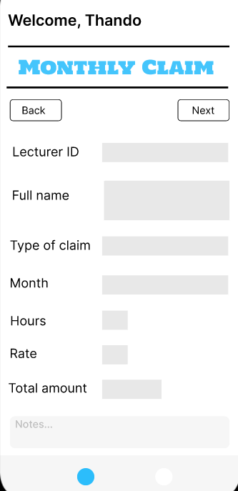
Part 1 – UI
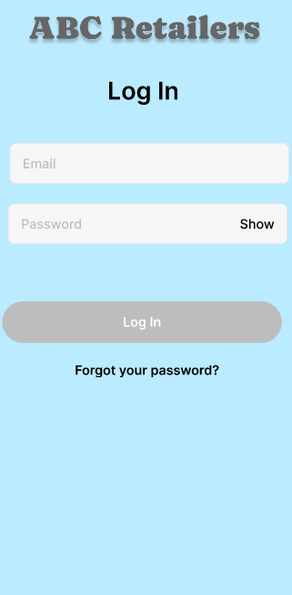

Figure 1: Login page
Figure 2: Information Page
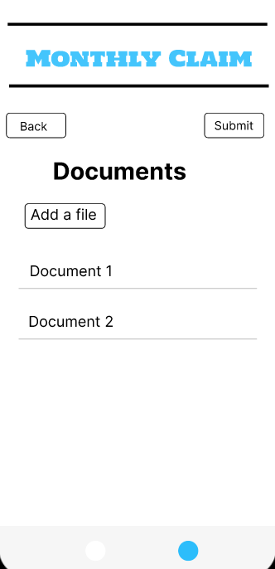
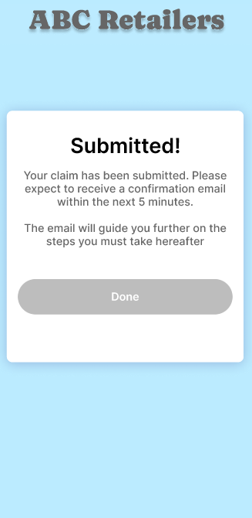
Figure 3: Documents upload page
Figure 4: Confirmation page

(Figma, 2025)

References
Figma. (2025). Figma. Available at: https://www.figma.com [Accessed 14 August 2025]

