***Analyze by visualizing data***

***Correlating***

***To confirm some of our observations and assumptions, we can quickly analyze our feature correlations by pivoting features against each other. We can only do so at this stage for features which do not have any empty values. It also makes sense doing so only for features which are categorical (Sex), ordinal (Pclass) or discrete (SibSp, Parch) type.***

***Pclass We observe significant correlation (>0.5) among Pclass=1 and Survived. We decide to include this feature in our model.***

***Sex We confirm the observation during problem definition that Sex=female had very high survival rate at 74%.***

***SibSp and Parch These features have zero correlation for certain values. It may be best to derive a feature or a set of features from these individual features.***

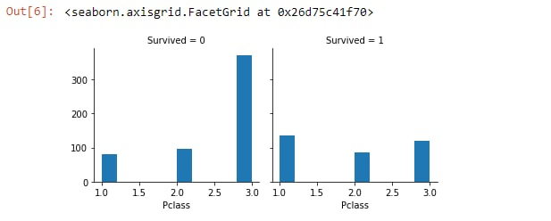

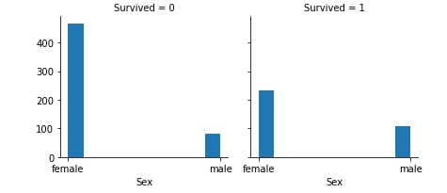

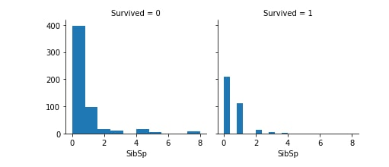

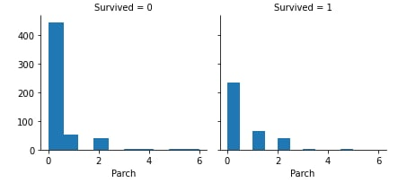

***This correlating between Age and Survived.***

***In this map, it shows us that the number of people who died ranged from 20 to 40 years old***

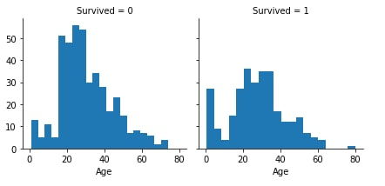

***This correlating among Age ,Pclass and Survived.***

***In this map, it shows us that the number of most people who died, ranging in age from 20 to 40 years, belonged to Pclass 3 and Most of the people who were saved belonged to Pclass 1.***

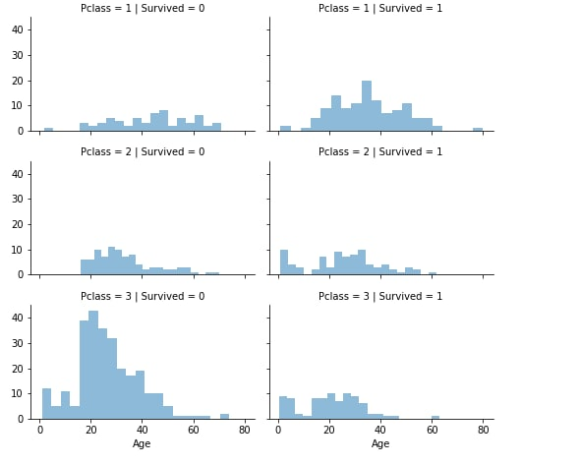

***We may also want to correlate categorical features (with non-numeric values) and numeric features. We can consider correlating Embarked (Categorical non-numeric), Sex (Categorical non-numeric), Fare (Numeric continuous), with Survived (Categorical numeric).***

***In this map it is shown that the number of more people who were rescued, whether men or women, belonged to Embarked C.***

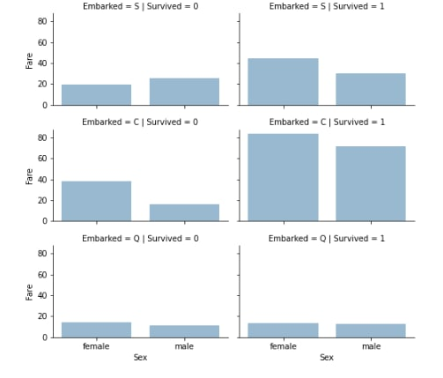

***correlating among (pclass),(Sex),(Age).***

***In this map, it shows that the number of most people who died between the ages of 20 and 40 years and belonged to Pclass 3 were men .***

