Codebook for mean_SD

Autogenerated data summary from dataMaid

2021-05-15 20:02:33

# Data report overview

The dataset examined has the following dimensions:

|  |  |
| --- | --- |
| Feature | Result |
| Number of observations | 10299 |
| Number of variables | 87 |

# Codebook summary table

|  |  |  |  |  |  |
| --- | --- | --- | --- | --- | --- |
| Label | Variable | Class | # unique values | Missing | Description |
|  | **subject** | integer | 30 | 0.00 % |  |
|  | **timeBodyAccelerometer.mean…X** | numeric | 10292 | 0.00 % |  |
|  | **timeBodyAccelerometer.mean…Y** | numeric | 10299 | 0.00 % |  |
|  | **timeBodyAccelerometer.mean…Z** | numeric | 10293 | 0.00 % |  |
|  | **timeGravityAccelerometer.mean…X** | numeric | 10296 | 0.00 % |  |
|  | **timeGravityAccelerometer.mean…Y** | numeric | 10298 | 0.00 % |  |
|  | **timeGravityAccelerometer.mean…Z** | numeric | 10299 | 0.00 % |  |
|  | **timeBodyAccelerometerJerk.mean…X** | numeric | 10299 | 0.00 % |  |
|  | **timeBodyAccelerometerJerk.mean…Y** | numeric | 10299 | 0.00 % |  |
|  | **timeBodyAccelerometerJerk.mean…Z** | numeric | 10299 | 0.00 % |  |
|  | **timeBodyGyroscope.mean…X** | numeric | 10298 | 0.00 % |  |
|  | **timeBodyGyroscope.mean…Y** | numeric | 10299 | 0.00 % |  |
|  | **timeBodyGyroscope.mean…Z** | numeric | 10297 | 0.00 % |  |
|  | **timeBodyGyroscopeJerk.mean…X** | numeric | 10295 | 0.00 % |  |
|  | **timeBodyGyroscopeJerk.mean…Y** | numeric | 10299 | 0.00 % |  |
|  | **timeBodyGyroscopeJerk.mean…Z** | numeric | 10298 | 0.00 % |  |
|  | **timeBodyAccelerometerMagnitude.mean..** | numeric | 10296 | 0.00 % |  |
|  | **timeGravityAccelerometerMagnitude.mean..** | numeric | 10296 | 0.00 % |  |
|  | **timeBodyAccelerometerJerkMagnitude.mean..** | numeric | 10292 | 0.00 % |  |
|  | **timeBodyGyroscopeMagnitude.mean..** | numeric | 10298 | 0.00 % |  |
|  | **timeBodyGyroscopeJerkMagnitude.mean..** | numeric | 10293 | 0.00 % |  |
|  | **frequencyBodyAccelerometer.mean…X** | numeric | 10295 | 0.00 % |  |
|  | **frequencyBodyAccelerometer.mean…Y** | numeric | 10292 | 0.00 % |  |
|  | **frequencyBodyAccelerometer.mean…Z** | numeric | 10295 | 0.00 % |  |
|  | **frequencyBodyAccelerometer.meanFreq…X** | numeric | 10299 | 0.00 % |  |
|  | **frequencyBodyAccelerometer.meanFreq…Y** | numeric | 10299 | 0.00 % |  |
|  | **frequencyBodyAccelerometer.meanFreq…Z** | numeric | 10299 | 0.00 % |  |
|  | **frequencyBodyAccelerometerJerk.mean…X** | numeric | 10293 | 0.00 % |  |
|  | **frequencyBodyAccelerometerJerk.mean…Y** | numeric | 10296 | 0.00 % |  |
|  | **activity** | numeric | 10294 | 0.00 % |  |
|  | **frequencyBodyAccelerometerJerk.meanFreq…X** | numeric | 10298 | 0.00 % |  |
|  | **frequencyBodyAccelerometerJerk.meanFreq…Y** | numeric | 10299 | 0.00 % |  |
|  | **frequencyBodyAccelerometerJerk.meanFreq…Z** | numeric | 10298 | 0.00 % |  |
|  | **frequencyBodyGyroscope.mean…X** | numeric | 10297 | 0.00 % |  |
|  | **frequencyBodyGyroscope.mean…Y** | numeric | 10296 | 0.00 % |  |
|  | **frequencyBodyGyroscope.mean…Z** | numeric | 10297 | 0.00 % |  |
|  | **frequencyBodyGyroscope.meanFreq…X** | numeric | 10298 | 0.00 % |  |
|  | **frequencyBodyGyroscope.meanFreq…Y** | numeric | 10299 | 0.00 % |  |
|  | **frequencyBodyGyroscope.meanFreq…Z** | numeric | 10299 | 0.00 % |  |
|  | **frequencyBodyAccelerometerMagnitude.mean..** | numeric | 10296 | 0.00 % |  |
|  | **frequencyBodyAccelerometerMagnitude.meanFreq..** | numeric | 10299 | 0.00 % |  |
|  | **frequencyBodyAccelerometerJerkMagnitude.mean..** | numeric | 10290 | 0.00 % |  |
|  | **frequencyBodyAccelerometerJerkMagnitude.meanFreq..** | numeric | 10299 | 0.00 % |  |
|  | **frequencyBodyGyroscopeMagnitude.mean..** | numeric | 10297 | 0.00 % |  |
|  | **frequencyBodyGyroscopeMagnitude.meanFreq..** | numeric | 10299 | 0.00 % |  |
|  | **frequencyBodyGyroscopeJerkMagnitude.mean..** | numeric | 10293 | 0.00 % |  |
|  | **frequencyBodyGyroscopeJerkMagnitude.meanFreq..** | numeric | 10299 | 0.00 % |  |
|  | **angle.tBodyAccelerometerMean.gravity.** | numeric | 10299 | 0.00 % |  |
|  | **angle.tBodyAccelerometerJerkMean..gravityMean.** | numeric | 10299 | 0.00 % |  |
|  | **angle.tBodyGyroscopeMean.gravityMean.** | numeric | 10299 | 0.00 % |  |
|  | **angle.tBodyGyroscopeJerkMean.gravityMean.** | numeric | 10299 | 0.00 % |  |
|  | **angle.X.gravityMean.** | numeric | 10299 | 0.00 % |  |
|  | **angle.Y.gravityMean.** | numeric | 10299 | 0.00 % |  |
|  | **angle.Z.gravityMean.** | numeric | 10299 | 0.00 % |  |
|  | **timeBodyAccelerometer.std…X** | numeric | 10295 | 0.00 % |  |
|  | **timeBodyAccelerometer.std…Y** | numeric | 10297 | 0.00 % |  |
|  | **timeBodyAccelerometer.std…Z** | numeric | 10297 | 0.00 % |  |
|  | **timeGravityAccelerometer.std…X** | numeric | 10288 | 0.00 % |  |
|  | **timeGravityAccelerometer.std…Y** | numeric | 10293 | 0.00 % |  |
|  | **timeGravityAccelerometer.std…Z** | numeric | 10296 | 0.00 % |  |
|  | **timeBodyAccelerometerJerk.std…X** | numeric | 10290 | 0.00 % |  |
|  | **timeBodyAccelerometerJerk.std…Y** | numeric | 10296 | 0.00 % |  |
|  | **timeBodyAccelerometerJerk.std…Z** | numeric | 10293 | 0.00 % |  |
|  | **timeBodyGyroscope.std…X** | numeric | 10292 | 0.00 % |  |
|  | **timeBodyGyroscope.std…Y** | numeric | 10296 | 0.00 % |  |
|  | **timeBodyGyroscope.std…Z** | numeric | 10296 | 0.00 % |  |
|  | **timeBodyGyroscopeJerk.std…X** | numeric | 10292 | 0.00 % |  |
|  | **timeBodyGyroscopeJerk.std…Y** | numeric | 10295 | 0.00 % |  |
|  | **timeBodyGyroscopeJerk.std…Z** | numeric | 10291 | 0.00 % |  |
|  | **timeBodyAccelerometerMagnitude.std..** | numeric | 10294 | 0.00 % |  |
|  | **timeGravityAccelerometerMagnitude.std..** | numeric | 10294 | 0.00 % |  |
|  | **timeBodyAccelerometerJerkMagnitude.std..** | numeric | 10294 | 0.00 % |  |
|  | **timeBodyGyroscopeMagnitude.std..** | numeric | 10298 | 0.00 % |  |
|  | **timeBodyGyroscopeJerkMagnitude.std..** | numeric | 10297 | 0.00 % |  |
|  | **frequencyBodyAccelerometer.std…X** | numeric | 10294 | 0.00 % |  |
|  | **frequencyBodyAccelerometer.std…Y** | numeric | 10297 | 0.00 % |  |
|  | **frequencyBodyAccelerometer.std…Z** | numeric | 10296 | 0.00 % |  |
|  | **frequencyBodyAccelerometerJerk.std…X** | numeric | 10291 | 0.00 % |  |
|  | **frequencyBodyAccelerometerJerk.std…Y** | numeric | 10294 | 0.00 % |  |
|  | **frequencyBodyAccelerometerJerk.std…Z** | numeric | 10290 | 0.00 % |  |
|  | **frequencyBodyGyroscope.std…X** | numeric | 10297 | 0.00 % |  |
|  | **frequencyBodyGyroscope.std…Y** | numeric | 10293 | 0.00 % |  |
|  | **frequencyBodyGyroscope.std…Z** | numeric | 10295 | 0.00 % |  |
|  | **frequencyBodyAccelerometerMagnitude.std..** | numeric | 10298 | 0.00 % |  |
|  | **frequencyBodyAccelerometerJerkMagnitude.std..** | numeric | 10296 | 0.00 % |  |
|  | **frequencyBodyGyroscopeMagnitude.std..** | numeric | 10296 | 0.00 % |  |
|  | **frequencyBodyGyroscopeJerkMagnitude.std..** | numeric | 10292 | 0.00 % |  |

# Variable list

## subject

|  |  |
| --- | --- |
| Feature | Result |
| Variable type | integer |
| Number of missing obs. | 0 (0 %) |
| Number of unique values | 30 |
| Median | 17 |
| 1st and 3rd quartiles | 9; 24 |
| Min. and max. | 1; 30 |

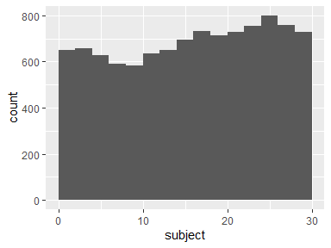

## timeBodyAccelerometer.mean…X

|  |  |
| --- | --- |
| Feature | Result |
| Variable type | numeric |
| Number of missing obs. | 0 (0 %) |
| Number of unique values | 10292 |
| Median | 0.28 |
| 1st and 3rd quartiles | 0.26; 0.29 |
| Min. and max. | -1; 1 |

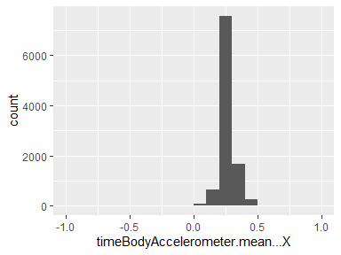

## timeBodyAccelerometer.mean…Y

|  |  |
| --- | --- |
| Feature | Result |
| Variable type | numeric |
| Number of missing obs. | 0 (0 %) |
| Number of unique values | 10299 |
| Median | -0.02 |
| 1st and 3rd quartiles | -0.02; -0.01 |
| Min. and max. | -1; 1 |

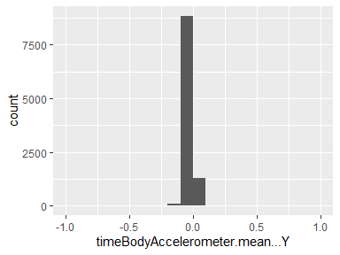

## timeBodyAccelerometer.mean…Z

|  |  |
| --- | --- |
| Feature | Result |
| Variable type | numeric |
| Number of missing obs. | 0 (0 %) |
| Number of unique values | 10293 |
| Median | -0.11 |
| 1st and 3rd quartiles | -0.12; -0.1 |
| Min. and max. | -1; 1 |

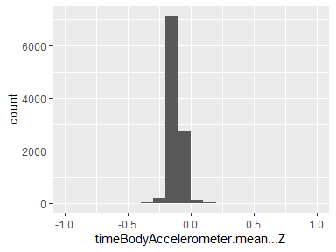

## timeGravityAccelerometer.mean…X

|  |  |
| --- | --- |
| Feature | Result |
| Variable type | numeric |
| Number of missing obs. | 0 (0 %) |
| Number of unique values | 10296 |
| Median | 0.92 |
| 1st and 3rd quartiles | 0.81; 0.95 |
| Min. and max. | -1; 1 |

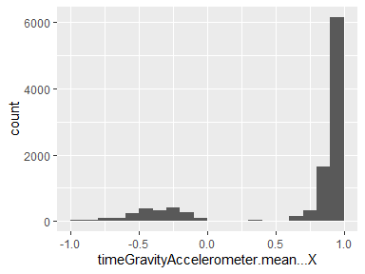

## timeGravityAccelerometer.mean…Y

|  |  |
| --- | --- |
| Feature | Result |
| Variable type | numeric |
| Number of missing obs. | 0 (0 %) |
| Number of unique values | 10298 |
| Median | -0.14 |
| 1st and 3rd quartiles | -0.24; 0.12 |
| Min. and max. | -1; 1 |

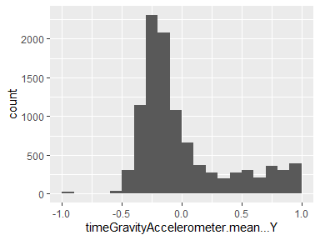

## timeGravityAccelerometer.mean…Z

|  |  |
| --- | --- |
| Feature | Result |
| Variable type | numeric |
| Number of missing obs. | 0 (0 %) |
| Number of unique values | 10299 |
| Median | 0.04 |
| 1st and 3rd quartiles | -0.12; 0.22 |
| Min. and max. | -1; 1 |

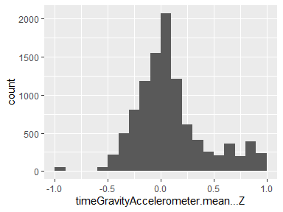

## timeBodyAccelerometerJerk.mean…X

|  |  |
| --- | --- |
| Feature | Result |
| Variable type | numeric |
| Number of missing obs. | 0 (0 %) |
| Number of unique values | 10299 |
| Median | 0.08 |
| 1st and 3rd quartiles | 0.06; 0.09 |
| Min. and max. | -1; 1 |

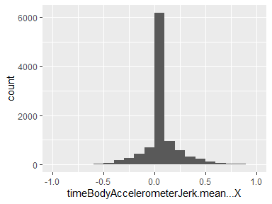

## timeBodyAccelerometerJerk.mean…Y

|  |  |
| --- | --- |
| Feature | Result |
| Variable type | numeric |
| Number of missing obs. | 0 (0 %) |
| Number of unique values | 10299 |
| Median | 0.01 |
| 1st and 3rd quartiles | -0.02; 0.03 |
| Min. and max. | -1; 1 |

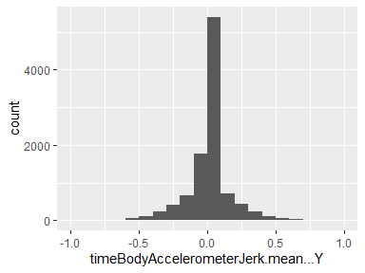

## timeBodyAccelerometerJerk.mean…Z

|  |  |
| --- | --- |
| Feature | Result |
| Variable type | numeric |
| Number of missing obs. | 0 (0 %) |
| Number of unique values | 10299 |
| Median | 0 |
| 1st and 3rd quartiles | -0.03; 0.02 |
| Min. and max. | -1; 1 |

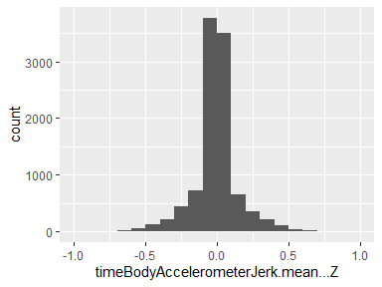

## timeBodyGyroscope.mean…X

|  |  |
| --- | --- |
| Feature | Result |
| Variable type | numeric |
| Number of missing obs. | 0 (0 %) |
| Number of unique values | 10298 |
| Median | -0.03 |
| 1st and 3rd quartiles | -0.05; -0.01 |
| Min. and max. | -1; 1 |

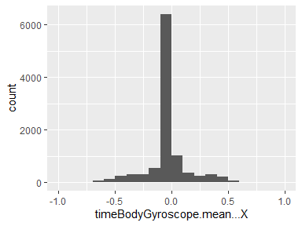

## timeBodyGyroscope.mean…Y

|  |  |
| --- | --- |
| Feature | Result |
| Variable type | numeric |
| Number of missing obs. | 0 (0 %) |
| Number of unique values | 10299 |
| Median | -0.07 |
| 1st and 3rd quartiles | -0.1; -0.05 |
| Min. and max. | -1; 1 |

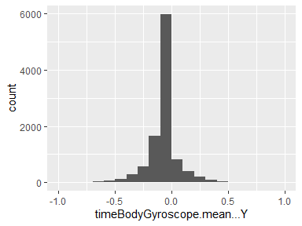

## timeBodyGyroscope.mean…Z

|  |  |
| --- | --- |
| Feature | Result |
| Variable type | numeric |
| Number of missing obs. | 0 (0 %) |
| Number of unique values | 10297 |
| Median | 0.09 |
| 1st and 3rd quartiles | 0.06; 0.11 |
| Min. and max. | -1; 1 |

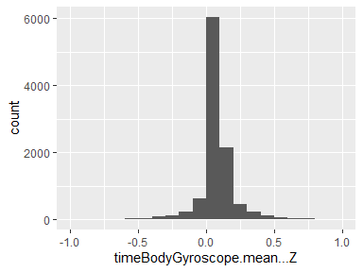

## timeBodyGyroscopeJerk.mean…X

|  |  |
| --- | --- |
| Feature | Result |
| Variable type | numeric |
| Number of missing obs. | 0 (0 %) |
| Number of unique values | 10295 |
| Median | -0.1 |
| 1st and 3rd quartiles | -0.12; -0.08 |
| Min. and max. | -1; 1 |

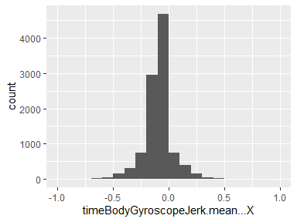

## timeBodyGyroscopeJerk.mean…Y

|  |  |
| --- | --- |
| Feature | Result |
| Variable type | numeric |
| Number of missing obs. | 0 (0 %) |
| Number of unique values | 10299 |
| Median | -0.04 |
| 1st and 3rd quartiles | -0.06; -0.03 |
| Min. and max. | -1; 1 |

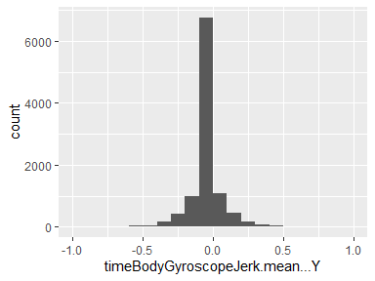

## timeBodyGyroscopeJerk.mean…Z

|  |  |
| --- | --- |
| Feature | Result |
| Variable type | numeric |
| Number of missing obs. | 0 (0 %) |
| Number of unique values | 10298 |
| Median | -0.05 |
| 1st and 3rd quartiles | -0.08; -0.03 |
| Min. and max. | -1; 1 |

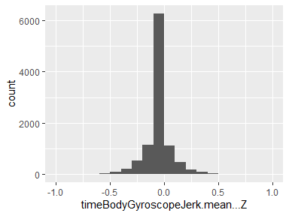

## timeBodyAccelerometerMagnitude.mean..

|  |  |
| --- | --- |
| Feature | Result |
| Variable type | numeric |
| Number of missing obs. | 0 (0 %) |
| Number of unique values | 10296 |
| Median | -0.87 |
| 1st and 3rd quartiles | -0.98; -0.12 |
| Min. and max. | -1; 1 |

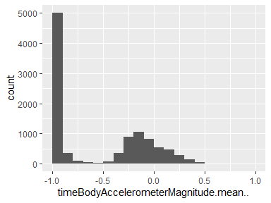

## timeGravityAccelerometerMagnitude.mean..

|  |  |
| --- | --- |
| Feature | Result |
| Variable type | numeric |
| Number of missing obs. | 0 (0 %) |
| Number of unique values | 10296 |
| Median | -0.87 |
| 1st and 3rd quartiles | -0.98; -0.12 |
| Min. and max. | -1; 1 |

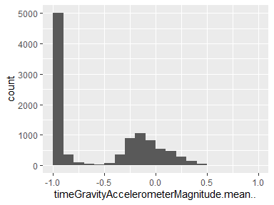

## timeBodyAccelerometerJerkMagnitude.mean..

|  |  |
| --- | --- |
| Feature | Result |
| Variable type | numeric |
| Number of missing obs. | 0 (0 %) |
| Number of unique values | 10292 |
| Median | -0.95 |
| 1st and 3rd quartiles | -0.99; -0.3 |
| Min. and max. | -1; 1 |

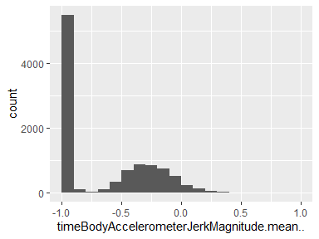

## timeBodyGyroscopeMagnitude.mean..

|  |  |
| --- | --- |
| Feature | Result |
| Variable type | numeric |
| Number of missing obs. | 0 (0 %) |
| Number of unique values | 10298 |
| Median | -0.82 |
| 1st and 3rd quartiles | -0.98; -0.25 |
| Min. and max. | -1; 1 |

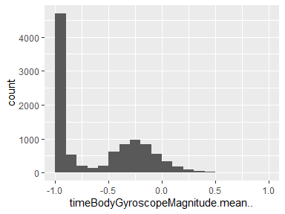

## timeBodyGyroscopeJerkMagnitude.mean..

|  |  |
| --- | --- |
| Feature | Result |
| Variable type | numeric |
| Number of missing obs. | 0 (0 %) |
| Number of unique values | 10293 |
| Median | -0.96 |
| 1st and 3rd quartiles | -0.99; -0.55 |
| Min. and max. | -1; 1 |

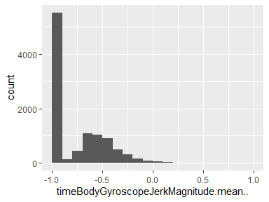

## frequencyBodyAccelerometer.mean…X

|  |  |
| --- | --- |
| Feature | Result |
| Variable type | numeric |
| Number of missing obs. | 0 (0 %) |
| Number of unique values | 10295 |
| Median | -0.95 |
| 1st and 3rd quartiles | -0.99; -0.26 |
| Min. and max. | -1; 1 |

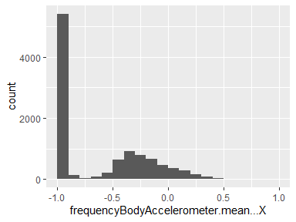

## frequencyBodyAccelerometer.mean…Y

|  |  |
| --- | --- |
| Feature | Result |
| Variable type | numeric |
| Number of missing obs. | 0 (0 %) |
| Number of unique values | 10292 |
| Median | -0.86 |
| 1st and 3rd quartiles | -0.98; -0.1 |
| Min. and max. | -1; 1 |

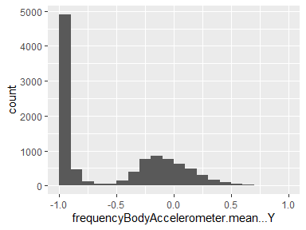

## frequencyBodyAccelerometer.mean…Z

|  |  |
| --- | --- |
| Feature | Result |
| Variable type | numeric |
| Number of missing obs. | 0 (0 %) |
| Number of unique values | 10295 |
| Median | -0.9 |
| 1st and 3rd quartiles | -0.98; -0.37 |
| Min. and max. | -1; 1 |

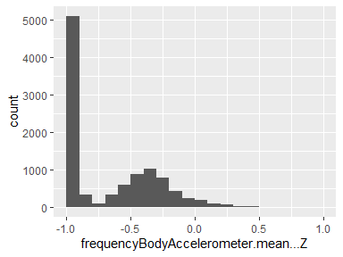

## frequencyBodyAccelerometer.meanFreq…X

|  |  |
| --- | --- |
| Feature | Result |
| Variable type | numeric |
| Number of missing obs. | 0 (0 %) |
| Number of unique values | 10299 |
| Median | -0.24 |
| 1st and 3rd quartiles | -0.42; -0.02 |
| Min. and max. | -1; 1 |

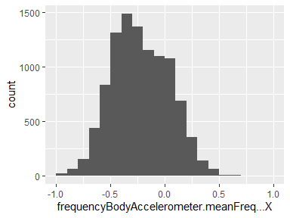

## frequencyBodyAccelerometer.meanFreq…Y

|  |  |
| --- | --- |
| Feature | Result |
| Variable type | numeric |
| Number of missing obs. | 0 (0 %) |
| Number of unique values | 10299 |
| Median | 0 |
| 1st and 3rd quartiles | -0.14; 0.18 |
| Min. and max. | -1; 1 |

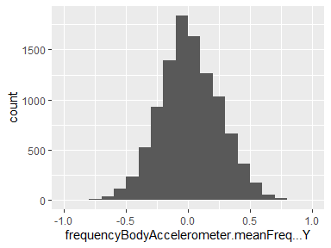

## frequencyBodyAccelerometer.meanFreq…Z

|  |  |
| --- | --- |
| Feature | Result |
| Variable type | numeric |
| Number of missing obs. | 0 (0 %) |
| Number of unique values | 10299 |
| Median | 0.06 |
| 1st and 3rd quartiles | -0.14; 0.25 |
| Min. and max. | -1; 1 |

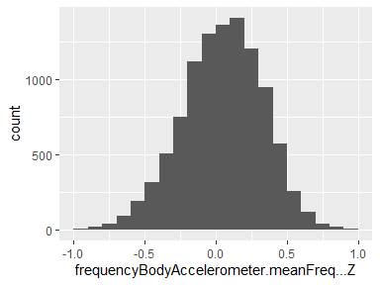

## frequencyBodyAccelerometerJerk.mean…X

|  |  |
| --- | --- |
| Feature | Result |
| Variable type | numeric |
| Number of missing obs. | 0 (0 %) |
| Number of unique values | 10293 |
| Median | -0.95 |
| 1st and 3rd quartiles | -0.99; -0.33 |
| Min. and max. | -1; 1 |

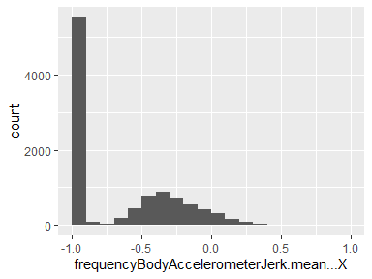

## frequencyBodyAccelerometerJerk.mean…Y

|  |  |
| --- | --- |
| Feature | Result |
| Variable type | numeric |
| Number of missing obs. | 0 (0 %) |
| Number of unique values | 10296 |
| Median | -0.93 |
| 1st and 3rd quartiles | -0.98; -0.26 |
| Min. and max. | -1; 1 |

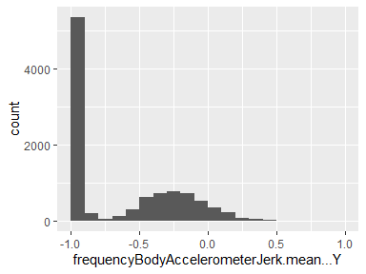

## activity

|  |  |
| --- | --- |
| Feature | Result |
| Variable type | numeric |
| Number of missing obs. | 0 (0 %) |
| Number of unique values | 10294 |
| Median | -0.95 |
| 1st and 3rd quartiles | -0.99; -0.51 |
| Min. and max. | -1; 1 |

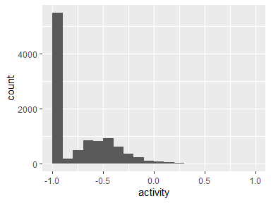

## frequencyBodyAccelerometerJerk.meanFreq…X

|  |  |
| --- | --- |
| Feature | Result |
| Variable type | numeric |
| Number of missing obs. | 0 (0 %) |
| Number of unique values | 10298 |
| Median | -0.05 |
| 1st and 3rd quartiles | -0.3; 0.2 |
| Min. and max. | -1; 1 |

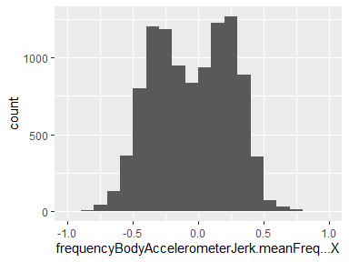

## frequencyBodyAccelerometerJerk.meanFreq…Y

|  |  |
| --- | --- |
| Feature | Result |
| Variable type | numeric |
| Number of missing obs. | 0 (0 %) |
| Number of unique values | 10299 |
| Median | -0.24 |
| 1st and 3rd quartiles | -0.43; 0.01 |
| Min. and max. | -1; 1 |

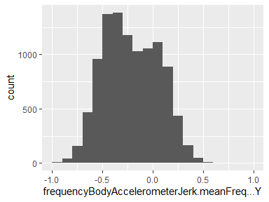

## frequencyBodyAccelerometerJerk.meanFreq…Z

|  |  |
| --- | --- |
| Feature | Result |
| Variable type | numeric |
| Number of missing obs. | 0 (0 %) |
| Number of unique values | 10298 |
| Median | -0.1 |
| 1st and 3rd quartiles | -0.33; 0.09 |
| Min. and max. | -1; 1 |

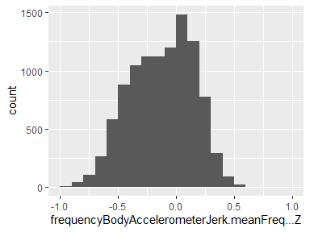

## frequencyBodyGyroscope.mean…X

|  |  |
| --- | --- |
| Feature | Result |
| Variable type | numeric |
| Number of missing obs. | 0 (0 %) |
| Number of unique values | 10297 |
| Median | -0.89 |
| 1st and 3rd quartiles | -0.99; -0.38 |
| Min. and max. | -1; 1 |

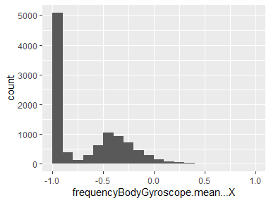

## frequencyBodyGyroscope.mean…Y

|  |  |
| --- | --- |
| Feature | Result |
| Variable type | numeric |
| Number of missing obs. | 0 (0 %) |
| Number of unique values | 10296 |
| Median | -0.92 |
| 1st and 3rd quartiles | -0.98; -0.47 |
| Min. and max. | -1; 1 |

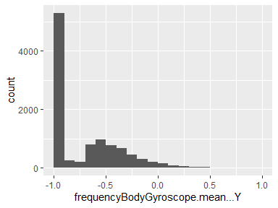

## frequencyBodyGyroscope.mean…Z

|  |  |
| --- | --- |
| Feature | Result |
| Variable type | numeric |
| Number of missing obs. | 0 (0 %) |
| Number of unique values | 10297 |
| Median | -0.89 |
| 1st and 3rd quartiles | -0.99; -0.32 |
| Min. and max. | -1; 1 |

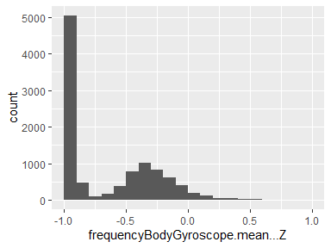

## frequencyBodyGyroscope.meanFreq…X

|  |  |
| --- | --- |
| Feature | Result |
| Variable type | numeric |
| Number of missing obs. | 0 (0 %) |
| Number of unique values | 10298 |
| Median | -0.1 |
| 1st and 3rd quartiles | -0.27; 0.07 |
| Min. and max. | -1; 1 |

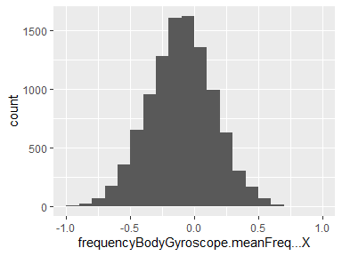

## frequencyBodyGyroscope.meanFreq…Y

|  |  |
| --- | --- |
| Feature | Result |
| Variable type | numeric |
| Number of missing obs. | 0 (0 %) |
| Number of unique values | 10299 |
| Median | -0.17 |
| 1st and 3rd quartiles | -0.36; 0.01 |
| Min. and max. | -1; 1 |

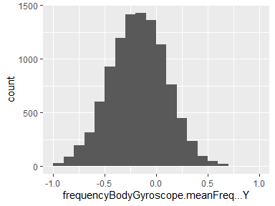

## frequencyBodyGyroscope.meanFreq…Z

|  |  |
| --- | --- |
| Feature | Result |
| Variable type | numeric |
| Number of missing obs. | 0 (0 %) |
| Number of unique values | 10299 |
| Median | -0.05 |
| 1st and 3rd quartiles | -0.23; 0.12 |
| Min. and max. | -1; 1 |

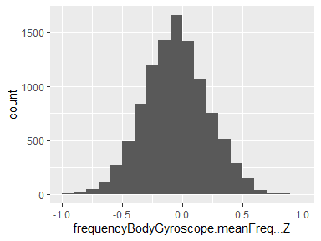

## frequencyBodyAccelerometerMagnitude.mean..

|  |  |
| --- | --- |
| Feature | Result |
| Variable type | numeric |
| Number of missing obs. | 0 (0 %) |
| Number of unique values | 10296 |
| Median | -0.88 |
| 1st and 3rd quartiles | -0.98; -0.22 |
| Min. and max. | -1; 1 |

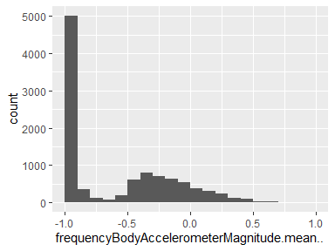

## frequencyBodyAccelerometerMagnitude.meanFreq..

|  |  |
| --- | --- |
| Feature | Result |
| Variable type | numeric |
| Number of missing obs. | 0 (0 %) |
| Number of unique values | 10299 |
| Median | 0.07 |
| 1st and 3rd quartiles | -0.1; 0.24 |
| Min. and max. | -1; 1 |

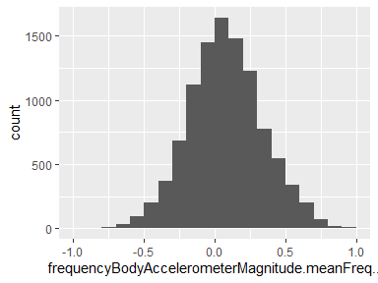

## frequencyBodyAccelerometerJerkMagnitude.mean..

|  |  |
| --- | --- |
| Feature | Result |
| Variable type | numeric |
| Number of missing obs. | 0 (0 %) |
| Number of unique values | 10290 |
| Median | -0.93 |
| 1st and 3rd quartiles | -0.99; -0.26 |
| Min. and max. | -1; 1 |

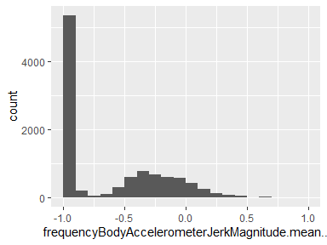

## frequencyBodyAccelerometerJerkMagnitude.meanFreq..

|  |  |
| --- | --- |
| Feature | Result |
| Variable type | numeric |
| Number of missing obs. | 0 (0 %) |
| Number of unique values | 10299 |
| Median | 0.16 |
| 1st and 3rd quartiles | 0; 0.36 |
| Min. and max. | -1; 1 |

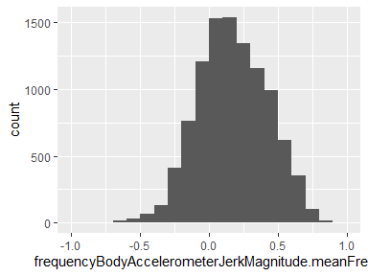

## frequencyBodyGyroscopeMagnitude.mean..

|  |  |
| --- | --- |
| Feature | Result |
| Variable type | numeric |
| Number of missing obs. | 0 (0 %) |
| Number of unique values | 10297 |
| Median | -0.88 |
| 1st and 3rd quartiles | -0.98; -0.45 |
| Min. and max. | -1; 1 |

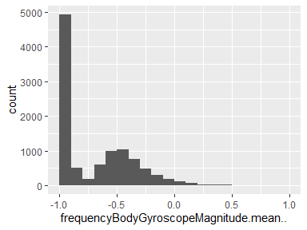

## frequencyBodyGyroscopeMagnitude.meanFreq..

|  |  |
| --- | --- |
| Feature | Result |
| Variable type | numeric |
| Number of missing obs. | 0 (0 %) |
| Number of unique values | 10299 |
| Median | -0.05 |
| 1st and 3rd quartiles | -0.23; 0.15 |
| Min. and max. | -1; 1 |

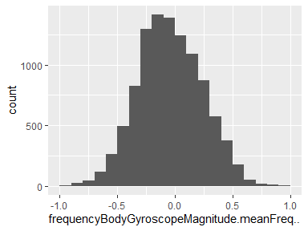

## frequencyBodyGyroscopeJerkMagnitude.mean..

|  |  |
| --- | --- |
| Feature | Result |
| Variable type | numeric |
| Number of missing obs. | 0 (0 %) |
| Number of unique values | 10293 |
| Median | -0.95 |
| 1st and 3rd quartiles | -0.99; -0.61 |
| Min. and max. | -1; 1 |

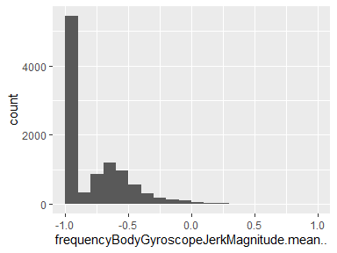

## frequencyBodyGyroscopeJerkMagnitude.meanFreq..

|  |  |
| --- | --- |
| Feature | Result |
| Variable type | numeric |
| Number of missing obs. | 0 (0 %) |
| Number of unique values | 10299 |
| Median | 0.14 |
| 1st and 3rd quartiles | -0.02; 0.29 |
| Min. and max. | -1; 1 |

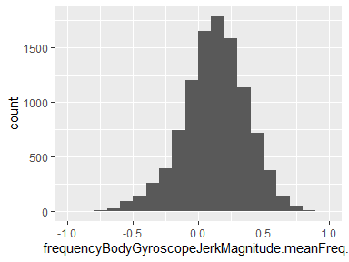

## angle.tBodyAccelerometerMean.gravity.

|  |  |
| --- | --- |
| Feature | Result |
| Variable type | numeric |
| Number of missing obs. | 0 (0 %) |
| Number of unique values | 10299 |
| Median | 0.01 |
| 1st and 3rd quartiles | -0.12; 0.15 |
| Min. and max. | -1; 1 |

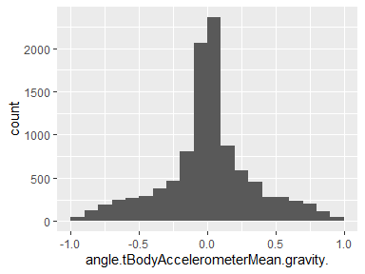

## angle.tBodyAccelerometerJerkMean..gravityMean.

|  |  |
| --- | --- |
| Feature | Result |
| Variable type | numeric |
| Number of missing obs. | 0 (0 %) |
| Number of unique values | 10299 |
| Median | 0.01 |
| 1st and 3rd quartiles | -0.29; 0.29 |
| Min. and max. | -1; 1 |

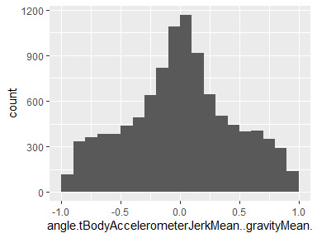

## angle.tBodyGyroscopeMean.gravityMean.

|  |  |
| --- | --- |
| Feature | Result |
| Variable type | numeric |
| Number of missing obs. | 0 (0 %) |
| Number of unique values | 10299 |
| Median | 0.02 |
| 1st and 3rd quartiles | -0.49; 0.54 |
| Min. and max. | -1; 1 |

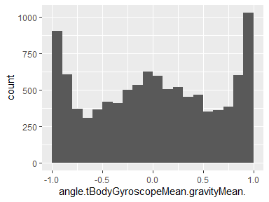

## angle.tBodyGyroscopeJerkMean.gravityMean.

|  |  |
| --- | --- |
| Feature | Result |
| Variable type | numeric |
| Number of missing obs. | 0 (0 %) |
| Number of unique values | 10299 |
| Median | -0.01 |
| 1st and 3rd quartiles | -0.39; 0.37 |
| Min. and max. | -1; 1 |

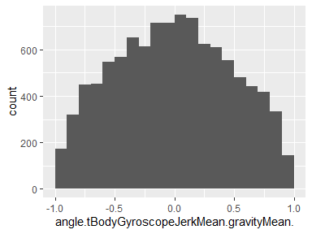

## angle.X.gravityMean.

|  |  |
| --- | --- |
| Feature | Result |
| Variable type | numeric |
| Number of missing obs. | 0 (0 %) |
| Number of unique values | 10299 |
| Median | -0.72 |
| 1st and 3rd quartiles | -0.82; -0.52 |
| Min. and max. | -1; 1 |

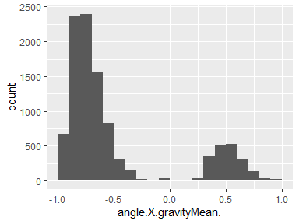

## angle.Y.gravityMean.

|  |  |
| --- | --- |
| Feature | Result |
| Variable type | numeric |
| Number of missing obs. | 0 (0 %) |
| Number of unique values | 10299 |
| Median | 0.18 |
| 1st and 3rd quartiles | 0; 0.25 |
| Min. and max. | -1; 1 |

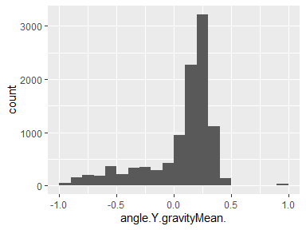

## angle.Z.gravityMean.

|  |  |
| --- | --- |
| Feature | Result |
| Variable type | numeric |
| Number of missing obs. | 0 (0 %) |
| Number of unique values | 10299 |
| Median | 0 |
| 1st and 3rd quartiles | -0.13; 0.1 |
| Min. and max. | -1; 1 |

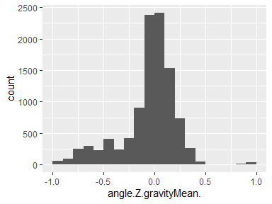

## timeBodyAccelerometer.std…X

|  |  |
| --- | --- |
| Feature | Result |
| Variable type | numeric |
| Number of missing obs. | 0 (0 %) |
| Number of unique values | 10295 |
| Median | -0.94 |
| 1st and 3rd quartiles | -0.99; -0.25 |
| Min. and max. | -1; 1 |

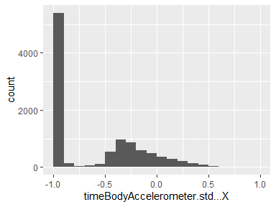

## timeBodyAccelerometer.std…Y

|  |  |
| --- | --- |
| Feature | Result |
| Variable type | numeric |
| Number of missing obs. | 0 (0 %) |
| Number of unique values | 10297 |
| Median | -0.84 |
| 1st and 3rd quartiles | -0.98; -0.06 |
| Min. and max. | -1; 1 |

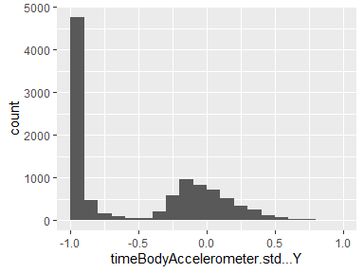

## timeBodyAccelerometer.std…Z

|  |  |
| --- | --- |
| Feature | Result |
| Variable type | numeric |
| Number of missing obs. | 0 (0 %) |
| Number of unique values | 10297 |
| Median | -0.85 |
| 1st and 3rd quartiles | -0.98; -0.28 |
| Min. and max. | -1; 1 |

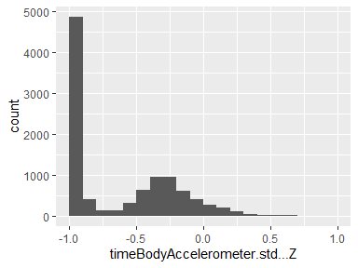

## timeGravityAccelerometer.std…X

|  |  |
| --- | --- |
| Feature | Result |
| Variable type | numeric |
| Number of missing obs. | 0 (0 %) |
| Number of unique values | 10288 |
| Median | -0.98 |
| 1st and 3rd quartiles | -0.99; -0.96 |
| Min. and max. | -1; 1 |

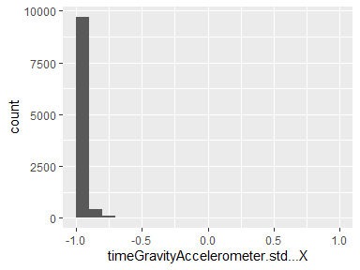

## timeGravityAccelerometer.std…Y

|  |  |
| --- | --- |
| Feature | Result |
| Variable type | numeric |
| Number of missing obs. | 0 (0 %) |
| Number of unique values | 10293 |
| Median | -0.98 |
| 1st and 3rd quartiles | -0.99; -0.95 |
| Min. and max. | -1; 1 |

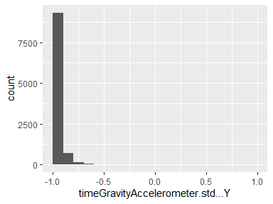

## timeGravityAccelerometer.std…Z

|  |  |
| --- | --- |
| Feature | Result |
| Variable type | numeric |
| Number of missing obs. | 0 (0 %) |
| Number of unique values | 10296 |
| Median | -0.97 |
| 1st and 3rd quartiles | -0.99; -0.93 |
| Min. and max. | -1; 1 |

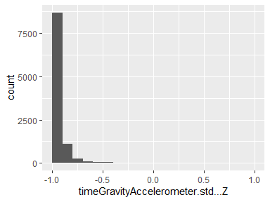

## timeBodyAccelerometerJerk.std…X

|  |  |
| --- | --- |
| Feature | Result |
| Variable type | numeric |
| Number of missing obs. | 0 (0 %) |
| Number of unique values | 10290 |
| Median | -0.95 |
| 1st and 3rd quartiles | -0.99; -0.29 |
| Min. and max. | -1; 1 |

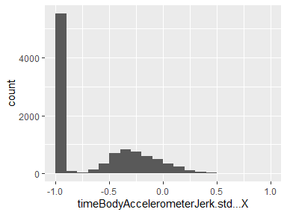

## timeBodyAccelerometerJerk.std…Y

|  |  |
| --- | --- |
| Feature | Result |
| Variable type | numeric |
| Number of missing obs. | 0 (0 %) |
| Number of unique values | 10296 |
| Median | -0.93 |
| 1st and 3rd quartiles | -0.99; -0.22 |
| Min. and max. | -1; 1 |

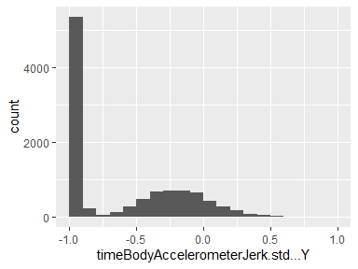

## timeBodyAccelerometerJerk.std…Z

|  |  |
| --- | --- |
| Feature | Result |
| Variable type | numeric |
| Number of missing obs. | 0 (0 %) |
| Number of unique values | 10293 |
| Median | -0.95 |
| 1st and 3rd quartiles | -0.99; -0.55 |
| Min. and max. | -1; 1 |

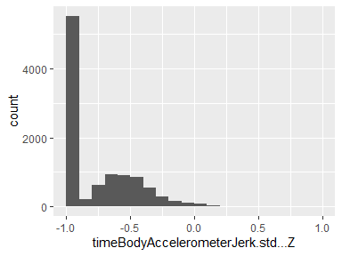

## timeBodyGyroscope.std…X

|  |  |
| --- | --- |
| Feature | Result |
| Variable type | numeric |
| Number of missing obs. | 0 (0 %) |
| Number of unique values | 10292 |
| Median | -0.9 |
| 1st and 3rd quartiles | -0.99; -0.48 |
| Min. and max. | -1; 1 |

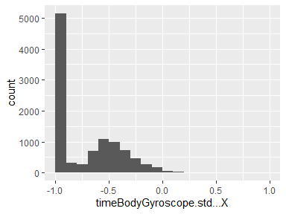

## timeBodyGyroscope.std…Y

|  |  |
| --- | --- |
| Feature | Result |
| Variable type | numeric |
| Number of missing obs. | 0 (0 %) |
| Number of unique values | 10296 |
| Median | -0.91 |
| 1st and 3rd quartiles | -0.98; -0.45 |
| Min. and max. | -1; 1 |

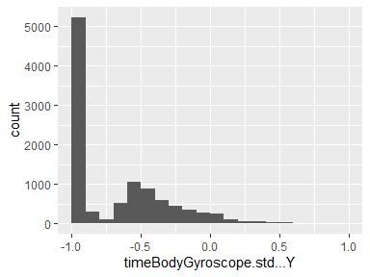

## timeBodyGyroscope.std…Z

|  |  |
| --- | --- |
| Feature | Result |
| Variable type | numeric |
| Number of missing obs. | 0 (0 %) |
| Number of unique values | 10296 |
| Median | -0.88 |
| 1st and 3rd quartiles | -0.99; -0.34 |
| Min. and max. | -1; 1 |

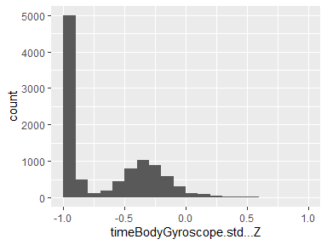

## timeBodyGyroscopeJerk.std…X

|  |  |
| --- | --- |
| Feature | Result |
| Variable type | numeric |
| Number of missing obs. | 0 (0 %) |
| Number of unique values | 10292 |
| Median | -0.93 |
| 1st and 3rd quartiles | -0.99; -0.49 |
| Min. and max. | -1; 1 |

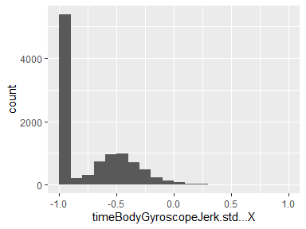

## timeBodyGyroscopeJerk.std…Y

|  |  |
| --- | --- |
| Feature | Result |
| Variable type | numeric |
| Number of missing obs. | 0 (0 %) |
| Number of unique values | 10295 |
| Median | -0.95 |
| 1st and 3rd quartiles | -0.99; -0.63 |
| Min. and max. | -1; 1 |

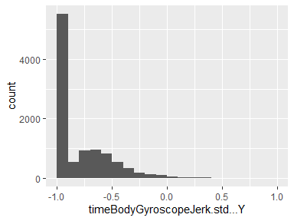

## timeBodyGyroscopeJerk.std…Z

|  |  |
| --- | --- |
| Feature | Result |
| Variable type | numeric |
| Number of missing obs. | 0 (0 %) |
| Number of unique values | 10291 |
| Median | -0.95 |
| 1st and 3rd quartiles | -0.99; -0.51 |
| Min. and max. | -1; 1 |

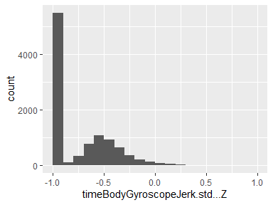

## timeBodyAccelerometerMagnitude.std..

|  |  |
| --- | --- |
| Feature | Result |
| Variable type | numeric |
| Number of missing obs. | 0 (0 %) |
| Number of unique values | 10294 |
| Median | -0.84 |
| 1st and 3rd quartiles | -0.98; -0.24 |
| Min. and max. | -1; 1 |

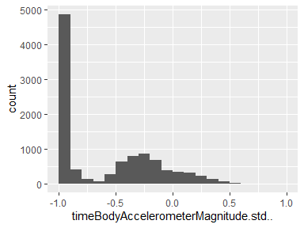

## timeGravityAccelerometerMagnitude.std..

|  |  |
| --- | --- |
| Feature | Result |
| Variable type | numeric |
| Number of missing obs. | 0 (0 %) |
| Number of unique values | 10294 |
| Median | -0.84 |
| 1st and 3rd quartiles | -0.98; -0.24 |
| Min. and max. | -1; 1 |

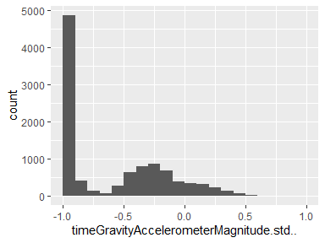

## timeBodyAccelerometerJerkMagnitude.std..

|  |  |
| --- | --- |
| Feature | Result |
| Variable type | numeric |
| Number of missing obs. | 0 (0 %) |
| Number of unique values | 10294 |
| Median | -0.93 |
| 1st and 3rd quartiles | -0.99; -0.27 |
| Min. and max. | -1; 1 |

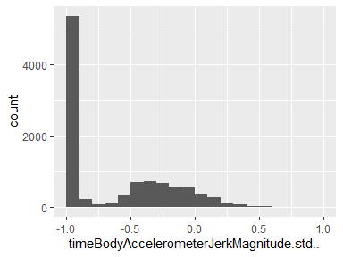

## timeBodyGyroscopeMagnitude.std..

|  |  |
| --- | --- |
| Feature | Result |
| Variable type | numeric |
| Number of missing obs. | 0 (0 %) |
| Number of unique values | 10298 |
| Median | -0.83 |
| 1st and 3rd quartiles | -0.98; -0.39 |
| Min. and max. | -1; 1 |

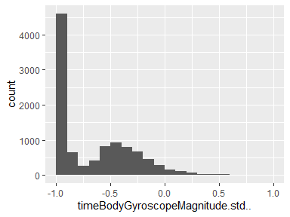

## timeBodyGyroscopeJerkMagnitude.std..

|  |  |
| --- | --- |
| Feature | Result |
| Variable type | numeric |
| Number of missing obs. | 0 (0 %) |
| Number of unique values | 10297 |
| Median | -0.94 |
| 1st and 3rd quartiles | -0.99; -0.61 |
| Min. and max. | -1; 1 |

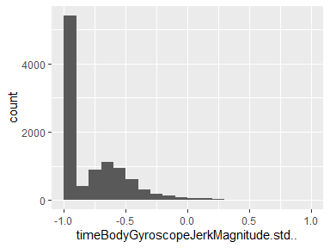

## frequencyBodyAccelerometer.std…X

|  |  |
| --- | --- |
| Feature | Result |
| Variable type | numeric |
| Number of missing obs. | 0 (0 %) |
| Number of unique values | 10294 |
| Median | -0.94 |
| 1st and 3rd quartiles | -0.99; -0.25 |
| Min. and max. | -1; 1 |

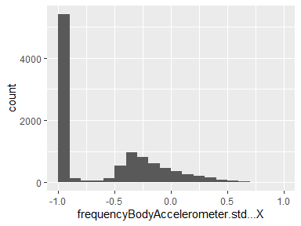

## frequencyBodyAccelerometer.std…Y

|  |  |
| --- | --- |
| Feature | Result |
| Variable type | numeric |
| Number of missing obs. | 0 (0 %) |
| Number of unique values | 10297 |
| Median | -0.83 |
| 1st and 3rd quartiles | -0.98; -0.09 |
| Min. and max. | -1; 1 |

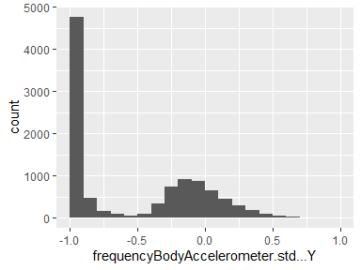

## frequencyBodyAccelerometer.std…Z

|  |  |
| --- | --- |
| Feature | Result |
| Variable type | numeric |
| Number of missing obs. | 0 (0 %) |
| Number of unique values | 10296 |
| Median | -0.84 |
| 1st and 3rd quartiles | -0.98; -0.3 |
| Min. and max. | -1; 1 |

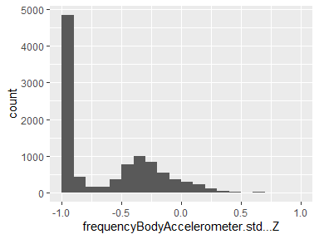

## frequencyBodyAccelerometerJerk.std…X

|  |  |
| --- | --- |
| Feature | Result |
| Variable type | numeric |
| Number of missing obs. | 0 (0 %) |
| Number of unique values | 10291 |
| Median | -0.96 |
| 1st and 3rd quartiles | -0.99; -0.32 |
| Min. and max. | -1; 1 |

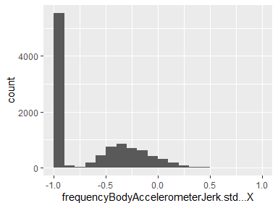

## frequencyBodyAccelerometerJerk.std…Y

|  |  |
| --- | --- |
| Feature | Result |
| Variable type | numeric |
| Number of missing obs. | 0 (0 %) |
| Number of unique values | 10294 |
| Median | -0.93 |
| 1st and 3rd quartiles | -0.99; -0.24 |
| Min. and max. | -1; 1 |

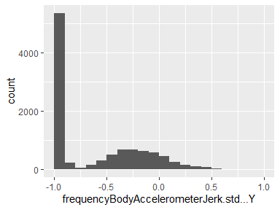

## frequencyBodyAccelerometerJerk.std…Z

|  |  |
| --- | --- |
| Feature | Result |
| Variable type | numeric |
| Number of missing obs. | 0 (0 %) |
| Number of unique values | 10290 |
| Median | -0.96 |
| 1st and 3rd quartiles | -0.99; -0.59 |
| Min. and max. | -1; 1 |

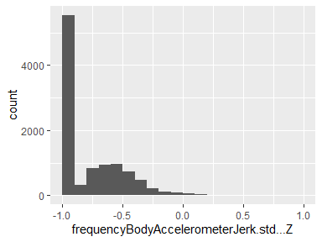

## frequencyBodyGyroscope.std…X

|  |  |
| --- | --- |
| Feature | Result |
| Variable type | numeric |
| Number of missing obs. | 0 (0 %) |
| Number of unique values | 10297 |
| Median | -0.91 |
| 1st and 3rd quartiles | -0.99; -0.52 |
| Min. and max. | -1; 1 |

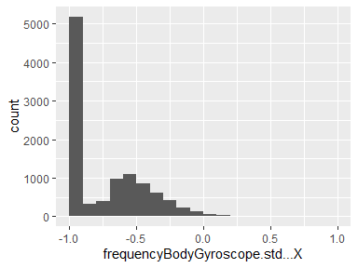

## frequencyBodyGyroscope.std…Y

|  |  |
| --- | --- |
| Feature | Result |
| Variable type | numeric |
| Number of missing obs. | 0 (0 %) |
| Number of unique values | 10293 |
| Median | -0.91 |
| 1st and 3rd quartiles | -0.98; -0.44 |
| Min. and max. | -1; 1 |

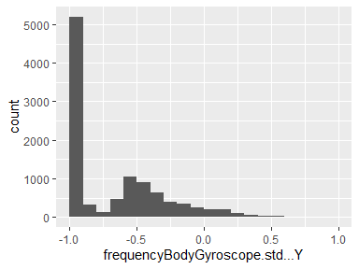

## frequencyBodyGyroscope.std…Z

|  |  |
| --- | --- |
| Feature | Result |
| Variable type | numeric |
| Number of missing obs. | 0 (0 %) |
| Number of unique values | 10295 |
| Median | -0.89 |
| 1st and 3rd quartiles | -0.99; -0.42 |
| Min. and max. | -1; 1 |

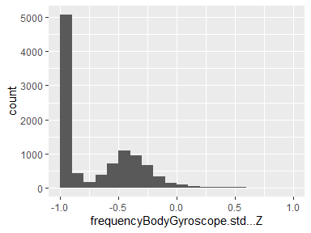

## frequencyBodyAccelerometerMagnitude.std..

|  |  |
| --- | --- |
| Feature | Result |
| Variable type | numeric |
| Number of missing obs. | 0 (0 %) |
| Number of unique values | 10298 |
| Median | -0.85 |
| 1st and 3rd quartiles | -0.98; -0.38 |
| Min. and max. | -1; 1 |

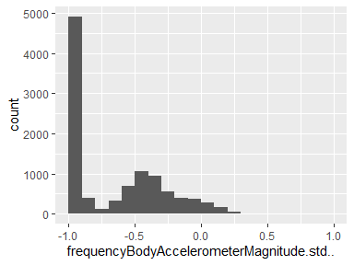

## frequencyBodyAccelerometerJerkMagnitude.std..

|  |  |
| --- | --- |
| Feature | Result |
| Variable type | numeric |
| Number of missing obs. | 0 (0 %) |
| Number of unique values | 10296 |
| Median | -0.93 |
| 1st and 3rd quartiles | -0.99; -0.31 |
| Min. and max. | -1; 1 |

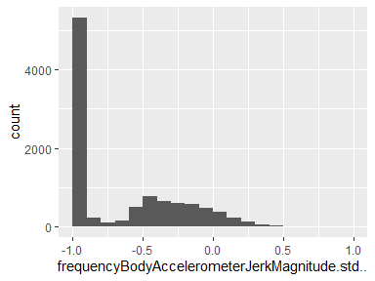

## frequencyBodyGyroscopeMagnitude.std..

|  |  |
| --- | --- |
| Feature | Result |
| Variable type | numeric |
| Number of missing obs. | 0 (0 %) |
| Number of unique values | 10296 |
| Median | -0.83 |
| 1st and 3rd quartiles | -0.98; -0.47 |
| Min. and max. | -1; 1 |

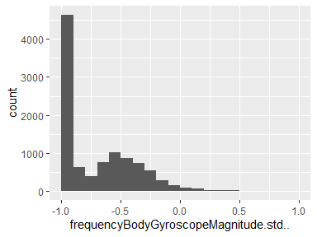

## frequencyBodyGyroscopeJerkMagnitude.std..

|  |  |
| --- | --- |
| Feature | Result |
| Variable type | numeric |
| Number of missing obs. | 0 (0 %) |
| Number of unique values | 10292 |
| Median | -0.94 |
| 1st and 3rd quartiles | -0.99; -0.64 |
| Min. and max. | -1; 1 |

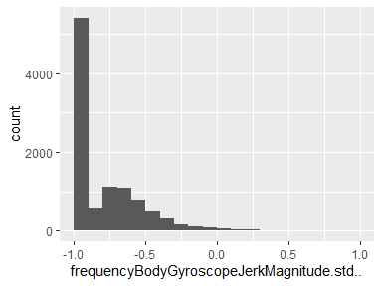

Report generation information:

* Created by: abc (username: Maureen).
* Report creation time: Sat May 15 2021 20:02:37
* Report was run from directory: C:/Users/Maureen/Desktop/RRRRR/Getting-and-Cleaning-Data
* dataMaid v1.4.0 [Pkg: 2019-12-10 from CRAN (R 4.0.5)]
* R version 4.0.4 (2021-02-15).
* Platform: x86_64-w64-mingw32/x64 (64-bit)(Windows 7 x64 (build 7601) Service Pack 1).
* Function call: dataMaid::makeDataReport(data = mean_SD, mode = c("summarize", "visualize", "check"), smartNum = FALSE, file = "codebook_mean_SD.Rmd", checks = list(character = "showAllFactorLevels", factor = "showAllFactorLevels", labelled = "showAllFactorLevels", haven_labelled = "showAllFactorLevels", numeric = NULL, integer = NULL, logical = NULL, Date = NULL), listChecks = FALSE, maxProbVals = Inf, codebook = TRUE, reportTitle = "Codebook for mean_SD")