**Building an Event Management System: Designing the Blueprint, Crafting the Schema, and Executing with SQL**

In a world driven by experiences and live interactions, the need for efficient event management systems (EMS) has become paramount. Whether it’s a conference, a music festival, or a corporate meeting, a well-designed EMS can transform chaos into a seamless experience. In this article, we’ll explore the intricacies of designing an EMS from the ground up, including creating a robust database schema and implementing it with SQL commands.

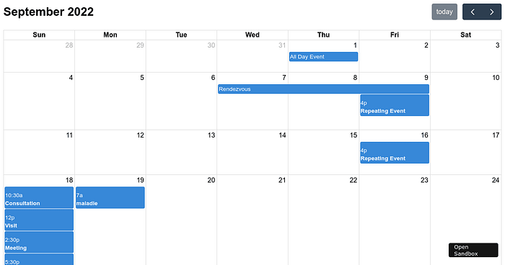

**The Vision: Crafting an EMS**

Before we dive into the technicalities, let’s start with the vision. Imagine an entrepreneur, Alice, who envisions a versatile EMS that can cater to a diverse range of events. Her EMS should allow event organizers to effortlessly create and manage events, enable attendees to register and book tickets, and provide valuable insights through analytics. This vision sets the stage for our EMS project.

**The Foundation: Entities and Relationships**

Every successful EMS begins with a well-structured database schema. In our case, we’ll identify key entities and relationships:

Entities:

1. Events: The heart of the EMS. Each event is unique with attributes such as event_id, event_name, description, start_date, end_date, venue, organizer_id, and status. The status can be 'Upcoming,' 'Past,' or 'Canceled.'
2. Users: The backbone of the system. Users include attendees, organizers, and administrators. User attributes comprise user_id, username, password (securely hashed), email, full_name, and role.
3. Attendees: These are the links between events and users. An attendee_id associates each attendee with a specific event_id and user_id.
4. Event_Schedule: To keep events organized, we use schedule_id, event_id, start_time, end_time, activity, and location.
5. Bookings: These enable attendees to participate in events. Each booking is tracked with booking_id, event_id, user_id, booking_date, and ticket_quantity.

User Roles:

* Admins manage the EMS kingdom. They can create, update, or delete events and schedules, manage user accounts, and access analytics and reports.
* Organizers are the conductors. They manage events they organize, access attendee lists and schedules, and send notifications.
* Attendees are the heart of the system, registering for events and keeping track of their bookings and histories.

**The Key Features**

An EMS must cater to a multitude of functionalities. Here are some key features:

1. Event Creation and Management: Organizers and admins can create, update, or cancel events. Events have details like names, descriptions, dates, venues, and statuses.
2. User Management: Admins manage user accounts and roles, ensuring a seamless experience.
3. Attendee Registration: Attendees can register for events, providing attendee information and ticket quantities.
4. Event Scheduling: Organizers create schedules, mapping out activities, start times, end times, and locations.
5. Booking and Tickets: Attendees book tickets, recording essential details like event, user, booking date, and ticket quantity.
6. Notifications: Organizers communicate with attendees, ensuring everyone is informed about event updates.
7. Reporting and Analytics: Admins delve into event analytics and reports, unveiling insights on attendance and revenue.

**Technologies**

Selecting the right technologies is crucial for bringing this vision to life:

* Front-end: HTML/CSS, JavaScript, React, or Vue.js.
* Back-end: Node.js, Python (Django or Flask), Ruby (Ruby on Rails), or Java (Spring Boot).
* Database: PostgreSQL, MySQL, or MongoDB.
* Authentication: JWT (JSON Web Tokens) or OAuth.
* Hosting and Deployment: AWS, Heroku, Azure, or similar platforms.
* Version Control: Git and GitHub.

**Security, Testing, Scalability, and Documentation**

Ensuring the EMS is secure, well-tested, scalable, and documented is essential:

* Security: Implement authentication and authorization mechanisms, input validation, and data encryption.
* Testing: Conduct unit testing, integration testing, and user acceptance testing to ensure the system functions correctly and meets user requirements.
* Scalability: Design the system to handle future growth in terms of users and events.
* Documentation: Thoroughly document the system’s architecture, API endpoints, and database schema for future reference and development.

**Crafting the Database Schema with SQL Commands**

Now, let’s take this blueprint and translate it into a structured database schema using SQL commands. Below are SQL commands for PostgreSQL:

-- Create the Events table  
CREATE TABLE Events (  
 event_id SERIAL PRIMARY KEY,  
 event_name VARCHAR(255) NOT NULL,  
 description TEXT,  
 start_date DATE NOT NULL,  
 end_date DATE NOT NULL,  
 venue VARCHAR(255) NOT NULL,  
 organizer_id INT,  
 status VARCHAR(20) NOT NULL  
);  
  
-- Create the Users table  
CREATE TABLE Users (  
 user_id SERIAL PRIMARY KEY,  
 username VARCHAR(255) NOT NULL,  
 password TEXT NOT NULL,  
 email VARCHAR(255) UNIQUE NOT NULL,  
 full_name VARCHAR(255) NOT NULL,  
 role VARCHAR(20) NOT NULL  
);  
  
-- Create the Attendees table  
CREATE TABLE Attendees (  
 attendee_id SERIAL PRIMARY KEY,  
 event_id INT NOT NULL,  
 user_id INT NOT NULL  
);  
  
-- Create the Event_Schedule table  
CREATE TABLE Event_Schedule (  
 schedule_id SERIAL PRIMARY KEY,  
 event_id INT NOT NULL,  
 start_time TIMESTAMP NOT NULL,  
 end_time TIMESTAMP NOT NULL,  
 activity TEXT NOT NULL,  
 location VARCHAR(255) NOT NULL  
);  
  
-- Create the Bookings table  
CREATE TABLE Bookings (  
 booking_id SERIAL PRIMARY KEY,  
 event_id INT NOT NULL,  
 user_id INT NOT NULL,  
 booking_date TIMESTAMP NOT NULL,  
 ticket_quantity INT NOT NULL  
);

These SQL commands create the necessary tables for our EMS database schema in PostgreSQL. You can further customize these commands based on your specific requirements and database system.