Name: Mallela Kranthikumar
Batch: June 01, 2022
Tutor: Raham Shaik
Project: Deployment of war file through jenkins
Project:
- Under SCM added github webhooks and configured Jenkins path to build the project when any commits are done to repo
- Configured Plugins (Deploy to Container) in Jenkins to install the web app in the tomcat web server.
- Configured the build job with post-build actions -> Deploy war/ear to a container and added tomcat user details.
- Build the Job. The Build is successful. 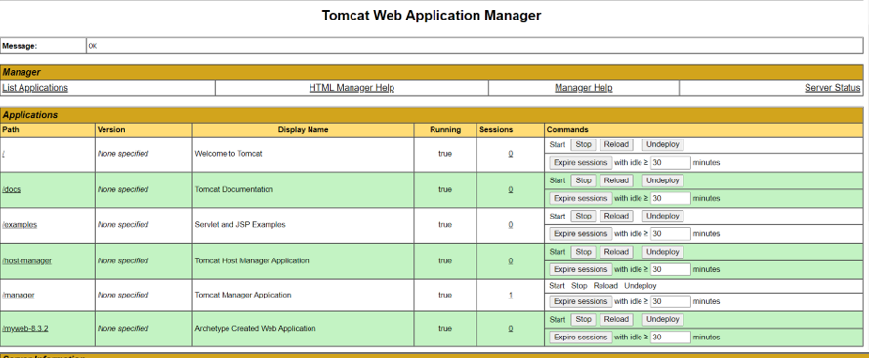

- In tomcat application the build is deployed

- Sonarqube report generated as we have added goal sonar:sonar and snapshot and release were stored in Nexus as goal clean deploy added

