Figure 15: ElderCareAI Current Use Case Diagram
The overview identifies the Caregiver, Elderly Person, and Administrator roles, including watch monitoring, care plans, health review, emergency support, and system administration.

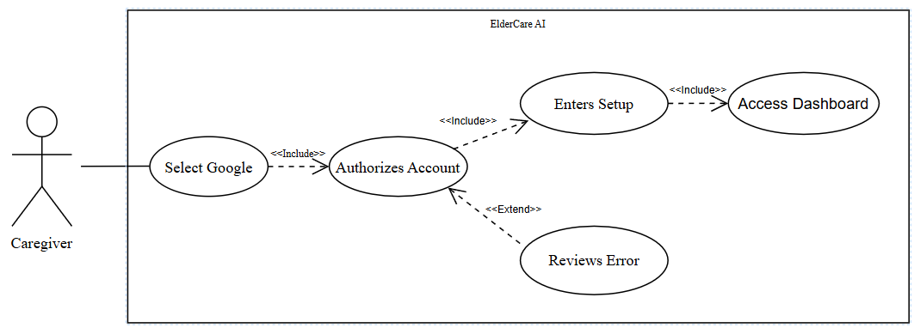
Figure 16: Authenticate Caregiver
The caregiver authenticates with Google through Supabase and is routed to the first unfinished setup step or the protected Home screen.
Table 4
AUTHENTICATE CAREGIVER
Use Case Name | Authenticate Caregiver
Actor | Caregiver
Brief Description | The caregiver authenticates with Google through Supabase and is routed to the first unfinished setup step or the protected Home screen.
Trigger | The caregiver opens ElderCareAI and selects Sign in with Google.
Pre-Conditions | The app has valid Supabase configuration and the device can open the system authentication browser.
Post Conditions | A persisted Supabase session exists, the caregiver profile is synchronized, and the app opens setup or Home.
Flow of Activities | Actor(s) | Application
Flow of Activities | 1. Open the app and select Sign in with Google.  3. Select the Google account.  4. Approve the requested sign-in access. | 2. Display the Google authentication page through the system browser.

recove
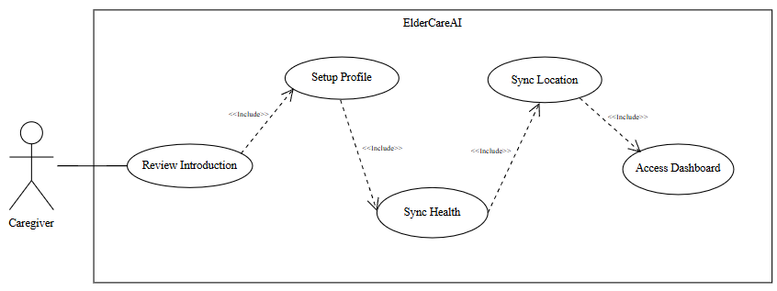
Figure 18: Complete Onboarding
A newly authenticated caregiver completes the introduction, caregiver and patient profiles, Galaxy Watch pairing, and watch-location sharing setup.

Use Case Name | Complete Onboarding
Actor | Caregiver
Brief Description | A newly authenticated caregiver completes the introduction, caregiver and patient profiles, Galaxy Watch pairing, and watch-location sharing setup.
Trigger | The app detects that onboarding_progress is incomplete.
Pre-Conditions | The caregiver has a valid Supabase session.
Post Conditions | Completed setup steps are saved and the caregiver enters Home; watch pairing may be completed later.
Flow of Activities | Actor(s) | Application
Flow of Activities | 1. Review or skip the introduction.  3. Enter caregiver information.  5. Enter older-adult and emergency-contact details.  7. Connect Galaxy Watch6 using the phone-generated code, or skip pairing.  9. Review watch location sharing and select Finish setup. | 2. Save intro completion in onboarding_progress.  4. Validate and save the caregiver profile.  4.1. If the caregiver information is valid, save the profile and continue.  4.2. Else, identify the fields that must be corrected.  6. Validate and save the older-adult profile.  6.1. If the older-adult and emergency-contact details are valid, save them and continue.  6.2. Else, keep the form open and display validation feedback.  8. Save the watch pairing state and paired-device count when available.  10. Complete setup and open Home; location permission is requested on the watch when monitoring starts.
COMPLETE ONBOARDING
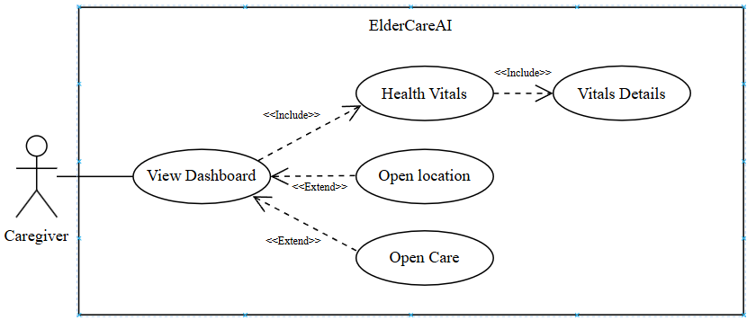
Figure 19: View Dashboard
The caregiver reviews current readings, measurement times, care tasks, doctor shortcuts, watch upload status, and the latest received watch location.
Table 7
VIEW DASHBOARD
Use Case Name | View Dashboard
Actor | Caregiver
Brief Description | The caregiver reviews current readings, measurement times, care tasks, doctor shortcuts, watch upload status, and the latest received watch location.
Trigger | The caregiver opens Home or returns to the foreground.
Pre-Conditions | Authentication and onboarding are complete; empty states are allowed when no readings exist.
Post Conditions | The latest available care and health status is displayed, with optional navigation to details, Care, doctor calling, or the location map.
Flow of Activities | Actor(s) | Application
Flow of Activities | 1. Open Home or pull to refresh.  3. Request Sync now when needed.  5. Review vital cards and measured times.  7. Open a metric, Care preview, doctor shortcut, or location. | 2. Load profiles, care tasks, doctor contacts, current vitals, and watch status.  4. Refresh saved watch data and available Health History imports.  4.1. If newer records exist, display their values and original measurement times.  4.2. Else, retain saved values and identify missing, stale, or disconnected data.  6. Show current values or explicit empty/disconnected states.  8. Navigate to the selected detail without changing the underlying record.
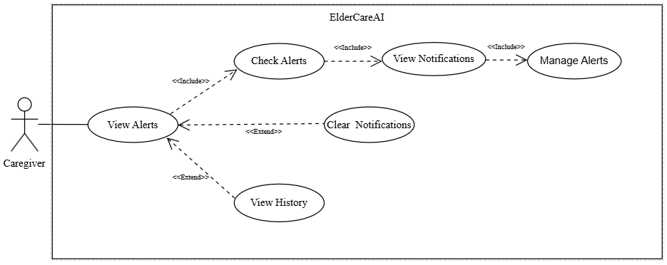
Figure 20: Review Health Alerts
The caregiver reviews health alerts, saved notifications, and emergency history, then marks, resolves, or clears the applicable records.
Table 8
REVIEW HEALTH ALERTS
Use Case Name | Review Health Alerts
Actor | Caregiver
Brief Description | The caregiver reviews saved health alerts and related in-app notifications, then updates the applicable status.
Trigger | The caregiver opens Alerts or follows a notification route.
Pre-Conditions | A caregiver session and elderly-person profile exist.
Post Conditions | Selected alerts are reviewed or resolved; notifications are marked read or cleared as permitted.
Flow of Activities | Actor(s) | Application
Flow of Activities | 1. Open Alerts.  3. Select a saved alert or notification.  5. Review alert details and available response actions.6. Mark a notification  read, resolve an alert with a response note, or clear a notification. | 2. Load alerts and notifications; display an empty state when none exist.  4. Show severity, original time, status, and linked medications when available.  7. Save the selected status change. Clearing a notification does not delete the underlying health alert or emergency record.

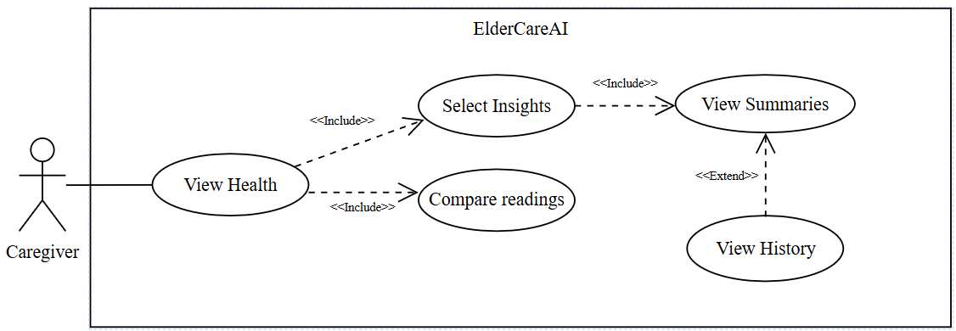
Figure 21: Review Health Insights
The caregiver reviews recorded vital values, readable status labels, recent changes, and general preventive care guidance for available metrics.
Table 9
REVIEW HEALTH INSIGHTS
Use Case Name | Review Health Insights
Actor | Caregiver
Brief Description | The caregiver reviews recorded vital values, readable status labels, recent changes, and general preventive care guidance for available metrics.
Trigger | The caregiver opens Health and selects AI Insights.
Pre-Conditions | The caregiver is signed in; synchronized history may be empty or partial.
Post Conditions | The app displays available metric summaries or a clear message that more readings are needed.
Flow of Activities | Actor(s) | Application
Flow of Activities | 1. Open Health and select AI Insights.  3. Review heart rate, SpO2, sleep, daily steps, wrist temperature, or experimental HRV-based stress summaries.  5. Open a related metric. | 2. Load the available synchronized vital history.  4. Derive status labels and recent changes from available recorded measurements.  4.1. If readings exist, show dated values and supported changes with general wellness guidance.  4.2. Else, identify the missing metric without inventing measurements or advice.  6. Show live values, saved history, and a stable Elle insight with manual refresh.

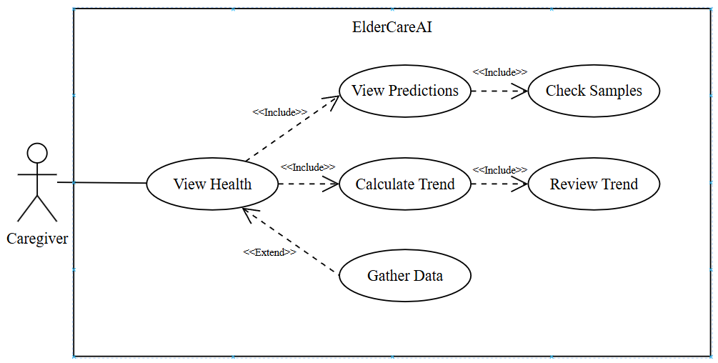
Figure 22: Analyze Health Trends
The caregiver reviews short-term statistical trend projections calculated from distinct synchronized readings, including the sample-based confidence label.
Table 10
ANALYZE HEALTH TRENDS
Use Case Name | Analyze Health Trends
Actor | Caregiver
Brief Description | The caregiver reviews short-term statistical trend projections calculated from distinct synchronized readings, including the sample-based confidence label.
Trigger | The caregiver opens Health and selects Predictions.
Pre-Conditions | At least four distinct readings are needed for a metric projection; otherwise the waiting state is shown.
Post Conditions | A non-diagnostic trend or an explicit insufficient-data message is displayed.
Flow of Activities | Actor(s) | Application
Flow of Activities | 1. Open Health and select Predictions.  3. Review a supported trend.  5. Continue collecting readings when a projection is unavailable. | 2. Build metric series from synchronized history.  4. Apply simple linear regression and label confidence from sample count and fit.  4.1. If at least four distinct readings exist, calculate the trend and confidence label.  4.2. Else, display the insufficient-data state.  6. Explain that at least four distinct readings per metric are required.

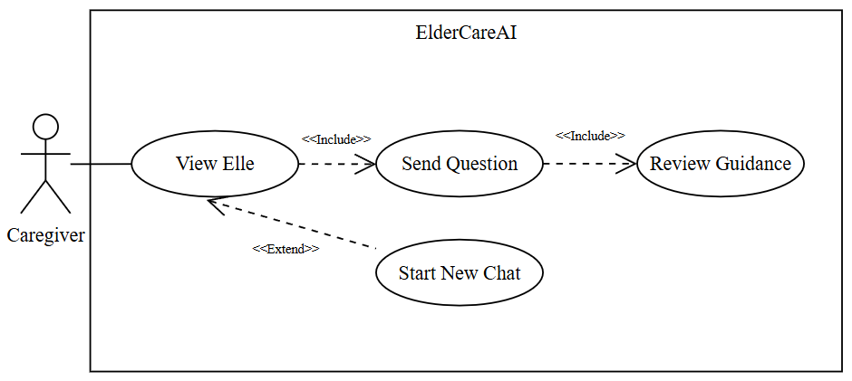
Figure 23: Consult Elle
The caregiver asks Elle a care-related question and receives non-diagnostic guidance informed by available saved care data.
Table 11
CONSULT ELLE
Use Case Name | Consult Elle
Actor | Caregiver
Brief Description | The caregiver asks Elle a care-related question and receives non-diagnostic guidance informed by available saved care data.
Trigger | The caregiver opens Elle, selects a quick topic, or enters a question.
Pre-Conditions | The caregiver is signed in and the ai-care-assistant function is deployed with its Gemini key.
Post Conditions | The conversation is saved in the active chat session and the caregiver may follow a suggested in-app action or start a new chat.
Flow of Activities | Actor(s) | Application
Flow of Activities | 1. Open Elle and enter or select a question.  3. Send the question.  5. Review the response and optional action links.  7. Start a new chat when desired. | 2. Create or reuse an active chatbot session.  4. Call the care assistant with the permitted saved-care context.  4.1. If guidance is returned, display it and save both messages in the active session.  4.2. Else, show a safe retry message without presenting diagnostic advice.  6. Save both messages and keep the response within non-diagnostic safety limits.  8. Close the prior active session and clear the visible conversation.

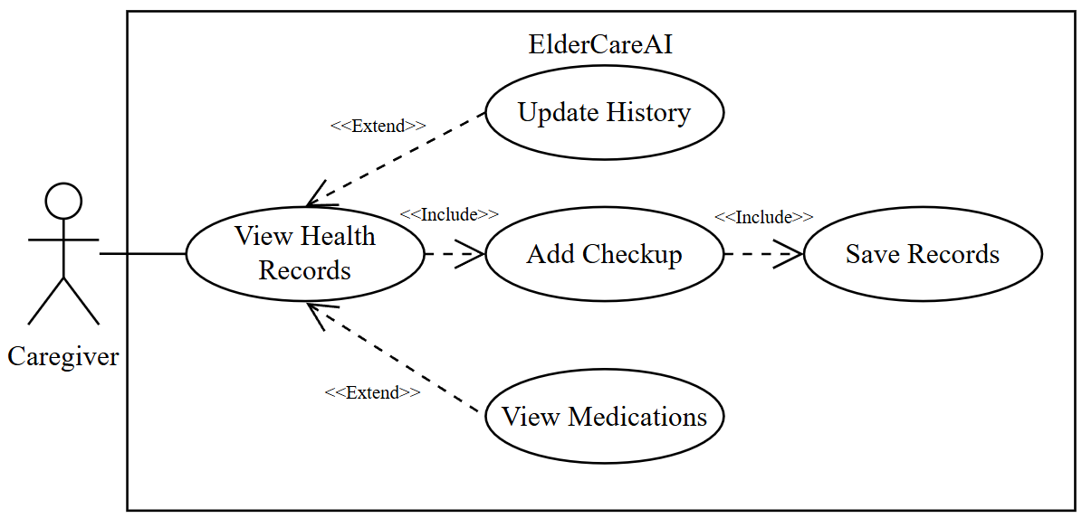
Figure 24: Manage Health Records
The caregiver maintains medical-history text and completed checkup records while reviewing the current active medication schedules.
Table 12
MANAGE HEALTH RECORDS
Use Case Name | Manage Health Records
Actor | Caregiver
Brief Description | The caregiver maintains medical-history text and completed checkup records while reviewing the current active medication schedules.
Trigger | The caregiver opens Settings and selects Manage health records.
Pre-Conditions | A caregiver session and older-adult profile exist.
Post Conditions | Validated history and checkup entries are saved and the current records reload.
Flow of Activities | Actor(s) | Application
Flow of Activities | 1. Open Manage health records.  3. Edit medical-history text.  5. Add a completed checkup dated today or earlier.  7. Review active medications. | 2. Load the older-adult profile, recent completed checkups, and active medications.  4. Validate and save the updated older-adult medical history.  4.1. If the medical-history entry is valid, save it to the older-adult profile.  4.2. Else, retain the entered text and display correction guidance.  6. Save the checkup as a completed appointment record.  6.1. If the checkup date is today or earlier, save it as a completed appointment.  6.2. Else, reject the future completion date and keep the form open.  8. Display medication details managed from the Care tab.

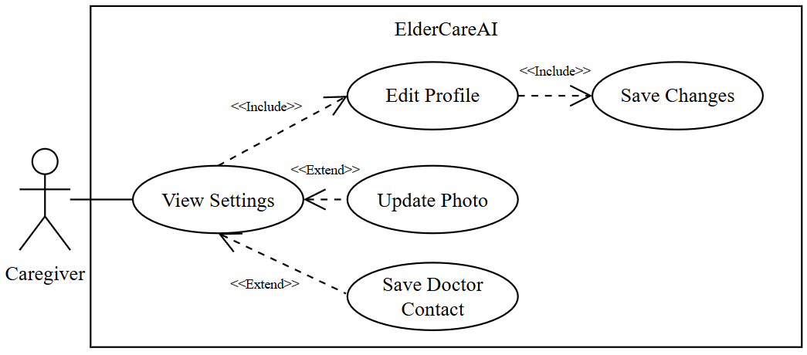
Figure 25: Manage User Profiles
The caregiver edits caregiver and older-adult information, uploads profile photos, and adds or updates the saved doctor contact.
Table 13
MANAGE USER PROFILES
Use Case Name | Manage User Profiles
Actor | Caregiver
Brief Description | The caregiver edits caregiver and older-adult information, uploads profile photos, and adds or updates the saved doctor contact.
Trigger | The caregiver opens Settings and selects a profile or doctor action.
Pre-Conditions | Authentication and onboarding are complete.
Post Conditions | Validated profile, photo, or doctor changes are saved and reflected in the app.
Flow of Activities | Actor(s) | Application
Flow of Activities | 1. Open Settings.  3. Edit caregiver or older-adult information.  5. Select a caregiver or older-adult photo.  7. Add or edit the doctor name, phone, and photo. | 2. Load caregiver, older-adult, photo, and doctor details.  4. Validate and save the selected profile.  4.1. If the selected profile fields are valid, save and refresh the profile.  4.2. Else, display field-level validation feedback.  6. Upload the image and save its storage URL.  6.1. If the selected image is supported, upload it and save its storage URL.  6.2. Else, keep the existing photo and display an upload error.  8. Validate the phone, save the contact, and refresh the display.

m
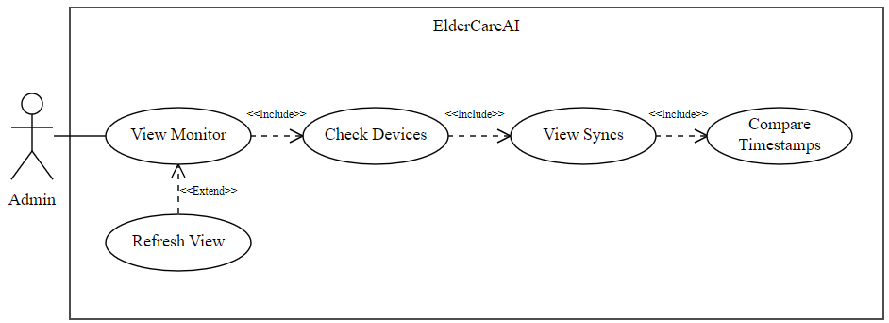
Figure 27: Monitor System Data
The administrator reviews onboarding-reported device connection state and recent saved health sync records, including measured time, saved time, and source.
Table 15
MONITOR SYSTEM DATA
Use Case Name | Monitor System Data
Actor | Administrator
Brief Description | The administrator reviews onboarding-reported device connection state and recent saved health sync records, including measured time, saved time, and source.
Trigger | The administrator opens System monitor or selects Refresh.
Pre-Conditions | An active administrator session exists.
Post Conditions | The latest available connection and sync records are displayed with an updated timestamp.
Flow of Activities | Actor(s) | Application
Flow of Activities | 1. Open System monitor.  3. Review paired-device count and state-change time.  5. Review sync source, measured time, and saved time.  7. Select Refresh. | 2. Load connection states reported during onboarding and recent vital writes.  2.1. If saved connection or sync records exist, display the newest records.  2.2. Else, display an explicit empty state rather than live-device telemetry.  4. Label this as connection state, not live device telemetry.  6. Show the newest records and recent admin activity.  8. Reload the current monitor view and update the displayed refresh time.

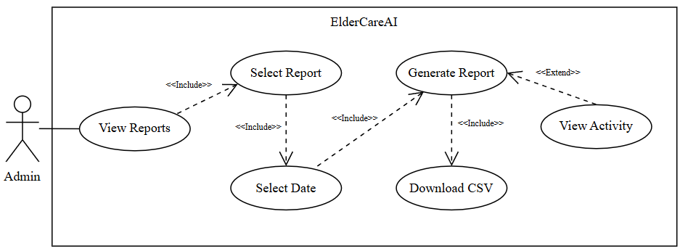
Figure 28: Export Admin Reports
The administrator exports a CSV for a selected saved-data category and date range, subject to the portal's 90-day and 2,000-row limits.
Table 16
EXPORT ADMIN REPORTS
Use Case Name | Export Admin Reports
Actor | Administrator
Brief Description | The administrator exports a CSV for a selected saved-data category and date range, subject to the portal's 90-day and 2,000-row limits.
Trigger | The administrator opens Reports and submits a report request.
Pre-Conditions | An active administrator session exists and matching saved data may be available.
Post Conditions | A formula-safe CSV downloads when rows exist and the report action is recorded in administrative activity.
Flow of Activities | Actor(s) | Application
Flow of Activities | 1. Open Reports and select a report type.  3. Choose From and To dates, then generate.  5. Download the CSV when data exists. | 2. Offer health readings, alerts, appointments, medications, medical history, or admin activity.  4. Validate the date range and retrieve no more than the configured limit.  4.1. If the date range is valid, retrieve up to the configured row limit.  4.2. Else, display the date-range validation error.  6. Escape spreadsheet-formula prefixes, create the file, and record the report event.  6.1. If matching rows exist, create and download the formula-safe CSV and record the report event.  6.2. Else, show that no matching records are available.

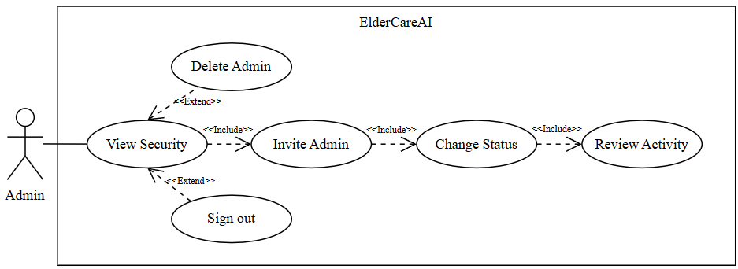
Figure 29: Manage System Security
The administrator invites administrators, changes administrator or caregiver access, deletes non-current administrators, reviews audit activity, and signs out.
Table 17
MANAGE SYSTEM SECURITY
Use Case Name | Manage System Security
Actor | Administrator
Brief Description | The administrator invites administrators, changes administrator or caregiver access, deletes non-current administrators, reviews audit activity, and signs out.
Trigger | The administrator opens Security.
Pre-Conditions | An active administrator session exists.
Post Conditions | Authorized security changes are applied and audited; safeguards prevent removal of the final active administrator.
Flow of Activities | Actor(s) | Application
Flow of Activities | 1. Open Security.  3. Invite an administrator by email.  5. Activate, suspend, or delete an eligible administrator; or change caregiver access.  7. Review activity or sign out. | 2. Load administrators, caregiver status options, current session details, and recent audit rows.  4. Create the invitation and show its delivery result.  6. Enforce current/final-admin safeguards and record accepted changes.  6.1. If the requested change passes the current-administrator and final-administrator safeguards, apply and audit it.  6.2. Else, block the change and explain the safeguard.  8. Clear the in-memory session and return to the locked portal.

v
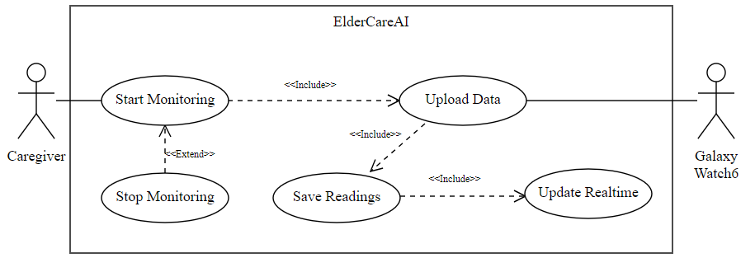
Figure 31: View Vitals From Tracker
Galaxy Watch6 uploads measurements directly to Supabase. Realtime and reconciliation refresh the caregiver view; Health History imports recorded sleep and supported oxygen.
Table 19
VIEW VITALS FROM TRACKER
Use Case Name | View Vitals From Tracker
Actor | Elderly Person
Brief Description | The elderly person views available readings on the ElderCareAI watch dashboard and checks their measurement age or sensor status.
Trigger | The elderly person opens ElderCareAI on the watch to inspect a reading.
Pre-Conditions | The watch is paired and the selected metric has a usable current or saved reading.
Post Conditions | The watch displays the available reading and status while accepted measurements are recorded through monitoring.
Flow of Activities | Actor(s) | Application
Flow of Activities | 1. Wake Galaxy Watch6 and open ElderCareAI.  2. View the dashboard or open a blood-oxygen spot check.  5. Review the measurement and its time or status.  7. Continue monitoring and keep internet available for uploads. | 3. Display available heart rate, wrist temperature, monitored steps, oxygen, or HRV-based stress estimate.  4. If a valid reading is unavailable, show waiting, missing-data, or retry feedback.  6. Treat the reading as informational and not as a medical diagnosis.

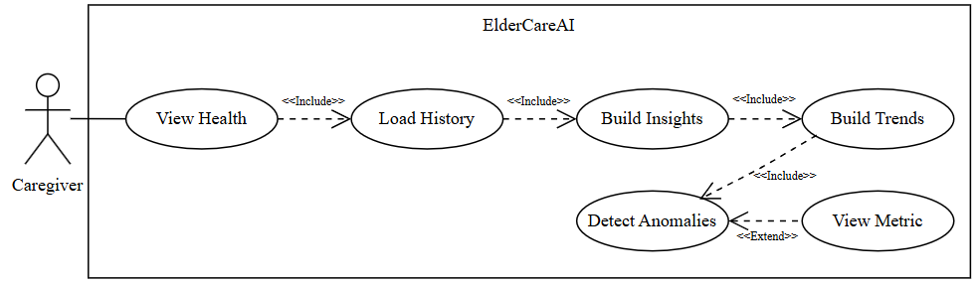
Figure 32: Analyze Health Trends Analysis Flow
The app derives insights, short-term statistical trends, and anomaly flags from saved vital history without presenting a medical diagnosis.
Table 20
ANALYZE HEALTH TRENDS
Use Case Name | Analyze Health Trends
Actor | Caregiver
Brief Description | The app derives insights, short-term statistical trends, and anomaly flags from saved vital history without presenting a medical diagnosis.
Trigger | The caregiver opens Health after synchronized data is loaded.
Pre-Conditions | A caregiver session exists; analysis can operate with partial data and reports its limitations.
Post Conditions | Available analysis results and confidence or insufficient-data states are displayed with access to metric details.
Flow of Activities | Actor(s) | Application
Flow of Activities | 1. Open Health.  3. Review insights and projections.  5. Review anomalies.  7. Open metric details. | 2. Load recent vital_sign_logs visible under caregiver access rules.  4. Compare personal averages and calculate supported linear trends.  4.1. If enough saved history exists, calculate the supported averages and trends.  4.2. Else, display the applicable insufficient-data state.  6. Apply explicit thresholds and personal-baseline deviation checks.  8. Show recent values, context, source, and a metric-specific safety caution.

export
authen
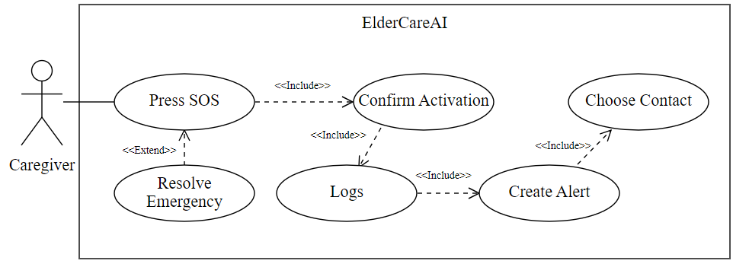
Figure 35: Activate SOS Emergency
The caregiver or watch wearer confirms SOS to save emergency records and notify the caregiver; the phone offers priority contacts for an explicit dial action.
Table 23
ACTIVATE SOS EMERGENCY
Use Case Name | Activate SOS Emergency
Actor | Caregiver, Elderly Person
Brief Description | The caregiver or watch wearer confirms SOS to save emergency records and notify the caregiver; the phone offers priority contacts for an explicit dial action.
Trigger | The caregiver confirms phone SOS or the watch wearer selects Send SOS.
Pre-Conditions | A patient profile or paired watch exists; delivery requires internet and enabled phone notifications.
Post Conditions | Emergency records are saved and an eligible push is queued; the caregiver chooses whether to dial a priority contact.
Flow of Activities | Actor(s) | Application
Flow of Activities | 1. Press phone SOS or open watch SOS and review the confirmation.  3. Confirm activation or tap Send SOS on the watch.  5. Choose a caregiver, family member, or doctor to contact.  7. Mark the event resolved later when appropriate. | 2. Require explicit confirmation before creating SOS records.  2.1. If the caregiver confirms, continue with the emergency workflow.  2.2. Else, cancel without creating records or opening the dialer.  4. Save the emergency and available vital context; provide send, pending, or error feedback.  6. Save a critical alert and notification; queue push and display priority contacts on the phone.  6.1. If the caregiver selects a saved number, open the supported dial action.  6.2. Else, retain emergency records without claiming that a call occurred.  8. Save the caregiver response or resolution while retaining emergency history.

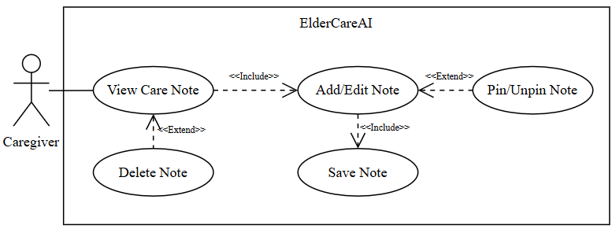
Figure 36: Manage Care Notes
The caregiver creates, edits, pins, unpins, and deletes care notes associated with the older adult.
Table 24
MANAGE CARE NOTES
Use Case Name | Manage Care Notes
Actor | Caregiver
Brief Description | The caregiver creates, edits, pins, unpins, and deletes care notes associated with the older adult.
Trigger | The caregiver opens Care and selects Notes.
Pre-Conditions | A caregiver session and older-adult profile exist.
Post Conditions | The note list reflects the saved content and pin state, or removes a note after confirmed deletion.
Flow of Activities | Actor(s) | Application
Flow of Activities | 1. Open Care and select Notes.  3. Add note content or edit an existing note.  5. Pin or unpin a note.  7. Confirm deletion when needed. | 2. Load notes for the current older-adult profile.  4. Validate non-empty content and insert or update caregiver_notes.  4.1. If the note contains non-empty content, insert or update it.  4.2. Else, reject the save and keep the note editor open.  6. Save is_pinned and refresh ordering.  8. Delete only the selected note and refresh the list.  8.1. If deletion is confirmed, delete only the selected note and refresh the list.  8.2. Else, leave the note unchanged.

co
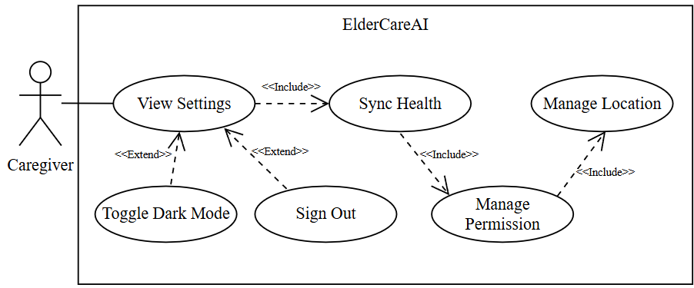
Figure 38: Configure App Settings
The caregiver manages Galaxy Watch pairing, Health History access, emergency contacts, care notifications, theme, and account sign-out in Settings.
Table 26
CONFIGURE APP SETTINGS
Use Case Name | Configure App Settings
Actor | Caregiver
Brief Description | The caregiver manages Galaxy Watch pairing, Health History access, emergency contacts, care notifications, theme, and account sign-out in Settings.
Trigger | The caregiver opens Settings and selects an integration, permission, preference, or account action.
Pre-Conditions | Authentication and onboarding are complete; phone settings may restrict permission changes.
Post Conditions | The chosen setting is updated or the relevant phone settings page opens with clear status feedback.
Flow of Activities | Actor(s) | Application
Flow of Activities | 1. Open Settings.  3. Manage Galaxy Watch pairing, Health History access, emergency contacts, or care-notification permissions.  5. Toggle Dark Mode.  7. Sign out when desired. | 2. Load watch, Health History, notification, contact, and theme status.  4. Run the supported app action or open system settings when required.  6. Persist and apply the theme preference.  8. Clear the Supabase session and return to Login.

e
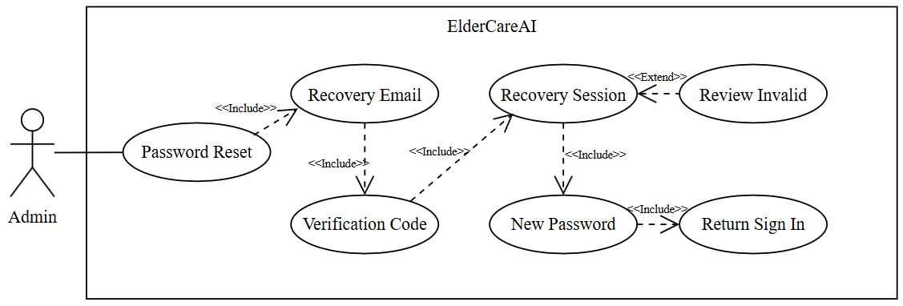
Figure 40: Recover Admin Password
An administrator requests a recovery email, verifies the newest one-time code, sets a new password, and returns to sign in.
Table 28
RECOVER ADMIN PASSWORD
Use Case Name | Recover Admin Password
Actor | Administrator
Brief Description | An administrator requests a recovery email, verifies the newest one-time code, sets a new password, and returns to sign in.
Trigger | The administrator selects Forgot password on the portal.
Pre-Conditions | The administrator enters the configured admin username or email and can access that email account.
Post Conditions | A valid recovery session updates the password; invalid, expired, or rate-limited attempts show safe feedback without opening the portal.
Flow of Activities | Actor(s) | Application
Flow of Activities | 1. Enter the admin username or email and select Forgot password.  3. Enter the newest 6- to 8-digit verification code.  5. Enter and confirm a new password.  7. Sign in with the new password. | 2. Request a Supabase recovery email and show non-enumerating feedback.  4. Verify the code and recovery session for the same email.  4.1. If the newest code and recovery session are valid, allow the administrator to set a new password.  4.2. Else, show invalid, expired, or rate-limited feedback and keep the portal locked.  6. Update the authenticated user's password and clear the recovery session.  6.1. If the password update succeeds, clear the recovery session and return to sign in.  6.2. Else, retain the recovery screen and display the update error.  8. Return to the normal admin sign-in form.
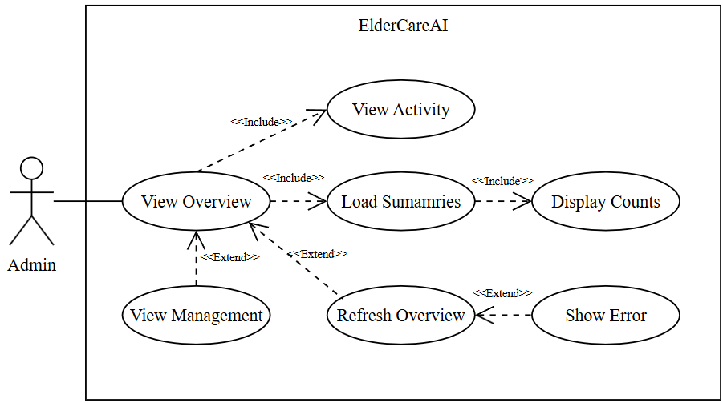
Figure 41: View System Overview
The administrator reviews system summaries and recent activity before opening the relevant management page.
Table 29
VIEW SYSTEM OVERVIEW
Use Case Name | View System Overview
Actor | Administrator
Brief Description | The administrator reviews current account, synchronization, alert, emergency, and administrative activity summaries.
Trigger | An authenticated administrator opens Overview.
Pre-Conditions | An active administrator session exists.
Post Conditions | Current summary counts and recent saved activity are displayed with a refresh time.
Flow of Activities | Actor(s) | Application
Flow of Activities | 1. Open Overview.  4. Review the available summary cards and recent activity.  5. Select Accounts, System monitor, Alerts and notifications, Reports, or Security.  7. Return to Overview and request a refresh when needed. | 2. Load current account counts, access status, recent synchronization records, alerts, emergencies, and audit activity.  3. Display the summary cards, recent activity, and refresh time. Show zero counts or empty states when a category has no records.  6. Open the selected management page.  8. Load and display the latest saved data and update the refresh time.  9. If refresh fails, preserve the last displayed data and show an error.

