Development and Construction / Build Phase
The Development and Construction/Build phase is the construction phase that requires a complete design specification, proper processes, and the tools used to accomplish system development.

Technology Stack Diagram
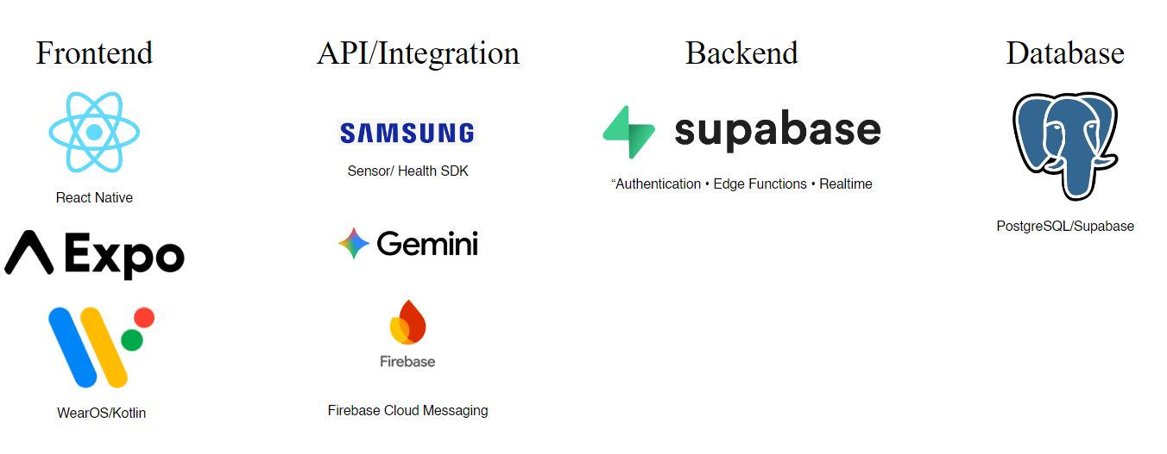
The technology stack diagram for the ElderCareAI system provides a solid foundation for its development.
The figure presents the technologies used in ElderCareAI. TypeScript and JavaScript, together with React Native and Expo, support the caregiver’s Android application, while Kotlin and Wear OS support the Galaxy Watch6 application. The Samsung Health Sensor SDK provides supported watch sensor readings, and the Samsung Health Data SDK imports available sleep and recorded blood-oxygen history. Supabase provides authentication, server-side processing, and real-time data synchronization. PostgreSQL stores structured system records, while Supabase Storage handles uploaded files. Gemini API supports Elle AI’s assistance, and Expo Push Service works with Firebase Cloud Messaging to deliver configured Android notifications.

Implementation Budget / Cost Specification

Hardware
Laptop | One unit | ₱30,000.00
Android phone | One unit | ₱14,000.00
Samsung Galaxy Watch6 | One unit | ₱4,500.00
Software |  | ₱48,500.00
Visual Studio Code and Android Studio | No-cost development tools | ₱0.00
React Native, Expo and required SDKs | Prototype development | ₱0.00
Supabase | Free-plan allowance | ₱0.00
Firebase FCM and Expo Push Service | No-cost messaging services | ₱0.00
Gemini API and Expo build services | Within available no-cost quotas | ₱0.00
Miscellaneous |  | ₱0.00
Internet connection | One month | ₱1,699.00
Electricity | One month | ₱3,000.00
Food allowance | Project allowance | ₱2,000.00
 |  | ₱6,699.00
Total Cost of the System |  | ₱55,199.00

Software Specification
The system is to be implemented with the following software specifications:
Table 32
SOFTWARE SPECIFICATION AND HARDWARE SPECIFICATION
ElderCareAI: An AI-Driven IoT System for Elderly Monitoring and Caregiver Support
SOFTWARE DEVELOPMENT REQUIREMENT SPECIFICATION
Back-end:
DBMS | PostgreSQL (Supabase)
Server-side Programming | TypeScript / Deno-compatible Supabase Edge Functions; PostgreSQL SQL functions
Cloud Service | Supabase Cloud (Auth, Realtime, Storage)
AI Service | Gemini API through server-side functions
Notification Service | Expo Push Service and Firebase Cloud Messaging v1
Front-end:
Platform Technologies | Custom Android APK with native modules
Programming / Scripting Language | TypeScript / JavaScript
Software Framework | React Native, Expo
UI Environment | Android mobile phone
Administration Portal | HTML, CSS and JavaScript in a modern web browser
Watch and Health Integration:
Watch Application | Kotlin, Android SDK and Wear OS
Live Sensor Integration | Samsung Health Sensor SDK; watch GPS for location
Health History Integration | Samsung Health Data SDK: sleep and recorded oxygen
Development Tools | Visual Studio Code, Android Studio, Android SDK, Gradle, JDK and Node.js
.

Hardware Specification
The system is to be implemented with the following hardware specifications:
Component | Minimum Requirement | Recommended Requirement
Development CPU | Compatible 64-bit processor; virtualization support for emulator use | Recent Intel Core i5 / AMD Ryzen 5 class or better
Development Memory (RAM) | 8 GB RAM for Android Studio without an emulator | 16 GB for physical-device work; 32 GB for heavier emulator use
Development Storage | Space for Android Studio, SDKs, Gradle caches and project files | SSD with at least 32 GB free for tools, plus project and build space
Development Display | 1280 × 800 pixels; USB or wireless debugging access | 1920 × 1080 pixels or higher; stable internet and USB access
Development Operating System | 64-bit Windows 10 supported by the tools | A currently supported 64-bit Windows release
Phone Operating System | Android 10 / API 29 or later | Android 13 or later, with current permission controls
Input Devices | Touchscreen controls on the Android phone and watch | Readable, accessible touch controls on both devices
Output Devices | Display, speaker and vibration | Display, sound and vibration with permitted Android push notifications
Wearable IoT Device | Samsung Galaxy Watch6 with the ElderCareAI Wear OS APK | Updated watch software and Health Sensor Service; enabled sensor and location permissions
Health and Location Sensing | Supported heart rate, SpO₂, wrist skin-temperature, motion and GPS readings | Valid sensor contact and GPS fix; sleep imported after recording and stress derived from HRV
Phone Health Integration | Samsung Health 6.30.2 or later and Galaxy Wearable on the paired phone | Patient’s watch paired to the same phone; required sleep and oxygen read permissions granted
Bluetooth and Messaging | Watch–phone pairing; Google Play services on the phone for FCM | Stable pairing with notification registration and permission enabled
Cloud Server | Supabase Cloud with PostgreSQL | Supabase Authentication, Realtime, Storage and Edge Functions
Internet Connection | Internet access for uploads and cloud services | Stable Wi-Fi or mobile data for watch / phone synchronization and caregiver access
Power Supply | Rechargeable phone and smartwatch batteries with appropriate chargers | Routine charging; sufficient charge for active sensor and GPS use
Administrator Device | Laptop or desktop with a modern browser and internet connection | Secure, updated browser access to the administration portal

Human Resource Specification
The research study, ElderCareAI, was designed to address the needs of the following users:
1. Caregiver
The caregiver manages the assigned older adult’s profile, pairs the watch, reviews readings and location, maintains medications and appointments, responds to alerts, and consults Elle AI. The caregiver also enables notification permissions and checks whether displayed data is current.
2. System Administrator
The administrator uses the web portal to manage authorized user accounts and patient records, review stored monitoring data and audit activity, and generate system reports. Administrative privileges must be restricted to approved personnel.
3. Older Adult / Watch Wearer
The older adult wears the Galaxy Watch6, keeps it charged, and uses the watch’s monitoring, spot oxygen, SOS and medication controls as needed. The caregiver can assist with setup and permissions. A separate caregiver-style phone account is not required simply to wear the paired watch.

Program Specification
The system is to be implemented with the following program specifications:

Functional Requirements
– Authentication and profiles. Provide caregiver Google sign-in and separate authenticated administrator access. Maintain caregiver, patient and emergency-contact details with role-based access.
– Watch integration. Pair the Galaxy Watch6 with the correct patient, request the necessary permissions, display connection status and provide monitoring start/stop controls.
– Health monitoring. Display supported heart rate, oxygen, wrist skin temperature, steps, sleep and derived stress/HRV information with units and individual measurement times.
– Vital-event history. Save every accepted new vital event with its original time and source. Retain unacknowledged watch samples for retry and prevent duplicate retry records. Missing metrics remain blank rather than being fabricated.
– Location tracking. Display the patient’s latest valid watch location and update the map when new positions arrive. Indicate location age or accuracy so an old fix is not presented as current movement.
– Medications and appointments. Create, update and display care schedules, instructions and reminders. Synchronize supported medication “Taken” actions between watch and app, with clear save and reminder-setup feedback.
– Threshold alerts. Evaluate valid uploaded readings against the configured app review rules. Save threshold warnings in Alerts and Notifications, apply duplicate/cooldown controls, and queue caregiver push delivery.
– SOS and notifications. Allow a watch SOS request to create a caregiver alert. Deliver SOS, vital warnings, medication reminders and appointment reminders through the configured notification paths. SOS is an assistance request, not an automatic emergency-services dispatch.
– Health history import. Import permitted sleep and recorded oxygen data from the selected patient watch through the phone’s health history integration. Retry failed uploads without inventing or duplicating readings.
– Elle AI and analytics. Answer questions about saved patient history, summarize trends and provide clearly qualified statistical insights. Distinguish missing data from a confirmed negative result; avoid diagnosis or guaranteed health predictions.
– Reports. Provide patient vital-history and medication-schedule PDF exports, together with authorized administrative reporting.
– Administration and settings. Support account and record management, audit review, device status, notification preferences and sound settings. Expose clear permission, connectivity and synchronization errors.

Nonfunctional Requirements
– Data quality. Validate values, timestamps and sensor quality. Mark missing or stale data clearly. Consumer wearable readings and derived scores must not be represented as clinical-grade measurements.
– Security and privacy. Use authenticated access, role checks, database row-level policies and encrypted network communication. Keep privileged backend, AI and push credentials out of client code.
– Reliability and integrity. Use event identifiers, acknowledgments and retries to reduce data loss and duplicate history. Preserve independent measurement times and source details.
– Responsiveness. Display new accepted data and queue threshold alerts promptly. Sensor intervals, continuous coverage and notification arrival times cannot be guaranteed.
– Background operation. Support Android push when the app is not open, using the correct APK, credentials, registration and permission. Force-stop, offline state, battery policies, muted channels and Do Not Disturb can affect delivery or sound.
– Usability and compatibility. Use readable labels, units, clear controls and understandable errors. Validate supported Android phones, Galaxy Watch6 and modern-browser administrator access.
– Maintainability and capacity. Keep mobile, watch and backend modules organized and testable. Monitor database growth, cloud quotas, failures and retry queues as the number of patients and recorded samples increases.

List of modules
The table below presents the proposed module assignments. Each proponent is responsible for implementing, testing and improving six modules of the updated ElderCareAI system.
An asterisk identifies use or participation, including wearing the watch. It does not grant permissions. Participation totals overlap when modules serve several user groups.
Table 31
LIST OF MODULES
Proponents | Modules | Elderly | Caregiver | Admin
 | Authentication & User Management Modules
Kristoffer James G. Layos | Landing page and role dashboards |  | * | *
Kristoffer James G. Layos | Login, authentication and role control |  | * | *
Kristoffer James G. Layos | Profiles and settings |  | * | *
Kristoffer James G. Layos | Caregiver account management |  |  | *
Kristoffer James G. Layos | Administrator access management |  |  | *
Kristoffer James G. Layos | Security and audit logs |  |  | *
No. of Points (1 point per module) |  | 0 | 3 | 6
 | Health Monitoring Modules
John Wayne C. Planos | Watch pairing and sensor integration | * | *
John Wayne C. Planos | Live vital signs and activity | * | *
John Wayne C. Planos | Oxygen measurement and sleep history | * | *
John Wayne C. Planos | HRV and experimental stress estimate | * | *
John Wayne C. Planos | Medication and appointment care | * | *
John Wayne C. Planos | Health history and PDF reports |  | * | *
No. of Points (1 point per module) |  | 5 | 6 | 1
 | Emergency & Monitoring Modules
Melvence R. Bagonggong | SOS and caregiver response | * | *
Melvence R. Bagonggong | Automatic vital-threshold alerts |  | * | *
Melvence R. Bagonggong | GPS tracking and map updates | * | *
Melvence R. Bagonggong | Caregiver push and reminder notifications |  | * | *
Melvence R. Bagonggong | Elle AI and health analytics |  | *
Melvence R. Bagonggong | System reports and device-status monitoring |  |  | *
No. of Points (1 point per module) |  | 2 | 5 | 3

