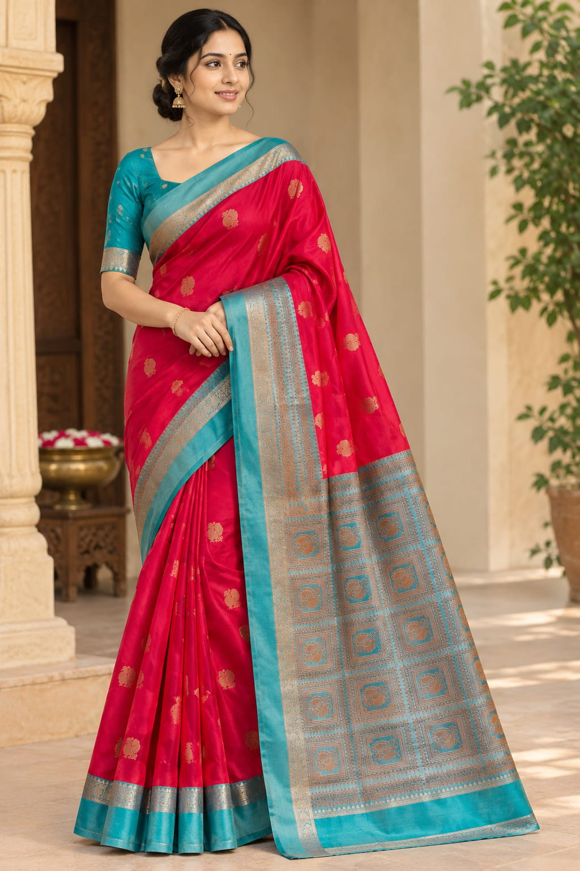Imation pattu saree with rich pallu 2499/-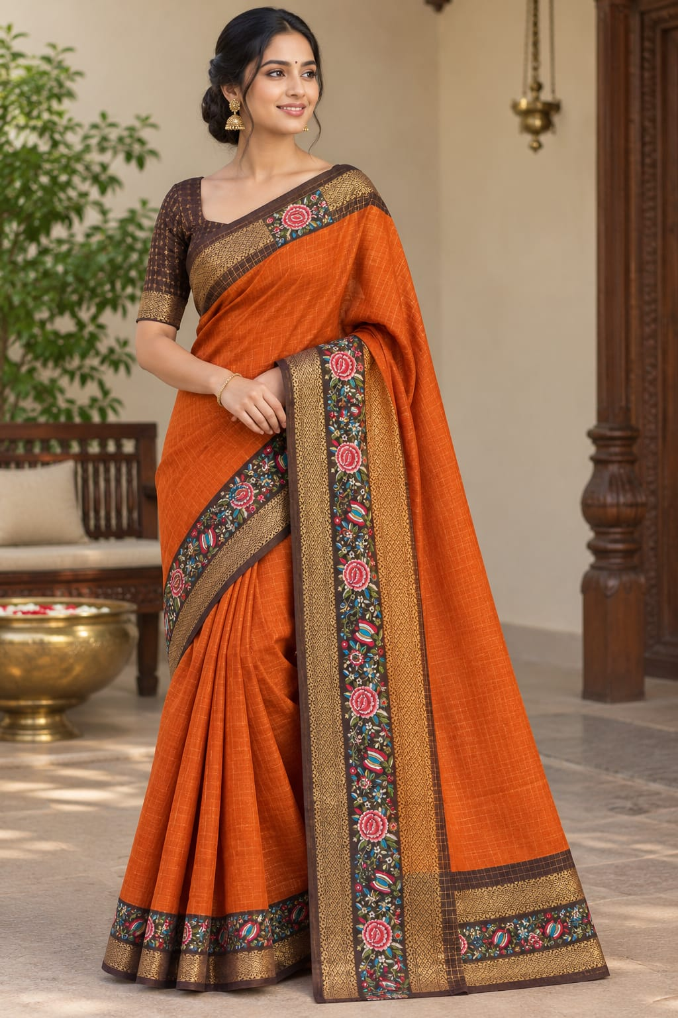Soft chinon trendy saree 1499/-
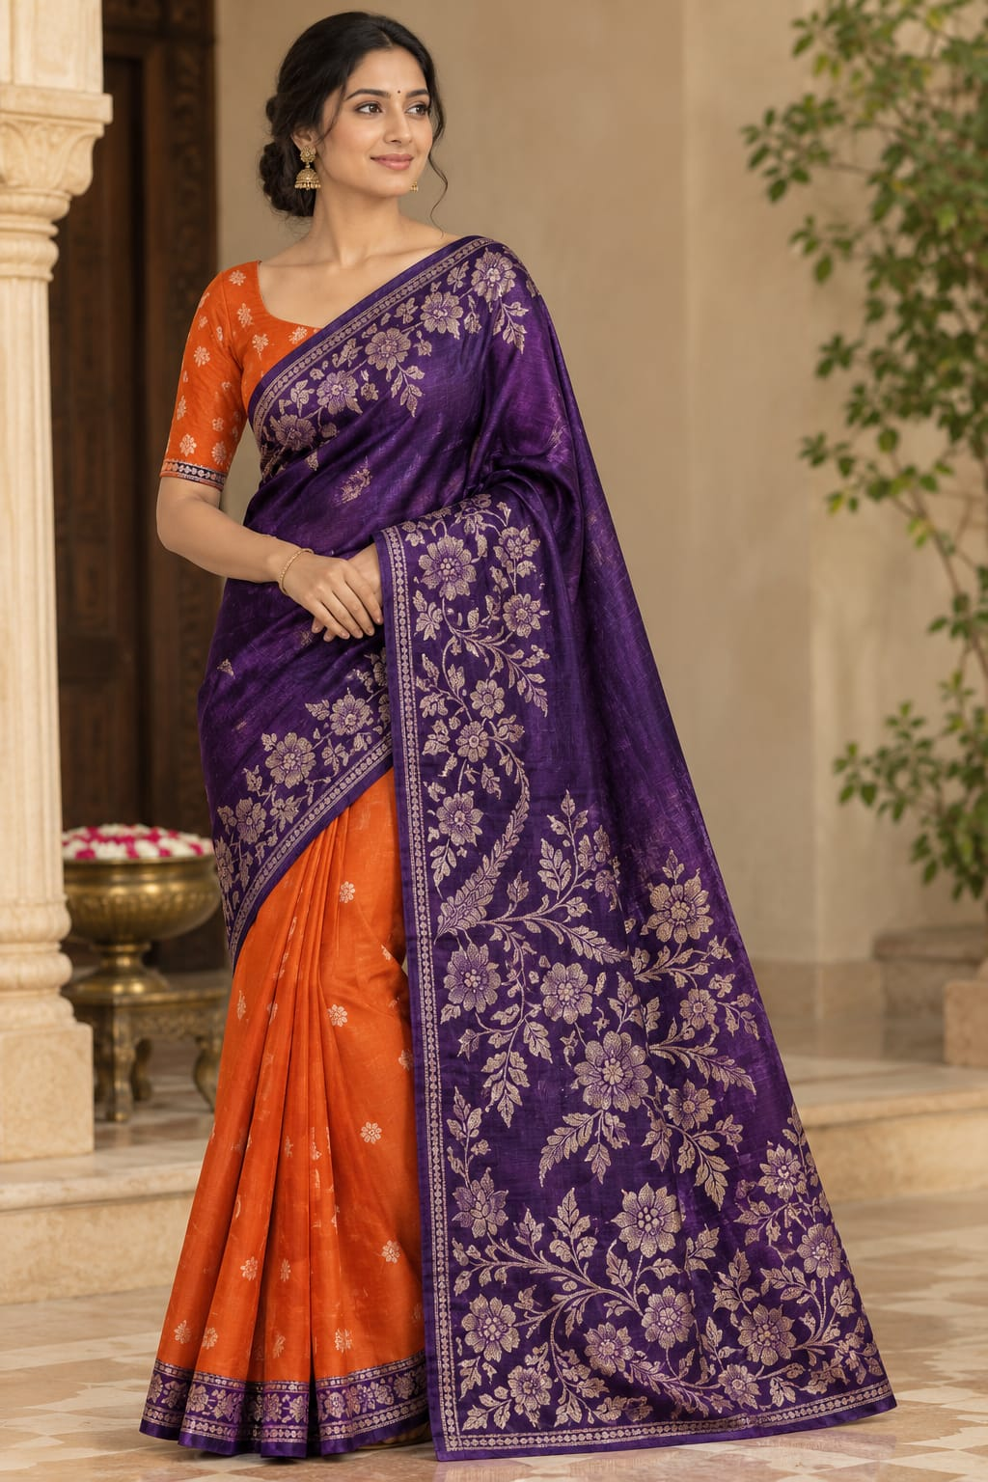Pure raw mango saree 4999/-
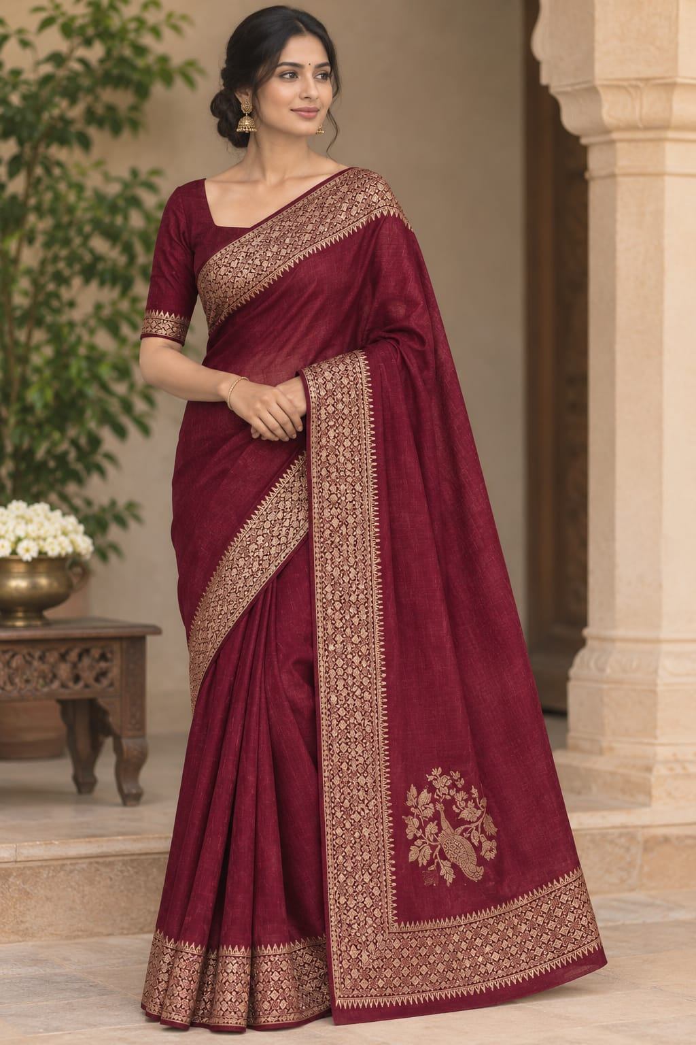Rich pure satin crepe saree rs - 2499/-Premium tissue banaras saree 2499/
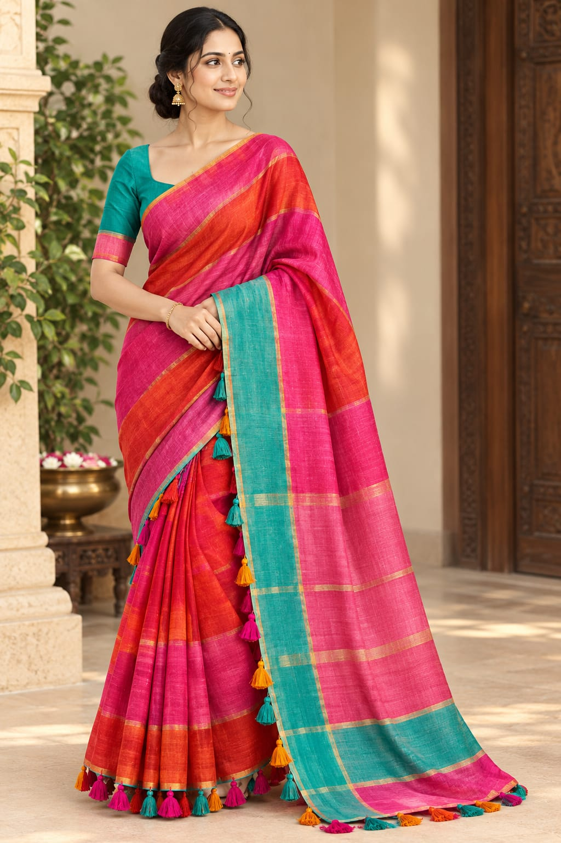Premium mul cotton saree 1399/-

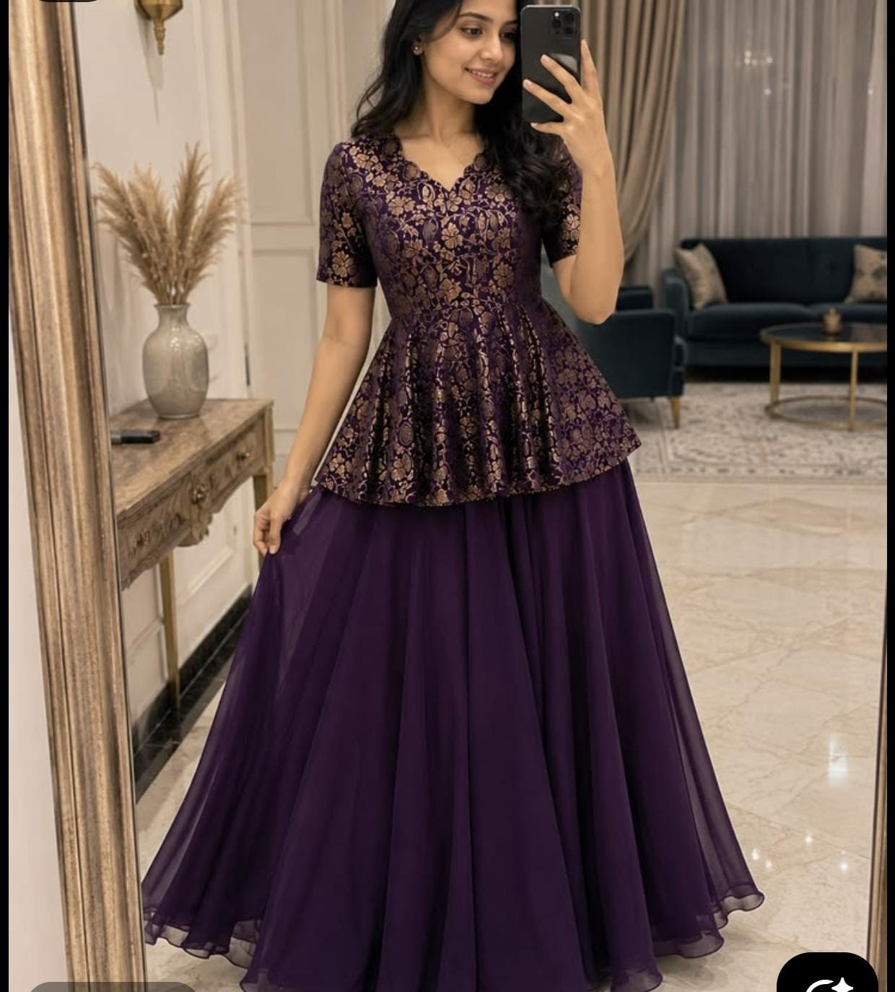Purple pepulum set 1899/

