[Administrative-portal-for-Learner-Academy](https://github.com/MujtabaMohsin/Administrative-portal-for-Learner-Academy)

SCREENSHOTS

[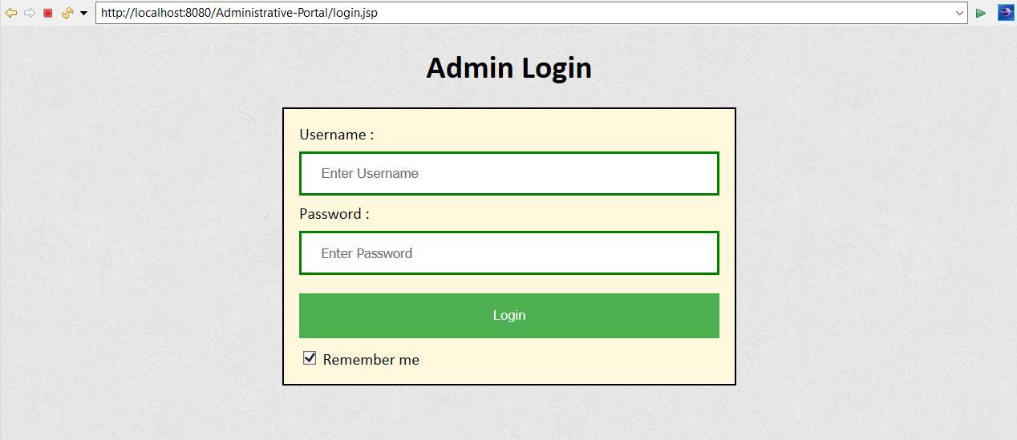](https://user-images.githubusercontent.com/64940728/120771774-47dd9600-c528-11eb-86c8-ee8a1b133a23.png)

[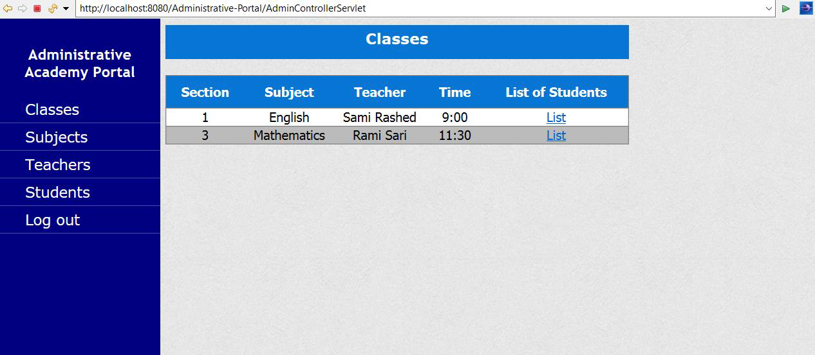](https://user-images.githubusercontent.com/64940728/120771806-4e6c0d80-c528-11eb-97bb-8abe14d8560c.png)

[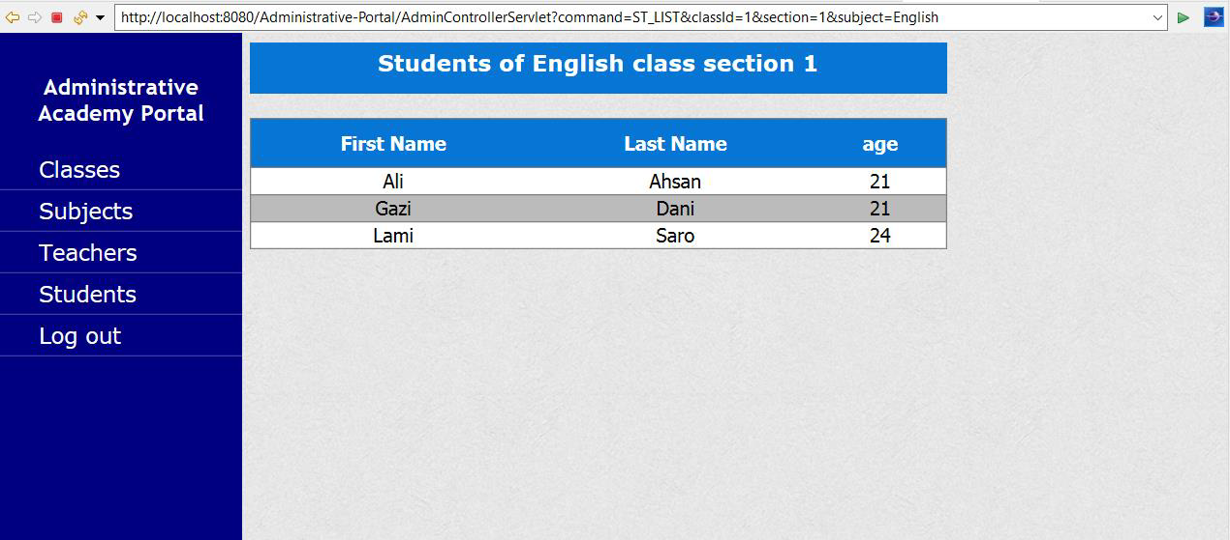](https://user-images.githubusercontent.com/64940728/120771819-51ff9480-c528-11eb-98fe-39b7767b8de6.png)

[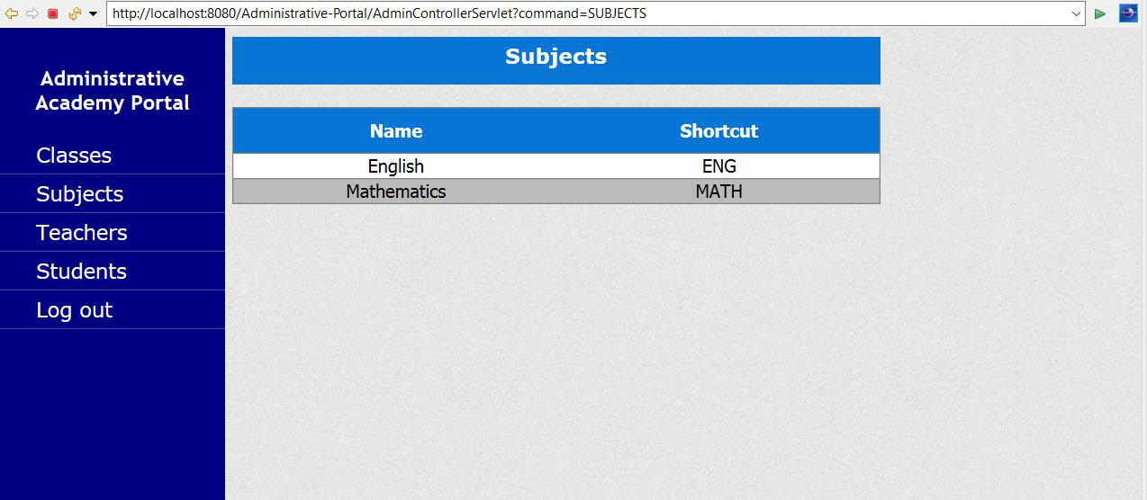](https://user-images.githubusercontent.com/64940728/120771833-54fa8500-c528-11eb-9291-2ab6c81528f3.png)

[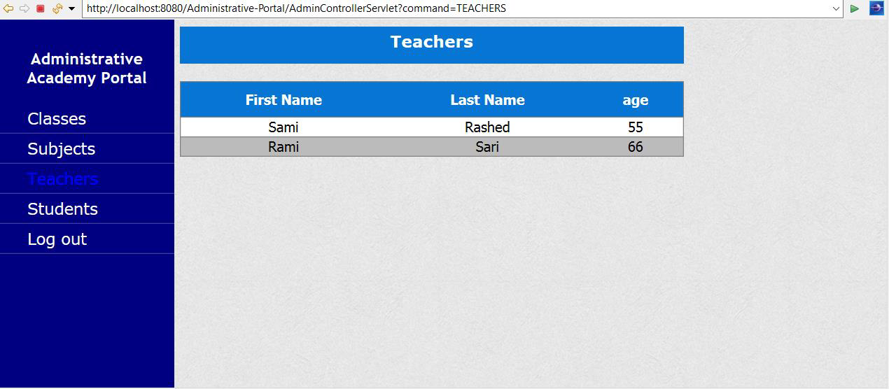](https://user-images.githubusercontent.com/64940728/120771849-588e0c00-c528-11eb-89d0-fbc960d1562e.png)

[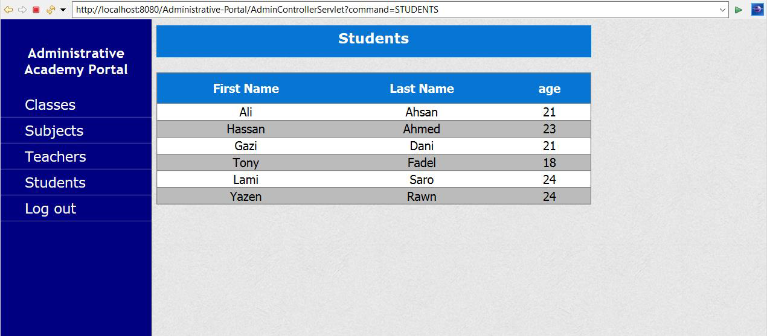](https://user-images.githubusercontent.com/64940728/120771867-5c219300-c528-11eb-8aed-e8d137640817.png)