Contents
BTR490 System 2016 2
(1) System Name and Team Number 2
(2) Team Members 2
(3) Client and/or Mentor 2
(4) System Overview 2
(5) Technology to be used 3
(6) Stakeholders 3
(7) A Diagrammatic Representation of the System 4
(8) System Components 6
Supplier Use Case 6
Distributor Use Case 8
Sub-Category Use Case 10
Contact Use Case 11
Category Use Case 13
(9) Who Did What Log 14

BTR490 System 2016

System Name and Team Number
Supplier and Distributor Tracking and Ranking System
Team 22

Team Members
Patrick Godbout, Michael Krushnisky, Jay Yin

Client and/or Mentor
Denis Godbout, president and owner of DG & Associates Inc.

System Overview
When searching in the business industries to know where you should buy from, research must be done to know which suppliers are the best to choose from. This research could be done on the internet, but when you work a job that requires this kind of information constantly, it becomes hard to keep 5000 supplier contacts & rankings on the top of your mind.

The system will be a Web app with an SQL Server as the back containing the database. This will allow for quick searches in a fairly large system and also allow for growth if required. We have also located an API which can convert PDF’s (where the ranking information is usually found) into Excel which could be used to semi or fully automatically update the supplier rankings based on the PDF’s.
The system includes add, edit, delete and search functionalities. The information that can be worked on is separated into 3 main categories:

- Supplier/Distributor information (includes locations, company name, company address, etc…)
- Supplier/Distributor contact lists (includes people working for the companies and their info)
- Category/Sub-Category rankings (includes list of all suppliers within the same category)

The user will be able to:

- Add supplier/distributor information, supplier/distributor contact lists, category/sub-category rankings.
- Edit supplier/distributor information, supplier/distributor contact lists, category/sub-category rankings.
- Delete supplier/distributor information, supplier/distributor contact lists, category/sub-category rankings.
- Search supplier/distributor information, supplier/distributor contact lists, category/sub-category rankings.

Technology to be used

Windows Server (Software) and Server (Hardware)
- The client has an expectation that this system will be able to hold a large amount of information of various diversity. A server will be able to accommodate any size problem we could possibly encounter.
Visual Studio
- Visual Studio will ensure we have a solid tool to be able to design more complex code to accomplish the most specific tasks this system needs to be able to do.

PDF converter API
- The efficiency of this converter will be tested, which could in turn minimize the amount of hard data input needed for this system to become more useful as a search engine.

Must run on Windows
- Being the most popular and/or versatile platform, this system will need to work with Windows and have all its functionality be compatible with it, so that the final product is as useable as it can be.

Must have an offline mode when no internet is available
- The client and people around the same business are people who travel often, and in various countries across the world. Internet policies could be a problem, which is why an offline mode will be needed in case such a problem occurs.

Stakeholders

Stakeholder | Role | Power  (H/M/L) | Interest  (H/M/L) | Opposition  (H/M/L/None)
President | Sponsor, Business Domain Expert, End User, Customer | H | H | None
Team 22 | Technical | M | H | None

A Diagrammatic Representation of the System
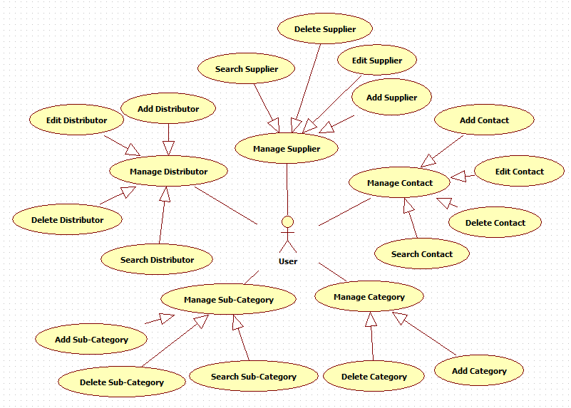
The system will be mainly divided in 4 different tasks as described before, which are add, edit, delete and search. Since these tasks accomplish everything this system is supposed to be designed for, the interface will include 4 tabs so that navigation through these main tasks is easy to use.

Add tab
- Adding a Supplier will prompt a form both displaying the required fields, and additional fields.
- Adding a Distributor will prompt a form displaying required and additional fields, and which supplier(s) this Distributor is working for.
- Adding a Contact to either a Supplier or Distributor’s contact list with the related required and/or additional fields.
- Adding a Supplier or Distributor’s market information including revenue, sales breakdown and ranking according to commodity/sub-commodity

Edit tab
- Editing a Supplier or Distributor by modifying or erasing any single field and saving changes.
- Editing a Contact from a Supplier or Distributor’s contact list by modifying or erasing any single field and saving changes.
- Editing information about a Supplier or Distributor’s market information which in turn changes search results on resource reports.

Delete tab
- Deleting a Supplier from the database, prompting the user to choose which commodity and sub-commodity, and then choosing the Supplier from the generated list. Only Suppliers that have no Distributors will be shown.
- Deleting a Distributor from the database, prompting the user to choose which commodity and sub-commodity, and then choosing the Distributor from generated list.
- Deleting a Contact from either a Supplier or Distributor’s contact lists. A prompt asking user for which Supplier or Distributor will afterwards lead to the selected Supplier/Distributor’s contact list.

Search tab
- Generate a resource report on given commodity and sub-commodity. A prompt will ask the user to enter commodity/sub-commodity and an option of how big the list of results should be. Report on every Supplier of given sub-commodity with according market information will be generated.
- Generate contact list on given commodity, sub-commodity. Those two inputs will lead to selecting from list of Supplier/Distributors which will then lead to list of contacts of given Supplier/Distributor.

This is a rough overview of the tasks the system accomplishes. We use this diagram as a generic one to demonstrate the abilities of the system. To view the tasks more specifically in each case, please refer to the use case diagrams in the following section (System Components)

System Components

Supplier Use Case
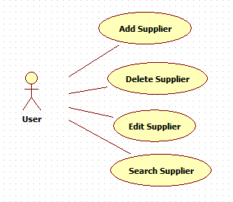

Add Supplier
Main Flow
Precondition: User logged in, system active.
 | Actor(s): User | System
1 | Enters a new Supplier | Validates; changes are valid.  Saves the new Supplier

Alternate Flows
 | Alternate Flow | Description
A1 | Error in entry (Did not enter required fields) | User can cancel or go to step 1.

Edit Supplier
Main Flow
Precondition: User logged in, system active.
 | Actor(s): User | System
1 | Enters Supplier Name in “Manage Suppliers” search field | Displays list of Supplier that match search information
2 | Selects Supplier | Displays Supplier information
3 | Updates entry and requests to save | Checks for required fields – they are all full. Requests confirmation
4 | Confirms | Updates Supplier information in the database. Displays Edit Search page.

Alternate Flows
 | Alternate Flow | Description
A1 | Error in entry (Did not enter required fields) | User can cancel or go to step 2.

Delete Supplier
Main Flow
Precondition: User logged in, system active.
 | Actor(s): User | System
1 | Enter Supplier Name in “Manage Suppliers” search field | Displays list of Supplier that match search information
2 | Requests Delete | Requests validation
3 | Confirms | Deletes Supplier from database.

Alternate Flows
 | Alternate Flow | Description
A1 | Validation rejected | User decides not to delete and when asked, clicks the Cancel button

Search Supplier
Main Flow
Precondition: User logged in, system active.
 | Actor(s): User | System
1 | Enters Desired Supplier Name into Search page | Displays list of Supplier that match search information
2 | Selects Supplier | Displays Supplier information

Alternate Flows
 | Alternate Flow | Description
A1

Distributor Use Case
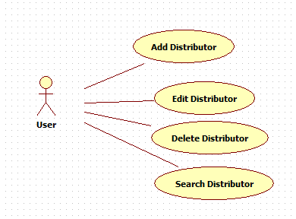

Add Distributor
Main Flow
Precondition: User logged in, system active.
 | Actor(s): User | System
1 | Enters a new Distributor | Validates; changes are valid.  Saves the new Distributor

Alternate Flows
 | Alternate Flow | Description
A1 | Error in entry (Did not enter required fields) | User can cancel or go to step 1.

Edit Distributor
Main Flow
Precondition: User logged in, system active.
 | Actor(s): User | System
1 | Enters Distributor Name in “Manage Distributors” search field | Displays list of Distributor that match search information
2 | Selects Distributor | Displays Distributor information
3 | Updates entry and requests to save | Checks for required fields – they are all full. Requests confirmation
4 | Confirms | Updates Distributor information in the database. Displays Edit Search page.

Alternate Flows
 | Alternate Flow | Description
A1 | Error in entry (Did not enter required fields) | User can cancel or go to step 2.

Delete Distributor
Main Flow
Precondition: User logged in, system active.
 | Actor(s): User | System
1 | Enter Distributor Name in Manage Distributors search field | Displays list of Distributor that match search information
2 | Requests Delete | Requests validation
3 | Confirms | Deletes Distributor from database.

Alternate Flows
 | Alternate Flow | Description
A1 | Validation rejected | User decides not to delete and when asked, clicks the Cancel button

Search Distributor
Main Flow
Precondition: User logged in, system active.
 | Actor(s): User | System
1 | Enters Desired Distributor Name into Search page | Displays list of Distributor that match search information
2 | Selects Distributor | Displays Distributor information

Alternate Flows
 | Alternate Flow | Description
A1

Sub-Category Use Case
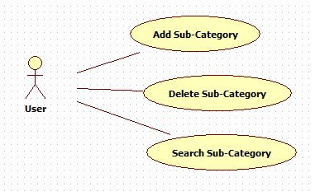

Add Sub-Category
Main Flow
Precondition: User logged in, system active.
 | Actor(s): User | System
1 | Enters Sub-Category Name and Selects Category Name that it will belong to | Checks to see if Sub-Category already exists – it does not. Saves the new Sub-Category

Alternate Flows
 | Alternate Flow | Description
A1 | Error in entry (Sub-Category already exists) | System will display what Category it belongs to and User can cancel or go to step 1.

Delete Sub-Category
Main Flow
Precondition: User logged in, system active.
 | Actor(s): User | System
1 | Enter Sub-Category Name in Manage Sub-Category search field | Displays list of Sub-Category names that match search information
2 | Requests Delete | Requests validation
3 | Confirms | Deletes Sub-Category from database and removes it from all suppliers.

Alternate Flows
 | Alternate Flow | Description
A1 | Validation rejected | User decides not to delete and when asked for validation, clicks the Cancel button

Search Sub-Category
Main Flow
Precondition: User logged in, system active.
 | Actor(s): User | System
1 | Enters Desired Sub-Category Name into Search page | Displays list of Suppliers and Distributors that match search information
2 | Selects Supplier or Distributor | Displays information

Alternate Flows
 | Alternate Flow | Description
A1 | Requests report | System will put together a report of all relevant information of the top 20 Suppliers and Distributors based on their rankings

Contact Use Case
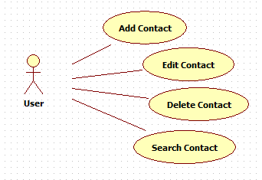

Add Contact
Main Flow
Precondition: User logged in, system active.
 | Actor(s): User | System
1 | Enters a new Contact and related Supplier or Distributor from Dropdown | Validates; changes are valid.  Saves the new Supplier

Alternate Flows
 | Alternate Flow | Description
A1 | Error in entry (Did not enter required fields) | User can cancel or go to step 1.

Edit Contact
Main Flow
Precondition: User logged in, system active.
 | Actor(s): User | System
1 | Enters Contact Name in “Manage Contacts” search field | Displays list of Contact and associated Supplier or Distributor Name that match search information
2 | Selects Contact | Displays Contact information
3 | Updates entry and requests to save | Checks for required fields – they are all full. Requests confirmation
4 | Confirms | Updates Contact information in the database. Displays Edit Search page.

Alternate Flows
 | Alternate Flow | Description
A1 | Error in entry (Did not enter required fields) | User can cancel or go to step 2.
A2 | User can also edit Contact information through the Edit Supplier/Distributor Use Cases | All contacts and their information will be visible from the Supplier/Distributor Details view. This would allow for the User to Search by Supplier/Distributor if the name of the Contact is not known.

Delete Contact
Main Flow
Precondition: User logged in, system active.
 | Actor(s): User | System
1 | Enters Contact Name in “Manage Contacts” search field | Displays list of Contact and associated Supplier or Distributor Name that match search information
2 | Requests Delete | Requests validation
3 | Confirms | Deletes Contact from database.

Alternate Flows
 | Alternate Flow | Description
A1 | Validation rejected | User decides not to delete and when asked, clicks the Cancel button
A2 | User can also Delete Contact information through the Edit Supplier/Distributor Use Cases | All contacts and their information will be visible from the Supplier/Distributor Details view. This would allow for the User to Search by Supplier/Distributor if the name of the Contact is not known.

Search Contact
Main Flow
Precondition: User logged in, system active.
 | Actor(s): User | System
1 | Enters Desired Contact Name into Search page | Displays list of Contact that match search information
2 | Selects Contact | Displays Contact information

Alternate Flows
 | Alternate Flow | Description
A1

Category Use Case

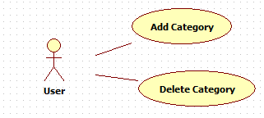

Add Category
Main Flow
Precondition: User logged in, system active.
 | Actor(s): User | System
1 | Enters Category Name | Checks to see if Category already exists – it does not. Saves the new Category and adds that same name into its own Sub-Category List.

Alternate Flows
 | Alternate Flow | Description
A1 | Error in entry (Category already exists) | User can cancel or go to step 1.

Delete Category
Main Flow
Precondition: User logged in, system active.
 | Actor(s): User | System
1 | Enter Category Name in Manage Category search field | Displays list of Category names that match search information
2 | Requests Delete | Requests validation
3 | Confirms | Deletes Category from database and removes all of its Sub-Categories from all suppliers.

Alternate Flows
 | Alternate Flow | Description
A1 | Validation rejected | User decides not to delete and when asked for validation, clicks the Cancel button

Who Did What Log

Team Member | Work completed on this Project (be specific please)
Michael Krushnisky | - Technology to be Used (First Draft)  - Stakeholders  - System Use Case Diagram  - Detailed explanations for Part 8 (First Draft)  - Use Case Diagrams for Part 8 (Final)
Patrick Godbout | - System Overview  - Aided Jay in Use Case Diagrams for Part 8 (First Draft)  - Aided Michael in Use Case Diagrams for Part 8 (Final)  - Detailed explanations for Part 8 (Final)
Jay Yin | - Use Case Diagrams for Part 8 (First Draft)  - Technology to be Used (Final)

