***NAME - MUKESH KUMAR***

***SYSTEM SHELL TASK***

To store previous commands and read line from terminal install the following library with given command:

Sudo apt-get install libreadline-dev

Store the attached file(shell.c and shell.sh) on desktop.

Give permission to execute this shell script file with given command .

chmod +x shell.sh

Run the following command so that shell script can be executed directly by double clicking.

gsettings set org.gnome.nautilus.preferences executable-text-activation ‘launch’

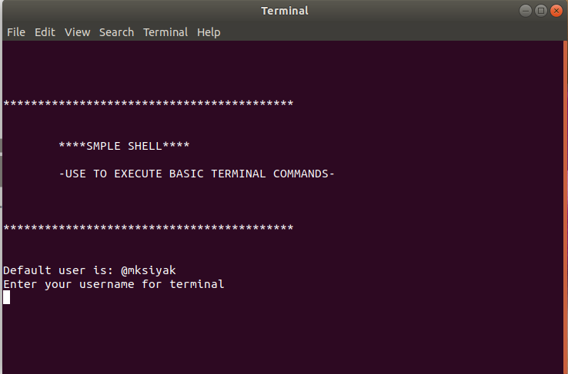

Source : GeeksforGeeks.com

