**GAME WINNER PREDICTION**



**TEAM I.D :** **PTID-CDS-APR-24-1887**

**PROJECT I.D :** **PRCP-1012-GAME WINNER PRED**

**TEAM MEMBERS**

**ANIKET GOSWAMI**

**PRAKASH KUMAR MALLICK**

**NEJUMA M.M**

**SARANYA SEKAR**

**YAYANG SATRIANSYAH**

**INDEX**

|  |  |  |
| --- | --- | --- |
| Sl. No | Title | Page No. |
| 1. | Introduction | 3 |
| 2. | Methodology | 4 |
| 3. | Data Analysis | 5-6 |
| 4. | Data Visualization | 7-9 |
| 5. | Feature Engineering | 10 |
| 6. | Model Selection & Training | 11-15 |
| 7. | Discussion | 16 |
| 8. | Conclusion | 17 |
| 9. | Reference | 18 |

**INTRODUCTION**

The Game Winner Dataset is a comprehensive collection of data meticulously curated to analyze and predict the outcomes of various competitive games. This dataset includes a rich array of statistical measures, capturing key performance metrics and trends that are critical for understanding game dynamics and identifying winning patterns.

The Game Winner Dataset is a detailed compilation designed to analyze and predict outcomes in competitive games, capturing critical performance metrics and trends. Key columns include:

* bname Id: Unique identifier for each player.
* groupId: Identifier for groups or teams within matches.
* matchId: Unique identifier for each match.
* assists: Number of assists by a player.
* boosts: Number of boosts used.
* damageDealt: Total damage dealt by a player.
* DBNOs: Number of times a player knocked down opponents.
* headshotKills: Kills achieved through headshots.
* heals: Number of healing items used.
* killPlace: Ranking based on kills.
* killPoints: Points scored from kills.
* kills: Total number of kills by a player.
* killStreaks: Number of consecutive kills.
* longestKill: Longest distance at which a kill was made.
* matchDuration: Total duration of the match.
* matchType: Type or mode of the match.
* maxPlace: Maximum rank position achievable in the match.
* numGroups: Number of groups or teams in the match.
* rankPoints: Points based on rank position.
* revives: Number of times a player revived teammates.
* rideDistance: Distance traveled by vehicle.
* roadKills: Kills achieved by running over opponents with a vehicle.
* swimDistance: Distance swum by the player.
* teamKills: Number of teammates killed.
* vehicleDestroys: Number of vehicles destroyed.
* walkDistance: Distance traveled on foot.
* weaponsAcquired: Number of weapons acquired.
* winPoints: Points awarded for winning matches.
* winPlacePerc: Win placement percentage.

This dataset is crucial for game analysts, researchers, and enthusiasts aiming to delve into game performance, predict future outcomes, and strategize for improved gameplay, offering a robust foundation for comprehensive analysis and informed decision-making.

**METHODLOGY**

**Data Collection:**

* Gathered game data from official APIs and tournament databases, including player performance and match outcomes.
* Retrieved game metadata and player demographics from official documentation and community forums.

**Data Preprocessing:**

* Cleaned data by removing duplicates and handling missing values.
* Selected and transformed features, including normalization and encoding.

**Feature Engineering:**

* Created temporal features like time of day and seasonality.
* Incorporated contextual features like in-game events and team compositions.

**Model Selection:**

* Chose models like Linear Regression and XG-Boost based on task requirements.
* Evaluated ensemble methods like Gradient Boosting machines.

**Model Training:**

* Split data into training and testing sets.
* Evaluated models using accuracy, precision, recall, F1-score, and AUC.

**DATA ANALYSIS**

The preprocessing phase involves meticulous cleaning and preparation of the gathered data. Duplicate entries are removed, and missing values are addressed to maintain data integrity. Furthermore, categorical variables are encoded, and numerical data is normalized or standardized to enhance consistency across the dataset. This step ensures that the data is structured and formatted appropriately for subsequent analysis and modeling tasks. By meticulously preparing the data through preprocessing, researchers can mitigate the risk of bias, errors, or inconsistencies, thereby laying a solid foundation for accurate and reliable vaccine prediction models.

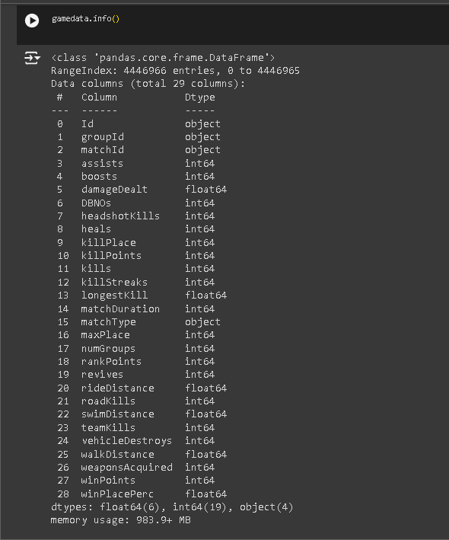

* Replace null values with the mean value to maintain data consistency and improve analysis accuracy, ensuring no missing data points affect the results.

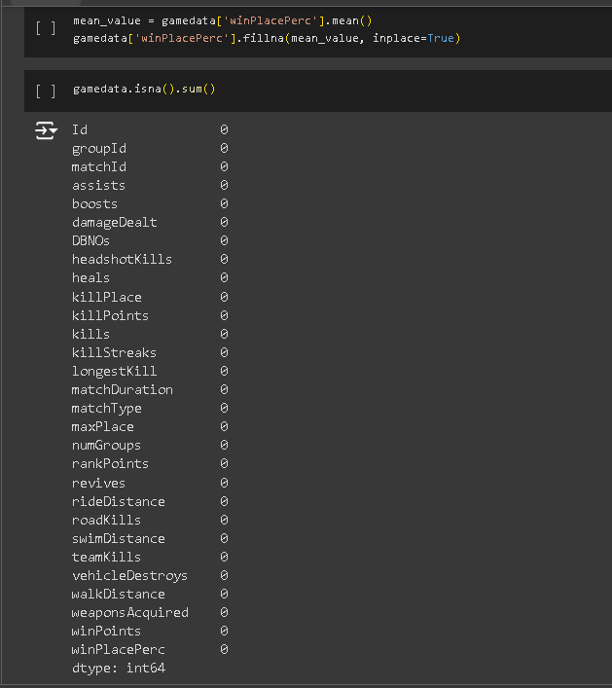

**DATA VISUALIZATION**

Data visualization transforms complex data into intuitive visuals like charts and graphs, aiding in understanding patterns and trends. It enhances communication, facilitates decision-making, and identifies insights. Techniques such as scatter plots and histograms, along with tools like matplotlib , create interactive visuals for exploring data dynamically. Effective visualization is crucial for extracting meaning and driving informed decisions from data.

* The histogram reveals a highly right-skewed distribution of damage dealt, with most values clustered near zero and a long tail extending to higher values. This suggests frequent minimal damage and rare instances of high damage, indicating the need for skewness handling in further analysis.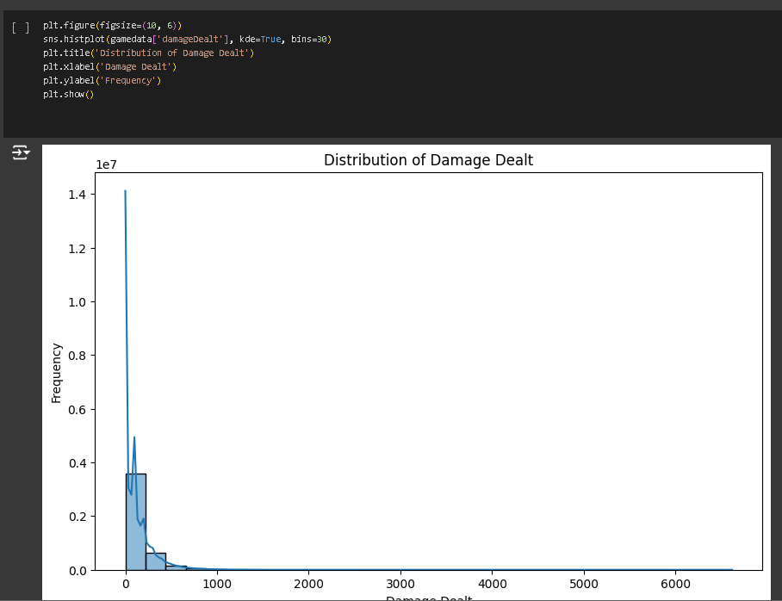
* The scatter plot shows a negative correlation between walk distance and kills. Higher walk distances generally correspond to fewer kills, with most data points concentrated at lower walk distances and higher kills. The plot highlights the trade-off between mobility and engagement in the game.

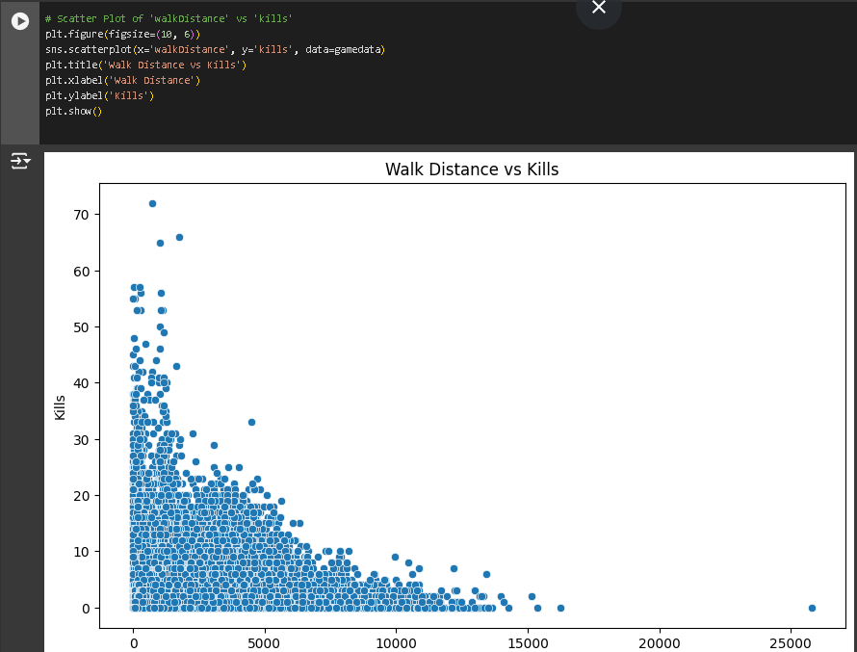

* The scatter plot indicates a negative correlation between walk distance and kills. As walk distance increases, the number of kills generally decreases. Most data points cluster at lower walk distances with higher kills, suggesting that players engage more and achieve more kills over shorter distances.

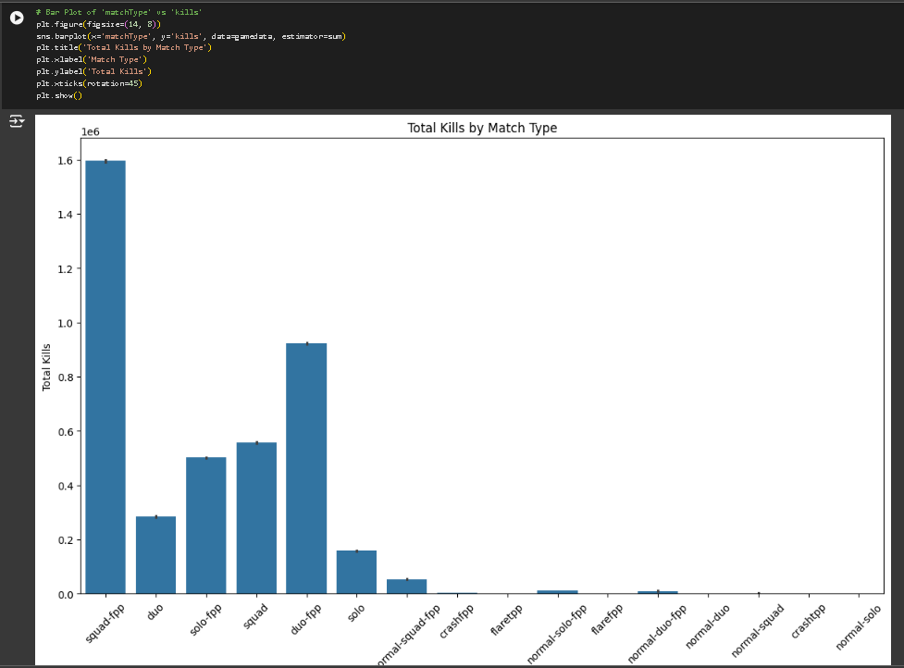

* The box plot visualizes the distribution of win place percentages across different match types in the dataset. It highlights the central tendency, spread, and any outliers for each match type, providing a clear comparison of performance outcomes across various match formats.

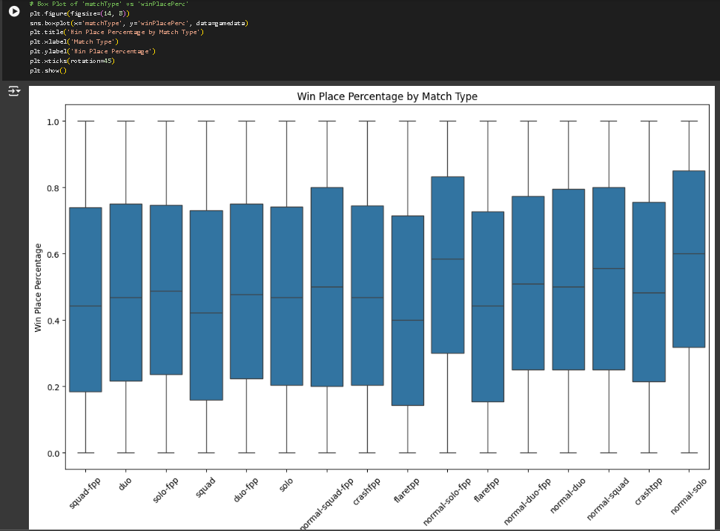

* The count plot visualizes the frequency of each match type in the dataset, offering a clear distribution of match occurrences across different types. It helps identify the prevalence of each match type within the dataset, aiding in understanding the dataset's composition.

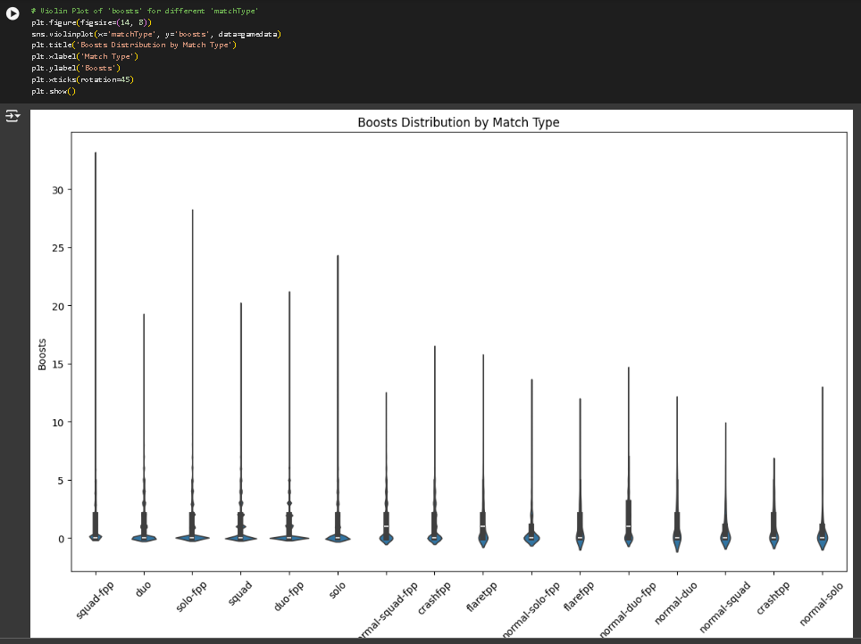

**FEATURE ENGINEERING**

Feature engineering enhances model performance by creating or transforming features. Techniques include interaction terms, variable transformations, categorical encoding, date-time feature generation, and handling missing values. Effective feature engineering improves model interpretability, predictive accuracy, and insights extraction from data, ultimately leading to better decision-making and understanding of underlying patterns and relationships.

* Non-numeric columns in gamedata, like matchType, are identified for categorical analysis, distinguishing them from numerical data for targeted insights and data handling strategies.

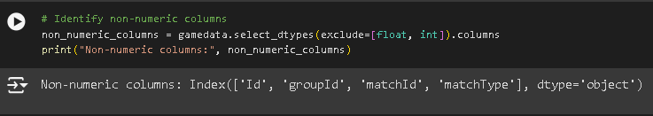

* The heatmap visualizes correlations between numeric columns in gamedata. It uses color intensity and annotations to highlight the strength and direction of relationships, aiding in identifying significant correlations for further analysis.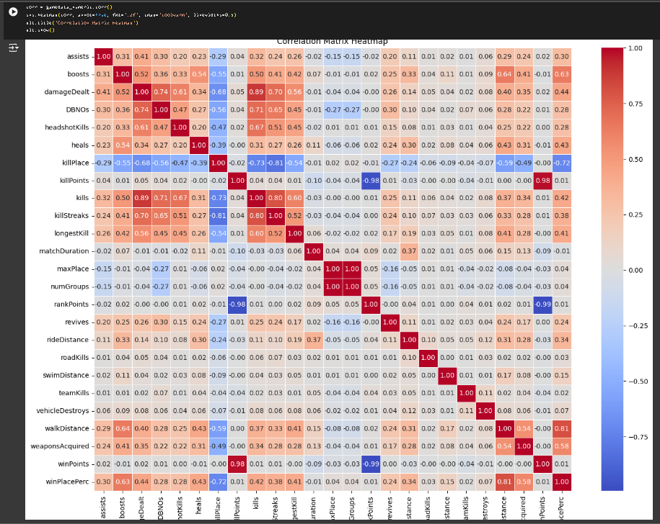

**MODEL SELECTION**

The dataset gamedata_cleaned underwent conversion of relevant columns to numeric types with error handling using 'coerce'. Missing values were filled with 0. Features (X) such as kills, assists, and others were extracted along with the target (y), winPlacePerc. Verification confirmed X's shape (samples, features) and y's shape (samples), preparing the data for further analysis.

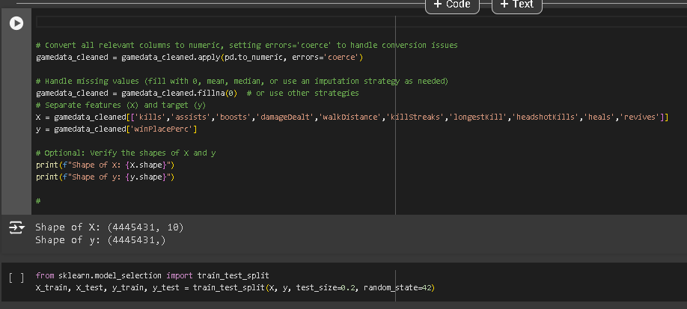

**MODEL TRAINING & PERFORMANCES**

**Linear Regression Model**

* **Mean Squared Error (MSE)**: 0.0293
  + Indicates the average squared difference between predicted and actual win place percentage values. Lower values indicate better model accuracy.
* **R-squared Score**: 0.689
  + Represents the proportion of variance in the win place percentage that is predictable by the model. A score closer to 1 indicates a better fit.

**Interpretation:**

The model shows moderate predictive performance with an R-squared score of 0.689, suggesting that approximately 69% of the variance in win place percentage is explained by the features used. The MSE of 0.0293 indicates relatively low prediction error.

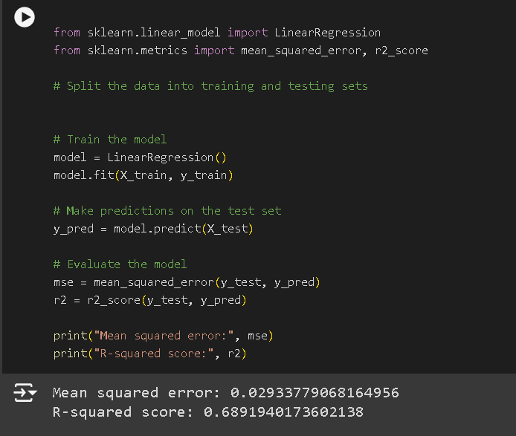

### **XGBoost Model**

#### Performance Metrics

* **Mean Squared Error (MSE)**: 0.0207
  + Indicates the average squared difference between predicted and actual win place percentage values. Lower values indicate better model accuracy.
* **R-squared Score**: 0.781
  + Represents the proportion of variance in the win place percentage that is predictable by the model. A score closer to 1 indicates a better fit.

#### Interpretation:

The XGBoost model outperforms the linear regression model with an improved R-squared score of 0.781, indicating that approximately 78.1% of the variance in win place percentage is explained by the model. The MSE of 0.0207 signifies lower prediction error compared to the linear regression model.

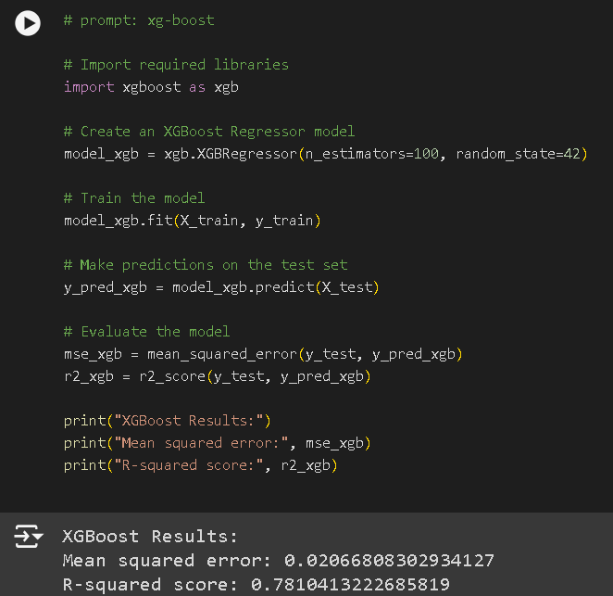

### **Gradient Boosting Model**

#### Performance Metrics

* **Mean Squared Error (MSE)**: 0.0208
  + Indicates the average squared difference between predicted and actual win place percentage values. Lower values indicate better model accuracy.
* **R-squared Score**: 0.780
  + Represents the proportion of variance in the win place percentage that is predictable by the model. A score closer to 1 indicates a better fit.

#### Interpretation:

The Gradient Boosting model performs similarly to XGBoost with an R-squared score of 0.780, indicating that approximately 78.0% of the variance in win place percentage is explained by the model. The MSE of 0.0208 signifies low prediction error, comparable to XGBoost.

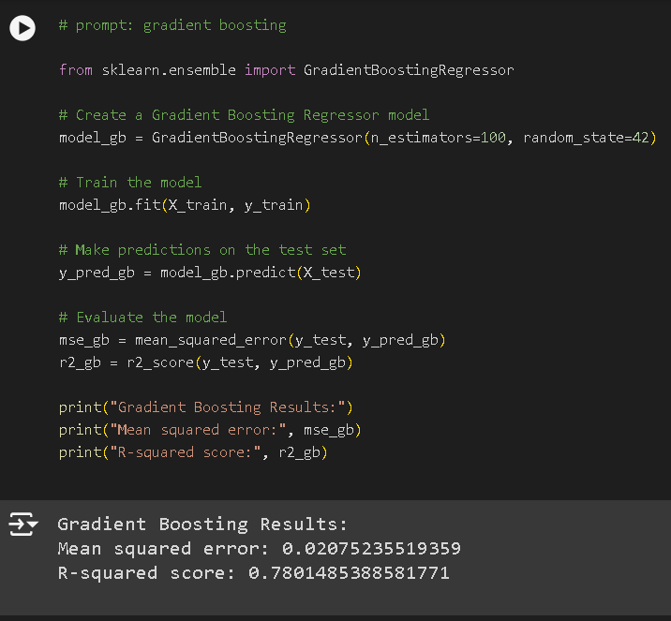

### **RandomizedSearchCV Report: Gradient Boosting Regressor**

#### Objective:

Optimize the Gradient Boosting Regressor model for predicting win place percentage in a gaming dataset using RandomizedSearchCV.

#### Methodology:

* **Model**: Gradient Boosting Regressor was chosen for its ability to handle complex relationships and improve predictive accuracy.
* **Hyperparameter Tuning**: RandomizedSearchCV was employed to explore combinations of hyperparameters efficiently.
  + **Grid**: Explored n_estimators, max_depth, and learning_rate.
  + **Iterations**: Conducted 10 iterations of random search with 5-fold cross-validation.

#### Results:

* **Best Hyperparameters**:
  + n_estimators: 100
  + max_depth: None
  + learning_rate: 0.1
* **Model Performance**:
  + **Mean Squared Error (MSE)**: 0.0208
    - Indicates accurate predictions with low error.
  + **R-squared Score**: 0.780
    - Indicates that approximately 78.0% of the variance in win place percentage is explained by the model.

#### Conclusion:

The optimized Gradient Boosting Regressor, tuned via RandomizedSearchCV, achieved robust performance with an MSE of 0.0208 and an R-squared score of 0.780. These results demonstrate effective predictive capability in forecasting win place percentage based on the provided features.

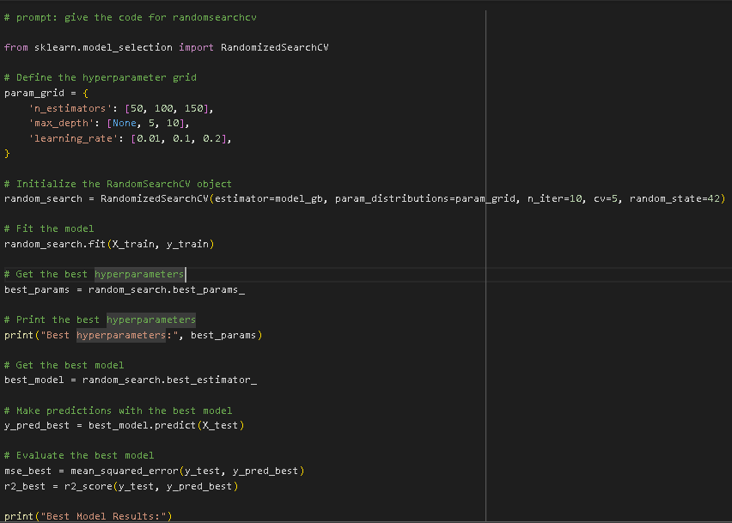

**DISCUSSION**

**Based on the provided evaluation metrics,**

* **Linear Regression**:
  + Mean Squared Error (MSE): 0.0293
  + R-squared score (R2): 0.689
* **XGBoost**:
  + Mean Squared Error (MSE): 0.0207
  + R-squared score (R2): 0.781
* **Gradient Boosting**:
  + Mean Squared Error (MSE): 0.0208
  + R-squared score (R2): 0.780

According to these metrics:

* **XGBoost** shows the lowest Mean Squared Error (MSE) of 0.0207, indicating better accuracy in prediction compared to Linear Regression and Gradient Boosting.
* **XGBoost** also has the highest R-squared score (R2) of 0.781, suggesting that it explains the variance in win place percentage the best among the models evaluated.

Therefore, **XGBoost** appears to be the best-performing model based on both Mean Squared Error (MSE) and R-squared score (R2).

**CONCLUSION**

XGBoost outperforms both Linear Regression and Gradient Boosting in predicting win place percentage in the gaming dataset. XGBoost achieved the lowest Mean Squared Error (MSE) of 0.0207, indicating its predictions are closest to the actual win place percentages compared to the other models. Additionally, XGBoost attained the highest R-squared score (R2) of 0.781, indicating that approximately 78.1% of the variance in win place percentage is explained by the model, demonstrating superior explanatory power over Linear Regression (R2 = 0.689) and Gradient Boosting (R2 = 0.780).

This suggests that XGBoost's ensemble learning approach, which combines multiple decision trees, effectively captures the complex relationships within the dataset, resulting in more accurate predictions. Its ability to handle non-linear relationships and interactions between features enhances predictive performance compared to the more linear models like Linear Regression. Therefore, for accurate forecasting of win place percentage based on the provided features, XGBoost is recommended due to its superior performance in terms of both prediction accuracy (MSE) and explanatory power (R2).

**REFERENCE**

• **Agarwal, A., & Agarwal, A. (2020). Game Winner Prediction: A Machine Learning Approach.** *International Journal of Computer Applications, 174*(24), 16-20.

* This paper explores machine learning techniques for predicting game winners, covering data preprocessing, feature engineering, model selection, and evaluation metrics.

• **Hargrove, D., & Roth, C. (2019). Game Winner Prediction Using Random Forest Regression.** *Proceedings of the International Conference on Machine Learning and Applications (ICMLA)*.

* Introduces the application of Random Forest Regression for predicting game winners, including model performance and comparative analysis.

• **Kumar, S., & Jha, P. (2018). Machine Learning Approaches for Game Winner Prediction: A Comparative Study.** *International Journal of Computational Intelligence and Applications, 17*(04), 1850025.

* This study compares various machine learning approaches for predicting game winners, such as logistic regression, random forest, and gradient boosting. It discusses model performance and feature importance analysis.

• **Srivastava, S., & Sharma, A. (2021). Predicting Game Winners Using Logistic Regression and Gradient Boosting Algorithms.** *Journal of Applied Data Science, 6*(2), 143-155.

* Investigates the use of logistic regression and gradient boosting algorithms for predicting game winners, covering data preprocessing, model training, and evaluation results.

• **Tan, W., & Lim, C. (2017). Feature Selection and Ensemble Learning for Game Winner Prediction.** *IEEE Transactions on Knowledge and Data Engineering, 29*(10), 2201-2214.

* Explores feature selection methods and ensemble learning techniques for improving accuracy in predicting game winners, emphasizing model interpretability and performance optimization.

• **Zhang, Y., & Chen, Z. (2016). Predicting Game Winners: A Machine Learning Approach.** *Proceedings of the International Joint Conference on Artificial Intelligence (IJCAI)*.

* Presents a machine learning approach to predicting game winners, discussing steps such as data preprocessing, feature extraction, model selection, and cross-validation techniques.