Data Visualization: Pandas Challenge

3/30/23

Michael Lambert

**Analysis**

In the Pandas challenge we looked at school performance through these five lens’; type of school (District or Charter), total students, total school budget and funding per student. Looking through these lens’ we wanted to draw some conclusions around the effectiveness of the education received. Specifically looking at; average math scores, average reading scores, the percentage passing math and reading, and the overall passing percent.

Highest performing schools

Aggregating the data to look at the top five performing schools, based on percentage overall passing, we see the following:

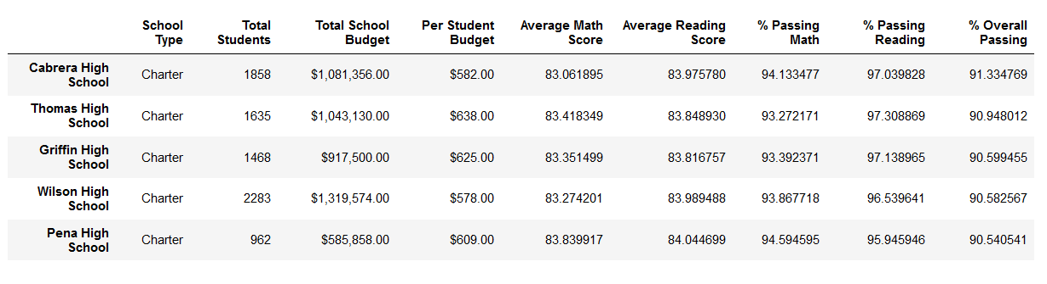

**Figure 1. Highest Performing Schools**

Lowest Performing Schools

Aggregating the data to look at the bottom five performing schools, based on percentage overall passing, we see the following:

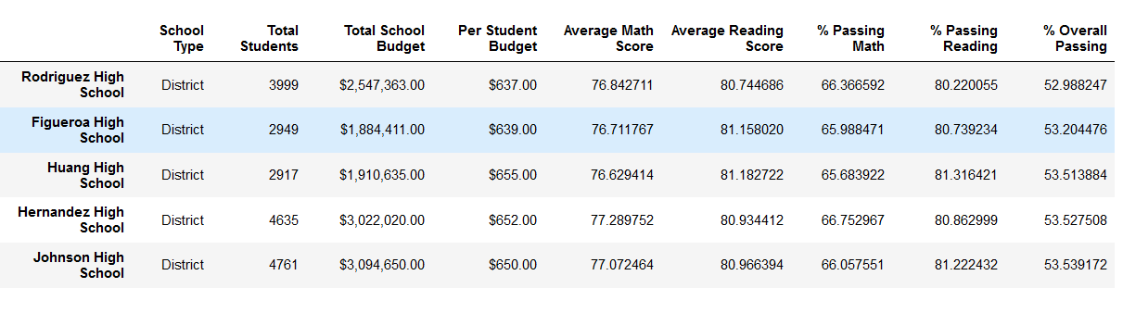

**Figure 2. Lowest Performing Schools**

Analysis of performing schools:

It is easy to see from the data that schools which are charter schools out perform district schools. As a check to see if this is true, we cut the data by type.

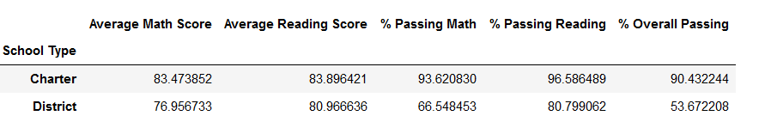

**Figure 3. Overall Passing by School Type**

This does seem to bear out our original hypothesis that charter schools generally do better.

However, this first cut at the data does not really consider school size. Generally, charter schools tend to be smaller than district schools. When we cut the data to compare results based on school size it provides another lens to look at.

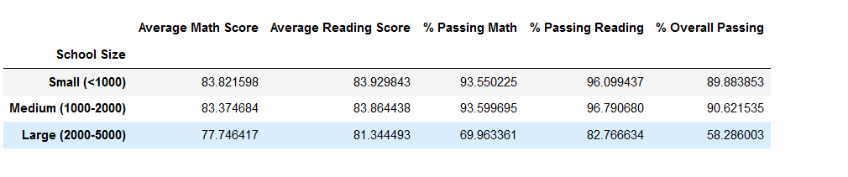

What seems to be coming forward is that it may be less the type of school, than the size of the school which matters. What is not represented in the analysis are student demographics and this might something to look at later.

Also, let’s look at per student budgets. Often, government decides to “fix” programs by throwing more money at them. Is this indeed the case? Does per capita spending on a student make a difference. Here is what the data shows us:

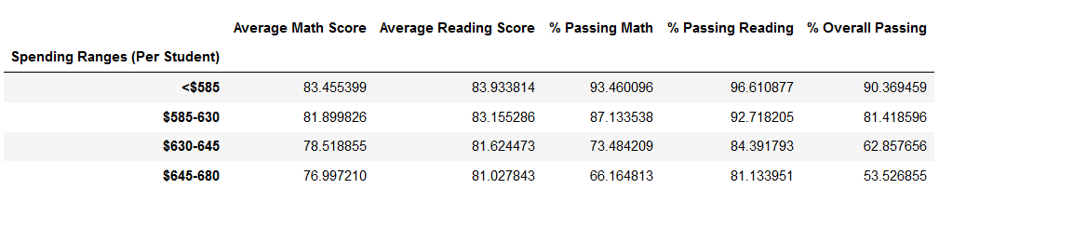

The answer, quite quickly is a resounding “no!” The amount of money spent per student appears to have no impact on percentage overall passing. In fact, it might look like the opposite may be true. Spending money over a certain amount (~$630) have the opposite effect in driving down scores, regardless of school type.

**Conclusion**

After looking at all the provided we can make the following suppositions:

1. The money spent per student within a range does not seem to affect the overall success of the student.
2. There might be a correlation between school type (district or charter)
3. This is a definite correlation between school size and overall student success.

Students who attend smaller schools, of which charter schools tend to be, seem to have greater success. It is less about the money and more about the size of the school.