# TASK 1

## Advantages and Disadvantages of different Information System Methodologies

|  |  |  |
| --- | --- | --- |
| **Methodology** | **Advantages** | **Disadvantages** |
| 1. Waterfall | * (Choudhary, 2025), argues that allocation is done correctly since project needs are known earlier. * Makes teamwork consistent because no special training is needed as highlighted by (Gaille, 2020). | * This method only focuses on project milestones rather than involving clients as pointed out by (Gaille, 2020). * According to (Choudhary, 2025), mistakes that are made in the first stage can lead to abandonment of projects. |
| 1. Agile | * (Singh & Petit, 2020), states that this method builds strong relationships and trust from engaging with stakeholders. * Improves control and better solves problems since projects are divided into smaller sections, according to (Idego, 2021). | * (Lynn, 2025), notes that unclear final project outcomes can be caused by minimal planning. * Depends on customer feedback that is likely to cause misinterpretations as pointed out by (Raymond, 2023). |
| 1. Prototyping | * Detects errors earlier since this method involves users as argued by (Ra, 2021). * Allows users to gain insights from using a working model of the system according to (lumitex, 2017). | * (Ra, 2021), argues that the users may request for more once seeing the product early. * The project gets more complex when adding extra features as highlighted by (lumitex, 2017). |
| 1. User-Centered Design | * Gives positive experience as it only focuses on user’s needs as stated by (Scatter, 2025). * Improves testing by allowing updates based on user feedbacks according to (Pilapil, 2025). | * (Pilapil, 2025), notes that method rejection is caused by lack of knowledge from some stakeholders. * (Scatter, 2025), argues that wastage of resources is a result of continuous improvements which is caused by this iterative method. |

**Agile Methodology** allows constant changes as pointed out by (Laoyan, 2025), making it ideal for Infinity Games who act on player feedbacks.

# TASK 2 (A)

|  |  |  |  |  |
| --- | --- | --- | --- | --- |
| **Approach** | **Social** | **Cultural** | **Organizational** | **Technical** |
| **Soft** | Allows Player support specialist to be active since they express their ideas freely according to (Rossingol, 2023), as also highlighted in (paragraph 6). | Makes a team accomplish tasks based on their environment as stated by (Zhang, et al., 2023), Infinity Games acts based off the concepts of new games (paragraph 1). |  |  |
| **Hard** | Provides a number of planning stages allowing team members to know the preferred styles of others as highlighted by (Dansereau, 2025), since Infinity games has different groups of people in their teams (paragraph 2). | Causes frustrations among teams due to cultural differences but still allows room for management according to (Brett, et al., 2025). |  |  |
| **Combined** | (People Possibility, 2024), notes that this approach enhances employee motivation which later leads to positive organization impacts. | Values employees by allowing them to share skills with other teammates creating great relationships as highlighted by (Guthrie, 2023). The organization collaborates different groups (paragraph 5). |  |  |

# TASK 3

**C – Customer:**

**Players:** provide constant feedback on games (paragraph 6).

**A – Actor:**

**Director:** leads the organization (paragraph 1).

**Project Manager:** handles the development of games (paragraph 2).

**Development Team:** comes up with games (paragraph 2).

**Marketing Team:** exposes the games to the public (paragraph 2).

**Sales Representative:** interacts with distributors to form relationships (paragraph 2).

**Player Support Specialist:** handles feedbacks from players (paragraph 2).

**T – Transformation:** Developing then releasing games from concepts (paragraph 1).

**W – Worldview:** the organization must provide great gaming experiences while generating revenue (paragraph 9).

**O – Owner:** Alex Scott (Director) (paragraph 1).

**E – Environment:**

**Competition:** It’s hard to be at the center of focus (paragraph 7).

**Technology Advancements:** engaging players with latest trends (paragraph 10).

# TASK 4 (A)

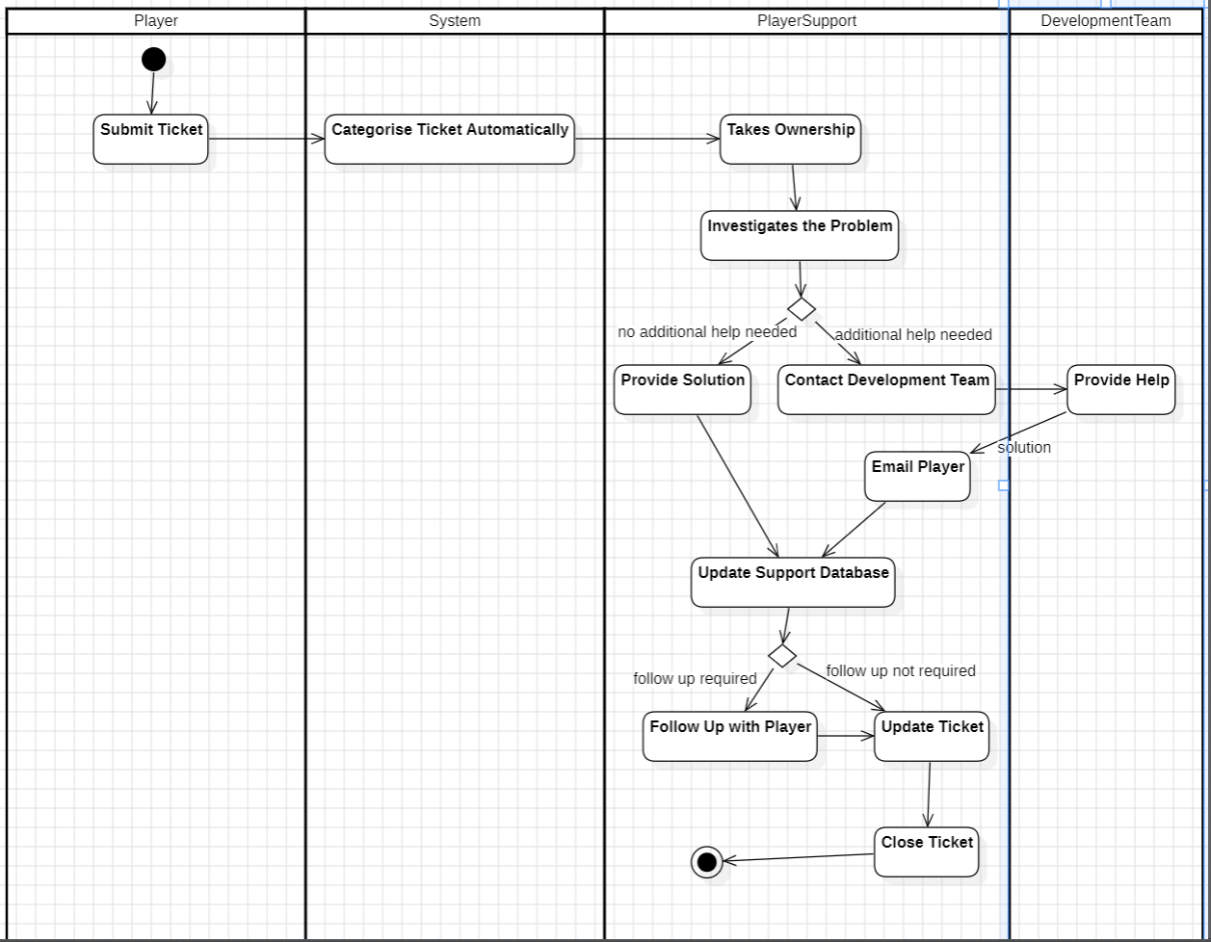

# TASK 4 (B)

**Process Oriented:** helps project teams in understanding potential improvements by analyzing client needs as pointed by (James Cook University, 2025).

**People Oriented:** prioritizes project teams over the needs of clients making the organization to be focused on the employee’s wellbeing as stated by (Guthrie, 2021).

For **Infinity Games** to have improved productivity performance they need to implement the **process oriented** methodology which accelerates projects, better utilizes resources, and allows project teams to be up to date, as noted by (Deecke, 2023).

# TASK 5 (A)

**P – Political:** Infinity Games fear of losing employees as a result of poaching from rival companies (paragraph 8), since they know it may be hard to find experienced developers under political factors like tightened VISA regulations as pointed out by (Fahey, 2017).

**E – Economic:** Integrating purchases in games (paragraph 9), will force the company to provide game goods at prices that’ll fit inflation as stated by (Ahmed, 2023).

**S – Social:** To shine brighter in the game industry (paragraph 7), Infinity Games must rapidly implement trending game cultures according to (CliffNotes, 2024).

**T – Technological:** Offering trending technologies like Virtual Reality (VR) (paragraph 10), will impact Infinity Games audience to increase as noted by (Telefonica, 2022).

# TASK 5 (B)

During economic downturns **allocating resources** to cost-efficient analysis of processes will help **Infinity Games** in optimizing new investments as pointed out by (McKinsey & Company , 2017).

Applying a market condition that will help in Game Industry shifts will efficiently allow **Infinity Games** in **adapting** easily according to (Ramos, 2024).

# TASK 6

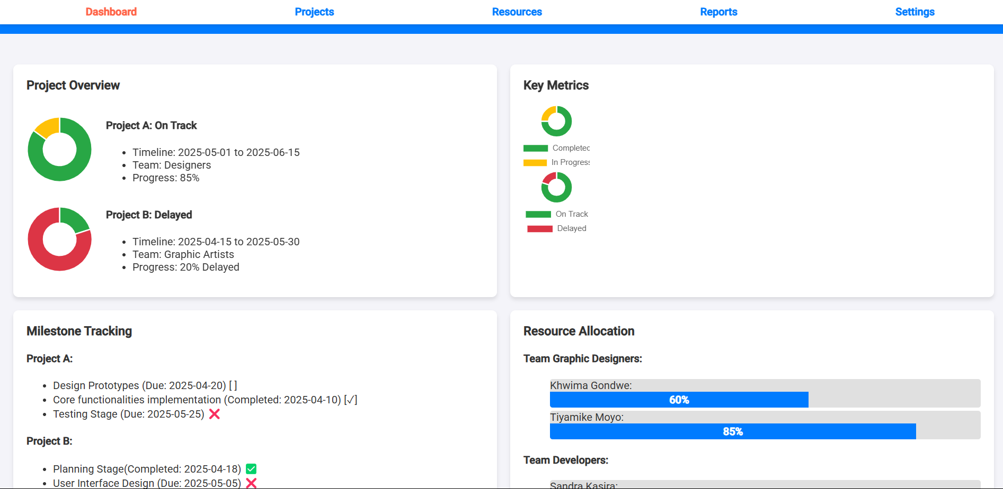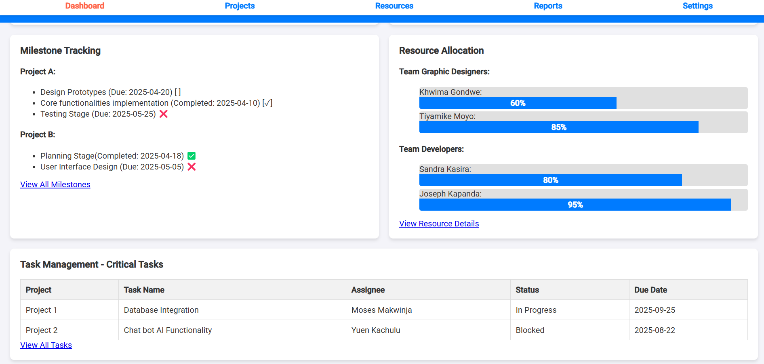

# TASK 7