The Effects of Stress Level and BMI Category on Sleep Duration
Maria Larson, Izzy Mika, Jiaming Zhang
STAT301 Project
April 27, 2026

Introduction
The analysis uses the Sleep Health and Lifestyle Dataset (see dataset), which contains information on individuals’ sleep habits and health characteristics. After data cleaning, 364 observations were used in the final analysis.

This analysis addresses two primary research questions: (1) whether the mean sleep duration differs across either stress level categories or BMI categories, and (2) whether there is an interaction between stress level category and BMI category on sleep duration.

The dependent variable is sleep duration, measured in hours, which is a quantitative variable. The independent variables are stress level category and BMI category, both treated as categorical variables. The stress level category has three levels (Low, Medium, and High), which represent a subjective rating of stress (low to high). BMI category represents weight classification groups. In the final analysis, BMI includes Normal and Overweight categories. Based on these variables, the following hypotheses were tested to evaluate differences in mean sleep duration.

The null hypothesis for stress level category states that the mean sleep duration is the same across all stress level groups. The alternative hypothesis states that the group means are not all equal.

H₀: μ_{Low} = μ_{Medium} = μ_{High}
H_{a}: At least one group mean differs
The null hypothesis for BMI category states that the mean sleep duration is the same between BMI groups, and the alternative hypothesis states that the mean sleep duration differs.

H₀: μ__{Normal} = μ__{Overweight}
H_{a}: μ__{Normal} ≠ μ__{Overweight}

The null hypothesis for the interaction states that there is no interaction between stress level category and BMI category on sleep duration, and the alternative states that an interaction exists.

H₀: There is no interaction between stress level category and BMI category
H_{a}: There is an interaction between stress level category and BMI category

Methods
A two-way analysis of variance (ANOVA) was conducted to examine the effects of stress level category and BMI category on sleep duration. This method is appropriate because the dependent variable is quantitative and both independent variables are categorical, allowing for comparison of group means across factors while also testing for an interaction effect. The dataset also suggests that multiple factors may influence sleep duration and sleep quality, which encourages us to check whether the impact of different factors on sleep duration is affected by an interaction.
Before analysis, the dataset was cleaned and prepared. No missing values were present. Column names were updated to remove spaces. The BMI category “Normal Weight” was combined into “Normal”, and the “Obese” category was removed due to its small sample size, which could affect the reliability of estimates.

Stress level, originally measured on a 1–10 scale, was converted into three categories (stress level category): Low (≤3), Medium (4–6), and High (>6). Both the stress level category and the BMI category were treated as categorical variables in the model.

Because the data were unbalanced across groups (see Table 1), a linear model (lm) with a Type II ANOVA was used instead of the standard aov() approach, consistent with the methods used in class. A significance level of α = 0.05 was used for all tests. Since the BMI category only has two factor levels (vs 3 or more), Welch two-sample t-tests were conducted to compare BMI groups within each stress level.

Table 1. Count of Observations per Factor Level (BMI Category; Stress Level Category)

BMI Category | Low | Medium | High
Normal | 38 | 140 | 38
Overweight | 31 | 39 | 78
Total | 69 | 179 | 116

Conclusion
The two-way ANOVA results show a significant main effect of stress level category on sleep duration, F(2, 358) = 1069.80, p < 0.001. There is also a significant main effect of BMI category, F(1, 358) = 107.49, p < 0.001. In addition, a significant interaction between stress level category and BMI category was found, F(2, 358) = 84.13, p < 0.001.

At a significance level of α = 0.05, all p-values are well below the threshold, so the null hypotheses for stress level, BMI category, and their interaction are rejected.
These results indicate that sleep duration differs significantly across stress levels and that stress has a strong negative association with sleep duration. The significant interaction indicates that the relationship between stress and sleep is not the same across BMI categories. Additional Welch two-sample t-tests were conducted within each stress level to further examine differences between BMI groups; these results supported the interaction observed in the ANOVA. This suggests that the effect of stress on sleep duration depends on BMI category. In general, individuals with Normal BMI tend to sleep more than those who are Overweight at lower stress levels, but this relationship changes as stress increases.

An interesting finding is that at High stress levels, the pattern between BMI groups reverses. At lower stress levels, individuals with Normal BMI tend to sleep more than those who are Overweight, but at High stress levels, Overweight individuals sleep slightly more (6.28 vs. 6.13 hours). This crossover pattern supports the significant interaction observed in the ANOVA results. During initial analysis, both the main effects of BMI category and the interaction between BMI category and stress level category were much less significant for individuals with an Obese BMI, which seemed inconsistent with the overall pattern. When we looked at the dataset more, we realized that this was caused by a small sample size that skewed the analysis results.

This analysis has several limitations. The Obese category was removed due to its small sample size, limiting generalizability to that group. The Low stress category is underrepresented relative to the other groups, which may affect the stability of estimates. Additionally, other variables that may influence sleep duration, such as age, physical activity, and occupation, were not included in the model. It is also possible that individuals with a higher BMI sleep longer than individuals with a lower BMI, but that their quality of sleep is worse, so the initial analysis may not show the full picture. Overall, these findings highlight the importance of considering both stress level and BMI simultaneously when analyzing sleep duration.

Figure 1. Interaction Plot of Mean Sleep Duration by BMI and Stress Level Category
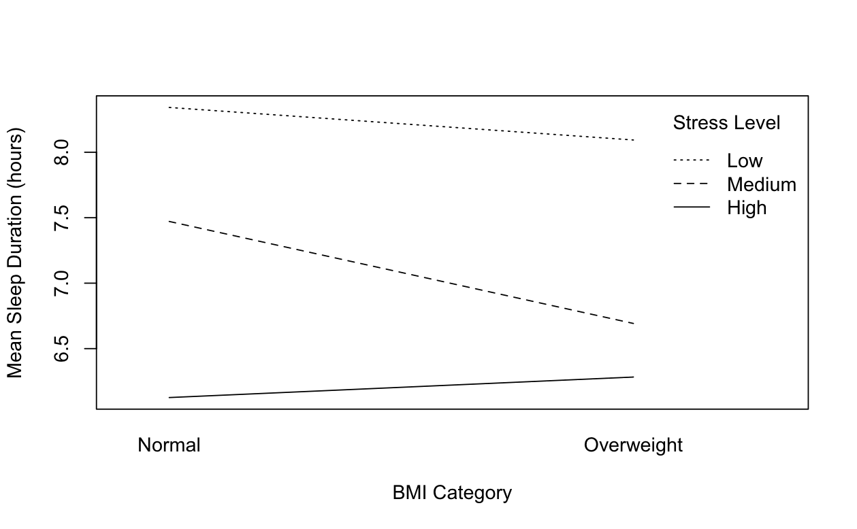
Sleep duration decreases as stress level increases for both BMI groups. The non-parallel lines indicate an interaction between stress level category and BMI category, suggesting that the effect of stress on sleep duration differs across BMI groups. This visual pattern is consistent with the statistical results of the ANOVA.

Figure 2. Mean Sleep Duration by Stress Level and BMI Category
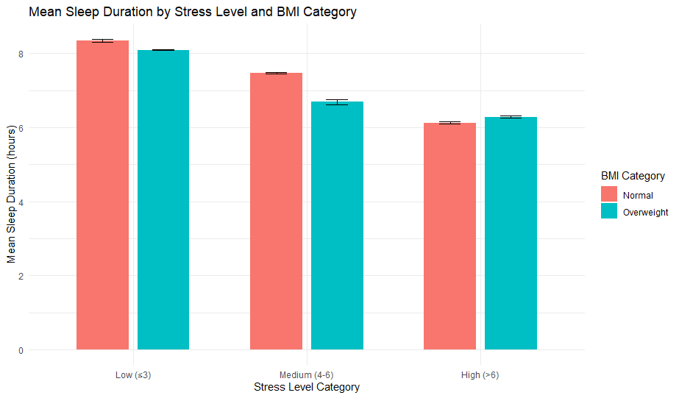
Figure 2 shows the mean sleep duration across stress level categories for Normal and Overweight BMI groups. Sleep duration decreases as stress increases for both groups. At Low and Medium stress levels, individuals with Normal BMI have slightly higher mean sleep duration than those who are Overweight. However, at High stress levels, this pattern reverses, with Overweight individuals sleeping slightly more than Normal individuals. This crossover pattern supports the significant interaction observed in the ANOVA results.

Table 2. Two-Way ANOVA Results

Source | Sum Sq | Df | F value | Pr(>F)
BMI_Cat | 7.875 | 1 | 107.49 | < 0.001
Stress_Lvl_Cat | 156.745 | 2 | 1069.80 | < 0.001
BMI_Cat:Stress_Lvl_Cat | 12.326 | 2 | 84.13 | < 0.001
Residuals | 26.227 | 358

Table 2 summarizes the results of the two-way ANOVA, showing significant main effects and a significant interaction between stress level category and BMI category.

