Final Project Report: xv6 Lottery Scheduler
Name: Michael Lartey
Course: Operating Systems
Project: xv6 Lottery Scheduler

Introduction
The purpose of this project was to modify the xv6 operating system and implement a Lottery Scheduler. Lottery scheduling is a proportional-share CPU scheduling algorithm where processes are assigned tickets. Processes with more tickets have a greater probability of being selected to run by the CPU scheduler.

Project Objectives
This project helped develop an understanding of xv6 kernel structure, CPU scheduling algorithms, system calls, and process management. The main objective was to replace the default scheduler with a lottery-based scheduler and analyze its behavior.

System Calls Implemented
Two new system calls were implemented for this project. The first system call, settickets(int number), allows a process to change the number of tickets it owns. The second system call, getpinfo(struct pstat *), returns information about processes such as process ID, ticket count, and how many times the process has been scheduled.

Kernel Modifications
Several kernel files were modified to support lottery scheduling. New fields named tickets and ticks were added to the process structure inside proc.h. The scheduler inside proc.c was modified to calculate the total number of tickets among runnable processes, generate a random winning ticket, and schedule the selected process. Child processes were also updated to inherit ticket values from their parent processes.

Scheduler Logic
The lottery scheduler works by first calculating the total number of tickets owned by runnable processes. A pseudo-random number generator selects a winning ticket. The process whose ticket range contains the winning ticket is scheduled to run. Each time a process is selected, its tick counter is incremented to track how many times it has executed.

Testing and Results
The scheduler was tested using three processes with ticket ratios of 30, 20, and 10. The getpinfo() system call was used to collect scheduling statistics. The results showed that the process with the highest ticket count received the most CPU time, while the process with the fewest tickets received the least CPU time. This confirmed that the lottery scheduler was working correctly.
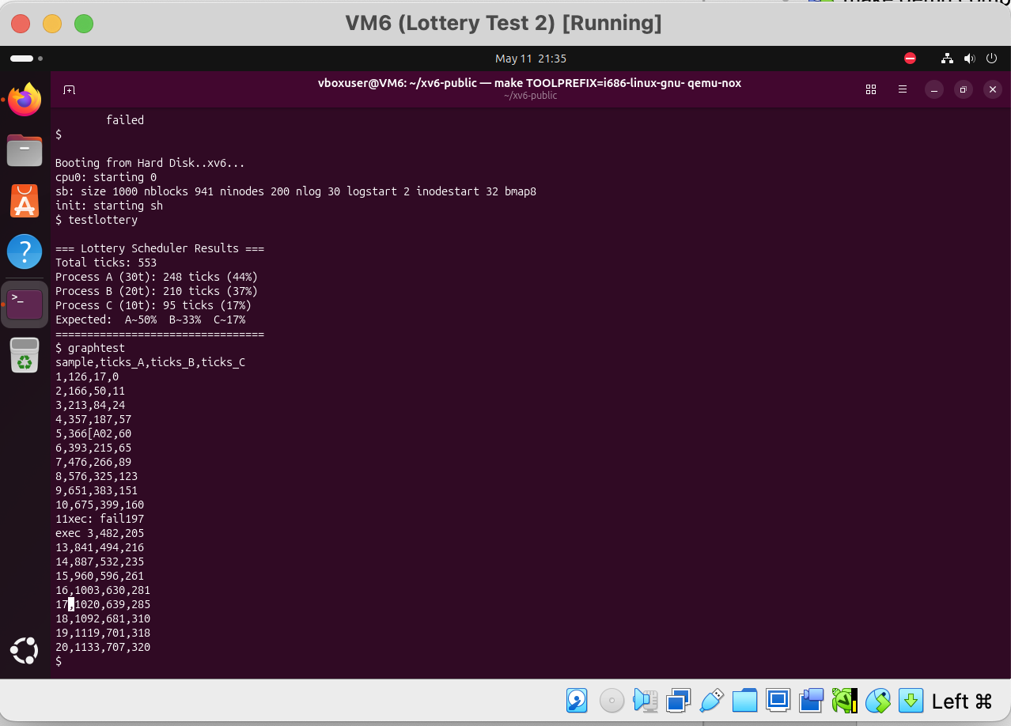

Graph Analysis
The graph created from the collected scheduling data showed proportional CPU allocation between the three processes. The process with 30 tickets consistently accumulated more ticks over time than the processes with 20 and 10 tickets. The graph demonstrated that the scheduler distributed CPU time fairly according to ticket allocation.
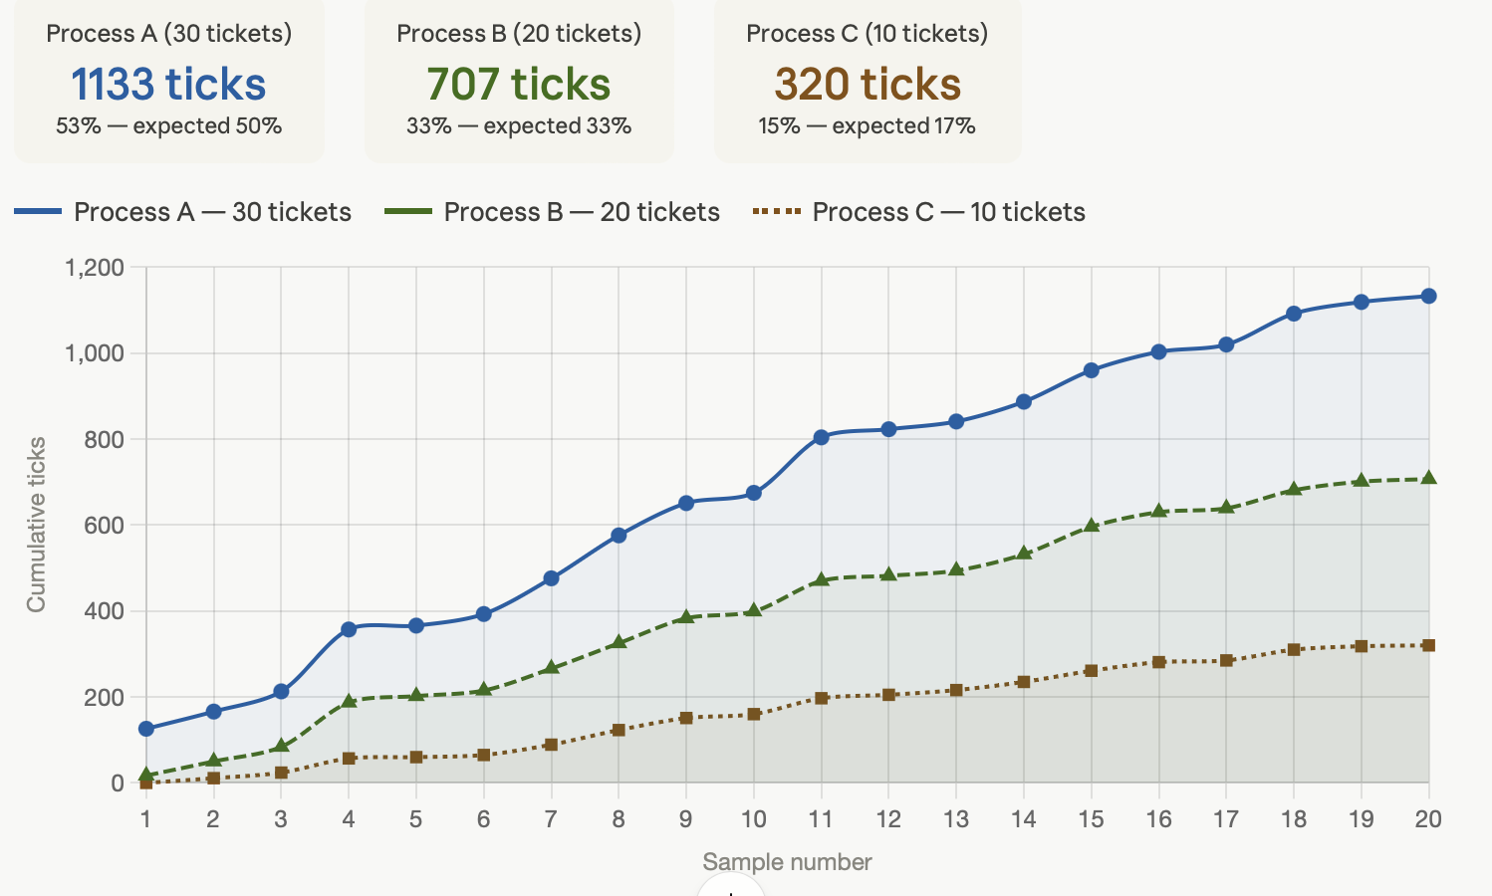

Challenges Encountered
Several challenges were encountered during development, including system call registration, kernel compilation errors, debugging scheduler logic, and adapting the implementation to xv6-riscv. These issues were resolved through debugging, restoring modified kernel files, and carefully updating the scheduler implementation.

Conclusion
This project successfully implemented a Lottery Scheduler in xv6. The scheduler distributed CPU time proportionally according to ticket allocation and demonstrated how probabilistic scheduling algorithms work inside an operating system kernel. The project provided valuable experience working with system calls, process scheduling, and low-level kernel programming.

Files Modified
• kernel/proc.h
• kernel/proc.c
• kernel/sysproc.c
• kernel/syscall.c
• kernel/syscall.h
• user/user.h
• user/usys.pl
• kernel/pstat.h
• user/testsched.c
• Makefile

References
1. xv6 Operating System Source Code
2. Operating Systems: Three Easy Pieces (OSTEP)
3. xv6-riscv Documentation

