Program Executed
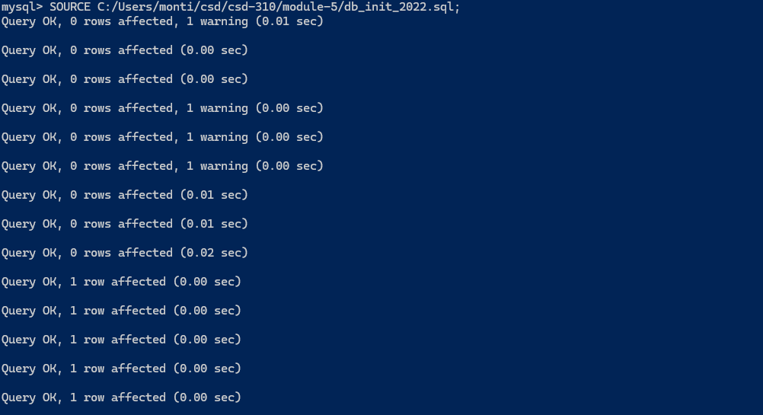
Database Tables
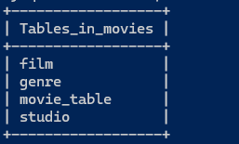
Note : There is an extra movie_table because I had experimented with the MySql Workbench for assignment 4.2 and added movie_table to the other tables.
Pycharm mysql_test.py Run
