Terminals
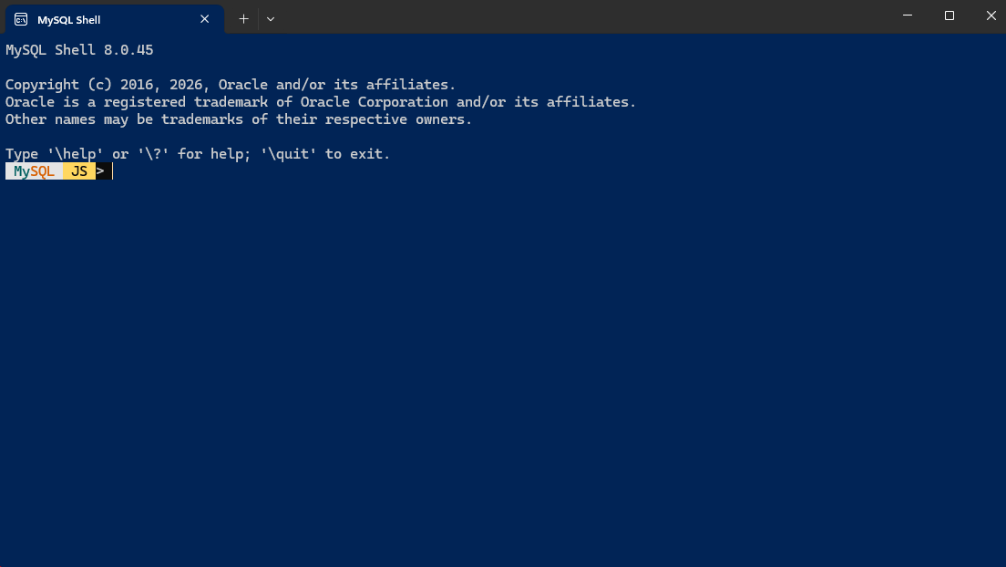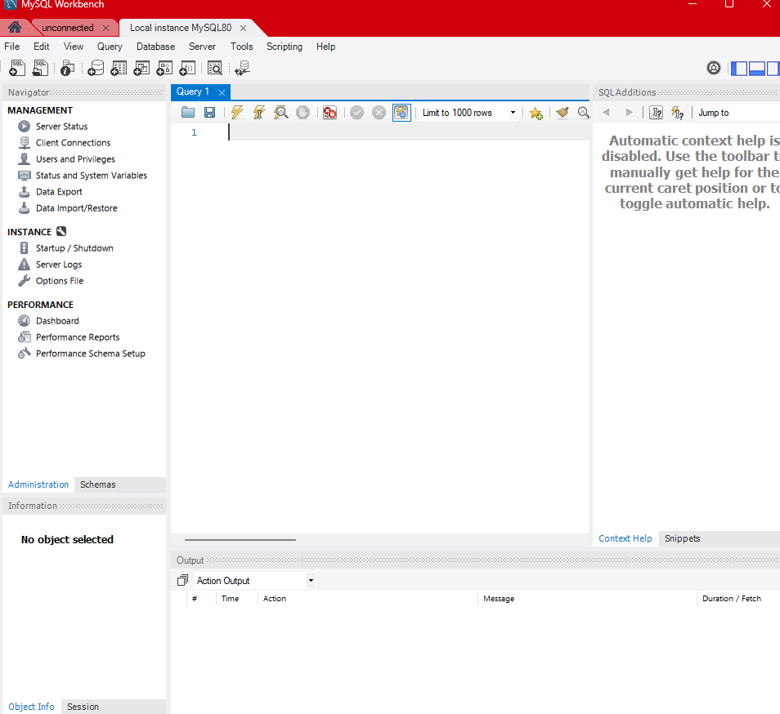
Movie Database Creation
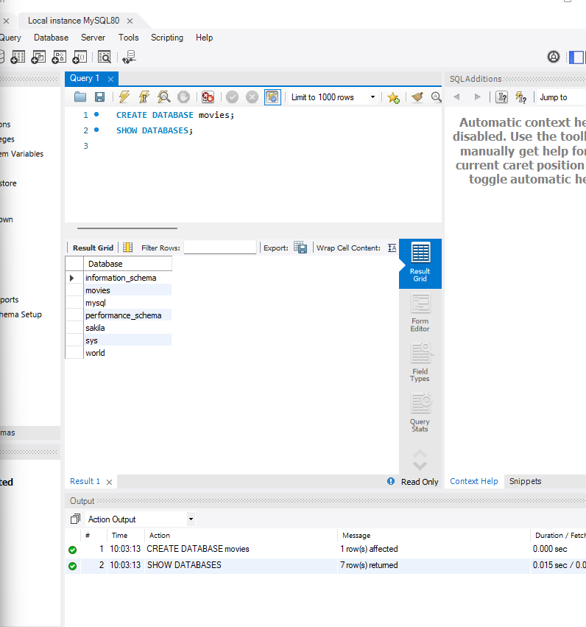
Functions Selected
CREATE TABLE, INSERT INTO, VALUES
Explanation
I used all three of these functions together in order to figure out basic usage of MQSQL.
CREATE TABLE was used to create a movie_table with the columns Dystopian and Utopian.
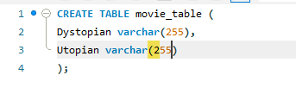
INSERT INTO was used to insert the
VALUE of Book_of_Eli.
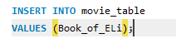
In my exploration, I realized I was trying to use MySQL Workbench like an IDE. Every time I executed, I believed the program would ignore the CREATE TABLE function. However, what happened instead was an error was created every time I executed. This made me realize how MySQL keeps information unique by ensuring no repeats happen.

